Name …………………………………………………………………………………………….….. Index No. ………………. Class …….


STAREHE GIRLS’ CENTRE MOCK EXAMINATION 2025

231/1
BIOLOGY
PAPER 1
THEORY

TIME: 2 HOURS

Biology
Paper 1
2 hours

INSTRUCTIONS TO CANDIDATES:
- Write your name and your admission number in the spaces provided above.
- Sign and write the date of the examination in the spaces provided above.
- Answer all the questions in the spaces provided.

For Examiner’s Use Only:

QUESTIONS | MAXIMUM SCORE | CADNIDATE’S SCORE
1 – 26 | 80

1. Name the cell organelles that would be abundant in:
a) White blood cells destroying pathogens 1mk
…………………………………………………………………………………………………………………………………………………………………………………………………………………………………….
b) Palisade mesophyl cells 1mk
……………………………………………………………………………………………………………………………………………………………………………………………………………………………………
c) Skeletal muscle cells 1mk
……………………………………………………………………………………………………………………………………………………………………………………………………………………………………
2. The following graph represents a growth pattern observed in a group of animals
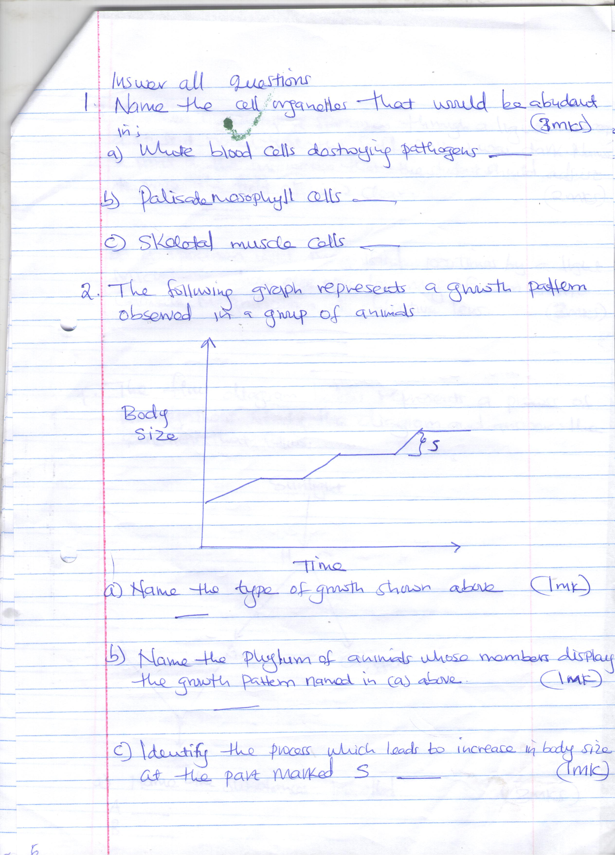
- Name the type of growth shown above (1mk)
…………………………………………………………………………………………………………………
b) Name the phylum of animals whose members display the growth pattern named in (a) above
(1mk)
…………………………………………………………………………………………………………………
c) Identify the process which leads to increase in body size at the part marked S (1mk)
…………………………………………………………………………………………………………………
3. (a) When observing a specimen through a light microscope, a student noted that the field of view
was dark. Name 2 parts of the microscope that the student should adjust to make the field of view clear (2mks)
…………………………………………………………………………………………………………………………………………………………………………………………………………………………………………………………………………………………………………………………………………………………………………………………………………………………………………………………………………
- A specimen was magnified 1000 times by a light microscope whose eye piece lens magnification is x10. Calculate magnification of objective lens (2mks)
………………………………………………………………………………………………………………………………………………………………………………………………………………………………………………………………………………………………………………………………………………………
4. The flow diagram below represents a process of photosynthesis. Study diagram and answer the questions that follow
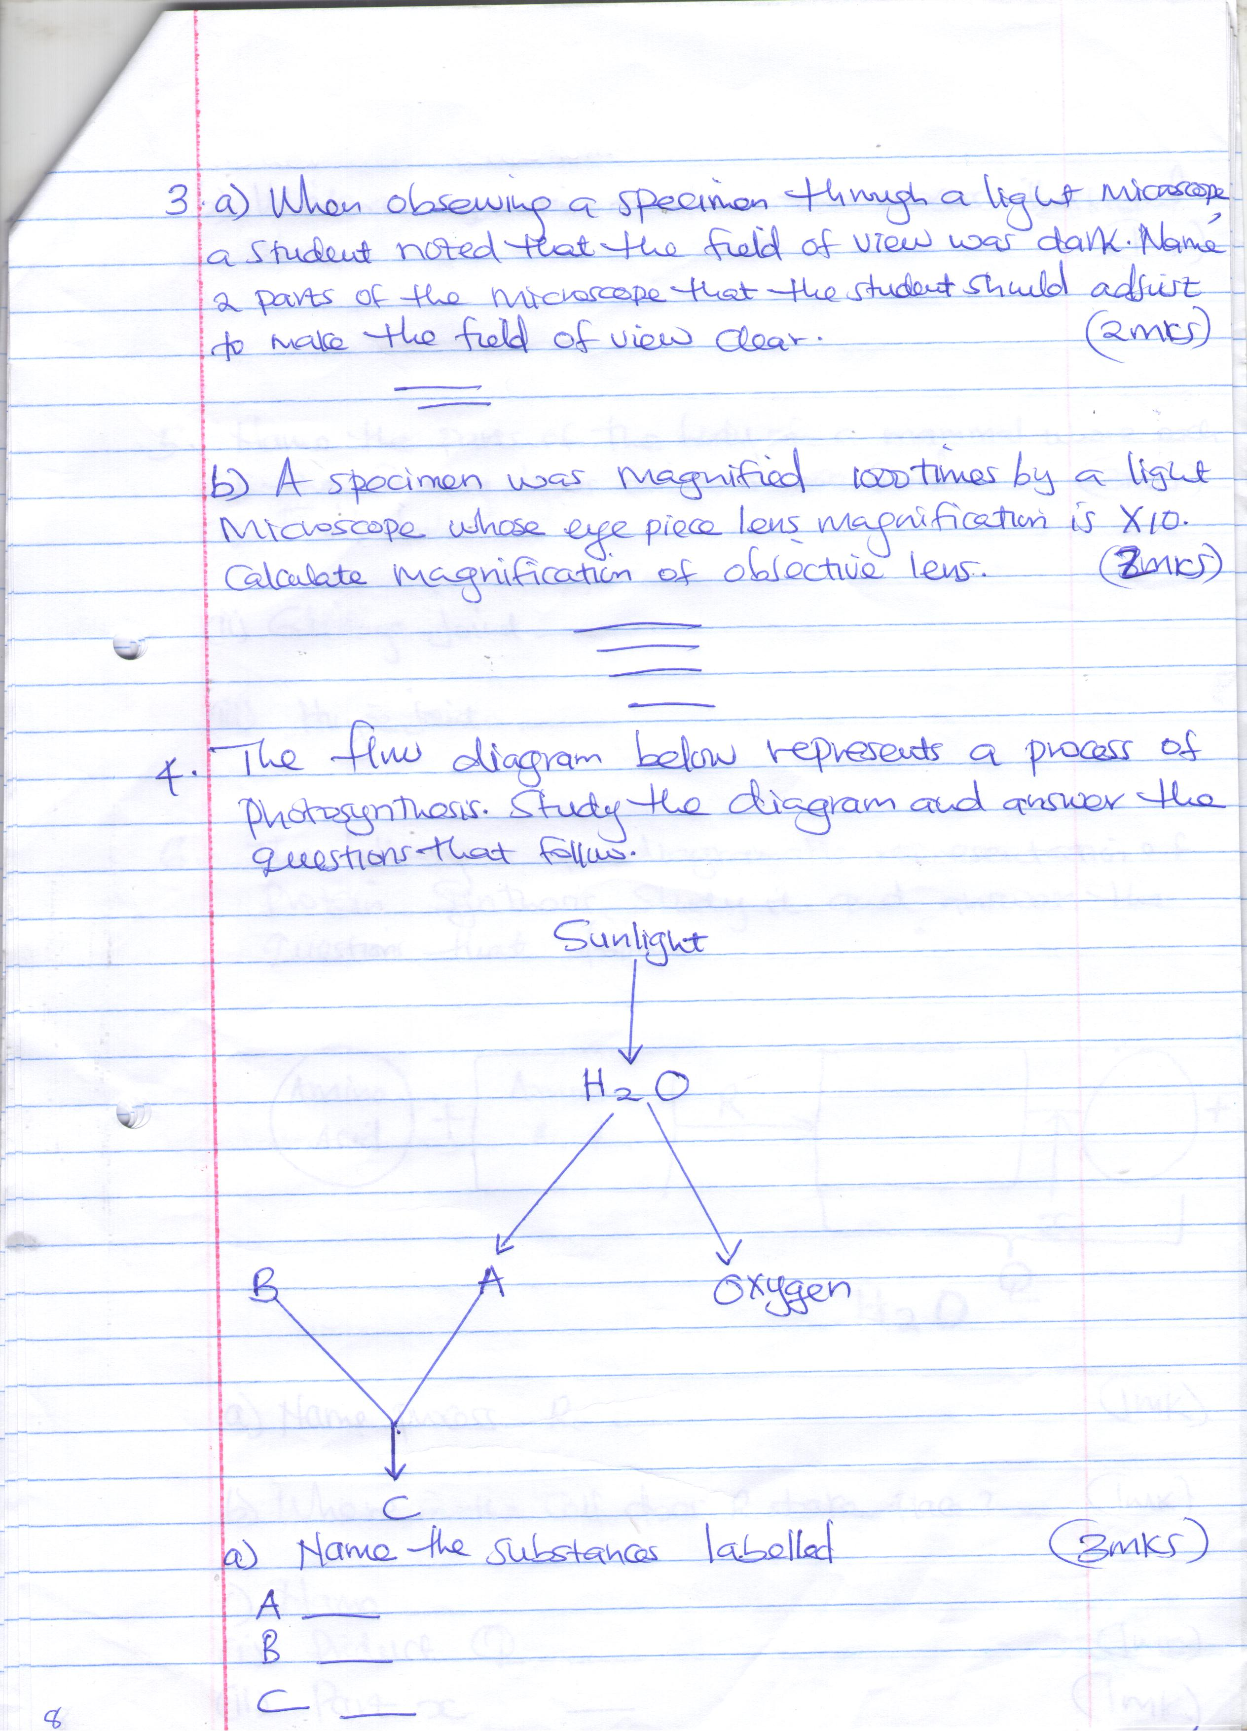
- Name the substances labeled (3mks)
A …………………………………………………………………………………………………
B ………………………………………………………………………………………………….
C ………………………………………………………………………………………………….
(b) Write an equation to show the process illustrated above (1mk)
………………………………………………………………………………………………………
5. Name the parts of the body of a mammal where each of the following types of joints are found
(3mks)
- Fixed joints
……………………………………………………………………………………………………………………………………………………………………………………………………………………………………
(ii) Gliding joint
……………………………………………………………………………………………………………………………………………………………………………………………………………………………………
- Huge joint
……………………………………………………………………………………………………………………………………………………………………………………………………………………………………
6. The following is a diagrammatic representation of protein synthesis. Study and answer the questions that follow.
X

Amino Acid
Amino acid
+ R + H₂O

Q
- Name process R (1mk)
………………………………………………………………………………………………………………
(b) Where in the cell does R take place? (1mk)
………………………………………………………………………………………………………………
(c) Name
(i) Product Q (1mk)
………………………………………………………………………………………………………………
(ii) Part X (1mk)
……………………………………………………………………………………………………………….
7. (a) Name an element which is a present in proteins but is not in carbohydrates (1mk)
…………………………………………………………………………………………………………………
(b) State three functions of proteins in the human body (3mks)
……………………………………………………………………………………………………………………………………………………………………………………………………………………………………………………………………………………………………………………………………………………….
8. State the functions of the following cell structures during cell division (2mks)
(i) Centriole
…………………………………………………………………………………………………………………………………………………………………………………………………………………………………….
(ii) Centromere
……………………………………………………………………………………………………………………………………………………………………………………………………………………………………
9. In a blood test, a few drops of anti- serum were added to two samples of blood. It was observed that agglutination occurred. What were the possible blood groups of the two blood samples (2mks)
……………………………………………………………………………………………………………………………………………………………………………………………………………………………………
10. Name the division of the kingdom Plantae with the following spores producing bodies (2mks)
(i) Sori
…………………………………………………………………………………………………………………
(ii) Sporangium
…………………………………………………………………………………………………………………
11.
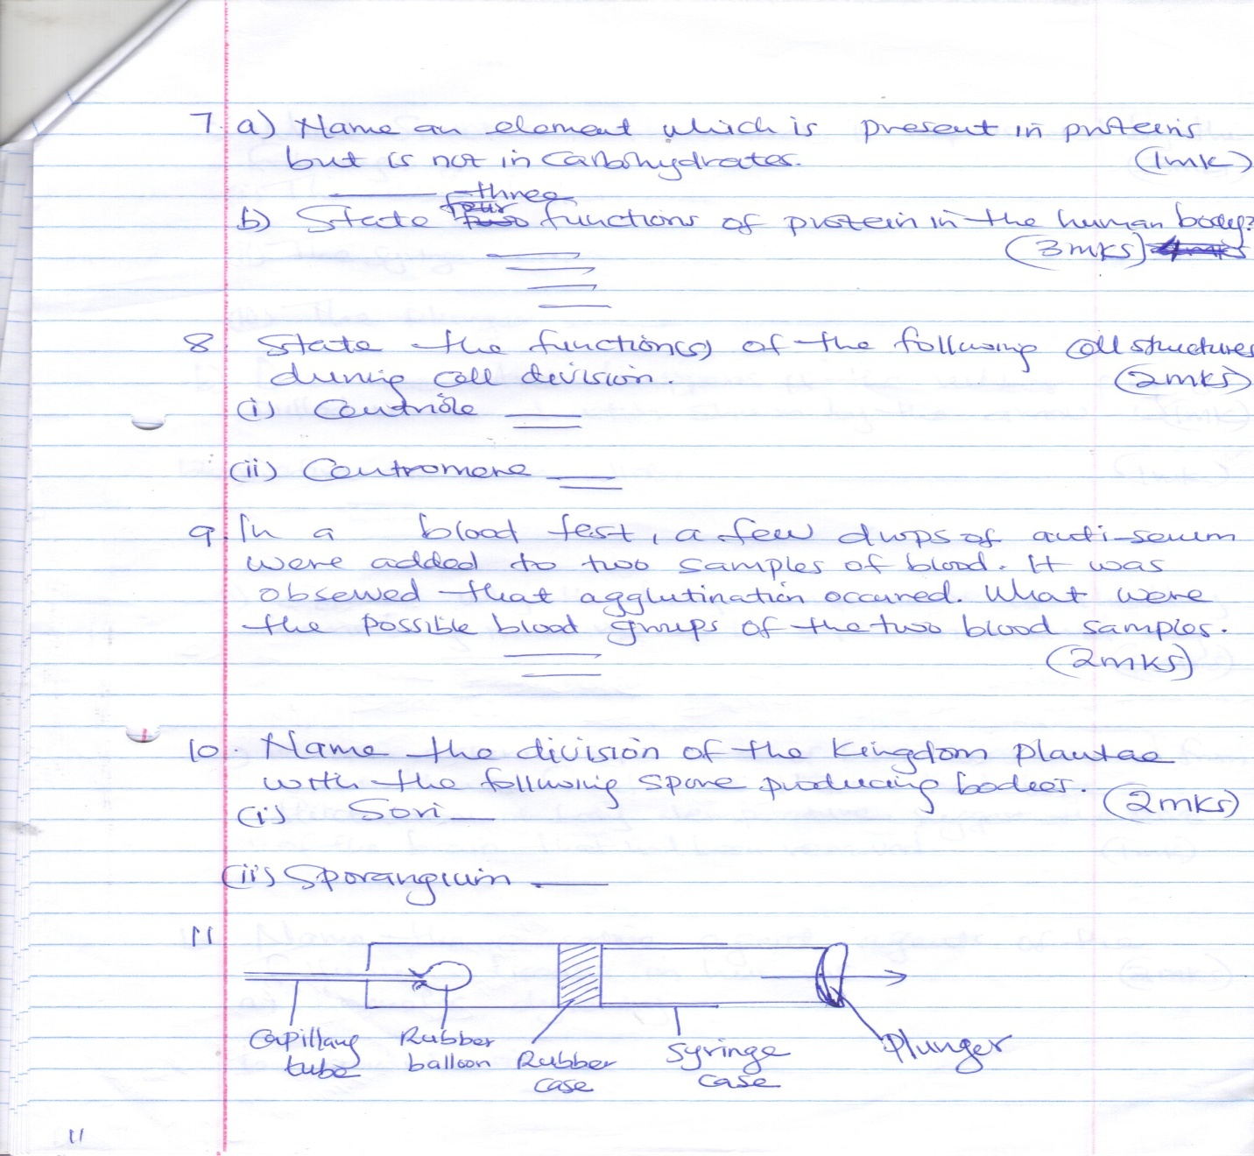
(a) What structure in a mammal is represented by the following? 3mks
(i) The rubber balloon
………………………………………………………………………………………………………..……….
(ii) The syringe case
…………………………………………………………………………………………………………………
(iii) The plunger
…………………………………………………………………………………………………………………
b) Describe what happens if the rubber plug is pulled in the direction shown by the arrow (1mk)
…………………………………………………………………………………………………………………………………………………………………………………………………………………………………..
12 (a) Define the term alleles (1mk)
……………………………………………………………………………………………………………………………………………………………………………………………………………………………………
(b) Explain why the body temperatures of a healthy human beings must rise up to 39⁰C on a humid day (2mks)
……………………………………………………………………………………………………………………………………………………………………………………………………………………………………………………………………………………………………………………………………………………….………………………………………………………………………………………………………………….
(c) In an experiment, a piece of brain was removed from a rat. It was found that the rat had large fluctuation of body temperatures. Suggest the part of the brain that had been removed (1mk)
………………………………………………………………………………………………………………….
………………………………………………………………………………………………………………….
13. Name the causative agent of the following diseases in humans (2mks)
(a) Ameobic dysentry
…………………………………………………………………………………………………………………..
(b) Candidiasis
………………………………………………………………………………………………………………….
14 (a) Define the term immunity (1mk)
…………………………………………………………………………………………………………………………………………………………………………………………………………………………………….
(b) Distinguish between natural immunity and acquired immunity (2mks)
………………………………………………………………………………………………………………………………………………………………………………………………………………………………………………………………………………………………………………………………………………………
(c) Identify one immunizable disease in Kenya (1mk)
…………………………………………………………………………………………………………………
15. The chart below shows a feeding relationship in a certain ecosystem
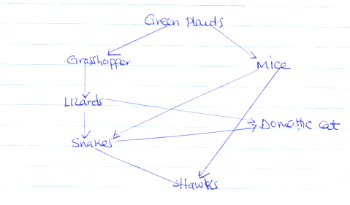
- Construct two food chains ending with a tertiary consumer in each case (2mks)
………………………………………………………………………………………………………………………………………………………………………………………………………………………………………………………………………………………………………………………………………………………………………………………………………………………………………………………………………….
- Suggest two ways in which the ecosystem would be affected if there was a prolonged drought
(2mks)
………………………………………………………………………………………………………………………………………………………………………………………………………………………………………………………………………………………………………………………………………………………………………………………………………………………………………………………………………….
16. State two functions of muscles found in the alimentary canal of mammals (2mks)
……………………………………………………………………………………………………………………………………………………………………………………………………………………………………………………………………………………………………………………………………………………….
17. Study the reaction below and answer the questions that follow
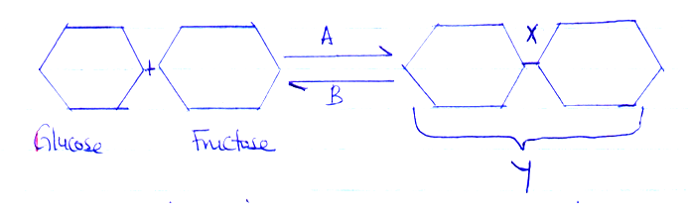

- What biological processes are represented by A and B (2mks)
A
………………………………………………………………………………………………………………….
B
………………………………………………………………………………………………………………….
(b) Identify the product Y (1mk)
…………………………………………………………………………………………………………………..
(c) State the bond represented by X (1mk)
…………………………………………………………………………………………………………………..
18. State one use of each of the following plant excretory products
(a) Tannins (1mk)
……………………………………………………………………………………………………………………………………………………………………………………………………………………………………
- Colchines (1mk)
…………………………………………………………………………………………………………………………………………………………………………………………………………………………………..
(c) Quinine (1mk)
……………………………………………………………………………………………………………………………………………………………………………………………………………………………………
19. State two characteristics of aerenchyma tissue (2mks)
………………………………………………………………………………………………………………………………………………………………………………………………………………………………………………………………………………………………………………………………………………………
………………………………………………………………………………………………………………….
20. The table below shows the percentage composition by volume of inhaled and exhaled air
Gas | Inhaled air % | Exhaled air %
Oxygen | 21 | 16
Carbon(iv) oxide | 0.04 | 4.0
Nitrogen | 79 | 79
- By what percentage is carbon (iv) oxide concentration in inhaled air higher than exhaled air (2mks)
………………………………………………………………………………………………………………………………………………………………………………………………………………………………………………………………………………………………………………………………………………………
- Explain the differences in the composition of the gases between inhaled and exhaled air (3mks)
…………………………………………………………………………………………………………………………………………………………………………………………………………………………………………………………………………………………………………………………………………………………………………………………………………………………………………………………………………
21 (a) what is metamorphosis (1mk)
…………………………………………………………………………………………………………………………………………………………………………………………………………………………………….
(b) What is the biological importance of the larval stage during metamorphosis (2mks)
………………………………………………………………………………………………………………………………………………………………………………………………………………………………………………………………………………………………………………………………………………………
22. Explain how the following forces contributes to the movement of water up the xylem vessels (2mks)
(a) Cohesion
…………………………………………………………………………………………………………………………………………………………………………………………………………………………………….
(b) Adhesion
……………………………………………………………………………………………………………………………………………………………………………………………………………………………………
23. A solution of sugarcane was boiled with hydrochloric acid; sodium hydrogen carbonate was added to the solution which was then heated with benedict’s solution. An orange precipitate was formed
(a) Why was the solution boiled with hydrochloric acid? (1mk)
……………………………………………………………………………………………………………………………………………………………………………………………………………………………………
(b) To which class of carbohydrates does sugarcane belong? 1mk
………………………………………………………………………………………………………………….
………………………………………………………………………………………………………………….
(c) State the form in which carbohydrates are stored in (2mks)
(i) Plants
…………………………………………………………………………………………………………………
(ii) Animals
…………………………………………………………………………………………………………………
24. How are lenticels adapted for gaseous exchange? (2mks)
……………………………………………………………………………………………………………………………………………………………………………………………………………………………………
25. State the importance of the following process that takes place in the nephrons of human kidney
(a) Ultrafiltration (1mk)
……………………………………………………………………………………………………………………………………………………………………………………………………………………………………
(b) Selective reabsorption (1mk)
……………………………………………………………………………………………………………………………………………………………………………………………………………………………………
26. The diagram below represents a section or portion of a certain nucleic acid
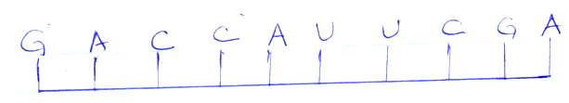
With a reason, identify the types of nucleic acid whose portion is shown above
Identity 1mk
…………………………………………………………………………………………………………………
Reason 1mk
…………………………………………………………………………………………………………………………………………………………………………………………………………………………………….

