NAME: …………………………………………. INDEX NO: ……………………………….

DATE : …………………………………..CANDIDATE’S SIGNATURE:…………………

MANGU HIGH SCHOOL TRIAL 4 MOCK 2025

FORM 4
AGRICULTURE
PAPER 2
TIME 2 HOURS
INSTRUCTIONS TO CANDIDATES
- This paper consists of three sections: A,B and C
- Answer all the question in section A and B
- Answer any two questions in section C
- All answers should be written in the spaces provided
SECTION A (30 Marks)
Answer ALL questions in the spaces provided
1 Name the pig breed which has the following characteristics: long, large, and white body, broad and dished face, upright ears. (½ mk)

2. Name any two characteristics of good quality whole milk. (1mk)

3. State three advantages of artificial calf rearing. (3mks)

4. State four qualities of clean milk. (2mks)

5. Outline four ways of controlling egg eating in poultry. (2mks)

6. (a) Name the cause of milk fever. (½ mk)

(b) Give one control measure of milk fever. (½ mk)

7. State three field conditions under which a disc plough should be used instead of a mouldboard plough. $(1\frac{1}{2}mks)$

8. (a) State two disadvantages of using metal frames in construction of farm building. (1mk)

(b) Give three reasons for seasoning timber. (1 ½ mks)

9. State four qualities of colostrum which make it suitable for feeding newly born calf. (2mks)

10. Name two dual purpose breeds of cattle (1mk)

11. Outline four reasons for swarming of bees. (2mks)

12. State four reasons for steaming up in animal production. (2 mks)

13. Give two causes of high mortality rate in piglets. (1mk)

14. (a) what is a notifiable disease? (1mk)

(b) Name four examples of notifiable diseases in livestock. (2mks)

15. Give three reasons why drenching alone is not an effective method of controlling intestinal parasites in livestock. $(1\frac{1}{2}mk$)

16. State four qualities of eggs preferred by consumers in the market (2 mks)

17. Give four light breeds of chicken in poultry rearing. (2mks)

SECTION B (20 Marks)
Answer all questions in this section in the spaces provided after every question
18. The illustration below show different presentation of foetus at the time of birth. Study the illustrations and answer questions that follow.
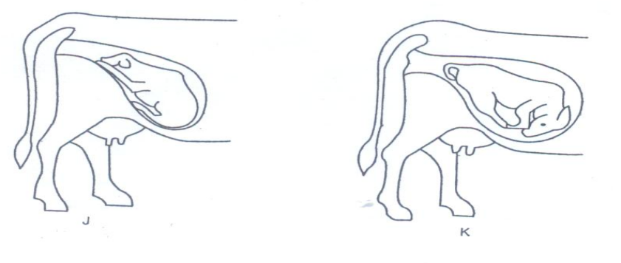
- What diagram represents the normal position of a calf at birth (1mk)

- What term is used to refer to position shown in diagram K? (1mk)

- State three signs of parturition in cattle. (3mks)

19. The diagram below shows a farm implement. Study it and answer the questions that follow:-

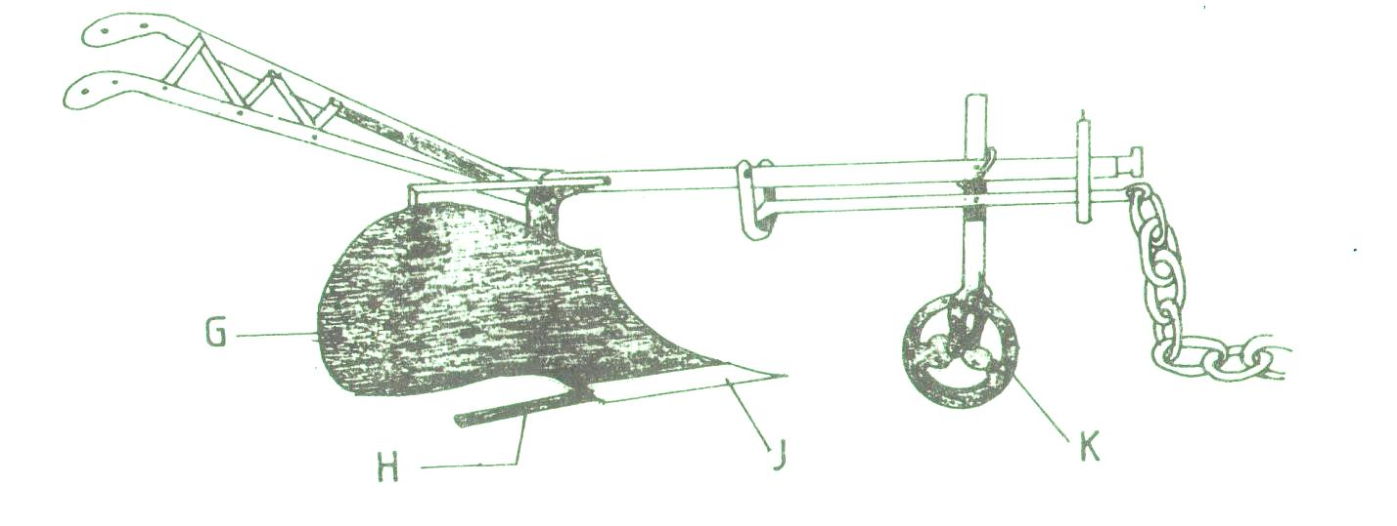
  - Identify the farm implement illustrated above. (1mk)

  - Name the parts labeled G,H and J (3mks)

(c)State two maintenance practices that should be carried out in the implement above (1mk)

20. The diagram below represents a poultry keeping structure.
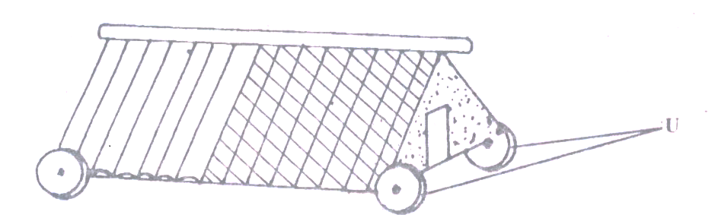
- Identify the structure. ( ½ mk)

ii) Identify the part labeled U. (½ mk)

iii) State the maintenance carried out on the structure illustrated above. (1mk)

21. The diagrams K, L, M and N below show four possible ways of drawing milk from the teat of a cow during milking.
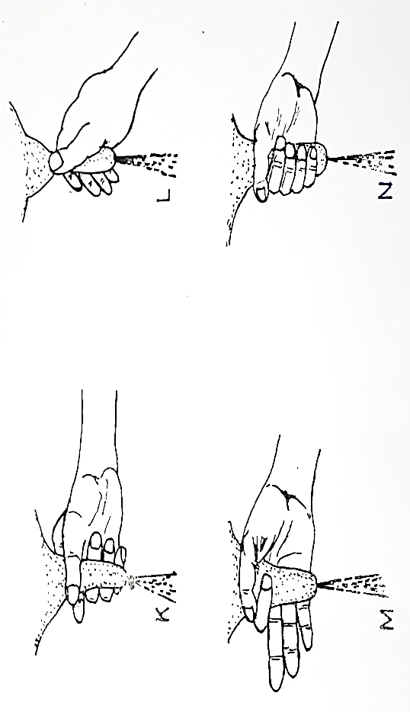

- Which diagram shows the proper way of drawing milk? (1mk)

- How long should it take to milk a cow from the start to the end of milking? (1mk)

- How would a milkman ensure that no milk remains in the udder at the end of milking? (1mk)

- Give two practices carried out on milk immediately after milking. (2mks)

22.Below is an illustration of an activity carried out by a poultry farmer keeping layers
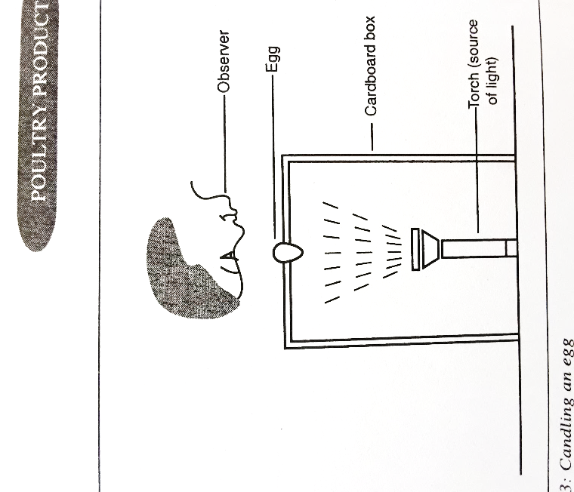
- Identify the activity carried out using the set-up. (1mk)

- State two abnormalities in eggs that can be detected using the set-up above. (1mk)

- How can a farmer improve the following?
- Hardness of egg shells. ( ½ mk)

- Yellowness of the egg yolk. ( ½ mk)

SECTION C (40 Marks)
Answer any two questions from this section in the spaces provided after each question.
23 a) Describe the artificial rearing of layer chicks from day old up to the end of brooding. (10mks)
b)Describe the characteristics of a poor layer, which should be considered during culling (4mks)
c) Discuss management practices that would ensure maximum harvest of fish from the pond. (4mks)
d) Give four methods used in preserving fish. (2mks)
24.a) State the functions of any six parts of a plunge dip. (6mks)
b) State and explain four factors considered when selecting a breeding stock. (4mks)
c) Explain five mechanical methods of controlling ticks. (10mks)
25 a) State five advantages of embryo transplant. (5mks)
b) Describe coccidiosis disease under the following sub- headings.
- Animals attacked (2mks)
- Causal organism (1mk)
- Symptoms (4mks)
- Control measures (3mks)
- A ration containing 20% DCP for growing chicks is to be obtained by mixing ground maize containing 10% DCP and fishmeal containing 50% DCP. Calculate the amount of each feedstuff in kilograms required to prepare 200kg of the feed (5mks )

