NAME: …………………………………………. INDEX NO: ……………………………….

DATE : …………………………………..CANDIDATE’S SIGNATURE:…………………

MANGU HIGH SCHOOL TRIAL 4 MOCK 2025

FORM 4
AGRICULTURE
PAPER 1
TIME 2 HOURS
INSTRUCTIONS TO CANDIDATES
- This paper consists of three sections: A,B and C
- Answer all the question in section A and B
- Answer any two questions in section C
- All answers should be written in the spaces provided
SECTION A (30 Marks)
Answer ALL questions in the spaces provided
- State four advantages of using farm yard manure. (2mks)

- State four merits of minimum tillage in crop production. (2mks)

- Mention four practices carried out to maintain grass pastures. (2mks)

- State four disadvantages of nomadic pastoralism. (2mks)

- Mention four cultural methods of used control in crop production. (2mks)

- State four ways of overcoming extremes of temperature in crop production. (2mks)

- List five precautions observed in harvesting tea to ensure high quality produce. (2¹/₂mks)

- List three ways in which primary cultivation can be achieved. (1¹/₂mks)

- An agriculture student was advised to apply complete fertilizer 40:30:10 in a (20x10) M plot and at
the rate of 40kg per hectare.
- Calculate the percentage of P₂O₅ in the complete fertilizer. (2mks)

- Calculate the amount of fertilizer the student would require for the plot. (2mks)

- State four divisions of livestock farming. (2mks)

- List four methods commonly used for applying nitrogenous fertilizers. (2mks)

- Name four factors influencing soil formation. (2mks)

- A farmer owns one hectare on which he can grow maize whose yield is 15 bags/hectare but has chosen to grow sorghum whose yield is 20 bags/hectare. If maize is sold at Shs. 1200 per bag while sorghum is sold at Shs. 700 per bag. Calculate the opportunity cost. (2mks)

- State four characteristics of plants used for preparation of green manure. (2mks)

SECTION B (20MKS)
- Students in an agriculture class set out to investigate the constituents of soil sample from school. They carried out a series of tests on various portions of the sample. They then prepared a table a shows below:

Description | Quantity
Mass of an empty evaporating disk  Fresh soil on evaporating disk  Mass of dried soil at 105oC on evaporating disk  Vol. of water in the tin  Vol. of water and soil after stirring  Mass of empty silica disk  Mass of silica disk and soil after ignition  Mass of silica disk and dried soil before ignition  Volume of water and soil before stirring | 10g  35g  28g  250cm³  410cm³  15g  45g  65g  500cm³

- Calculate the percentage of soil water in the sample. (1mk)

- Why was soil heated at 105ºC? (1mk)

- Calculate the percentage of soil air in the sample? (1mk)

- Calculate the percentage of soil organic matter in the sample. (1mk)

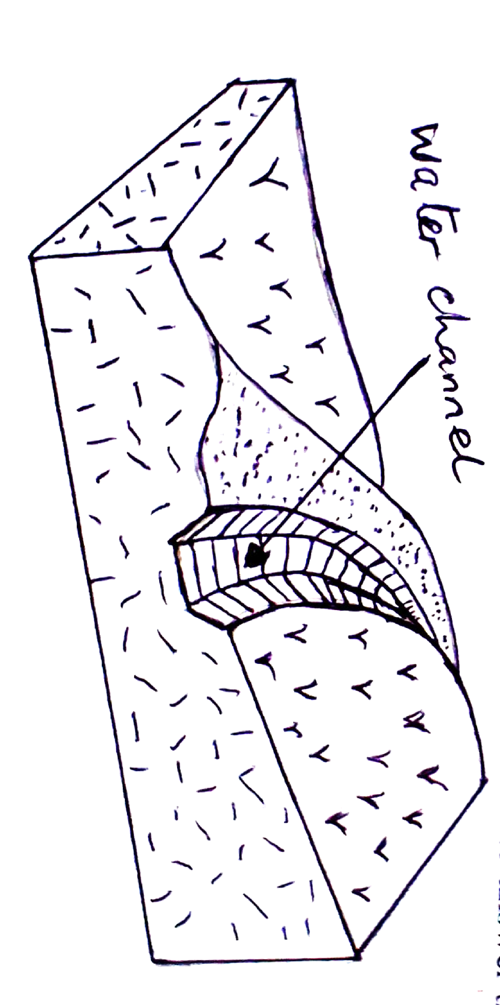
- Name one other soil constituent not tested above. (1mk)

- The diagram below shows a construction on farm. Use it to answer the questions that follow
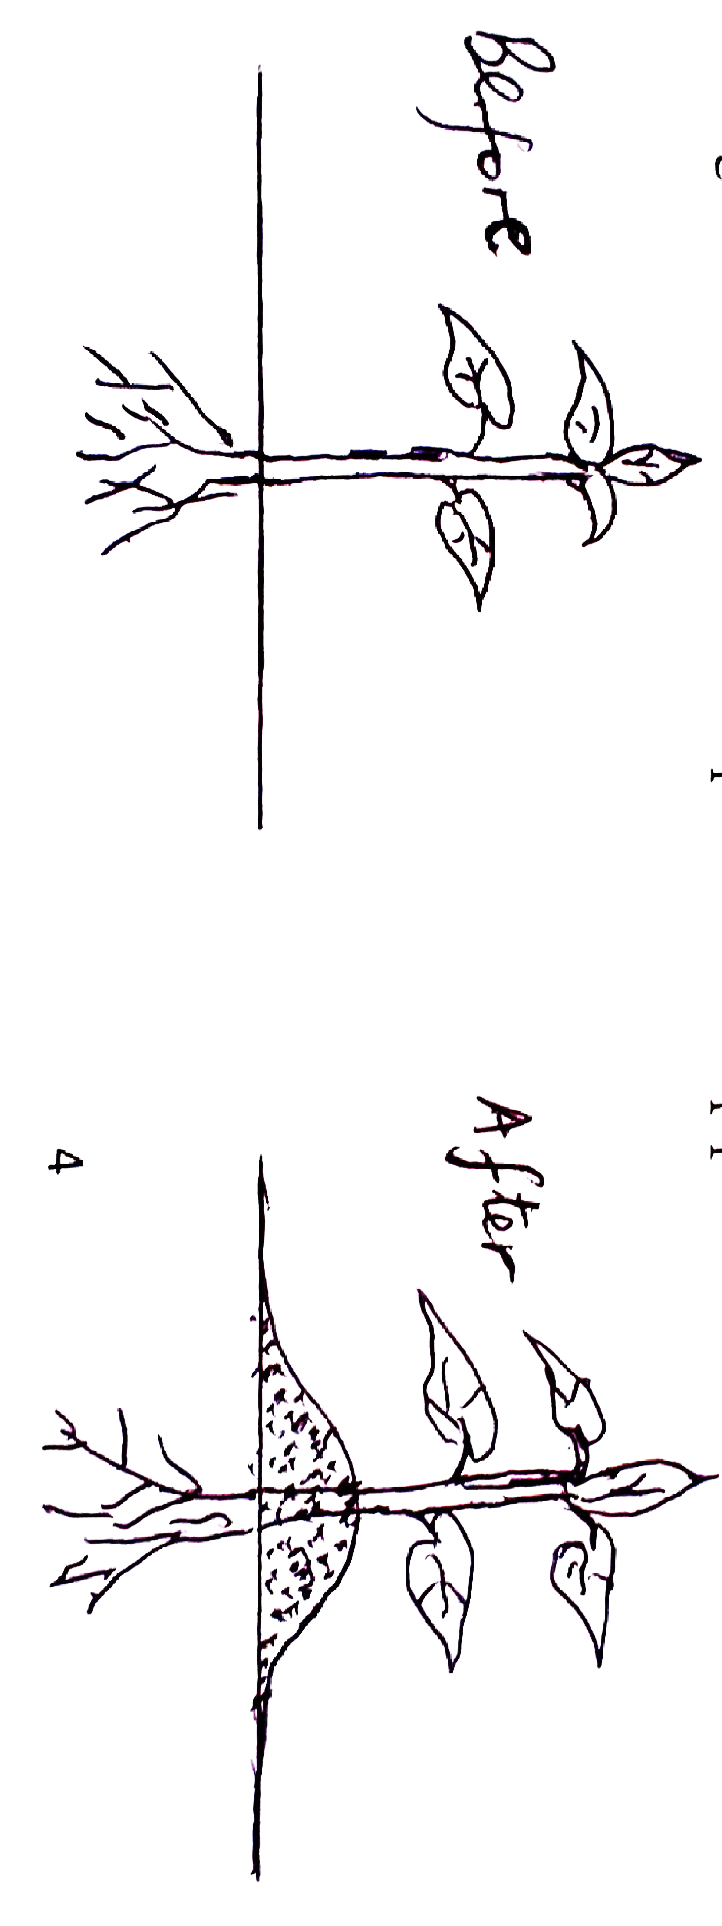
- Identify the above structure. (1mk)

- State four areas where water in the channel is directed to: (4mks)

- The diagram below shows a field practice in crop production.

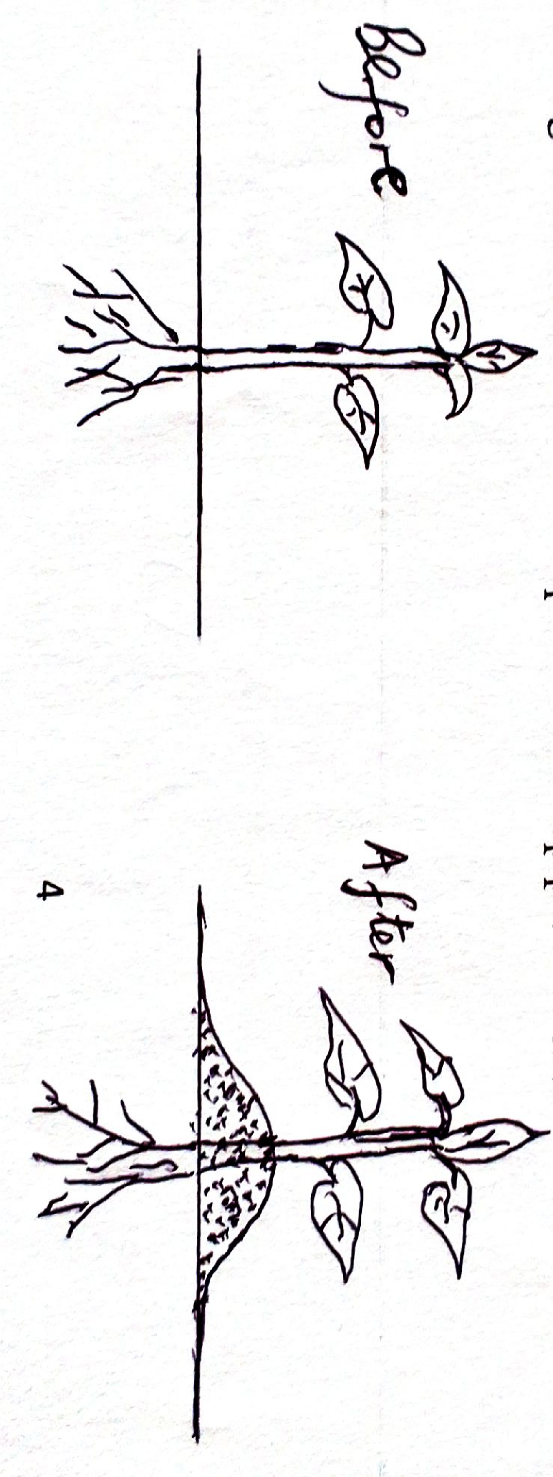
- Identify the practice. (1mk)

- State two advantages of the practice named in (a) above to Irish potatoes. (2mks)

- Name two other crops that require the above practice. (2mks)

- Use the diagram below to answer the questions.

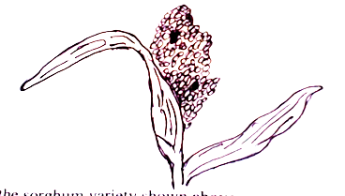

- Identify the sorghum variety shown above. (1mk)

- State two bird pests that commonly attack the crop. (2mks)

- Name two other varieties commonly grown by farmers. (2mks)

SECTION C (40MKS)
- a)State five importance of budgeting in a farming enterprise (5mks)
b) State six ways through which farmers adjust to risks and uncertainties (6mks)
c) State four ways in which labour productivity can be improved in the farm (4 mks)
d) State five importance of a title deed to a farmer (5 mks)
20. a) Describe the production of maize for grain production under the following sub-heading
- Four varieties common in Kenya (2mks)
- Seedbed preparation (3mks)
- Field practices (5mks)
b) State and explain five cultural methods used to control weeds (5mks)
c) State five effects of late defoliation of forage crops (5mks)
21. Study the table below showing quantities of fertilizers used and yield of maize obtained over a period of years and answer the questions that follow.

Land (in ha) | DAP fertilizers  (in 20kg units) | Yield  (90kg bags) | Marginal production(MP)  (in 90 kg bags) | Average production(AP)  (in 90 kg bags)
1 | 0 | 2
1 | 1 | 10
1 | 2 | 24
1 | 3 | 42
1 | 4 | 56
1 | 5 | 62
1 | 6 | 60
1 | 7 | 56

(a) i) Fill in the marginal and average product columns in the table (4mks)
ii) Using the graph paper provided draw the production function curve (6mks)
iii) Show the three zones of production on the graph (3mks)
b) Highlight seven effects of land fragmentation (7mks)

