COMPETENCY BASED CURRICULUM ASSESSMENT
MATHEMATICS ACTIVITIES PLAY GROUP END TERM 2 2025

NAME: …………………………………………… DATE……………………
1.Join the dots (10mks)
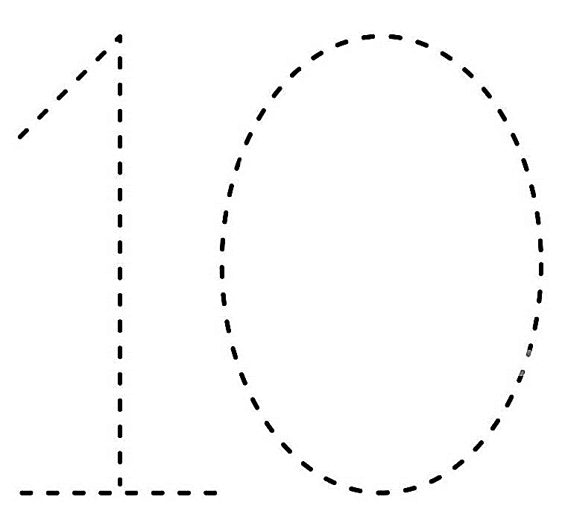





2.Match and colour animals with the number (9 mks)
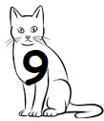

1
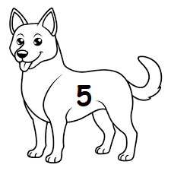

4
5
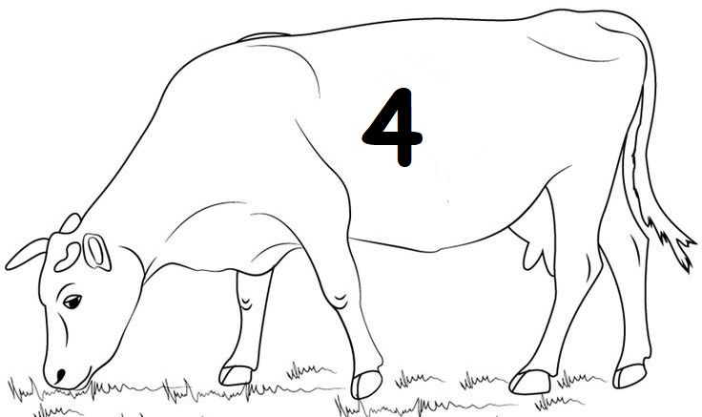

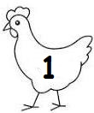
9

3.Re-write the numbers (6 marks)
0 0 0 0_______
1 1 1 1________
7 7 7 7__________
Assessment Rubrics 25×4=100%
Score % | Below expectation  0-39 | Approaching expectation  40-59 | Meeting expectation  60-79 | Exceeding expectation  81-100
Level | 1 | 2 | 3 | 4
Pupil score level

COMPETENCY BASED CURRICULUM ASSESSMENT
LANGUAGE ACTIVITIES PLAY GROUP END TERM2, 2025
NAME: …………………………….……………DATE…………………………
- Match the sounds (8 mks)
d
a
b
c
d
a

b
c

2.Colour well (6mks)


3.Identify and colour the pictures ( 11mks




Assessment Rubrics 25×4=100%
Score % | Below expectation  0-39 | Approaching expectation  40-59 | Meeting expectation  60-79 | Exceeding expectation  81-100
Level | 1 | 2 | 3 | 4
Pupil score level

COMPETENCY BASED CURRICULUM ASSESSMENT
ENVIRONMENTAL/CRE ACTIVITIES PLAY GROUP END TERM 2 2025
NAME___________________________DATE________
1.Trace and Colour (10mks)

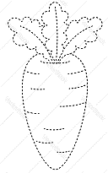

2.Match and colour the pictures (9mks)
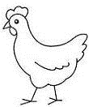




3. Colour the pictures (6mk)



Assessment Rubrics 25×4=100%
Score % | Below expectation  0-39 | Approaching expectation  40-59 | Meeting expectation  60-79 | Exceeding expectation  81-100
Level | 1 | 2 | 3 | 4
Pupil score level

COMPETENCY BASED CURRICULUM ASSESSMENT
CREATIVE ACTIVITIES PLAY GROUP END TERM 2 2025
NAME: ………………..………………….………….. DATE……………………
- Colour the pictures.(10 mks)



2.Join the dots and colour the pictures;(15 mks)



Assessment Rubrics 25×4=100%
Score % | Below expectation  0-39 | Approaching expectation  40-59 | Meeting expectation  60-79 | Exceeding expectation  81-100
Level | 1 | 2 | 3 | 4
Pupil score level


