NAME……………………………………………………………...ADM NO……………………..CLASS…….
END TERM 2 EXAMINATION
JULY/AUGUST 2025
PHYSICS PP2
FORM 3
TIME: 2 HOURS
INSTRUCTIONS: ANSWER ALL QUESTIONS IN THE SPAES PROVIDED
SECTION A
- State the condition under which the P.d across the terminals of a cell is equal to its e.m.f. (1 mark)

- Figure below shows the pattern of water ripples in a dam.
What information about the depth of the dam at point X can you deduce from the pattern? Explain your answer. (2 marks)

- Radio Maisha is broadcasting at a frequency of 70MHz. What is the wavelength of the waves, if the speed of the waves is 3.0 x 10⁸ m/s? (2 marks)

- How can it be shown that the strength of a magnet is concentrated at the poles? (1 mark)

- State the Snell’s law of refraction. (1 mark)

- Give two reasons why soft iron is used as a core of the coil in an electric bell. (2 marks)

- Figure below shows three capacitors connected between two points A and B.
$$1.3μF$$
B
A
$$2.0μF$$
$$0.7μF$$
Determine the capacitance across AB. (3 marks)

- Sound is classified as a longitudinal mechanical wave. Explain why sound is classified as;
- A longitudinal wave. (1 mark)

- A mechanical wave. (1 mark)

- State two application of total internal reflection (2 mark)

10. State four differences between stationary and progressive waves (4 marks)

11.A ray is incident on two mirrors inclined at 60⁰ as shown in the diagram below.
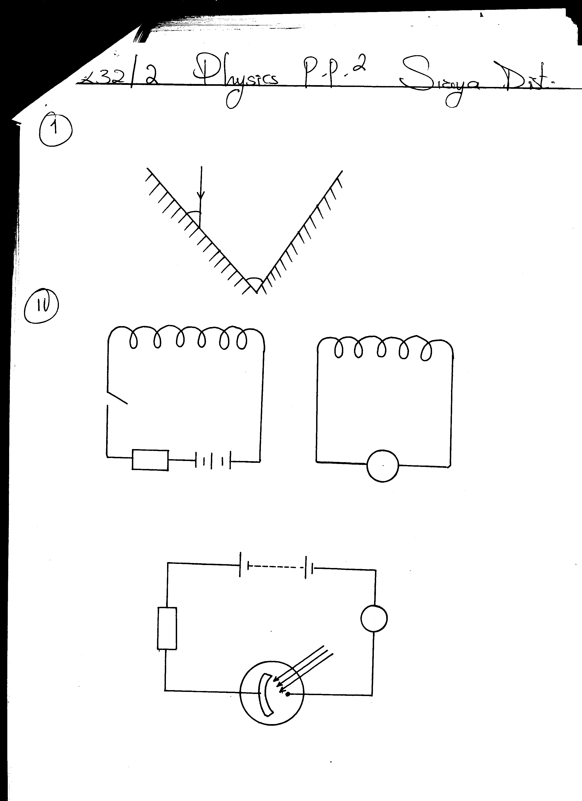
40⁰
60⁰
Mirror B
Mirror A

Determine the angle of reflection on mirror B, hence trace the path of the ray as it leaves mirror B (2 marks)

12. (a)State and explain the observation made when an acetate rod rubbed with fur is brought close to the cap of a negatively charged electroscope. (2 marks)

(b) Give a reason why its not advisable to carry fuel in a plastic can (1 mark)

SECTION B: 55 markS
13. (a) State Ohm’s Law. (1 mark)

(b) Explain why a 12V car battery is able to start the motor car engine while eight dry cells of 1.5v each connected in series will not. (2 marks)

(c) In the figure below, the current in the circuit is 1.80A
2Ω
4Ω

X Y
2Ω

3Ω
6Ω

- Find the effective resistance between X and Y. (3 marks)

- The p.d of the source. (2 marks)

- Current through the 3Ω resistor (3 marks)

14. The figure below shows a dry cell.

B

A

C

- Name the parts labelled A, B and C (3 marks)

- State the function of each of the parts labelled ( 3 marks)

- State how the following defects affect the efficient working of the dry cell
- Polarization (1 mark)

- Local action (1 mark)

d) State any two ways in which the above-mentioned defects can be reduced (2 marks)

15. (a) State three factors which affects the strength of electromagnet (3 marks)

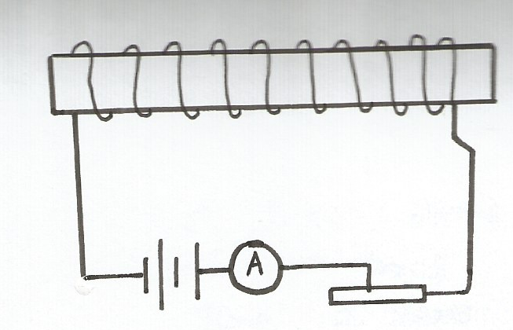
(b) Figure shows a solenoid with a ferromagnetic core connected to a battery E, ammeter A and rheostat R

E
R

On the figure indicate
- The direction of current in the external circuit and around the coils (1 mark)

- The polarity of the resulting electromagnet (2 marks)

- The direction of the magnetic field lines created around the solenoid (2 marks)

(c) A conductor through which an electric current is flowing into the paper in a magnetic field as shown in figure below
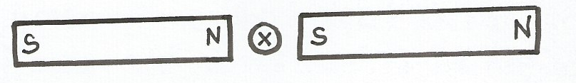

On the same diagram sketch the resulting magnetic field pattern and show the direction of the resulting mechanical force F, on the conductor (3 marks)

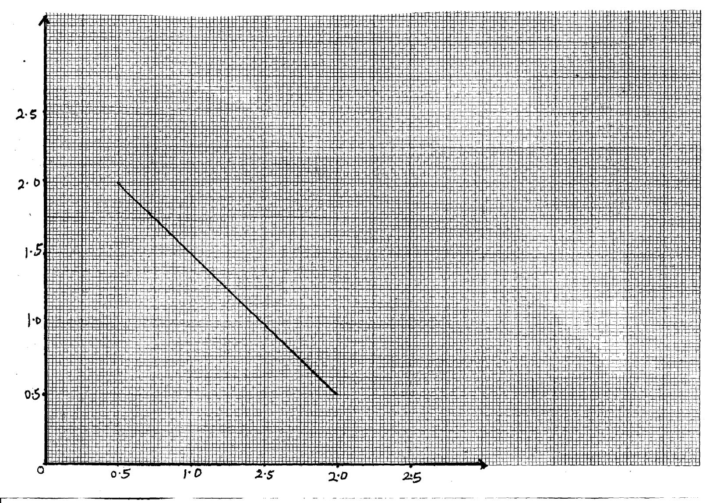
16. (a) The graph below shows the relationship between $1/u$ for $1/v$for a converging lens where u and v are the object and image distances respectively.

1 x 10⁻² (cm⁻¹)
u

1/V x10⁻² (cm⁻¹)

From the graph, determine the focal length f, of the lens. (3 marks)

b) State two conditions necessary for total internal reflection to occur. (2 marks)

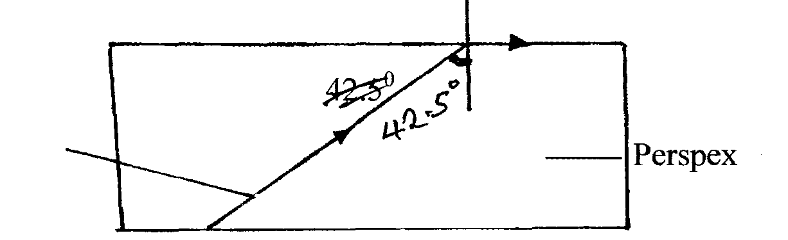
c) The figure below shows the path of a ray of light passing through a rectangular block of Perspex placed in air.

Ray of light
Perspex

- Calculate the refractive index of Perspex. (3 marks)

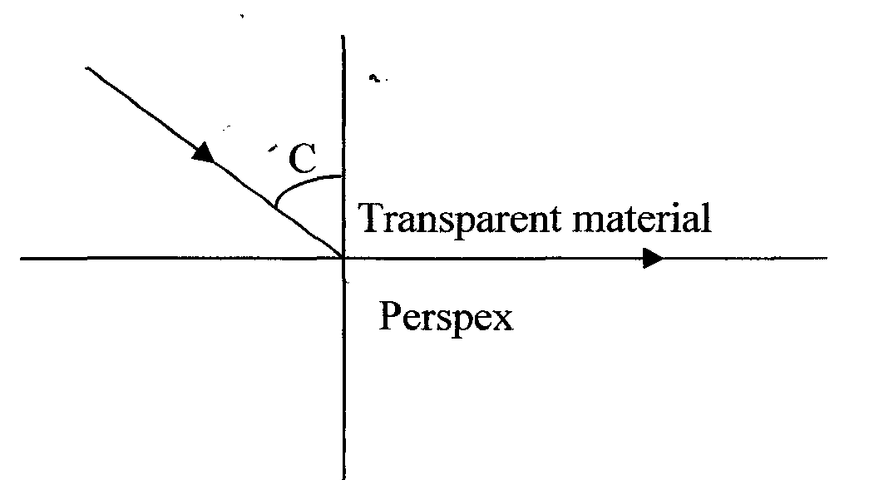
(ii) A ray of light now travels from a transparent medium of refractive index 2.4 into the Perspex as shown below

Calculate the critical angle C. (3 marks)

17 (a) The figure below shows straight wave fronts incident on convex reflector.
Complete the diagram to show the reflected wave fronts. (1 mark)
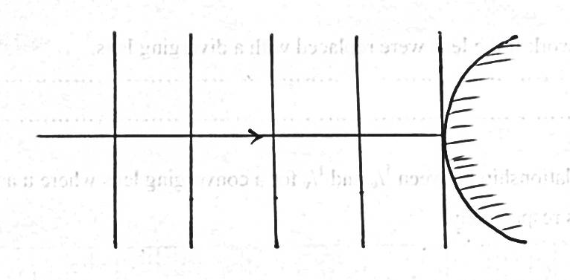
b) Narrow slits cannot be used to demonstrate interference of sound waves. Explain. (1 mark)

c) The figure below shows sound waves emitted by a drum struck.
Wave fronts

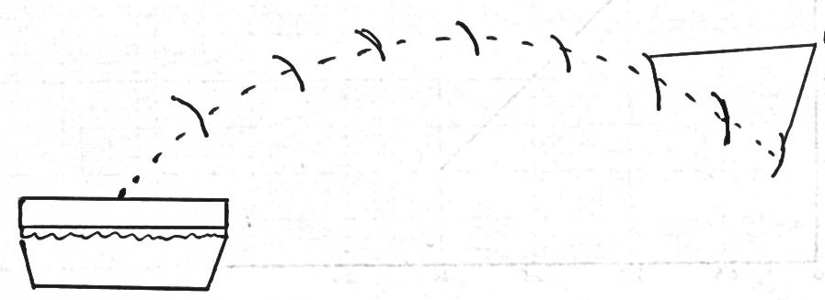
Explain why the wave fronts are directed to the ground. (2 marks)

- An echo sounder produces a pulse and an echo is received from the seabed after 0.4 seconds. If the speed of sound in water is 1500m/s. Calculate the depth of the sea bed. (2 marks)

18. The set up in figure below can be used in a laboratory for lifting and releasing a steel ball.
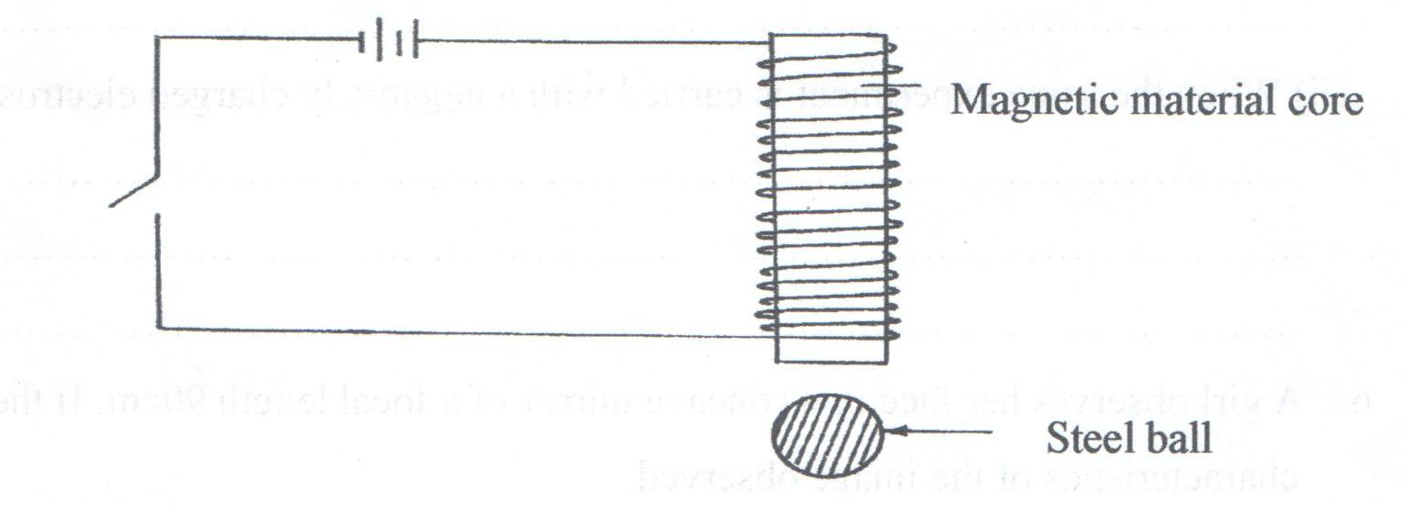
- Name the material, which is suitable for use in the core. (1 mark)

- If a slightly larger ball is to be lifted, it is necessary to make an electromagnet stronger. Name Three ways of increasing the strength of the magnet (3 marks)

- State any other two uses of an electromagnet (2 marks)

