Name: _____________________________________________ Adm No: ____________Class: _____

Candidate’s Signature: ________________________ Date: __________________________

PHYSICS
FORM 2
END TERM 2 EXAMINATION
JULY/AUGUST 2025
TIME: 2 HOURS

Instructions to Candidates
- Write your name, class and admission number in the spaces provided above.
- Answer ALL the questions in the spaces provided.
- Answers must be written in the spaces provided in the question paper. Additional pages must not be inserted.
- Candidates should check to ensure that all pages are printed and no questions are missing

- Name any four branches of physics? (4 marks)

- Define the following (4 marks)

- Length-
- Area-
- Volume-
- Density-

- Explain how you would determine the volume of a stone. (3 marks)

- State and explain four types of forces. (4 marks)

- Explain using molecular theory surface tension. (1 mark)

- Highlight two differences between mass and weight. (2 marks)

- A diver is 10 m below the surface of the water in a dam. If the density of water is 1,000kg/m³ determine the pressure due to the water on the diver. (Take g=10Nkg-¹ ) (3 marks)

- Explain how a car hydraulic brake system works (3 marks)

- State any two properties of a good brake fluid ( 2 marks)

- State and explain any three effects of anomalous expansion of water. (3 marks)

- State four factors that affect thermal conductivity. (4 marks)

- Why are liquids poor conductors of heat? (2 marks)

- Find the angle of reflection in the diagram below (3 marks)
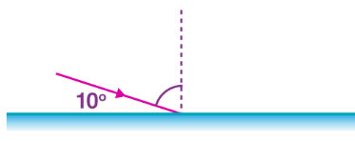

- Explain how you would charge a gold leaf electroscope negatively by induction (3 marks)

- State the principle of moments (2 mark)

- Calculate the force required to balance the plank of 20m uniform length below , calculate the position from the 10m where X is with a force of 240N (4 marks)

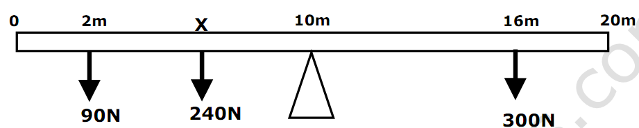

- What is the diameter of the circular disc in the figure below ( 3 marks)
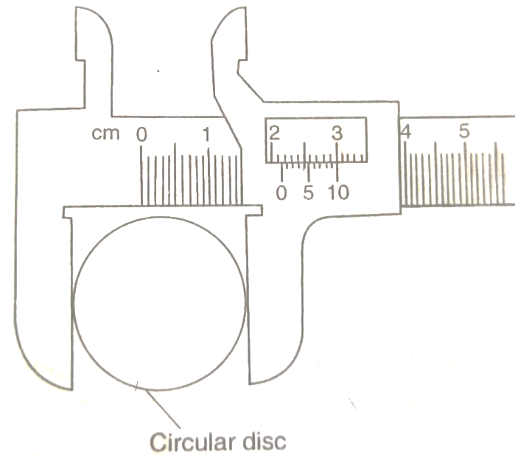
- State three applications of anti-parallel forces (3 marks)

- Describe two methods of magnetizing a steel rod. (6 marks)

- State the laws of reflection (2 marks)

- Name three applications of the reflection of light in everyday life. (3 marks)

- How does a person see an object (2 marks)

- Explain how a fountain pen is filled with ink (2 marks)

- State two applications of a bimetallic strip. (2 marks)

