MARKING SCHEME
PHYSICS
FORM 2
END TERM 2 EXAMINATION
JULY/AUGUST 2025

- Name any four branches of physics? (4 marks)
- Mechanics
- Electricity and magnetism
- Thermodynamics
- Geometrical optics
- Waves
- Atomic physics

- Define the following (4 marks)
- Length- measure of distance between two points.
- Area- is the quantity that expresses the extent of a given surface on a plane.
- Volume-amount of space occupied by matter.
- Density-mass per unit volume.
- Explain how you would determine the volume of a stone. (3 marks)
- Use a measuring cylinder filled with water. Tie a stone with a string and lower it down the cylinder record the reading before lowering the stone and after the stone is immersed in the water. Volume =V2-V1.
- State and explain four types of forces. (4 marks)
- Tension,gravity, friction,magnetic,centripetal,cohesive and adhesive,surface tension,molecular,electric,nuclear,electrostatic.
- Explain using molecular theory surface tension. (1 mark)
- There are fewer molecules of water on the vapor side thus the molecules on the surface experience a resultant inward force causing the liquid to be in tension.
- Highlight two differences between mass and weight. (2 marks)
- Mass is quantity of mater/weight is pull of gravity
- Kg/newton
- Same everywhere/changes from place to place
- Measured with a beam balance/use spring balance
- Magnitude/both magnitude and direction
- A diver is 10 m below the surface of the water in a dam. If the density of water is 1,000kg/m³ determine the pressure due to the water on the diver. (Take g=10Nkg-¹ ) (3 marks)
- P=h𝞺g = 10×1000×10= 100, 000Nm⁻²
- Explain how a car hydraulic brake system works (3 marks)
- Force applied on the brake pedal exerts pressure on the master cylinder the master cylinder transmits the pressure to the slave cylinder causing the piston of the slave cylinder to open the brake shoe and hence the brake lining presses on the drum. When the force on the pedal is withdrawn the spring pulls back the brake shoe which then pushes the slave cylinder piston back.
- State any two properties of a good brake fluid ( 2 marks)
- Be incompressible for equal pressure conveyance to all parts
- Low freezing point and high boiling point
- Should not corrode the parts of the parts system
- State and explain any three effects of anomalous expansion of water. (3 marks)
- Freezing of lakes and ponds fish survive beneath
- Icebergs danger to sailors/ships
- Water pipes bursting
- Weathering of rocks expansion breaks the rocks
- State four factors that affect thermal conductivity. (4 marks)
- Temperature difference
- Length of the conductor
- Nature of the material
- Cross-sectional area
- Why are liquids poor conductors of heat? (2 marks)
- Molecules are further apart/intermolecular space is larger compared to solids there are no electrons to move about to transfer heat the collision between the molecules is also fewer.
- Find the angle of reflection in the diagram below (3 marks)
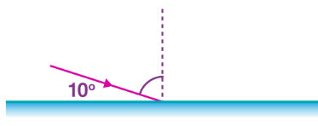 angle of i=angle of r = 90-10 = 80

- Explain how you would charge a gold leaf electroscope negatively by induction (3 marks)
- Use a glass rod and rub it with silk thread to acquire +ve charges. Move the rod near the cap of the electroscope to attract negative charges touch the cap earth the charges on withdrawing the earth and the rod the negatively charges repelled to the leaf redistributed through the electroscope. Accept diagrams as answers.
- A concave mirror of focal length 10cm forms a real image four times the size of the object. If the object height is 5 cm determine graphically. (5 marks)
- The object distance 12.5 cm
- The image distance 50 cm
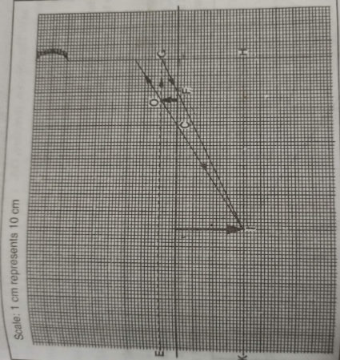
- State the principle of moments (1 mark)
- The sum of clockwise moments is equal to the sum of clockwise moments.
- Calculate the force required to balance X is at 5.5m form the pivot. (4 marks)
.
- What is the diameter of the circular disc in the figure below ( 3 marks)

- Main scale= 2.1 cm
- Vernier scale= 0.04 cm
- Diameter of the disc = (2.1 + 0.04) = 2.14 cm
- State three applications of anti-parallel forces (3 marks)
- Steering wheel
- Water tap
- Bicycle handle-bars
- Describe two methods of magnetizing a steel rod. (6 marks)
- Electrical or stroking or hammering
- State the laws of reflection (2 marks)
- The angle of incidence = angle of reflection
- The incident, reflected and the normal at the point of incidence all line on the same plane.
- Name three applications of the reflection of light in everyday life. (3 marks)
- Shaving mirrors
- Periscope
- Kaleidoscope
- How does a person see an object (2 marks)
- Light shines on objects and is reflected to a person’s eye
- Explain how a fountain pen is filled with ink (2 marks)
- Atmospheric pressure and air squeezed out to create low pressure.
- State two applications of a bimetallic strip. (2 marks)
- Thermostat

