

MARANDA HIGH SCHOOL
Kenya Certificate of Secondary Education
THE MOCK EXAMINATIONS, 2025
232/2 PHYSICS PAPER 2
May, 2025 TIME: 2 Hrs

Name: …………………………………….…….…… Admission No: …………
Stream: ……………….. Signature: ………............ Monday, 30th June, 2025; 2:00-4:00pm
Instructions

- Write your name, admission number, date, stream and signature in the spaces provided above.
- All answers must be written in the spaces provided in this question paper.
- This paper consists of 13 printed pages with 2 sections.
- Candidates should check the question paper to ascertain that all the pages are printed as indicated and that no questions are missing
- Candidate should answer the questions in English
______________________________________________________
FOR EXAMINERS’ USE ONLY
Section | Question | Maximum Score | Candidate’s Score
A | 1 – 13 | 25
B | 14 | 13
B | 15 | 14
B | 16 | 15
B | 17 | 07
B | 18 | 06
B | Total Score | 80

SECTION A (25 MARKS)
Answer ALL questions in this section in the spaces provided
- State and explain the effect of increasing the E.H.T. in an X- ray tube on the X-rays produced (2 marks)
………………………………………………………………………………………………………………………………………………………………………………………………………………………………………………………………………………………………………………………
- Give a reason why attraction in magnetism is not regarded as a reliable method of testing for polarity. (1 mark)
………………………………………………………………………………………………………………………………………………………………………………………………………………………………………………………………………………………………………………………
- What is the purpose of having a national grid in power transmission? (1 mark)
………………………………………………………………………………………………………………………………………………………………………………………………………………………………………………………………………………………………………………………
- Figure 1 shows an object ‘O’ and its image ‘I’ as formed by a concave mirror

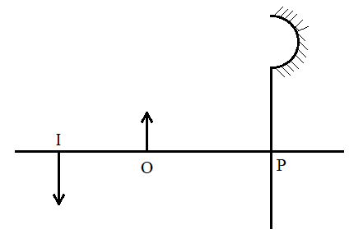
Figure 1

Complete the ray diagram and indicate the focal length of the mirror. (2 marks)

- In large circuits, large resistors in parallel are preferred to low resistors in series. Explain. (1 mark)
…………………………………………………………………………………………………………………………………………………………………………………………………………………………………………………………………………………………………..…………………
- Figure 2 (a) and Figure 2 (b) show diagrams of the human eye.
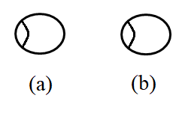
Figure 2
Sketch in Figure 2 (a) a ray diagram to show short sightedness and in Figure 2 (b) long sightedness.
(2 marks)
- Explain why the inner part of a pin hole camera is painted black (1 mark)
………………………………………………………………………………………………………………………………………………………………………………………………………………………………………………………………………………………………………………………
- Figure 3 shows a simple water heater.

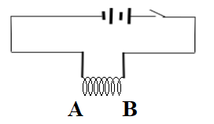
Figure 3
Give a reason why AB is coiled. (2 mark)
………………………………………………………………………………………………………………………………………………………………………………………………………………………………………………………………………………………………………………………

- With the use of a diagram, describe an experiment to show that sound cannot travel in a vacuum.
(4 marks)
………………………………………………………………………………………………………………………………………………………………………………………………………………………………………………………………………………………………………………………………………………………………………………………………………………………………………………………………………………………………………………………………………………………………………………………………………………………………………………
- State two qualities that are used to determine whether an accumulator require charging or not. (2 marks)
………………………………………………………………………………………………………………………………………………………………………………………………………………………………………………………………………………………………………………………
- Explain why radio wave signals are easier to receive than TV waves signals in a place surrounded by hills. (2 marks)
………………………………………………………………………………………………………………………………………………………………………………………………………………………………………………………………………………………………………………………………………………………………………………………………………………………………

- Figure 4 below shows a negatively charged rod placed near an uncharged conductor resting on an insulation support.
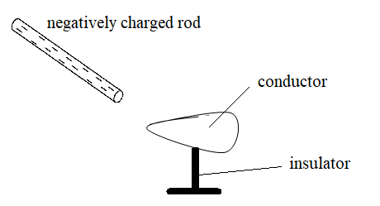
Figure 4

Show the charge distribution on the conductor. (1 mark)
- State the effect:
- Of momentarily touching the conductors with a finger while the charged rod is still near the conductor. (1 mark)
………………………………………………………………………………………………………………………………………………………………………………………………………………………………………………………………………………………………………
- On the charge distribution of withdrawing the negatively charged rod after momentarily touching the conductor (1 mark)
………………………………………………………………………………………………………………………………………………………………………………………………………………………………………………………………………………………………………
- State two ways by which the speed of rotation of a motor can be increased (2 marks)
………………………………………………………………………………………………………………………………………………………………………………………………………………………………………………………………………………………………………………………

SECTION B (55 MARKS)
Answer ALL questions in this section in the spaces provided

- Define the following:
- Photoelectric effect (1 mark)
………………………………………………………………………………………………………………………………………………………………………………………………………………………………………………………………………………………………………
- Threshold wavelength (1 mark)
………………………………………………………………………………………………………………………………………………………………………………………………………………………………………………………………………………………………………

- The graph below shows the stopping potential and corresponding frequencies of photocell.
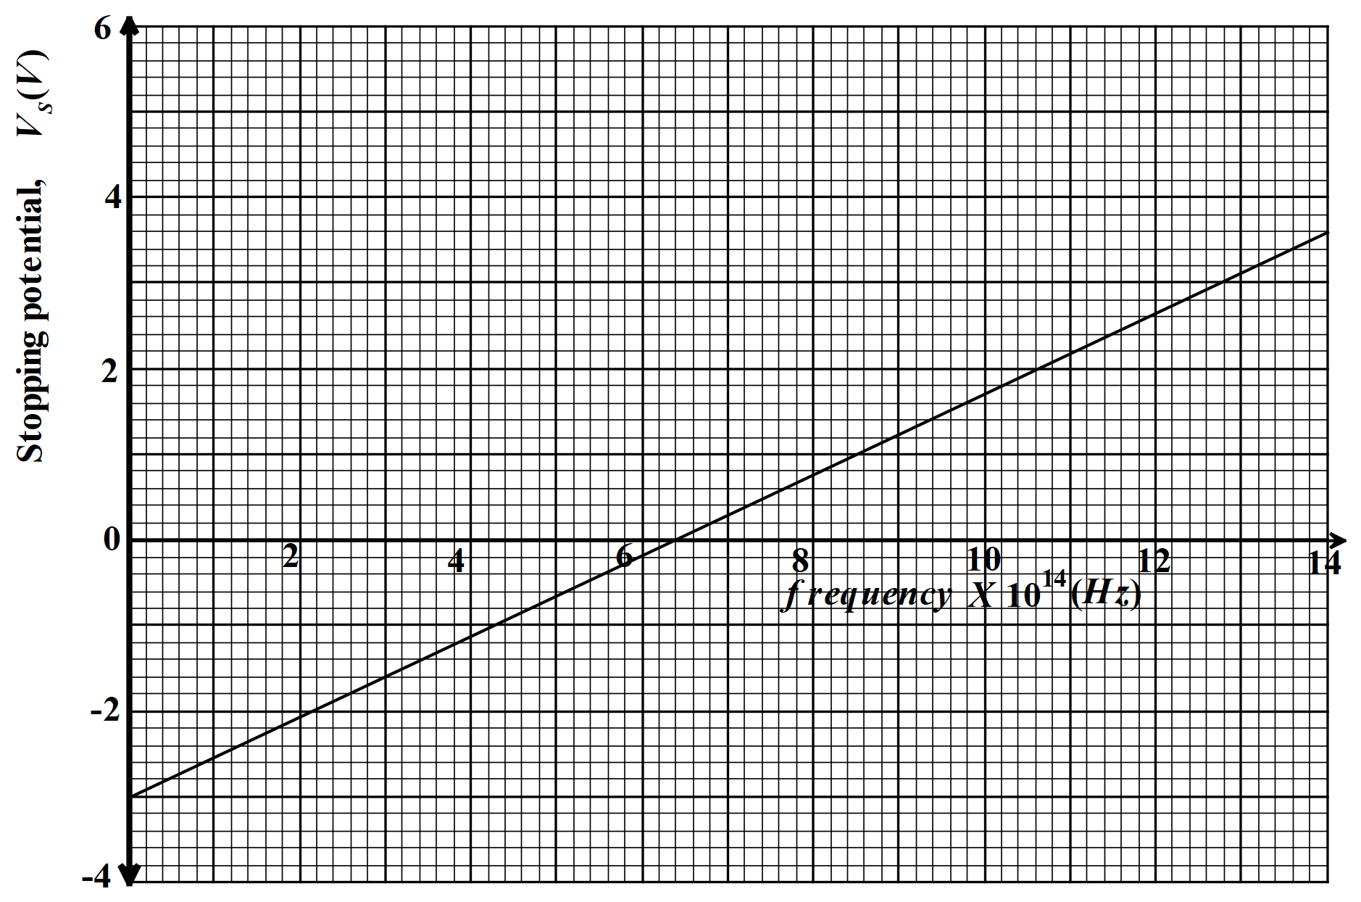
Figure 5
From the graph determine:
- The threshold wavelength (3 marks)
…………………………………………………………………………………………………………………………………………………………………………………………………………………………………………………………………………………………………………………………………………………………………………………………………………
- The plank’s constant (3 marks)
…………………………………………………………………………………………………………………………………………………………………………………………………………………………………………………………………………………………………………………………………………………………………………………………………………
- The work function of the metal (2 marks)
…………………………………………………………………………………………………………………………………………………………………………………………………………………………………………………………………………………………………………………………………………………………………………………………………………
- Figure 6 below shows the wiring in a modern mains appliance
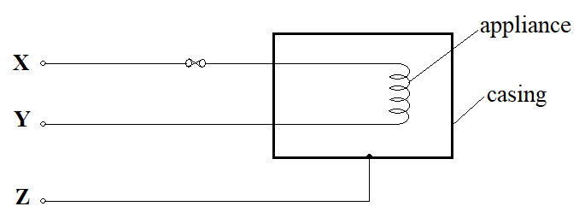
Figure 6

Identify the wire X, Y and Z (3 marks)
X ……………………………………………………………………………………………
Y ……………………………………………………………………………………………
Z ……………………………………………………………………………………………
- The Figure 7 below shows apparatus used to produce X-rays.
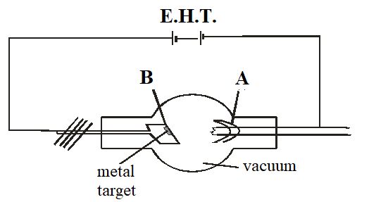
Figure 7
- Name the part marked A and B (2 marks)
A………………………………………………………………………………………..…………
B………………………..................................................................................................................
- Briefly explain how X-rays are produced in the X-ray tube (2 marks)
……………………………………………………………………………………………………………………………………………………………………………………………………………………………………………………………………………………………………………………………………………………………………………………………………………………
- An X-ray tube is operating with an anode potential of 5KV and a current of 10 mA.
- Explain how the intensity of X-rays from such a tube may be increased (1 mark)
…………………………………………………………………………………………………………………………………………………………………………………………………………………………………………………………………………………………………………………………………………………………………………………………………………
- Explain how penetrating power of the X-ray in such a tube may be increased (1 mark)
………………………………………………………………………………………………………………………………………………………………………………………………………………………………………………………………………………………………………………………………………………………………………………………………………….
- Calculate the number of electrons hitting the anode per second (2 mark)
…………………………………………………………………………………………………………………………………………………………………………………………………………………………………………………………………………………………………………………………………………………………………………………………………………

- Determine the velocity with which the electrons strike the target (Take e=1.6x10⁻¹⁹ C and M_{e}=9.1x10⁻³¹kg ) (2 marks)
………………………………………………………………………………………………………………………………………………………………………………………………………………………………………………………………………………………………………
- What property of lead makes it suitable for use as shielding material? (1 mark)
……………………………………………………………………………………………………………………………………………………………………………………………………
- A modern cathode ray oscilloscope has a set of deflection plates called X and Y-plates and a time base.
- What is the purpose of the time base (1 mark)
………………………………………………………………………………………………………………………..……..………………………………………………………………
- What would be the trace seen when the time base is switched off and
- A d.c. voltage applied to the y- plates (1 mark)
………………………………………………………………………………………………………………………………………………………………………………………………………………………………………………………………………………………………
- An a.c voltage is applied to the Y-plates? (1 mark)
………………………………………………………………………………………………………………………………………………………………………………………………………………………………………………………………………………………………

- State Lenz’s law of electromagnetic induction (1 mark)
………………………………………………………………………………………………………...………………………………………………………………………………………………………...…………………………………………………………………………………………
- A coil is moved quickly away from the end of a stationery magnet Y and current is flowing as shown by Figure 8 below;
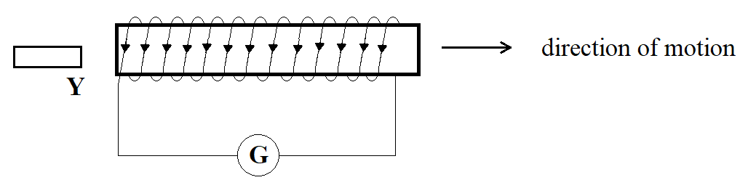
Figure 8
State the polarity of Y …………………………………….. (1 mark)

- State the essential condition for e.m.f to be induced in a conductor. (1 mark)
…………………………………………………………………………………………………………………………………………………………………………………………………………
- A student wound two coils on a cardboard tube as shown in Figure 9 below.
Figure 9
1stcoil
Galvanometer
Switch
2ndcoil

- Explain what happens when the switch is closed. (3 mark)
………………………………………………………………………………………………………………………………………………………………………………………………………………………………………………………………………………………………………

- What would happen if the experiment were repeated but this time a soft iron is put inside the cardboard tube? Explain. (2 marks)
………………………………………………………………………………………………………………………………………………………………………………………………………………………………………………………………………………………………………
- The Figure 10 below shows a transformer used to step down power for use by an electrical appliance.
Figure 10
240V a.c
A
12V
0.1 A
A

- Calculate the input power to the transformer from the mains. (1 mark)

……………………………………………………………………………………………………………………………………………………………………………………………………
- Assuming there is no power losses in the transformer; calculate the reading in the ammeter on output part. (2 marks)
………………………………………………………………………………………………………………………………………………………………………………………………………………………………………………………………………………………………………………………………………………………………………………………………………….
- What would be the output power if the transformer had been 80% efficient? (2 marks)
……………………………………………………………………………………………………………………………………………………….………………………………………………………………………………………………………………………………………………

- What would be the reading on the ammeter on the output part had the transformer been 80% efficient? (2 marks)
…………………………………………………………………………………………………………………………………………………………………………………………………………………………………………………………………………………………………………………………………………………………………………………………………………
- Figure 11 shows two speakers connected to an audio – frequency generator.

speaker Q

A B

Audio-frequency
Figure 11
generator speaker P

- Why are the loudspeakers connected to the same audio – frequency generator? (1 mark)
………………………………………………………………………………………………………………………………………………………………………………………………………………………………………………………………………………………………………………
- State and explain the observations made by an observer moving along the path PQ (2 marks)
………………………………………………………………………………………………………………………………………………………………………………………………………………………………………………………………………………………………………………
- State the observations made if the frequency of the signal generator was increased. (1 mark)
…………………………………………………………………………………………………………………………………………………………………………………………………………
- Explain the observation made when an observer walks along AB (2 mark)
…………………………………………………………………………………………………………………………………………………………………………………………………………
- State what would be observed if a cathode ray oscilloscope is moved along line PQ (1 mark)
……………………………………………………………………………………………………………………………………………………………………………………………………………………………………………………………………………………………………………………………………………………………………………………………………………………

- Define the term refractive index of a material (1 mark)
………………………………………………………………………………………………………………………………………………………………………………………………………………………………………………………………………………………………………………
- State two conditions necessary for total internal reflection to occur (2 marks)
………………………………………………………………………………………………………………………………………………………………………………………………………………………………………………………………………………………………………………
- Explain what you understand by the term critical angle as applied in optics (1 mark)
………………………………………………………………………………………………………………………………………………………………………………………………………………………………………………………………………………………………………………

- The Figure 12 below shows a ray of light incident on a glass prism
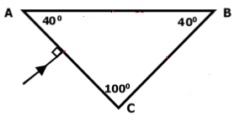
Figure 12
Given that the critical angle for the grass is 39⁰, sketch on the diagram the path of the ray through the prism (2 marks)

