

MARANDA HIGH SCHOOL
Kenya Certificate of Secondary Education
THE MOCK EXAMINATIONS, 2025
232/1 PHYSICS PAPER 1
May, 2025 TIME: 2 Hrs

Name: …………………………………….…….…… Admission No: …………
Stream: ……………….. Signature: ………......... Monday, 28th May, 2025; 2:00-4:00pm
Instructions

- Write your name, admission number, date, stream and signature in the spaces provided above.
- All answers must be written in the spaces provided in this question paper.
- This paper consists of 13 printed pages with 2 sections.
- Candidates should check the question paper to ascertain that all the pages are printed as indicated and that no questions are missing
- Candidate should answer the questions in English
______________________________________________________
FOR EXAMINERS’ USE ONLY
Section | Question | Maximum Score | Candidate’s Score
A | 1 – 12 | 25
B | 13 | 12
B | 14 | 12
B | 15 | 08
B | 16 | 10
B | 17 | 12
B | Total Score | 80

SECTION A (25 MARKS)

Answer all questions in this section in the spaces provided:
- Figure 1 shows a section of an un-graduated Vernier calipers.
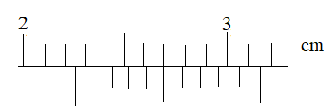
Figure 1
State the reading as indicated by the scale (1 mark) ………………………………………………………………………………………………………………………………………………………………………………………………………………
- Explain why a person would jump higher on earth than on Saturn. (2 marks)
………………………………………………………………………………………………………………………………………………………………………………………………………………………………………………………………………………………………………………………
- A mercury thermometer with its fixed points incorrectly marked has the reading of pure melting ice as -0.5⁰C and of steam at standard atmospheric pressure as 99.4⁰C.Calculate the correct temperature when the thermometer reads 60⁰C. (2 marks)
………………………………………………………………………………………………………………………………………………………………………………………………………………………………………………………………………………………………………………………
- State two ways the surface tension of a liquid may be increased. (2 marks)
………………………………………………………………………………………………………………………………………………………………………………………………………………

- Figure 2 shows a three identical springs and have negligible weights. The extension produced on the system of the spring is 40cm.
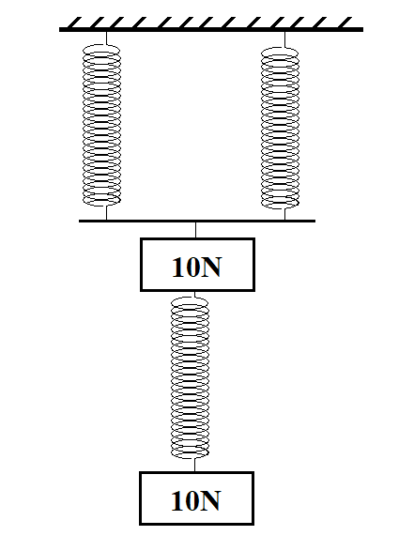
Figure 2
Determine the spring constant of each spring. (2 marks)
………………………………………………………………………………………………………………………………………………………………………………………………………………………………………………………………………………………………………………………
- An oil drop of radius 0.35mm when placed on water spreads out to form a circle of radius 35cm.Using this information:
- Estimate the size of the oil molecule. (2 marks)
………………………………………………………………………………………………………………………………………………………………………………………………………………………………………………………………………………………………
- State any one assumption you made during your calculation. (1 mark)
………………………………………………………………………………………………………………………………...…………………………………………………………….
- Figure 3 is a wooden sphere with a nail hammered into it at a point A as shown below
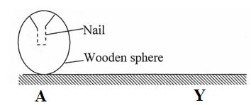
Figure 3
The sphere is rolled on a horizontal ground and comes to rest after some time at point Y. On the same Figure 3 draw the sphere after it comes to rest at point Y and explain (2 marks)

- In Figure 4 below, a pipe with two different cross-sectional areas has two pipes dipped into its walls at the points of different cross-section areas. The pipes A and B are identical in cross sectional areas.
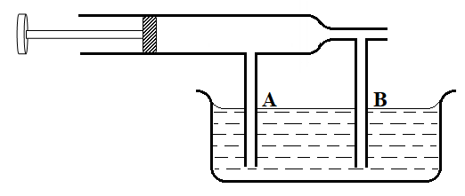
Figure 4
Show the new level of water in columns A and B when the piston is pulled back. (1 mark)

- A student performed an experiment find out how the length L of a spiral spring varies with the compression force, F. Figure 5 shows the results obtained.
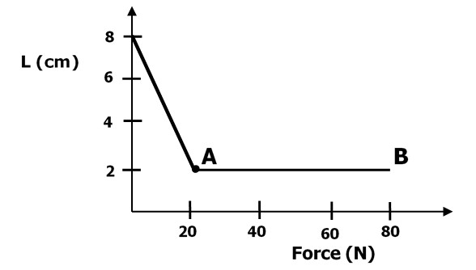
Figure 5

State a reason for the shape of the graph between 20N and 80N. (1 mark)
.
………………………………………………………………………………………………………………………………………………………………………………………………………………
- A string of length 0.7m is used to whirl a stone of mass 500g in a circle in a vertical plane at 5 rev/s. Determine:
- The period (2 marks)
………………………………………………………………………………………………………………………………………………………………………………………………………………………………………………………………………………………………
- The angular velocity. (3 marks)
………………………………………………………………………………………………………………………………………………………………………………………………………………………………………………………………………………………………
- Figure 6 shows a uniform meter rule of Weight 2N with two weights 0.36N and 0.24N suspended from its ends.
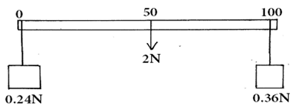
Figure 6
Determine how far from the 0.36N weight a pivot should be placed in order to balance the meter rule. (3 marks)
………………………………………………………………………………………………………………………………………………………………………………………………………………………………………………………………………………………………………………………………………………………………………………………………………………………………
- State a reason why water is not suitable as a barometric liquid (1 mark)
…………………………………………………………………………………………………..
…………………………………………………………………………………………………..

SECTION B: (55 MARKS)
Answer ALL questions in the spaces provided

- Figure 7 below shows a set-up that may be used to verify pressure law.
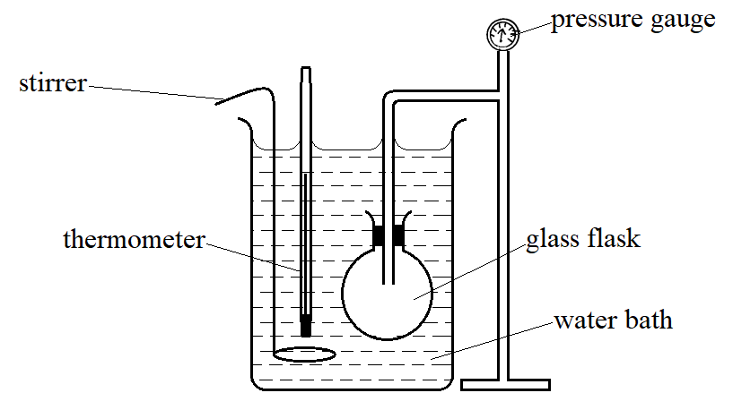
Figure 7

- State the measurements that should be taken in the experiment. (2 marks)
…….………………………………………………………………………………………………….……………………………………………………………
- Explain how the measurements in (i) above may be used to verify pressure law. (3 marks)
……………………………………………………………………………………………………………………………………………………………………………………………………………………………………………………………………………………………………….…………………………………………………………………

- A column of air 26cm long is trapped by mercury thread 5.0cm long as shown in the Figure 8 (a) below
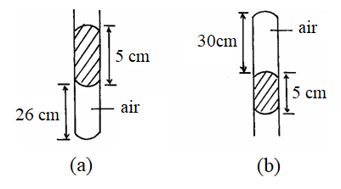
Figure 8

When the tube is inverted as in Figure 8(b) the air column becomes 30cm long. What is the value of atmospheric pressure? (3 marks)
………………………………………………………………………………………………………………………………………………………………………………………………………………………………………………………………………………………………………………………………………………………………………………………………
- A steel cylinder of capacity 0.5m³ contains nitrogen at a pressure of 30,000Pa when the temperature is 27°C. What will be the pressure of nitrogen if it is allowed to flow into another cylinder of capacity 9.5m³ with the temperature reduced to -23°C? (3 marks)
………………………………………………………………………………………………………………………………………………………………………………………………………………………………………………………………………………………………………………………………………………………………………………………………
- State the difference between the temperature in Kelvin scale and Celcius scale. (1 mark)
………………………………………………………………………………………………………………………………………………………………………………………………

- Figure 9 shows a block A immersed in water. It weighs 2N in air and has a density of 2.0g/cm³. If the bar is pivoted at its center and is in equilibrium find the distance x (ρ of water = 1g/cm³) (3 marks)
Figure 9

…………………………………………………………………………………………………………………………………………………………………………………………………………………………………………………………………………………………..…
- Figure 10 below shows a wooden log 10m long, density 800kg/m³ and cross-sectional area 0.06m² floating in water of density 1g/cm³ while partially submerged.
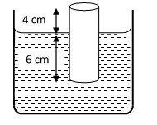
Figure 10
- Determine the weight of the block. (3 marks)
…………………………………………………………………………………………………………………………………………………………………………………………………………………………………………………………………………………………..………………………………………………………………………………

- The upthrust on the block (3 marks)
…………………………………………………………………………………………………………………………………………………………………………………………………………………………………………………………………………………………..………………………………………………………………………………
- The minimum weight that can be placed on the block to just make it fully submerged. (3 marks)
………………………………………………………………………………………………………………………………………………………………………..…………………………………………………………………………………………………………………………………………………………………………………………………
- A man used a wooden plank to lift a wooden log from the ground to a stationary truck as shown in Figure 11. The wooden plank is inclined at an angle of 30⁰ to the ground.
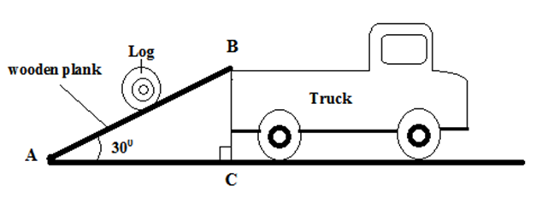
Figure 11

- Show that the velocity ratio of the system is Staten as V.R=$\frac{1}{{Sin 30}^{0}}$ (3 marks)
………………………………………………………………………………………………………………………………………………………………………………………………………………………………………………………………………………
- Explain why the efficiency of this system cannot be 100%. (1 mark)

……………………………………………………………………………………………………………………………………………………………………………………………………………………………………………………………………………….
- Figure 12 shows a pulley system.
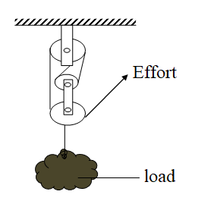
Figure 12

- State the velocity ratio of the machine. (1 mark)
………………………………………………………………………………………….
- Explain what happens to the mechanical advantage of the machine as the load is increased gradually. (1 mark)
……………………………………………………………………………………………………………………………………………………………………………………
- Water falls from a water fall to the bottom. The temperature of the water is found to be higher at the bottom than at the top. State the energy transformation. (1 mark)
………………………………………………………………………………………………………………………………………………………………………………………………………………………………………………………………………………………………

- A boy stands at the top of a cliff of height, h, above the ground and throws a ball vertically upwards.The variation of time t and velocity v of the ball is shown in Figure 13
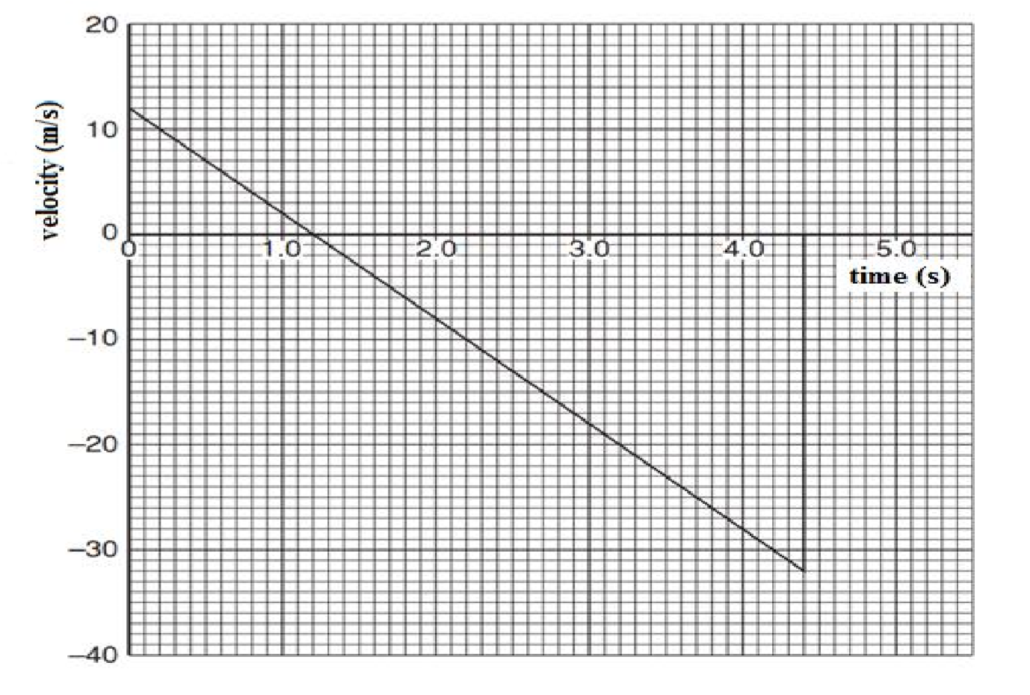
Figure 13

Use graph above to determine;
- Time taken to reach the maximum height (1 mark)
………………………………………………………………………………………………………………………………………………………………………………………………
- Time taken from the maximum height to the ground below the cliff. (1 mark)
………………………………………………………………………………………………………………………………………………………………………………………………
- Determine the maximum height above the base of the cliff to which the ball rises. (3 marks)
……………………………………………………………………………………………………………………………………………………………………………………………....
- the value of h, height of the ball before projection (2 marks)
………………………………………………………………………………………………………………………………………………………………………………………………………………………………………………………………………………………………
- The ball has mass 250 g. Calculate the magnitude of the change in momentum of the ball between the time that it leaves the girl’s hand to time t = 4.0 s. (3 marks)
………………………………………………………………………………………………………………………………………………………………………………………………………………………………………………………………………………………………

- The moon goes round the earth at a constant speed. Explain why it is true to say the moon is accelerating. (1 mark)
………………………………………………………………………………………………………………………………………………………………………………………………………………………………………………………………………………………………
- Figure 14 below shows a pail of water being swung in a vertical circle.
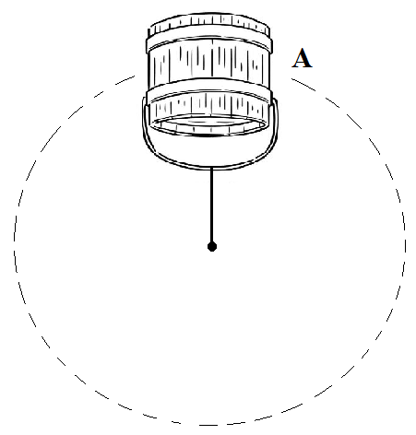
Figure 14

Explain why the water does not pour out when the pail is at position A. (1 mark)
………………………………………………………………………………..…..…
…………………………………………………………………………………..…
- A string of negligible mass has a bucket tied at the end. The string is 60cm long and the bucket has a mass of 45g. The bucket is swung horizontally making 6 revolutions per second. Calculate:
- The angular velocity. (2 marks)
……………………………………………………..…………………………………………………………….……………………………..……………………
- The angular acceleration. (3 marks)
…………………………………………………………………………………………………………………………….…………………………………………………………………………………………………………………………………………………
- The tension on the string. (3 marks) …………………………………………………………………………………..……………………………………………..………………………………………………………………………………………………………………………………………………..
- The linear velocity. (2 marks)
………………………………………………………………………………………………………………………………………………………………………………………………………………………………………………………………………………

