NAME: ……………………………………………. ADM NO: …………………CLASS...….

SCHOOL: ………………………… DATE: ……………………SIGN......................

232/3
PHYSICS
PAPER 3
(PRACTICAL)
END TERM 2 2025
JULY 2025
TIME: 2 ½ hours

Kenya Certificate of Secondary Education

INSTRUCTIONS TO CANDIDATES
- Write your Name, Index Number and Admission number in the spaces provided above.
- Sign and write the date of Examination in the spaces provided above.
- Answer all questions in the spaces provided.
- You are supposed to spend the first 15 minutes of the 2½ hours allowed for this paper reading the whole paper carefully before commencing your work.
- Marks will be given for clear records of observations actually made, their suitability, accuracy and the use made of them.
- Candidates are advised to record their observations as soon as they are made.
- All working must be clearly shown where necessary.
- Mathematical tables and silent electronic calculators may be used.
- This paper consists of 6 printed pages. Candidates are advised to check that all pages are printed as indicated and no questions are missing.

FOR EXAMINER’S USE ONLY

QUESTIONS | MAXIMUM SCORE | CANDIDATE’S SCORE
1 | 20
2 | 20
TOTAL | 40

Candidates should check the question paper to ensure that all the pages are printed as indicated and no questions missing.

1. PART A
You are provided with the following:
- A white screen with cross wires labeled O
- A lens and a lens holder
- A white screen labeled S
- A meter rule
- A candle

Proceed as follows:
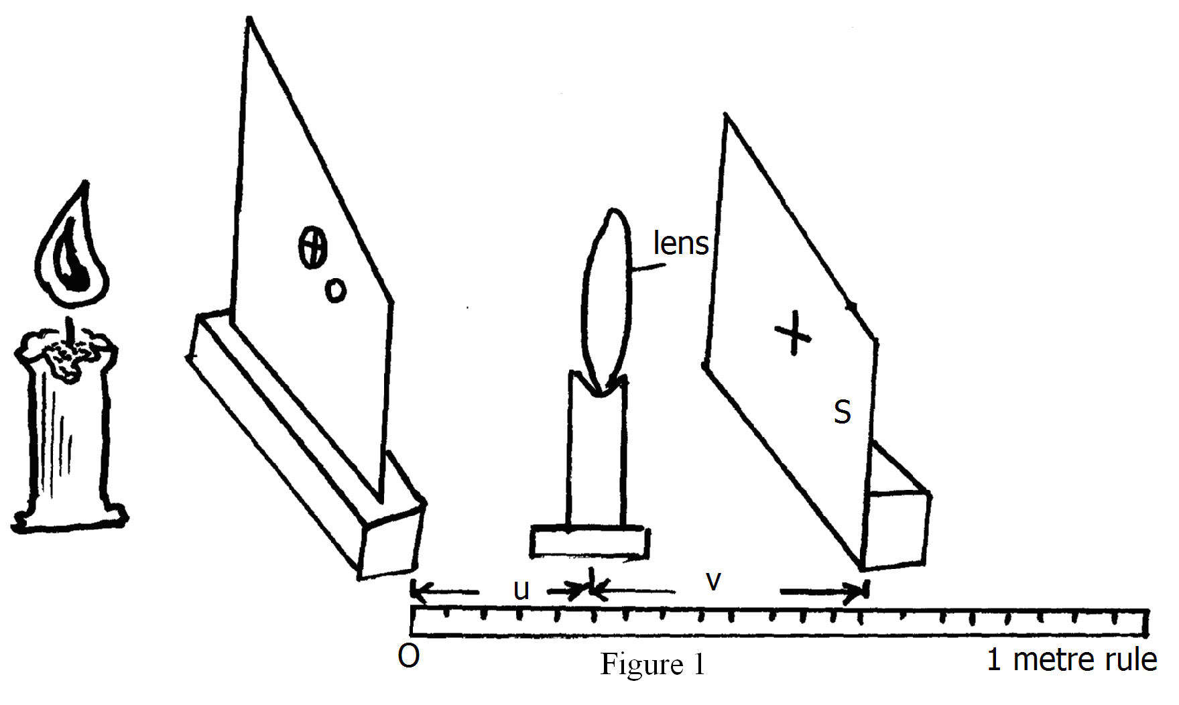
(a) Set up the apparatus as shown in fig 1
(b) Position the lens so that the object distance u = 20 cm
(c) Adjust the screen S so that a sharp image of the cross wires is formed on the screen S. Measure the image distance v. Record the value of u and the corresponding value of v in table 1
(d) Repeat (b) and (c) above for value of u = 20cm, 25cm, 30cm, 35cm, 40cm and 45cm.

(e) Complete table 1
u (cm) | 20 | 25 | 30 | 35 | 40 | 45
v (cm)
u + v (cm)
uv (cm²)
Table 1 (6mks)
(f) On the grid provided, plot a graph of uv (y axis) against u + v (5mks)

(g) Determine the slope of the graph (3mks)

PART B
You are provided with the following:
- A boiling tube
- Some dry sand
- A liquid in a measuring cylinder labelled L
- Half – metre rule
- A vernier calipers (to be shared)
- A weighing machine (one per room)
- Tissue paper

Proceed as follows:
(h) (i) Measure the length of the boiling tube
h = ………………………………………………………………cm (½ mk)

(ii) Put a little amount of sand in the boiling tube and place it in the measuring cylinder which is almost filled with a liquid labelled L. Add sand, little by little until the
tube floats upright as shown in figure 2.
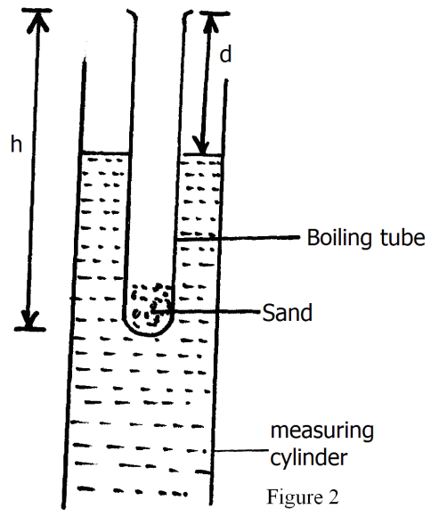
Measure the length, d, of the boiling tube which is above the liquid
d = ……………………………………………………………cm (½ mk)
(iii) Determine the length, t, of the boiling tube which is immersed in the liquid
t = ………………………………………………………………cm (½ mk)
(iv) Remove the boiling tube from the measuring cylinder, wipe it dry (on the outside) and weigh its mass, m, including the sand inside.
m = ……………………………………………………………….g (½ mk)
(v) Measure the external diameter, D, of the boiling tube
d = …………………………………………………………….cm (½ mk)
(vi) Determine external radius, R,
R = ……………………………………………………………....cm (½ mk)
(vii) Using the formula
m = ρ x (πR²), determine ρ for the liquid
ρ = ……………………………………………………………….. (3mks)

2. You are provided with the following:
- 2 dry cells
- A cell holder
- A nichrome wire mounted on a metre rule
- An ammeter, A
- A voltmeter, V
- A jockey J
- A switch S
- 8 connecting wires
Proceed as follows:
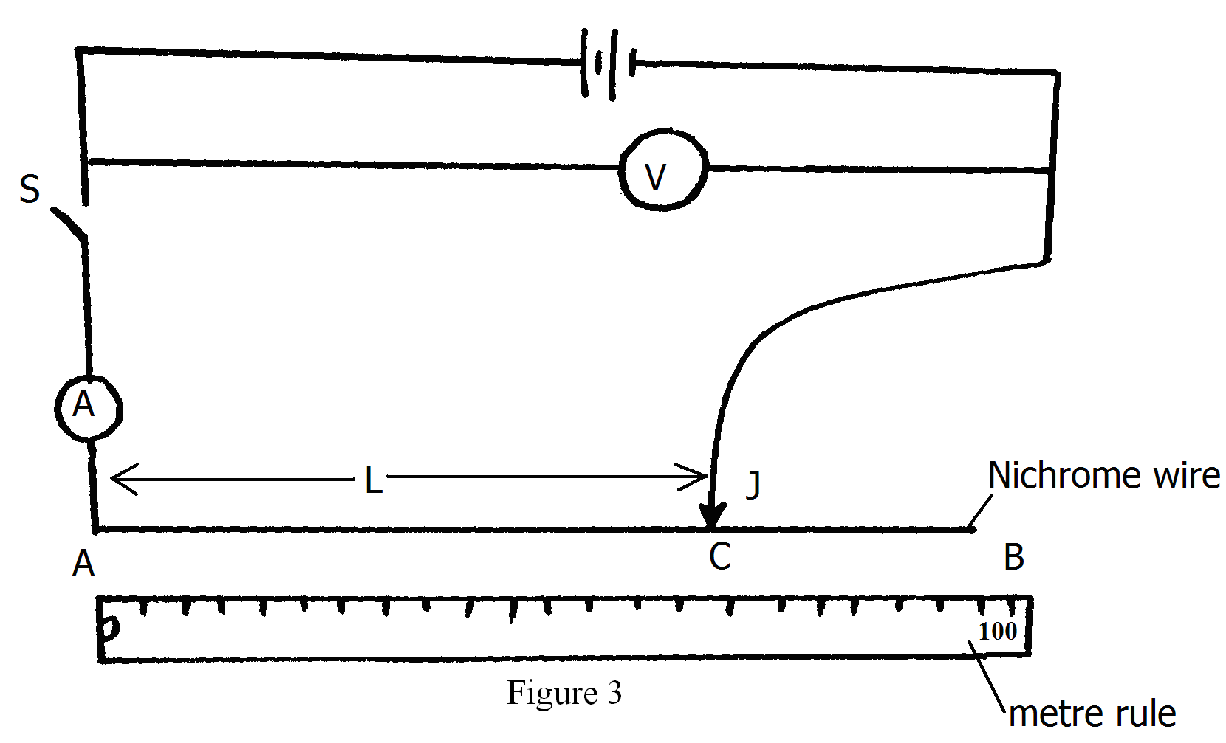
(a) Set the apparatus as shown in fig 3
(b) With the switch open, record the reading E, of the voltmeter
E = …………………………………………………………………… (1mks)
(c) Place the jockey, J , on the nichrome wire at 100cm mark. Close the switch, read and record the values of I (ammeter reading) and the corresponding values of V (voltmeter reading) in table 2
(d) Repeat (c) above for length, L = 70cm, 60cm, 50cm, 40cm and 20cm. Complete table 2

L (cm) | 100 | 70 | 60 | 50 | 40 | 20
I (A)
V (V)
E – V (V)
Table 2 (7mks)
(e) Plot a graph of (E – V) (y axis) against I (5mks)
(f) Determine the slope of the graph (3mks)

(g) Given that E = V + Ir, from the graph determine

(i) The internal resistance, r, of the battery (2mk)

(ii) V when I is 0.3A (2mk)

