Name: ……………………………....…………. Index No: ……………………….……….
School: ……………………………………….... Candidate’s Signature: ..............................

232/2
PHYSICS
PAPER 2

2 Hours

Kenya Certificate of Secondary Education

232/2
PHYSICS
PAPER 2
END TERM 2 2025
JULY 2025
2 Hours

INSTRUCTIONS TO CANDIDATES:
- Write your name, class, admission number and index number is the spaces provided above.
- Sign and write the date of examination in the spaces above.
- Answer ALL the questions in section A and B in the spaces provided.
- All working MUST be clearly shown.
- Non-programmable silent electronic calculators and KNEC mathematical tables may be used.
- This paper consists of 12 pages.
- Candidates should check the question paper to ascertain that ALL the pages are printed and that no questions are missing.

FOR EXAMINER’S USE ONLY.

SECTION | MAX. SCORE | CANDIDATE’S SCORE
A | 25
B | 55
 | 80

SECTION A (25 MARKS)
1. Two magnets A and B in the figure below were brought from a point high above a table towards a steel pin.
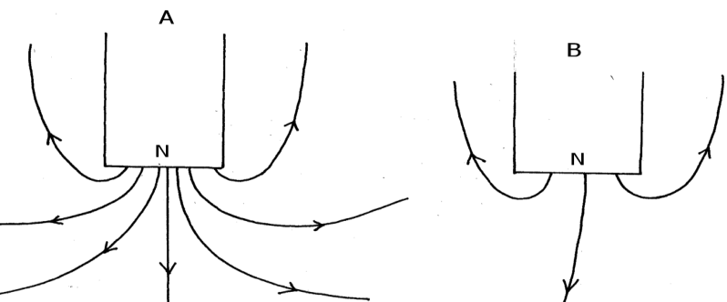
State with reason which magnet will attract the pin at a bigger height above the table. (2mks)
…………………………………………………………………………………………………………………………………………………………................……………………………………………………

2. The figure below shows container loader which uses electromagnet to offload containers from a ship.

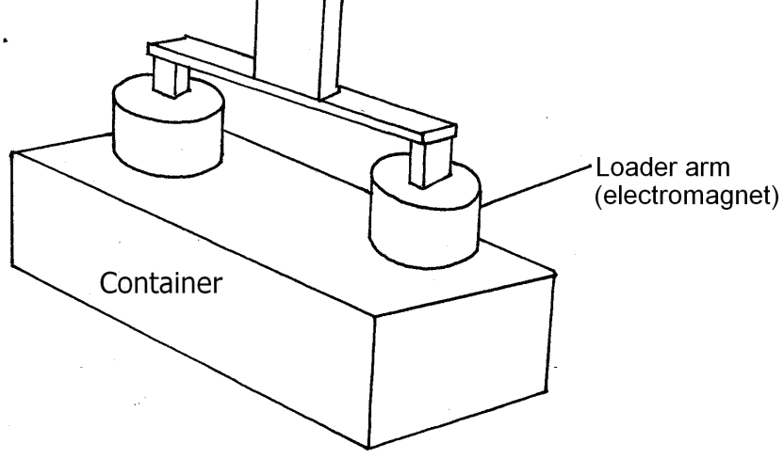
(i) Why should the container be made of iron or steel (1mk)
………………………………………………………………………………………………………………………………………………………………………………………………………………
(ii) State two ways in which the loader can be made to lift heavier container (2mks)
………………………………………………………………………………………………………………………………………………………………………………………………………………................

3. Explain why sound cannot be heard from far when one shouts in a forest (1mk)
………………………………………………………………………………………………………………………………………………………………………………………………………………...............

4. The figure 3 shows a ray of light incident on a mirror.
Fig. 3
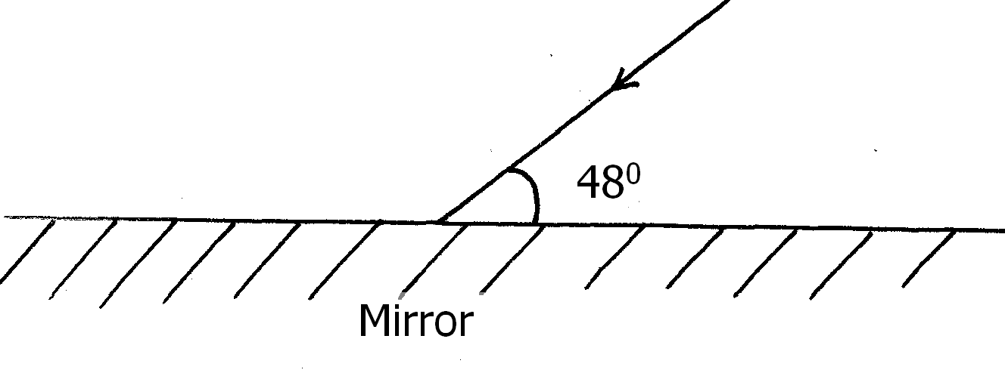
Determine the angle of reflection when the mirror is rotated 10⁰ anticlockwise (2mks)
………………………………………………………………………………………………………
………………………………………………………………………………………………………
………………………………………………………………………………………………………
5. Two 12V lead acid accumulators are vated 60Ah and 70Ah. State two physical differences between the accumulators (2mks)
………………………………………………………………………………………………………
………………………………………………………………………………………………………
………………………………………………………………………………………………………
………………………………………………………………………………………………………
6. When a new dry cell is connected in series with a 2.7 resistor, a current of 0.5A flows in the circuit. Determine the internal resistance of the cell. (3mks)
………………………………………………………………………………………………………
………………………………………………………………………………………………………
………………………………………………………………………………………………………
………………………………………………………………………………………………………

7. The diagram below shows part of a wave form. The numbers on the diagram show scales in meters. If the speed of the wave is 20ms⁻¹, determine the frequency and wavelength of the wave. (3mks)
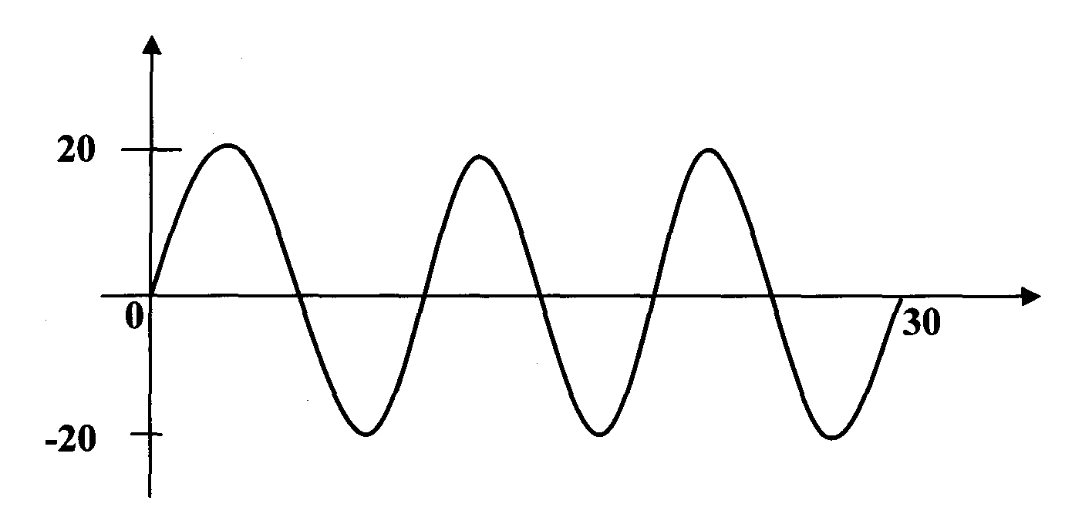
…………………………………………………………………………………………………………………………………………………………………………………………………………………………………………………………………………………………………………………………………………………………………………………………………………………………………………………………………………………………………………………………………………………………………
8. A form 4 student observed that his grandfather positions a book far from his eyes when
reading it. Explain the type of lenses that the student should advice his grandfather to wear. (2mks)
………………………………………………………………………………………………………
………………………………………………………………………………………………………
………………………………………………………………………………………………………
………………………………………………………………………………………………………
9. A gold leaf electroscope is positively charged as shown in the diagram below where C is the cap and L is the gold leaf. State and explain what happens to L when a positively charged rod is brought near C without touching it. (2mks)
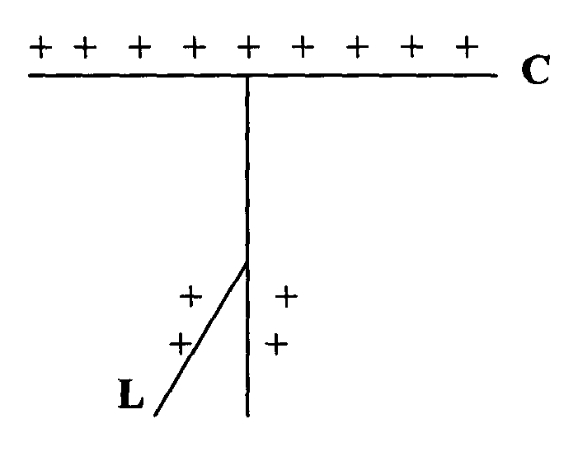
………………………………………………………………………………………………………………………………………………………………………………………………………………………………………………………………………………………………………………………………………

10. a) State two ways of increasing the capacitance of a parallel plate capacitor (2mks)
…………………………………………………………………………………………………………………………………………………………………………………………………………………………

b) The figure below shows a capacitor network setup.
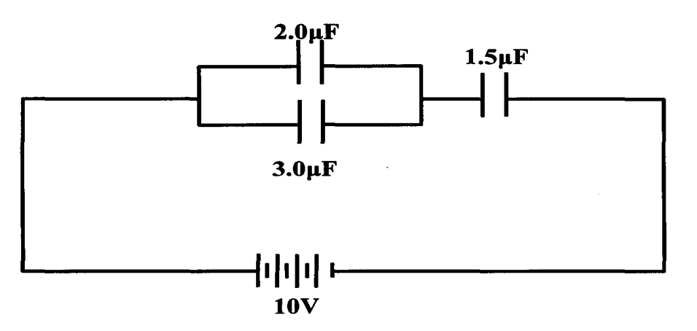
Calculate the charge stored by the 1.5 µ. F capacitor. (3mks)

………………………………………………………………………………………………………

………………………………………………………………………………………………………

……………………………………………………………………………………………………...
SECTION B (55 MARKS)
11. (a) (i) State Snell’s law of refraction of light (1mk)
………………………………………………………………………………………………………
………………………………………………………………………………………………………
(ii) Give two advantages of totally internally reflecting prisms over plane
mirrors. (2mks)
………………………………………………………………………………………………………
………………………………………………………………………………………………………

(b) A ray of light is incident on a kerosene water interfaces as shown in figure 7
Fig. 7
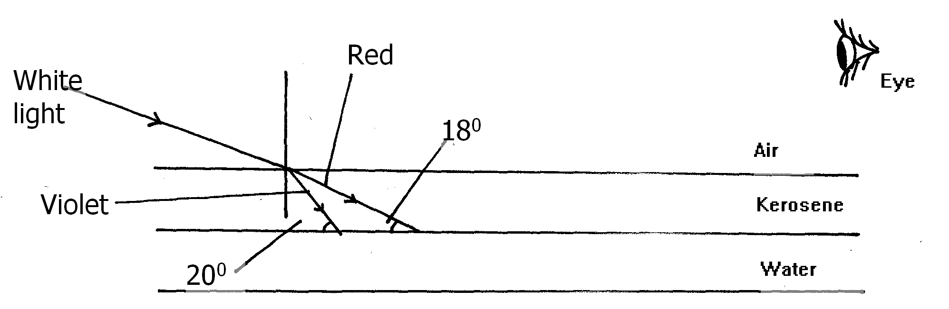
Given that the refractive index of water and kerosene are 1.33 and 1.44 respectively,
Determine
(i) the refractive index for the kerosene – water interface (3mks)
………………………………………………………………………………………………………
………………………………………………………………………………………………………
………………………………………………………………………………………………………
………………………………………………………………………………………………………
(ii) determine and show on the figure the path of the rays of light between the Kerosene-water surface (3mks)
………………………………………………………………………………………………………
………………………………………………………………………………………………………
………………………………………………………………………………………………………
………………………………………………………………………………………………………
(iii) Why do the colours of the light separate at the kerosene layer. (1mk)
………………………………………………………………………………………………………
………………………………………………………………………………………………………
iv) State and explain the observation that the eye above the two surfaces would see (2mks)
………………………………………………………………………………………………………
………………………………………………………………………………………………………
………………………………………………………………………………………………………
………………………………………………………………………………………………………

12. (a) State Ohm’s law (1mk)
………………………………………………………………………………………………………
………………………………………………………………………………………………………

(b) The figure below shows the voltage – current relating for a certain battery used in an electrical circuit.
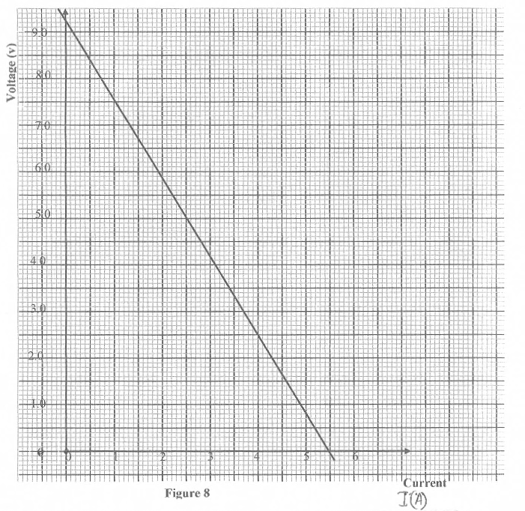

Given that the equation of the graph is V = E – Ir , from the graph , determine
(i) The e.m.f of the battery. (1mk)

(ii) The internal resistance of the battery used. (3mks)

(c) The figure below shows a circuit with a coil used to warm oil in a beaker.

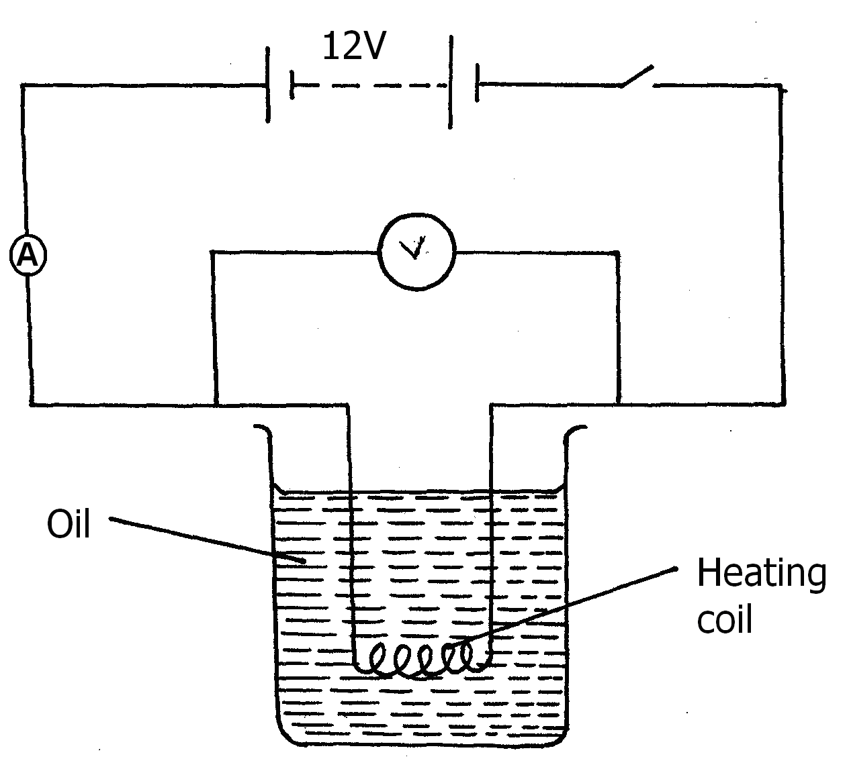

(i) Explain how heat is produced in the coil (2mks)
………………………………………………………………………………………………………
………………………………………………………………………………………………………
(ii) Given that the reading of the ammeter is 2.4A determine the resistance of the coil. (3mks)
………………………………………………………………………………………………………
………………………………………………………………………………………………………
………………………………………………………………………………………………………
(iii) How much heat is produced in the coil in a minute? (3mks)
………………………………………………………………………………………………………
………………………………………………………………………………………………………
………………………………………………………………………………………………………
(iv) Give two changes that can be made in the set up in order to produce more
heat per minute. (2mks)
………………………………………………………………………………………………………
………………………………………………………………………………………………………
……………………………………………………………………………………………………..

13. (a) (i) What is the difference between longitudinal and transverse waves? (1mk)
……………………………………………………………………………………………………..
…………………………………………………………………………………………………….
(ii) State two distinctions between the way sound waves and electromagnetic waves are transmitted (2mk)
……………………………………………………………………………………………………..
…………………………………………………………………………………………………….
……………………………………………………………………………………………………..
(b) A mineworker stands between two vertical cliffs 400m from the nearest cliff. The cliffs are X distance apart. Every time he strikes the rock once, he hears two echoes, the first one after 2.5s , while the second follows 2s later. From this information; calculate:
(i) The speed of the sound in air (2mk)
……………………………………………………………………………………………………..
…………………………………………………………………………………………………….
……………………………………………………………………………………………………..
…………………………………………………………………………………………………….

(ii) The value of X (3mk)
……………………………………………………………………………………………………..
…………………………………………………………………………………………………….
……………………………………………………………………………………………………..
…………………………………………………………………………………………………….

(c) In an experiment to observe interference of light waves a double slit is placed close to the source. See figure 5
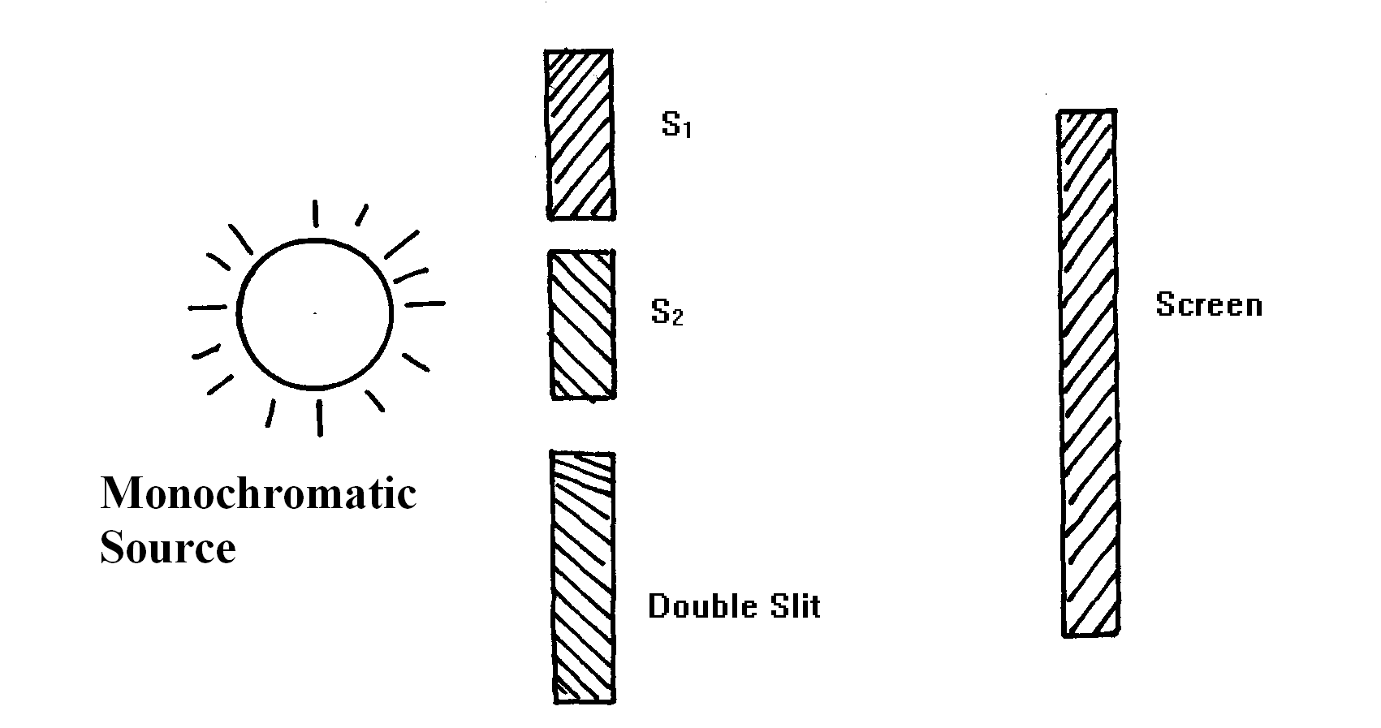
(i) State the function of the double slit (1mk)
……………………………………………………………………………………………………..
…………………………………………………………………………………………………….
……………………………………………………………………………………………………..

(ii) Describe what is observed on the screen (2 mks)
……………………………………………………………………………………………………..…………………………………………………………………………………………………….
……………………………………………………………………………………………………..
(iii) State what is observed on the screen when
I. The slit separation S1S2 is reduced (1mk)
……………………………………………………………………………………………………..
…………………………………………………………………………………………………….
II. White light source is used in place of monochromatic source. (1mk)
……………………………………………………………………………………………………..
…………………………………………………………………………………………………….……………………………………………………………………………………………………..

14. a) With an aid of a ray diagram show how a convex lens can be used as a magnifying glass
(3mks)

(b) From the definition of magnification M and equation f= uv show that magnification
v + u
M=v/f-1where the symbols have their usual meanings (3mks)

(c) Two converging lenses whose focal lengths are f₁=5cm and f₂=10cm are arranged to have a common axis as shown in figure below.
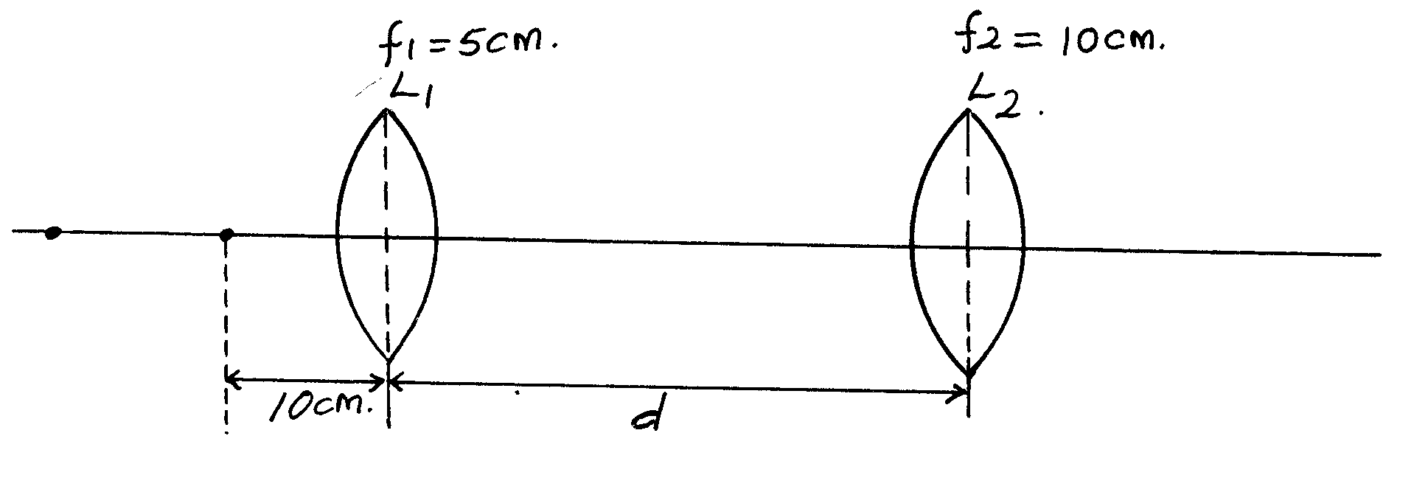

A point object is placed 10cm from L1. Given that the final image is formed 20cm to the left of L2₁ calculate the separation d of the lenses (3mks)

- The figure below shows a D.C electric motor.
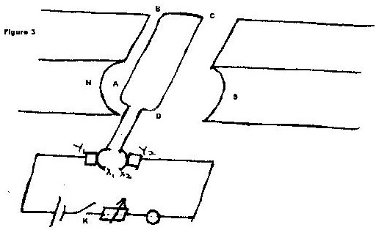

  - Name the parts labeled X₁ and X₂ and state their functions. (2mks)

  - What is the purpose of parts labeled Y₁ and Y₂? (1mk)

  - When the switch k is closed state the forces acting on the sides of the coil and the direction of movement of the coil (2mks)

  - What can be done to increase the speed of rotation of the motor? (1mk)

