Name: ……………………………....…………. Index No: ……………………….…………….
School: ……………………………………….... Candidate’s Signature: ……………………… Date: ………………………..
232/1
PHYSICS
PAPER 1
(THEORY)
END TERM 2 2025
JULY 2025
TIME: 2 HOURS

Kenya Certificate of Secondary Education (K.C.S.E)

232/1
PHYSICS
PAPER 1
(THEORY)
END TERM 2 2025
JULY 2025
TIME: 2 HOURS

INSTRUCTIONS TO THE CANDIDATES
- Write your name and Admn. Number in the spaces provided above.
- Sign and write the date of examination in the spaces provided.
- This paper consists of two sections, A and B.
- Answer all the questions in section A and B in the spaces provided.
- All workings must be clearly shown.
- Silent non programmable electronic calculators may be used.
- Candidates should answer the questions in English.

SECTION I (25 MARKS)
- In an experiment to determine the density of liquid X a student obtained the following data:
- Mass of density bottle 55.0g
- Mass of the density bottle + water = 80.0g
- Mass of the density bottle + liquid x = 70.0g
Determine the density of liquid X (Take density of water =2000kgm⁻³. (3 mks)
……………………………………………………………………………………………………………………………………………………………………………………………………………………………………………………………………………………………………………………………………………………………………………………………....................................
- It is observed that when 20cm³ of alcohol is mixed with 20cm³ of water, the volume of the mixture is 39cm³. State the reason why the volume of the mixture is not 40cm³. (2 mks)
…………………………..…………………………………………………………………………………………………………………………………………………………………………………………………………………………………………………………………........................
- When a liquid is heated in a glass flask, it is observed that the level at first goes down and then rises. Explain this observation. (2 mks)
……………………………………………………………………………………………………………………………………………………………………………………………………………………………………………………………………………………………………………………………………………………………………………………………...................................
- State the reason why the speed of water at the narrow section of a river is higher than at the wider section. (1 mk)
…………………………………………………………………………………………………………………………………………………………………………………………………………………………………………………………………….…………………………………...............

- Figure 4 below shows a wheel and axle.
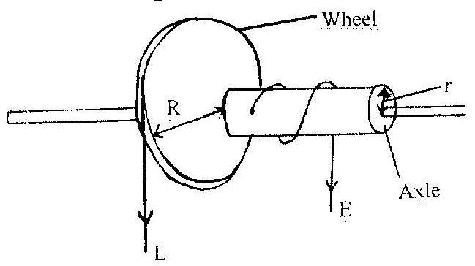

- Write expression for the velocity ratio of the above system in terms of r and R.(1mk)
……………………………………………………………………………………………………………………………………………………………………………………………....................
- The diameter of the wheel is 30cm and that of axle is 3.0cm, determine the velocity ratio. (2 mks)
…………………………………………………………………………………………………………………………………………………………………………………………………………………………………………………………………………………………………………………………………………………………………………...............................
- Using the definition of impulsive force, show that F=ma. (3 mks)
……………………………………………………………………………………………………………………………………………………………………………………………………………………………………………………………………………………………………………………………………………………………………………………………..................................
- A uniform metre rule is pivoted at its centre. Two weights of 20N and 10N are suspended at the 20cm and 100cm marks respectively. Determine the position at which a 10N weigh should be suspended in order to balance the system. (3 mks)
……………………………………………………………………………………………………………………………………………………………………………………………………………………………………………………………………………………………………………………………………………………………………………………………...................................

- State what is meant by polarization in simple cells. (1 mk)
……………………………………………………………………………………………………………………………………………………………………………………………....................
- A stone of mass 1.5kg is in uniform motion in a vertical plane of radius 0.5m as in the figure below.

0.5m
0.500

The stone is whirled at a speed of 6m/s. Determine the tension in the string at point A. (3mks)
……………………………………………………………………………………………………………………………………………………………………………………………………………………………………………………………………………………………………………………………………………………………………………………………....................................
- The figure below shows two possible designs of a three legged stool.

A

B

State a reason why B is more stable than A. (1 mk)
……………………………………………………………………………………………………………………………………………………………………………………………....................

SECTION II (55 MARKS)
- (a) A tape attached to an accelerating trolley passes through a ticker timer that makes dots on it at a frequency of 50HZ. The ticker makes 10 dots on a 10cm long tape such that; the distance a between the first two dots is 0.5cm and the distance b between the last two dots is 1.5cm.
- Determine the velocity of the trolley at:
I: Distance a. (4 mks)
……………………………………………………………………………………………………………………………………………………………………………………………………………………………………………………………………………………………………………………………………………………………………………………………....................................

II: Distance b (2 mks)
……………………………………………………………………………………………………………………………………………………………………………………………………………………………………………………………………………………………………………………………………………………………………………………………....................................
- Determine the acceleration of the trolley
……………………………………………………………………………………………………………………………………………………………………………………………………………………………………………………………………………………………………………………………………………………………………………………………....................................
- (a) A student was provided with several identical masses, a metre rule, a spring and a stand, boss and clamp. Outline five steps that the student should follow in order to verity Hooke’s Law. (5 mks)
……………………………………………………………………………………………………………………………………………………………………………………………………………………………………………………………………………………………………………………………………………………………………………………………....................................

b) The figure below shows a graph that was drawn from the results obtained in an experiment to study the extension of a spring.

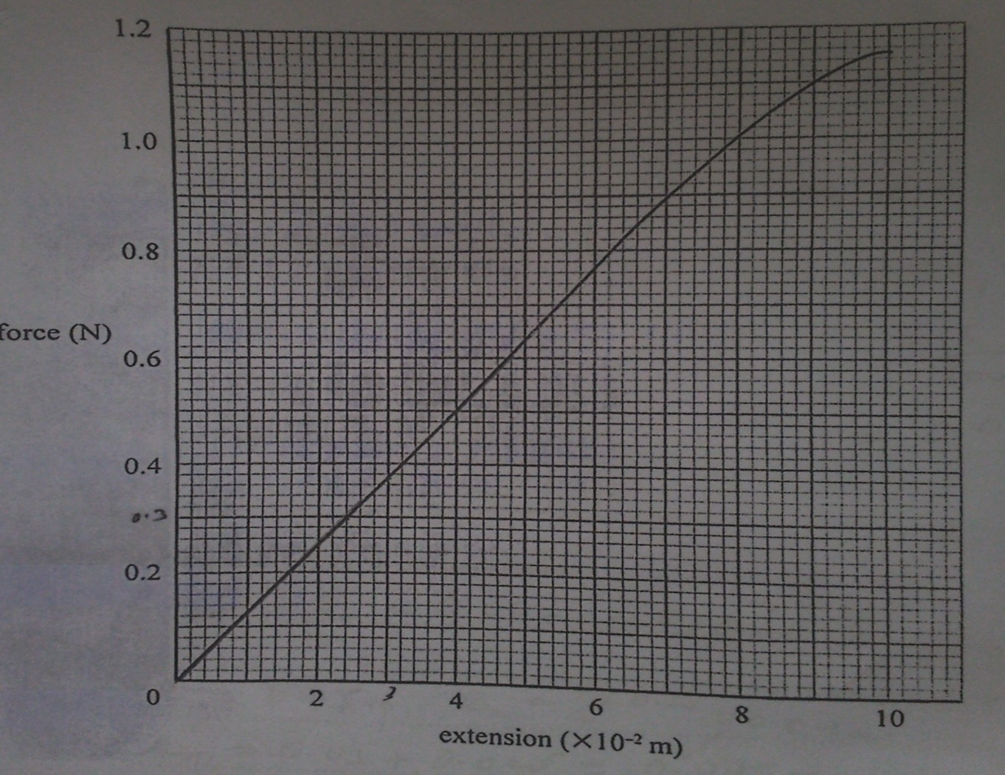
From the graph determine:
- The spring constant K (3 mks)
…………………………………………………………………………………………………………………………………………………………………………………………………………………………………………………………………………………………………………………………………………………………………………………………….
- The load that causes an extension of 3x10-2m. (1 mk)
…………………………………………………………………………………………………………………………………………………………………………………………….

c) Three identical springs constant 100Nm-1 are arranged as shown below to support a 5N load.
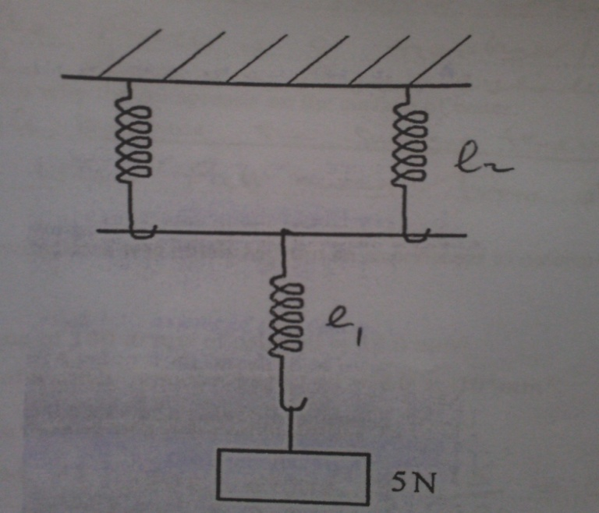
Determine the total extension in the arrangement. (3 mks)
……………………………………………………………………………………………………………………………………………………………………………………………………………………………………………………………………………………………………………………………………………………………………………………………..
- (a) In an experiment to determine the size of an oil molecule, oil is placed on the surface of water after sprinkling lycopodium powder on it.
- State two reasons why oil is used. (2 mks)
………………………………………………………………………………………………………………………………………………………………………………………………………………………………………………………………………………………………
- State the function of the lycopodium powder. (1 mk)
…………………………………………………………………………………………………………………………………………………………………………………………….

- State any two assumptions that are made in this experiment. (2 mks)
……………………………………………………………………………………………………………………………………………………………………………………………………………………………………………………………………………………………………………………………………………………………………………………………..
- Explain why the oil spreads on the surface of water. (2 mks)
…………………………………………………………………………………………………………………………………………………………………………………………………………………………………………………………………………………………………………………………………………………………………………………………….
b) The following data was obtained from an experiment to determine the size of a palm oil molecule.
- Volume of 100 drops of palm oil = 15.0mm³
- Area of a patch from one drop of oil = 8.0 x 10⁴mm²
Determine the size of a palm oil molecule. (3 mks)
……………………………………………………………………………………………………………………………………………………………………………………………………………………………………………………………………………………………………………………………………………………………………………………………………………………………………………………………………………………………………………………………………............................................

