
d
MARANDA HIGH SCHOOL
Kenya Certificate of Secondary Education
THE MOCK EXAMINATIONS, 2025
121/2 MATHEMATICS PAPER 2
June, 2025 TIME: 2½ Hrs

Name: …………………………………….…….…… Admission No: …………
Stream: ……………….. Signature: ………............ Wednesday, 4th Jun, 2025; 7:00-10:30pm
Instructions to candidates:
- Write your name, admission number and stream in the spaces provided above.
- Sign and write the date of examination in the spaces provided above.
- This paper consists of two sections: Section I and Section II.
- Answer all the questions in Section I and only five questions from Section II.
- Show all the steps in your calculations, giving your answers at each stage in the spaces provided below each question.
- Marks may be given for correct working even if the answer is wrong.
- Non-programmable silent electronic calculators and KNEC Mathematical tables may be used, except where stated otherwise.
- This paper consists of 18 printed pages.
- Candidates should check the question paper to ascertain that all the pages are printed as indicated and that no questions are missing.
- Candidates should answer the questions in English

For Examiner’s Use Only
Section I
1 | 2 | 3 | 4 | 5 | 6 | 7 | 8 | 9 | 10 | 11 | 12 | 13 | 14 | 15 | 16 | Total

Section II Grand Total

17 | 18 | 19 | 20 | 21 | 22 | 23 | 24 | Total

SECTION I (50 marks)
Answer all the questions in this section
- The height of a rectangular based pyramid tank is exactly 7.1metres. If the dimensions of its base are given correct to the nearest 10cm as 2.5m by 1.8m, calculate the percentage error in its volume to 4 s.f (3marks)

- The trigonometric equation of a curve is given as $y=2tan{(zx-40)}^{0}$ given that z is a constant Determine the:
- Amplitude ( 1mark )

- Phase angle ( 1mark )

- Period ( 1mark )
- Given that log a = x and log b = y, find x and y, if $log\frac{a^{2}}{b}$ = 4 and log ab² = 7 ( 3marks)

- Given that $\sin{{15}^{0 }= \frac{\sqrt{3 } - 1 }{2\sqrt{2}}}$ simplify ${\frac{1}{{sin15}^{0}}}$ ( 2marks)

- A buyer pays for a car on hire purchase in 12 equal monthly instalments. The cash price was kshs. 450 000 and the interest rate was 15% p.a. A deposit of Kshs. 75 000 was paid. Calculate his monthly repayments to the nearest shillings. ( 3marks)

- In the figure below, BT is a tangent to the circle at B. AXCT and BXD are straight lines. AX = 6 cm, CT = 8 cm, BX = 4.8 cm and XD = 5cm (figure not drawn to scale)
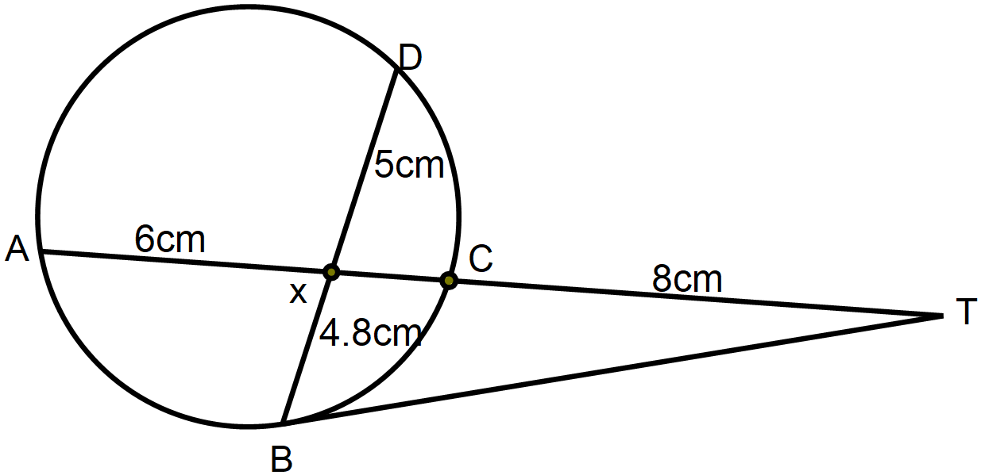
Find the length of:
a). XC ( 1 mark)

b). BT (2marks)

- A jewel is guarded by three guards A, B and C in that order. On his way in, the probability of a thief getting caught by guard A is $\frac{2}{3}$ , by B is $\frac{3}{7}$ and by C is $\frac{1}{4}$ . On his way out, the probability of being caught by guard C is $\frac{4}{5}$ ,by B is $\frac{1}{2}$ and by A is $\frac{2. }{5}$ Calculate the probability that :
- The jewel is stolen and the thief escaped. (2 marks)

- The thief was caught by guard C ( 2 marks)

- The position vectors of points P, Q and Rare given as OP = 7i – 10j , OQ = i + 2j and OR = 10j + -3i. Show that points P, Q and R are collinear. (3marks)

- The mean mark of 10 students in a test is 47 while the standard deviation is 11. An eleventh student had scored 58 marks in the same test. Calculate
  - The new mean ( 1 marks)

  - the new standard deviation of 11 students ( 3 marks)

- Given that $m=q+r$ and q varies directly as t and r varies directly as the square of t. If m = 16, t = 2 and when m = 33, t = 3. Find m when t = 8 ( 3marks)

- The temperature of a cooling water was measured at intervals of two minutes and recorded as shown in the table below
Time ( minutes ) | 0 | 2 | 4 | 6 | 8 | 10 | 12
Temperature( ⁰C) | 80 | 60 | 46 | 35 | 26 | 20 | 15
- On the grid provided, draw the graph of the temperature against time ( 2 marks)
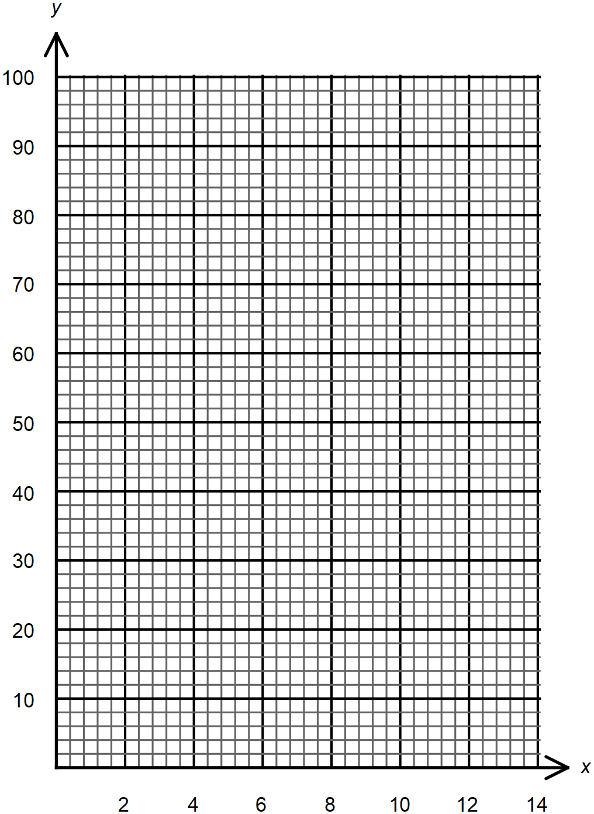
- Determine the rate of cooling at the 8th second ( 2marks)

- The figure below shows a triangular prism wedge with a flat bottom ABCD. AB = EF =15cm and AD = BC = 8cm, CF = DE = 6cm.

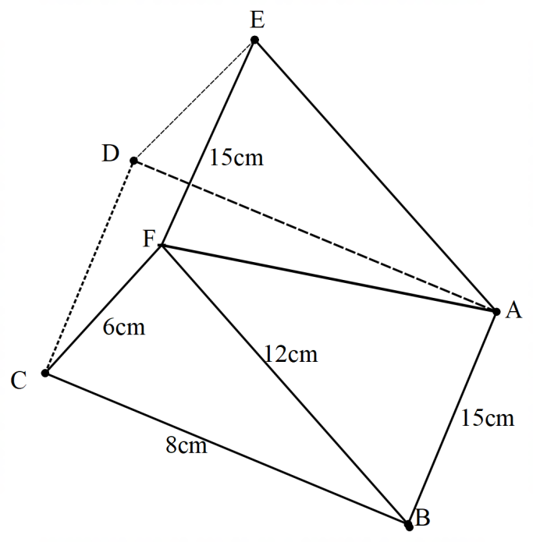
Find the angle that line AF makes with the base ABCD given that angle BCF = angle ADE = 90⁰. ( 2marks)

- The points with coordinates (7, 10) and (-3, 8) are the end points of a diameter of a cycle centre A. determine the equation of the circle in the form $x^{2}+y^{2}+ax+by+c=0$ where a, b and c are constants. ( 3marks)

- The matrices A and B are such that $A= \left[\begin{matrix}k & 4 \\ 3 & 2\end{matrix}\right]$ and$B= \left[\begin{matrix}1 & 2 \\ 3 & 4\end{matrix}\right]$. Given that the determinant of AB = k, find the value of k ( 3marks)

- Evaluate $\int_{-2}^{3}{\left({4x}^{3}+2x+1\right)dx}$ ( 3marks)

- Construct using a scale of 1:100 a triangular ranch ABC where AB = 6m, AC= 7m and BC = 7.5m using AB as the base. Goats are allowed to graze inside the ranch provided that they are at least 2metres from AB and more than 3metres from C. Indicate by shading the area available for grazing ( 4marks)

SECTION II (50 marks)
Answer only five questions in this section
- A triangle Z whose vertices are A(2, 3), B(5, 3) and C(4,1) is mapped onto triangle Z¹ whose vertices are A¹(x, y), B¹ (-1, 3) and C¹(2, 1) by a transformation R. find;
- The transformation matrix represented by R. (4 marks)

- Co-ordinates of A¹. (2 marks)

- Triangle Z² is the image of triangle Z¹ under a reflection in the line y = - x. Using a unit square, find the matrix that represent this transformation, hence calculate the co-ordinates of Z². (2 marks)

- Find a single matrix that maps Z² onto Z... (2 marks)

- (a) Complete the table below giving the values correct to 2 decimal places. (2 marks)
xo | 0 | 20 | 40 | 60 | 80 | 100 | 120 | 140 | 160 | 180
Cos x | 1.00 | 0.94 | 0.77 | 0.50 |  | -0.17 |  | -0.77 |  | -1.00
Sin x – Cos x | -1.00 | -0.60 |  | 0.37 | 0.81 |  | 1.37 |  | 1.28 | 1.00

- Draw the graph of $y={\cos{x}}^{0}$ and $y={\sin{x}}^{0}- {\cos{x}}^{0}$for $0^{0}≤x≤{180}^{0}$. Use the scale; 1 cm for 20 on the x – axis and 4 cm for 1 unit on the y – axis. (5 marks)

- Using the graph drawn;
  - solve the equation ${\sin{x}}^{0}- {\cos{x}}^{0}≥1.2$ (1 mark)

  - solve the equation ${\cos{x}}^{0}=½{\sin{x}}^{0}$ (1 mark)

- A tour company has eight minibuses and 7 troopers. The manager of the company has contracted to transport a party of 54 tourists to a game lodge in one convoy. A minibus can take a maximum of six tourists while a trooper can take a maximum of five.
  - If the manager decides to use x troopers and y minibuses, write down three inequalities other than $x≥0$ and $y≥$0 that have to be satisfied (3marks)

  - On the grid provided, draw the inequalities in (a) above (4marks)
  - If it cost shs. 3000 per trip to run a minibus and shs. 2000 per trip to run a trooper, determine the least cost of organizing the tour (3marks)

- An aircraft leaves town A (60⁰N, 20⁰W) at 1300 hours and arrives at town B (60⁰N, 40⁰E) at 2100hrs local time.
  - Calculate the average speed of the aircraft in knots (3marks)

  - A helicopter S leaves A at 1300hrs local time and moves due west. After some time helicopter T leaves B and moves due north. The two helicopters are moving at 500 knots and 600knots respectively. If the two helicopters met at the same latitude NEC( 60⁰N, 140⁰W) at the same local time;
Find:
- The time taken by S to reach C (3 marks)

- The local time when T left town B for C to reach C at the same local time (4marks)

- Mr. Kosgei an acting chief inspector in the police service has a monthly earnings of; a basic salary of Ksh.56 000, 10 % of basic salary as house allowance, commuter allowance of Ksh.12 000 and acting allowance of Ksh.10 000. He has a life insurance policy for which he pays Ksh.6 000 per month as premium and for which he is allowed 15% as insurance relief on the premium paid. He is also entitled to a personal tax relief of Ksh.1 162 per month.
Monthly income | Percentage tax rate
in Kenya shillings | in each shilling
0 – 10164 | 10
10165 – 19740 | 15
19741 – 29316 | 20
29317 – 38892 | 25
38893 and above | 30
  - Using the tax table above:
- Determine Mr. Kosgei’s monthly taxable income. (1 marks)

- Calculate net tax paid by Mr. Kosgei per month. (4 marks)

  - Mr. Kosgei also had the following monthly deductions from his salary. Sacco loan repayment of Ksh.1 000, WCPS 2% of basic salary, NHIF Ksh.1 500. Determine his net monthly salary. (2marks)

  - After consultation, the first tax band was expanded by 50% while retaining the next three other tax bands. Determine the percentage change in net tax paid per month by Mr. Kosgei.
(3 marks)

- The table below shows a number of goals scored in a handball match during a tournament.
No of goals | 0 − 9 | 10 − 19 | 20 − 19 | 30 − 39 | 40 − 49 | 50 – 59 | 60 – 69
No of matches | 4 | 7 | 10 | 12 | 9 | 5 | 3
- Draw a cumulative frequency curve on the grid provided. ( 3marks)

- Using the curve in (a) above determine:
- The median (1 mark)

- The number of matches in which goals scored were t goals where 15≤ t ≤ 23
(1 mark)
- Calculate the quartile deviation (2marks)

- Find the range of goals scored by the middle 80% of the matches played as a percentage of the total number of matches played. (3 marks)

- A contractor wishes to make a stair case up a building from one floor down to the next floor. The stair – cases are to diminish uniformly in lengths from 630 cm at the bottom to 270 cm at the top. Given that the sum of the lengths of the stair – cases was 4500cm.
a) Calculate:
(i) The length in centimetres of the seventh stair – case from the bottom. (4 marks)

    - The length in centimetres of the fourth stair – case from the top. (1 marks)

b). The third, fifth and eighth terms of another Arithmetic Progression (A.P.) form the first three consecutive terms of a Geometric Progression (G.P.). If the common difference of the AP is 3, find:
      - The first term of the Geometric Progression. (3 marks)

      - The sum of the first eleven terms of the Geometric Progression to 4 s.f. (2 marks)

- A particle moving along a line passes a point O at a velocity of 15m/s and its acceleration t seconds later is given by a = (2t - 8) m/s²

  - Find the expression of the velocity after passing the point O. (3marks)

  - Find the time when the particle is at rest. (3marks)

  - Find the distance between the points when the particle is at rest. (4marks)

…….. THIS IS THE LAST PRINTED PAGE ……

