Name: ……………………………....…………. Index No: ……………………….…………….
School: ……………………………………….... Candidate’s Signature: ……………………… Date: ………………………..
121/1
MATHEMATICS
PAPER 1
END TERM 2 2025
JULY 2025
TIME: 2 ½ HOURS

Kenya Certificate of Secondary Education (K.C.S.E)

121/1
MATHEMATICS
PAPER 1
2 ½ HOURS

INSTRUCTIONS TO THE CANDIDATES

- Write your name and Admn number in the spaces provided above.
- Sign and write date of examination in the spaces provided above.
- This paper consists of two sections; Section I and Section II.
- Answer All questions in Section I and only Five questions from section II
- All answers and working must be written on the question paper in the spaces provided below each question.
- Show all the steps in your calculations giving answers at each stage in the spaces provided below each question.
- Marks may be given for correct working even if the answer is wrong.
- Non-programmable silent electronic calculators and KNEC Mathematical tables may be used except where stated otherwise.
- This paper consists of 14 printed pages. Candidates should check the question paper to ascertain that all pages are printed as indicated and that no questions are missing.
m) Candidates should answer questions in English.

For examiner’s use only.

Section I
1 | 2 | 3 | 4 | 5 | 6 | 7 | 8 | 9 | 10 | 11 | 12 | 13 | 14 | 15 | 16 | Total

Section II
17 | 18 | 19 | 20 | 21 | 22 | 23 | 24 | Total

GRAND TOTA
(Answer all the questions in the spaces provided)

1. Without using a calculator, evaluate
36 – 8 x –4 - 15 ÷ - 3
3 x –3 + -8 [6 – (⁻2)] (3mks)

2. The G.C.D of two numbers is 12 and their L.C.M is 240. If one of the numbers is 60, find the other number. (2mks)

3. Agnes paid rent which was $\frac{1}{10}$ of her net salary. She used $\frac{1}{2}$ of the remaining amount to make a down payment for a plot. She gave her mother sh. 2500 and did shopping worth sh. 7500 for herself. She saved the remaining which was sh. 12,500. How much was the down payment that she made? (4 marks)

4. Elvis exchanged Ksh.600,000 to Sterling pounds. After settling the bills worth £1200, he changed the balance to Euros. He then purchased goods worthy 200 Euros. Using the exchange rates below, calculate his balance in Kenyan shillings. (4mks)
 | Buying (Ksh) | Selling (Ksh)
1 Sterling pound | 114.20 | 114.50
1 Euro | 101.20 | 101.30

5. Each exterior angle of a regular polygon is a fifth of the interior angle.
- Find the size of the exterior angle (2mks)

- Find the number of sides of the polygon (1mk)

6. In the figure below, O is the center of the circle. AOD and BCD are straight lines. Angle AOC = 138⁰ and angle OAB=35⁰. Determine the size of angle ADB. (3mks)
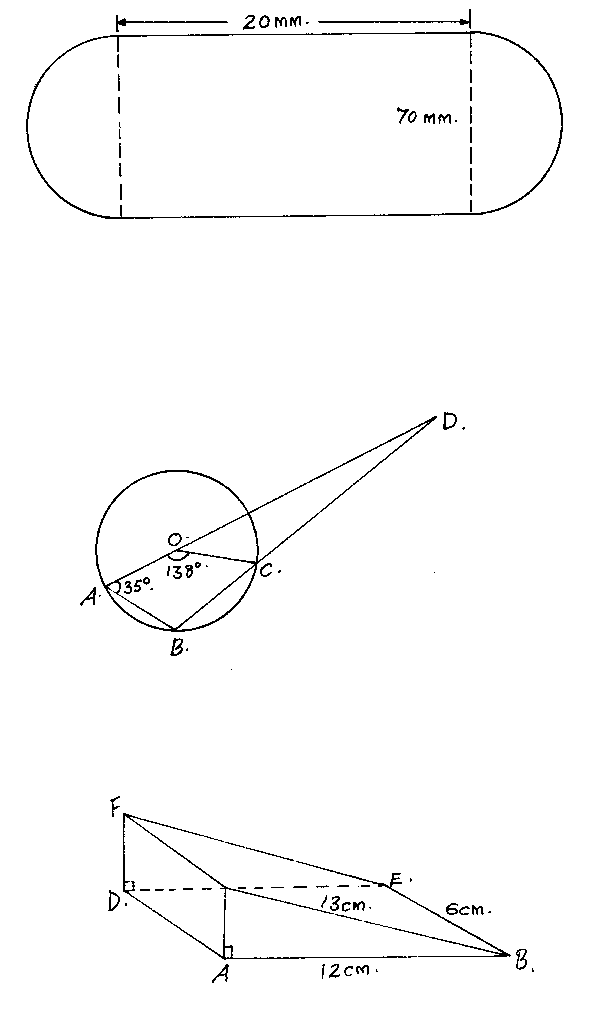

7. An observer stationed 20m away from a tall building finds that the angle of elevation of the top of the building is 68⁰ and the angle of depression of its foot is 50⁰. Calculate the height of the building. (3mks)

8. Simplify the expression (3mks)
P² – 4m²
2m² – 7mp + 3p²

9. a) Sketch the net of a wedge in the following figure.

b) Calculate the surface area of the net drawn above. (3mks)

10 Express the inequalities in the form p ≤ x ≤ q hence state the integral values (3mks)

11. Two similar cylindrical containers are such that the capacity of the larger container is 5 litres and that of the smaller is 320 millilitres. If the base area of the larger container is 0.25 m². Find the base area of the smaller container. (3mks)

12. Solve for x in the following equation (3mks)
4^{x} (8 ^{x-1}) = Tan 45⁰

13. Use tables of logarithms to evaluate (3mks)
$$\frac{4.28 X 0.01677}{tan {20}^{O}}$$

14. A solid block in the shape of a cylinder has a height of 14cm and weighs 22kg. If it is made of material of density 5g/cm³, find the radius of the cylinder. Take π= (3mks)

15 Use the reciprocal, square and square-root tables to evaluate to 4 significant figures the expression.
(4mks)

16. Without using a calculator or tables, find the value of y given that y = (a+b) (x – c) ² and a = 5, b =6 ,x = -3 and c = 2. (3mks)

SECTION II
(Answer ANY FIVE questions in the spaces provided)

17. (a) A straight line L, whose equation is 3y - 2x = -2 meets the x-axis at R.
Determine the co-ordinates of R. (2 mks)

b) A second line L₂ is perpendicular to L₁ at R. Find the equation of L₂ in
the form y = mx + c, where m and c are constants. (3 mks)

(c) A third line L₃ passes through (-4,1) and is parallel to L₂ Find:
(i) the equation of L₃ in the form y = mx + c, where m and c are constants
(2 mks)

(ii) the co-ordinates of point S, at which L intersects L (3 mks)

18 The diagram below represents a solid conical frustrum .Given that the height of the frustrum is 4cm, the radius of the base is 4.9cm and slant height of the frustrum is 2.1 cm.

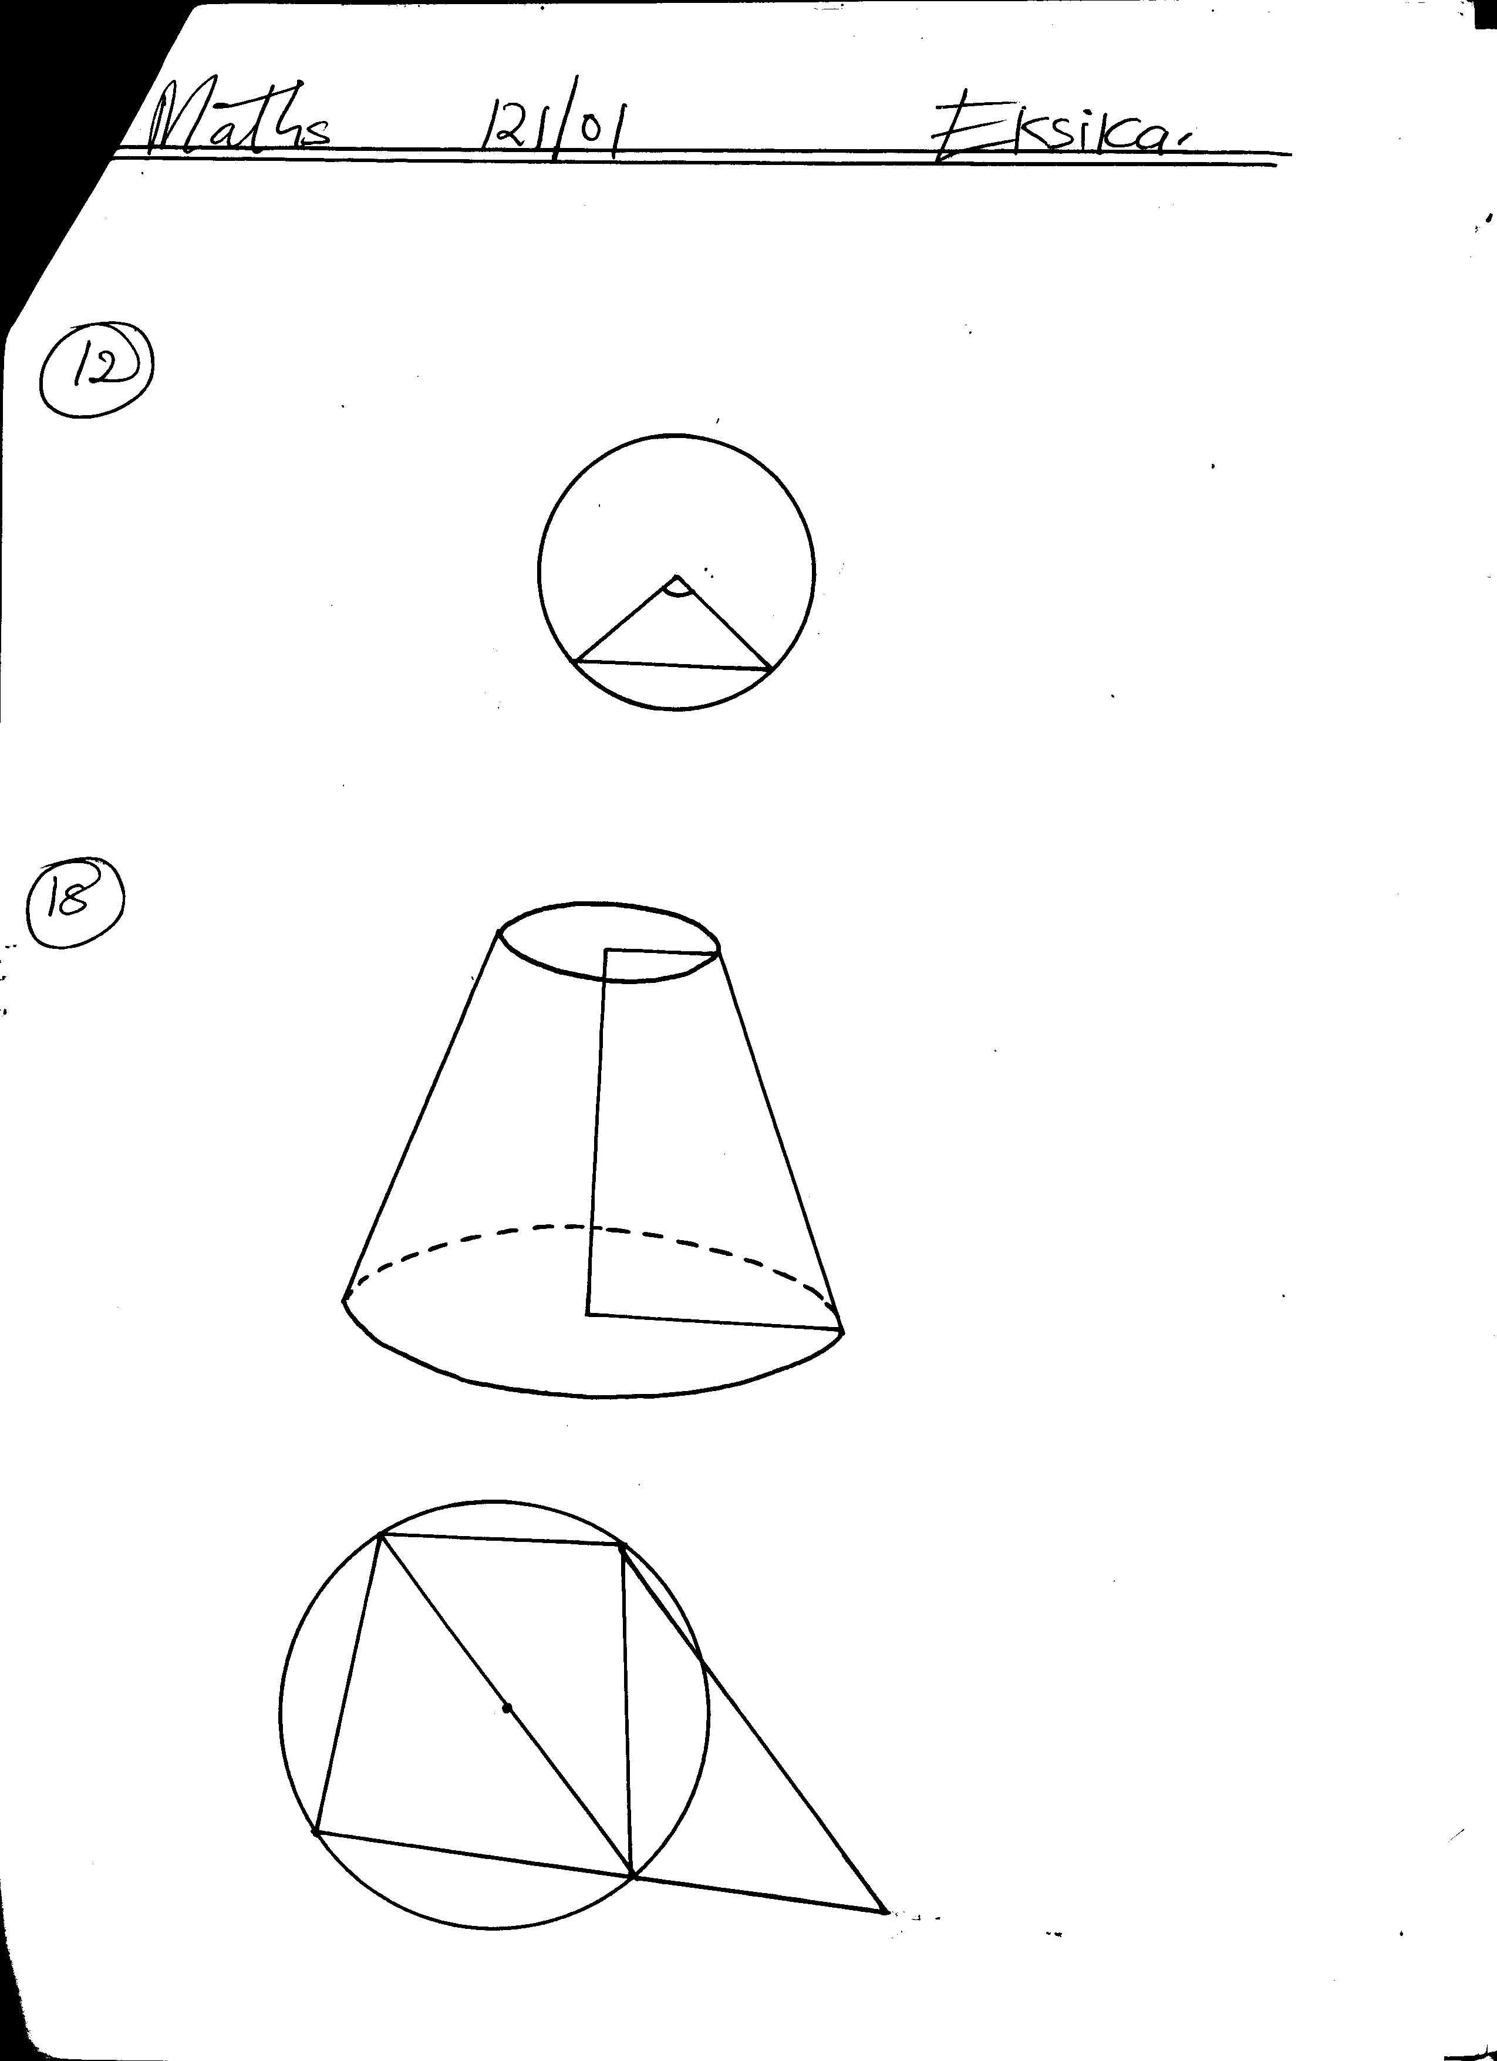

B

a) Determine the height of the chopped off cone and hence the height of the bigger cone. (2mks)

b) Calculate the surface area of the solid. (4mks)

c) Calculate the volume of the solid. (4mks)

19. A matatu left Ravine for Torongo 51km away at an average speed of 48km/h at 7.00am. At 7.30am a Boda boda left Torongo for Ravine travelling along the same route at an average speed of 60km/h.Find:
(a) The time when Boda boda meet the matatu (3mks)

(b) How far from Ravine did the Boda boda meet the matatu (3mks)

(c) After meeting the Boda boda the matatu stopped for fifteen minutes before resuming the journey. At what speed should it travel then to reach Torongo at the same time when the Boda boda reached Ravine (4mks)

20. The table shows the marks obtained by 40 candidates in an examination

Marks | 5-14 | 15-29 | 30-34 | 35-44 | 45-49
Frequency | 2 | 12 | 7 | 15 | x
(a) Find the value of x (2mks)

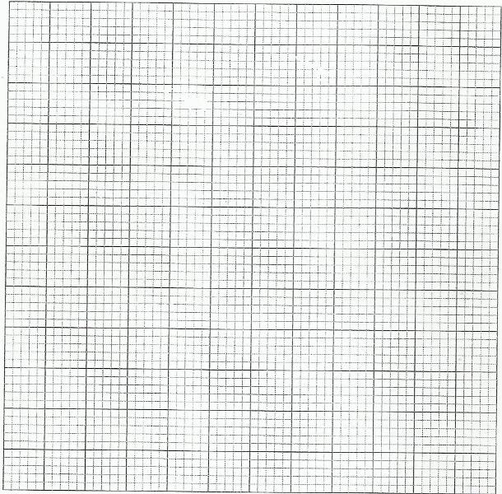
(b) On the grid provided below draw a histogram to represent the data (5mks)

(c) By drawing a straight line on the graph above determine the median mark (3mks)
21. A certain number of people agreed to contribute equally to buy a book worth sh. 1,200 for a school library. Five people pulled out so the others agreed to contribute an extra sh. 10 each. Their contribution enabled them to buy a book worth sh. 200 more than they originally expected.
- If the original number of people was x, write an expression of how much each was originally to contribute. (1mk)

- Write down two expressions of how much each contributed after the people pulled out.
(2mks)

- Calculate how many people made the contribution. (5mks)

- Calculate how much each contributed. (2mks)

22. Three planes P,Q and R left Jomo Kenyatta International Airport at 8.10a.m, 8:40a.m and 9.20a.m respectively. Plane P travelled at 300km/h along N70⁰W, plane Q travelled at 240km/h along N67.5⁰E and R travelled at 400km/h along 210⁰.
a) Using a scale of 1cm to represent 100km, locate the position of the planes at 10.50a.m. (6mks)

b) Find the distance of plane Q and R at 10.50a.m. (2mks)

c) Find the bearing of plane Q from plane P (1mk)

d) Find the bearing of plane R from plane Q. (1mk)

- The figure below represents a cuboid EFGHJKLM in which EF =40cm, FG=9cm and GM=30cm. N is the midpoint of LM.
M
J
N
L
K

30cm

H
G

9cm
F
E
40cm

Calculate correct to 4 significant figures:
- the length of GL; (1mk)

- the length of FJ; (2mks)

- the angle between EM and the plane EFGH; (3mks)

- the angle between the planes EFGH and ENH. (2mks)

- the angle between the lines EH and GL. (2mks)

- A triangle ABC with vertices A (-4,2), B(-6,6) and C(-6,2) is enlarged by scale factor -1 and centre (-2,6) to produce triangle A¹B¹C¹. Triangle A¹B¹C¹ is then reflected in line y=x to give triangle A¹¹ B¹¹C¹¹.
a) Draw triangle ABC and its successive images on the grid provided. State the co-ordinates of A¹B¹C¹ and A¹¹B¹¹C¹¹. (6mks)

(b) If triangle A¹¹B¹¹C¹¹ is mapped onto a triangle whose co-ordinates are A¹¹¹(0,-2), B¹¹¹(4,-4) and C¹¹¹(0,-4) by a rotation, find the centre and the angle of rotation. (4mks)
END

