Name: _____________________________________________ Adm No: ____________Class: _____
Candidate’s Signature: ________________________ Date: __________________________
MATHEMAMATICS
FORM TWO
END TERM 2 EXAMINATION
JULY/AUGUST 2025
Time: 2HOURS

Instructions to Candidates:
- Answer all the questions in section I and three questions in section II

SECTION I 40 Marks
- Use tables to evaluate. (3marks)

3.45 x 16.7
31.5

- Solve for x in each of the following equations. (3marks)
- 3^{(2x-5)} = 27

- 3^{4x} ÷ 3 ⁻⁷=3¹⁵ (3marks)

- A metallic cuboid measuring 16cm by 8cm by 4 cm was melted . The material was then used to make a cube. What was the length of the cube? (3marks)

- Simplify

27x³y⁹ (3marks)
X⁶y³

- Owino spends $\frac{1}{4}$ of his salary on school fees. He spends $\frac{2}{3}$ of the remainder on food and a fifth of what is left on transport. He saves the balance. In certain month he saved Sh. 3400. What was his salary?
(3marks)

- A number m is such that when it is divided by 30, 36, and 45, the remainder is always 7. Find the smallest possible value of m. (3marks)

- A Kenyan bank buys and sells foreign currencies at the exchange rates shown below:
Buying Selling
(Kshs.) (Kshs.)
1 Euro 147.86 148.00
1 US Dollar 74.22 74.50
An American arrived in Kenya with 20,000 Euros. He converted all the Euros to Kenya
Shillings at the bank. He spent Kshs.2,510,200 while in Kenya and converted the remaining Kenya shillings into US Dollars at the bank. Find the amount in dollars that he received. (3 marks)

- Determine the equation of the line perpendicular to the line whose equation is y=-5x+3 and passes through the point (3, 2). (3marks)

- Use the reciprocal tables and square root to evaluate. (4marks)

$$\frac{\text{0.1}}{\text{0.0351}}\text{+}\sqrt{\text{0.498}}$$

- Two men each working for 8 hours a day cultivate an acre of land in 4 days. How long would 6 men each working 4 hours a day take to cultivate 4 acres? (3marks)

- The sum of interior angles of a regular polygon is 1080º. Find the size of each exterior angle. (3marks)

- A farmer has goats and chicken in his farm. The total number of heads is 20 and the total number of legs for the animals is 72. Determine the number of goats and chicken. (3mks)

SECTION II: Answer only three questions: 30 marks

13. On the graph paper provided, plot the triangle whose co-ordinates are A (1, 3) B(2, 1) and C(3, 4). (1 mark)
(a) On the same grid, draw;

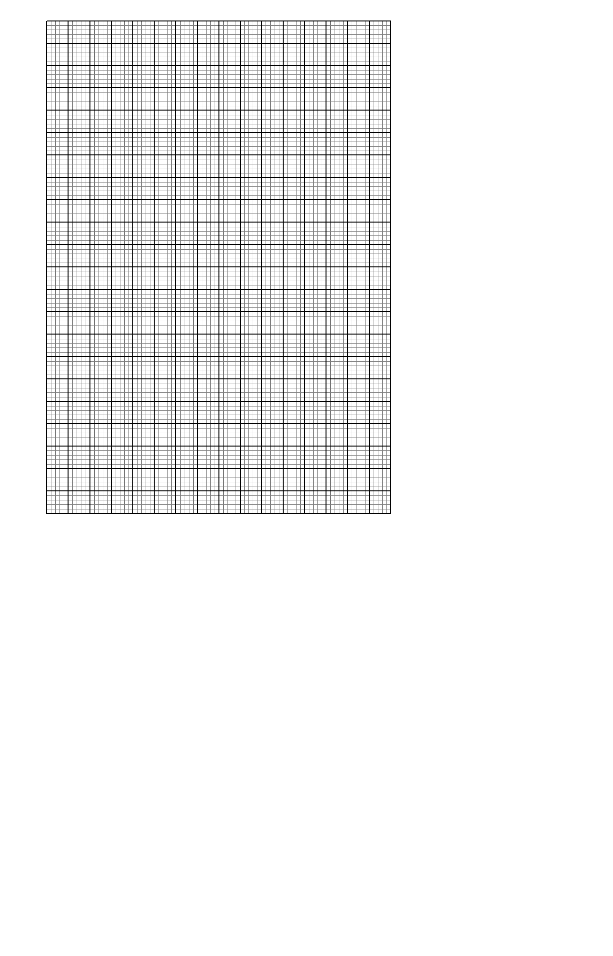
- A’B’C’ the image of ABC under an enlargement, centre (0,0), scale factor 2 and state its co-ordinates. (3 marks)

- A”B”C” the image of A’B’C’ under a rotation of +90º about origin. State the co-ordinates of A”B”C”. (3 marks)

(iii) A’’’B’’’C’’’ the image of A’’B’’C’’ under reflection in the line Y=x and state its coordinates (3 marks)

14. Three warships P,Q and R leave port X at 9.00 a.m. Ship P sails at a steady speed on a bearing of
070º, 100km from port X while ship Q sails on a bearing of 320º, 80km from port X. Ship R is on a
Bearing of ${150}^{0}$ from port X and due south of ship P.

(a) Construct a scale drawing to show the position of P, Q, R and X. (Use a scale 1cm rep 20km) (4 marks)

(b) Use the scale drawing to determine:
(i) The distance and bearing of ship P from ship Q. (2 marks)

(ii) The distance of ship R from port X. (2 marks)

(iii) The distance of ship R from ship P. (2 marks)

15. (a) Use a ruler and a pair of compasses only to construct triangle ABC such that AB = 2.5cm, BC =
3.5cm and AC = 5.5cm. Measure < ABC. (3 marks)

(b) Drop a perpendicular from A to a point T on CB produced. Measure the length AT. (3 marks)

- With BT as the base, calculate the area of triangle ABT and triangle ACT. (4 marks)

- Below are the measurements of a wheat field using a baseline XY recorded in metres.
 | Y
 | 240
TO R 60 | 190
 | 180 | 75 TO Q
 | 150 | 50 TO P
TO S 100 | 120
 | 100 | 100 TO N
TO T 30 | 50
 | 20 | 20 TO M
 | X

a) Using a scale of 1cm represents 20m. Sketch the map of the wheat field. (4marks)

(b) Find the area of the field in hectares. (4marks)

(c) If the cost of one hectare is sh65, 000 find the cost of the wheat field. (2marks)

