Name: _____________________________________________ Adm No: ____________Class: _____
Candidate’s Signature: ________________________ Date: __________________________

MATHEMATICS
FORM TWO
END TERM 2 EXAMINATION
JULY/AUGUST 2025
Time: 2$\frac{1}{2}$ HOURS

Instructions to Candidates
1. Write your name, class and your admission number in the spaces provided at the top of this page.
2. This paper consists of two sections: Section l and Section II
3. Answer all questions in section l and any THREE questions from Section II.
4. Show all the steps in your calculations, giving your answers at each stage in the spaces below each question.
5.marks may be given for correct working even if the answer is wrong.
6.Non- programmable silent electronic calculators and KNEC Mathematical tables may be used.
SECTION 1
- Use mathematical table to evaluate. (4 marks)
2849 x 0.00574
4
  - x 0.023

- Mr. Owino spends$\frac{1}{4}$ of his salary on school fees. He spends $\frac{2}{3}$ of the remainder on food and a fifth of what is left on transport. He saves the balance. In certain month he saved Sh. 3400. What was his salary?
(3 marks)

- A number m is such that when it is divided by 30, 36, and 45, the remainder is always 7. Find the smallest possible value of m. (3 marks)

- The volume of two similar cylinders are 4752 cm³ and 1408cm³. If the area of the curved surface of the smaller cylinder 352cm², find the area of the curved surface of the larger cylinder. (3 marks)

- Given that Sin 3X⁰=Cos 2X⁰, find the value of tan X⁰. ( 3 marks)

- If a: b =2: 3 and b: c=5:9 , find the ratio a:c ( 2 marks)

- A Kenyan bank buys and sells foreign currencies at the exchange rates shown below:
Buying Selling
(Kshs.) (Kshs.)
1 Euro 147.86 148.00
1 US Dollar 74.22 74.50
An American arrived in Kenya with 20,000 Euros. He converted all the Euros to Kenya
shillingsat the bank. He spent Kshs.2,510,200 while in Kenya and converted the remaining
Kenya shillings into US Dollars at the bank. Find the amount in dollars that he received. (3 marks)

- The size of an interior angle of a regular polygon is 3xº while its exterior angle is (x-20)^{o.} Find the number of sides of the polygon. ( 3 marks)

- Solve the equation 9 ^{x+1}$×$3 ^{2x + 1}= 243 ( 3 marks)

- Two lines L₁,2y - 3x - 6 ═ 0 and L_{2,} 3y + x- 20 = 0 intersect at a point A. Find the coordinates of A.
(3 marks

- Nduati owns a farm that is triangular in shape as shown below. Calculate the area of the triangle. (3 marks)
C
B
A
440m
320m
250m

- The distance between towns A and B is 360km. A minibus left town A at 8.15 a.m. and traveled towards town B at an average speed of 90km/hr. A matatu left town B two and a third hours later on the same day and travelled towards A at average speed of 110km/hr. At what time did the two vehicles meet? (4 marks)

- Solve the following inequalities and state the integral values. (3 marks)
$2x - 2 ≤ 3x + 1 < x + 11$

- Given that tan x = $\frac{5}{12}$ find the value of the Cos (90-x) without using mathematical tables or calculator.
(3 marks)

- If OA = $\left({18 \atop 8}\right)$and OB = $\left({16 \atop 4}\right)$. Find the magnitude of AB. (4 marks)

- In the figure below BD is the diameter of the circle and O is the centre. Find the size of ∠ADC. (3 marks)
A
B
D

E

33º

O

48º

C

SECTION II

- The table shows marks obtained by 100 candidates at Star Boys High School. School in Biology examination.
marks | 15-24 | 25-34 | 35-44 | 45-54 | 55-64 | 65-74 | 75-84 | 85-94
Frequency | 6 | 14 | 24 | 14 | x | 10 | 6 | 4

- Determine the value of x (1 Mark)

- State the modal class (1 Mark)

- Calculate the median mark (4 marks)

- Calculate the mean mark (4 marks)

- The diagram below shows the speed-time graph for a bus traveling between two towns. The bus starts from rest and accelerates uniformly for 50seconds. It then travels at a constant speed for 150seconds and finally decelerates uniformly for 100seconds.

Speed m/s
Time in seconds

Given that the distance between the two towns is 2700m, calculate the ;
- maximum speed in km/h, the bus attained.(3 marks)

- acceleration. (2 marks)

- distance the bus traveled during the last 50seconds. (2 marks)

(d) time the bus takes to travel the first half of the journey (3 marks)

- Four ships are at sea such that a streamliner S is 150km on a bearing of 025° from a cargo
shipC. A trawler T is 300km on a bearing of 145° from the cargo shipC and a yacht Y is due
West of C and on a bearing of 300° from T.
a) Using a scale of 1cm= 50km, draw on accurate scale drawing showing the positions of S, C, T
and Y. ( 5 marks)

b) By measurement from your scale drawing determine:
i) The distance and bearing of Y from S ( 3 marks)

ii) The distance ST (1 marks)

iii) The distance YT ( 1 marks)

- Three business partners Lewis, James and Richard contributed Ksh.112,000,Ksh.128,000 and Ksh.128,000 respectively to start a business. They agreed to share their profit as follows: 30% to be shared equally 30% to be shared in the ratio of their contributions 40% to be retained for the running of the business. If at the end of the year the business realized a profit of ksh. 1,350,000
Calculate :
a)The amount of money retained for the running of the business at the end of the year (1mark)

b)The difference between the amounts received by Richard and Lewis. (6marks)

c) Express James’s share as a percentage of the total amount of money shared between the three partners. (3marks)

- The figure below shows a frustrum cut from a cone. Calculate:

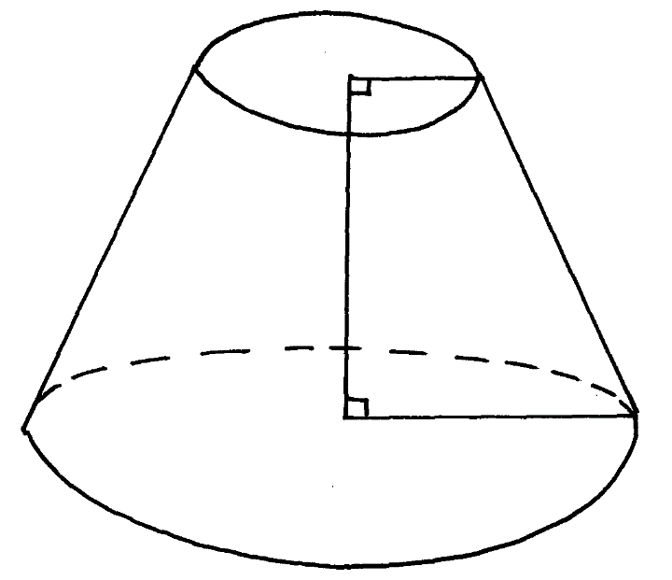
9cm

3cm

14cm

- The original height of the cone. (3 marks)

- The curved surface area of the frustrum. (4 marks)

- Volume of the frustrum. ( 3 marks)

