Candidate’s Name |  | Assessment Number
School Name |  | School Code
Candidate’s Signature |  | Date

THE KENYA NATIONAL EXAMINATION AND ASSESSMENT PREDICTION SERIES KENYA JUNIOR SCHOOL EDUCATION ASSESSMENT
907: SOCIAL STUDIES
Time: 1 Hour 30 Minutes
-SOCIAL STUDIES-

INSTRUCTIONS TO CANDIDATES:
- Write your name and assessment number correctly.
- Write the date of the assessment.
- Write the name and code of your school in the spaces as indicated above.
- This paper consists of two sections: A and B.
- Section A comprises Multiple Choice Questions.
- Section B comprises structured questions and essay questions.
- Answer ALL the questions in Section A on the separate ANSWER SHEET provided.
- Answer ALL the questions in Section B in the spaces provided on this question paper.
- Do NOT remove any page from this question paper.
- Answer the questions in English.

For Official Use Only: SECTION B
Ques | 21 | 22 | 23 | 24 | 25 | 26 | 27 | 28 | 29 | 30 | 31 | 32 | 33 | 34 | 35 | 36 | 37 | 38 | 39 | Total B
(a) Max Marks | 1 | 1 | 1 | 1 | 1 | 1 | 1 | 4 | 1 | 1 | 1 | 1 | 2 | 1 | 1 | 1 | 1 | 1 | 1 | 60
(a) Score
(b) Max Marks | 1 | 1 | 1 | 1 | 1 | 1 | 1 | 4 | 1 | 1 | 1 | 1 | 2 | 1 | 1 | 1 | 1 | 1 | 1
(b) Score
(c) Max Marks | 1 | 1 | 1 | 1 | 1 | 1 | 1 | 4 | 1 | 1 | 1 | 1 | 2 | 1 | 1 | 1 | 1 | 1 | 1
(c) Score
(d) Max Marks | 1 | 1 | 1 | 1 | 1 | 1 | 1 | 4 | 1 | 1 | 1 | 1 | N/A | 1 | 1 | 1 | 1 | 1 | 1
(d) Score
(e) Max Marks | 1 | N/A | N/A | N/A | N/A | N/A | N/A | N/A | N/A | N/A | N/A | N/A | N/A | N/A | N/A | 1 | N/A | N/A | N/A
(e) Score
(f) Max Marks | N/A | N/A | N/A | N/A | N/A | N/A | N/A | N/A | N/A | N/A | N/A | N/A | N/A | N/A | N/A | 1 | N/A | N/A | N/A
(f) Score
Question Total | 5 | 4 | 4 | 4 | 4 | 4 | 4 | 12 | 4 | 4 | 4 | 4 | 6 | 4 | 4 | 6 | 4 | 4 | 4 | /60
This paper consists of 9 printed pages. Candidates should check the question paper to ascertain that all the pages are printed as indicated and that no questions are missing.
© 2025 The Kenya National Examination and Assessment Prediction Series Turn over

SECTION A (20 Marks)
Answer ALL questions in this section on the separate answer sheet provided.

- Risper was asked by her deskmate to state the size of Africa. Which answer was correct? A. 50.1 million km² B. 30.3 million km² C. 43.5 million km² D. 110 million km²
- Which one of the following historical sites and monuments is found in Egypt? A. Robben islands. B. The Pyramids of Giza. C. Victoria monuments. D. Zimbabwe ruins.
- Tom was asked to name the factors that influence the climate of Africa. Which response was not correct? A. Oceanic currents. B. Winds. C. Meridians. D. Altitude.
- Grade 7 learners were tasked to name primary sources of information. Which of the answers they gave was not correct? A. Constitution. B. Manuscripts. C. Diaries. D. Journals.
- During a discussion, Grade 9 learners were asked to identify the chapter of the constitution that emphasizes on leadership and integrity. Which response did they give? A. Chapter 4 B. Chapter 6 C. Chapter 1 D. Chapter 8
- Silvia was asked by her teacher to mention a peaceful way of resolving conflicts in a family. Which was her correct response? A. Using force to make decisions. B. Decisions made by one person. C. Holding dialogue on a round table at home. D. Punishing those who argue a lot.
- The time in Kampala 40°E is 12:00 noon. What will be the time in Ivory Coast 20°W? A. 8:00 pm B. 8:00 am C. 10:00 pm D. 10:00 am
- Grade 7 learners were asked to construct a windvane using locally available materials. Which one of the following was not one of the materials they assembled? A. Pin. B. Manilla paper. C. Pencil. D. Socks.
- A type of map with a collection of several maps that are bound together in one volume is called: A. sketch map B. topographical map C. atlas map D. google map.
- Pre-career mapping is very important for individual growth. Which one of the following is not one of its importances? A. Exploring on interests. B. Discovering of one's strength. C. Setting of clear goals. D. Limited resources.
- Three of the following were socio-economic activities in the Middle Stone Age. Which one was not? A. Invention of fire. B. Hunting and gathering. C. Painting of the rocks and the caves. D. Domestication of animals and crops.
- Grade 9 learners were asked to use their gadgets to find out sources of population data in a country. Which one is not? A. Registration. B. Census. C. Sample surveys. D. Population structure.
- When applying emotional intelligence, it can promote integrity in society through the following ways except: A. building trust through communication B. conflict resolution with understanding C. social differences D. showing empathy in making decisions.
- Mzee Nyakundi's family moved from Nairobi town and built a home in the interior parts of Maasai Mara. This type of migration is known as: A. rural - rural migration B. urban - rural migration C. urban - urban migration D. rural - urban migration.
- Effective human rights should have the following characteristics except: A. indivisible B. inviolable C. incontrovertible D. alienable.

- Kim, a Grade 8 learner, was asked to identify factors which led to the development of the Trans-Saharan trade. Which response was not correct? A. Availability of rich merchants in the area. B. Demand for slaves in the outside world. C. Availability of slaves and slave trade in Western Sudan. D. Spread of Islamic religion in Western Sudan.
- Which one of the following is not a reason why money was introduced in Africa? A. Coming of the visitors who were used to use of money as a medium of exchange. B. Demand for variety of goods outside Africa. C. Need for a standard measure of value of goods. D. Introduction of mobile money transfer.

- Grade 8 learners were discussing ways of promotion of social justice. Which one of the following was not one of them? A. Engaging in dialogue. B. Raising awareness. C. Practising prejudice. D. Challenging injustice.
- Emotions can be managed through the following ways except: A. self-control. B. talking to a confidant. C. accepting the situation. D. taking wine to calm down.

- Grade 8 learners were asked to identify factors that led to the growth of the Swahili civilization. Which response was not correct? A. The location of the East African Coast facilitated the trade. B. The interaction with the outsiders enriched the culture. C. The partition of Africa enhanced the Swahili civilization. D. Good climate and fertile soil encouraged agriculture.

SECTION B (60 Marks)
Answer ALL questions in this section in the spaces provided.
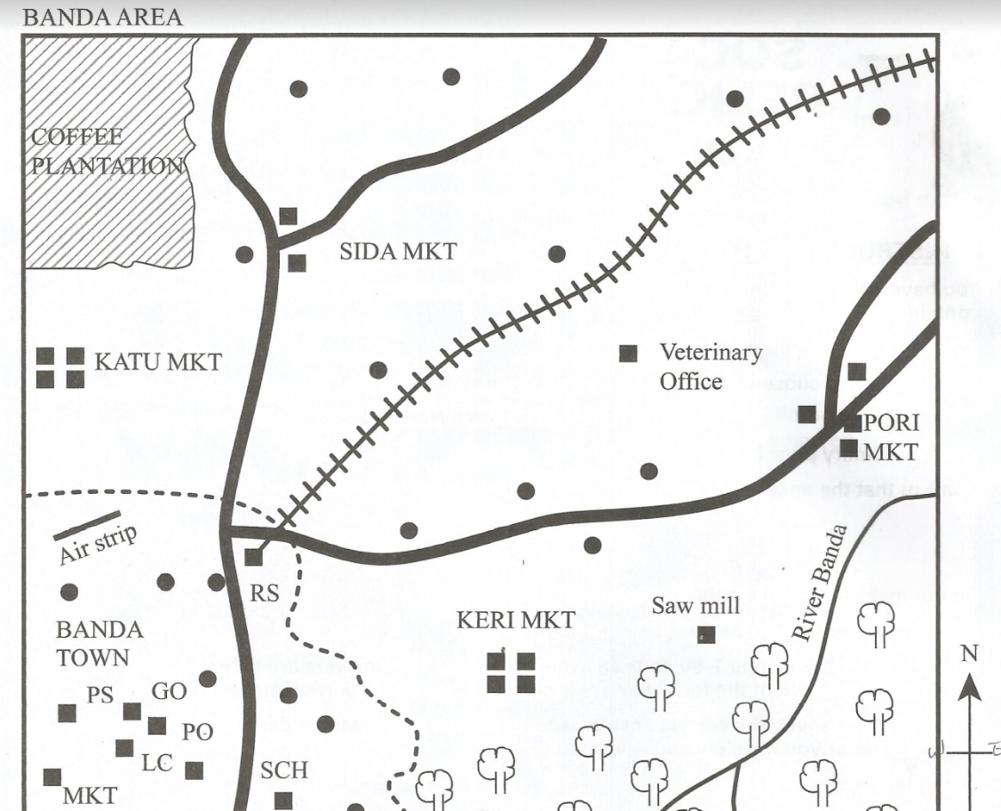
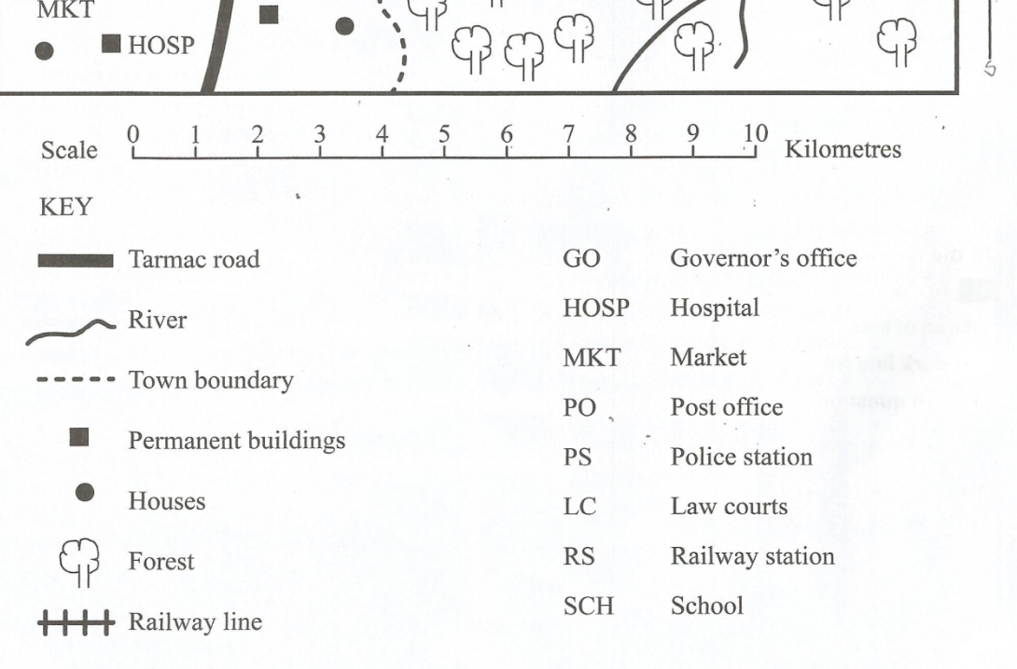
- Use the map of Banda area below to answer question 21.

  - What is the direction of the veterinary office from the market at Banda town?
_______________________________________________________________
- The approximate area of the coffee plantation in square kilometres is
___________________________________________________________
- The climate of the area around Keri market is likely to be
___________________________________________________________
- What type of settlement in found in Banda area?
___________________________________________________________
- What evidence on the map shows that Banda town is an administrative centre?
___________________________________________________________
- Kelvin was asked by his friend to state four characteristics of a person with low self-esteem. Which responses did he give? (4mks)
a) ___________________________________________________________________________________
b) ___________________________________________________________________________________
c) ____________________________________________________________________________________
d) ____________________________________________________________________________________
- Grade 8 learners were tasked to search the uses of maps in Social Studies. Which four uses did they give? (4mks)
a) ____________________________________________________________________________________
b) ____________________________________________________________________________________
c) _____________________________________________________________________________________
d) _______________________________________________________________________________________

- Evans wanted to find out forms of slavery and servitude in traditional African societies. Highlight any four types he gave. (4mks)
a) ___________________________________________________________________________________
b) _____________________________________________________________________________________
c) _____________________________________________________________________________________
d) _____________________________________________________________________________________
- Grade 9 learners were discussing ways of reducing poverty in Africa. Identify four ways they pinpointed. (4mks)
a) _____________________________________________________________________________________
b) _____________________________________________________________________________________
c) _____________________________________________________________________________________
d) ____________________________________________________________________________________
- Teacher Raphael asked his learners to outline four responsibilities of a global citizen. Which correct responses did they give? (4mks)
a) _____________________________________________________________________________________
b) _____________________________________________________________________________________
c) ____________________________________________________________________________________
d) ____________________________________________________________________________________
- Mary was asked to state four factors that influence population distribution in Africa. Which was her correct response? (4mks)
a) _____________________________________________________________________________________
b) _____________________________________________________________________________________
c) _____________________________________________________________________________________
d) _____________________________________________________________________________________
- While learning about climatic regions in Africa, Grade 9 learners were asked to use the map below.
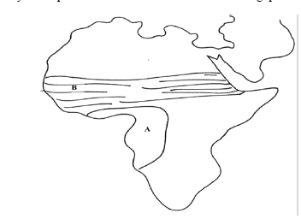
23 ½^{O} N

0 ^{O}

X

Y 23 ½^{O} S

a) State four characteristics of the climatic region marked A. (4mks)
a) _________________________________________________________________________________
b) _________________________________________________________________________________
c) __________________________________________________________________________________
d) __________________________________________________________________________________
b) Identify four countries crossed by the Tropic marked Y. (4mks)
a) _______________________________________________________________________________
b) _______________________________________________________________________________
c) _______________________________________________________________________________
d) _______________________________________________________________________________

c) Name four factors that led to the growth of the ancient kingdom marked X. (4mks)
a) ___________________________________________________________________________________
b) ___________________________________________________________________________________
c) ___________________________________________________________________________________
d) ___________________________________________________________________________________
- Grade 9 learners were asked to identify four differences between the population of Kenya and Germany. Write the differences they identified. (4mks)
a) ____________________________________________________________________________________
b) ____________________________________________________________________________________
c) ____________________________________________________________________________________
d) ____________________________________________________________________________________
- Grade 8 learners were role-playing to show the various socio-cultural diversities in Kenya. List down any four socio-cultural diversities they came up with. (4mks)
a) _____________________________________________________________________________________
b) _____________________________________________________________________________________
c) ______________________________________________________________________________________
d) ______________________________________________________________________________________
- Name four terms of the Berlin Conference of 1884-1885. (4mks)
a) ______________________________________________________________________________________
b) ______________________________________________________________________________________
c) ______________________________________________________________________________________
d) ______________________________________________________________________________________
- Name the European countries that colonized the following African countries: (4mks)
a) Morocco: _____________________________________________
b) Democratic Republic of Congo: _____________________________
c) Libya: __________________________________________________
d) Madagascar: ______________________________________________

- Fidel, a Grade 9 learner, was asked by his teacher to give two functions of each of the three arms of government. Which correct answers did he give? (6mks)
i) Legislature
a) _____________________________________________________________________________________
b) _____________________________________________________________________________________
ii) Executive
a) _____________________________________________________________________________________
b) _____________________________________________________________________________________
iii) Judiciary
a) _____________________________________________________________________________________
b) ______________________________________________________________________________________
- Identify four methods used in recording data in fieldwork. (4mks)
a) _____________________________________________________________________________________
b) _______________________________________________________________________________________
c) _____________________________________________________________________________________
d) ______________________________________________________________________________________
- Grade 8 learners were discussing about evolution. Their teacher asked them to find out from their digital devices reasons why Africa is regarded as the cradle for humankind. State four reasons they came up with. (4mks)
a) ___________________________________________________________________________________
b) ___________________________________________________________________________________
c) ___________________________________________________________________________________
d) ___________________________________________________________________________________
- Grade 9 learners are planning to carry out a Community Service Learning Project. State the six stages they should follow to accomplish their mission. (6mks)
a) __________________________________________________________________________________
b) __________________________________________________________________________________
c) ___________________________________________________________________________________
d) ____________________________________________________________________________________
e) _____________________________________________________________________________________
f) ____________________________________________________________________________________
- In choosing Career Pathways, a learner requires different support systems. Name four such support systems that one requires. (4mks)
a) ______________________________________________________________________________________
b) ______________________________________________________________________________________
c) ______________________________________________________________________________________
d) ______________________________________________________________________________________
- Explain four processes that result from internal land-forming forces. (4mks)
a) ______________________________________________________________________________________
b) ______________________________________________________________________________________
c) ______________________________________________________________________________________
d) ______________________________________________________________________________________
- Outline four pieces of evidence that support the Continental Drift Theory. (4mks)
a) _____________________________________________________________________________________
b) ______________________________________________________________________________________
c) ______________________________________________________________________________________
d) _____________________________________________________________________________________

THIS IS THE LAST PRINTED PAGE

