Candidate’s Name |  | Assessment Number
School Name |  | School Code
Candidate’s Signature |  | Date

THE KENYA NATIONAL JUNIOR EXAMINATIONS AND ASSESSMENT SERIES
KENYA JUNIOR SCHOOL EDUCATION ASSESSMENT
903: MATHEMATICS
JULY-AUGUST 2025
Time: 2 hours
INSTRUCTIONS TO CANDIDATES
- Write your name and assessment number in the spaces provided above.
- Write the name and code of your school in the spaces provided above.
- Sign and write the date of the assessment in the spaces provided above.
- This question paper consists of TWO sections: A and B.
- Answer ALL the questions in section A on the separate ANSWER SHEET provided.
- Answer ALL the questions in section B in the spaces provided in this QUESTION PAPER.
- Show all the workings in section B in the spaces provided.
- Non-programmable calculators may be used, except where stated otherwise.
-MATHEMATICS-
- Give non-exact numerical answers, correct to 3 significant figures, and one decimal place for angles in degrees, unless a different level of accuracy is specified in the question.
- For π, use either the calculator value or 3.142.
- Do NOT remove any page from this question paper.
- Answer ALL the questions in English.
For official use only SECTION B
SECTION | Task | Question Numbers | Max. Score | Candidate's Score
A |  | 1 – 20 | 20
B | Task 1 | 21, 22, 23, 24, 25 | 20
 | Task 2 | 26, 27, 28 | 10
 | Task 3 | 29, 30, 31, 32, 33 | 22
 | Task 4 | 34, 35, 36, 37 | 20
 | Task 5 | 38, 39, 40 | 8
TOTAL |  |  | 100
This paper consists of 13 printed pages. Candidates should check the question paper to ascertain that all the pages are printed as indicated and that no questions are missing.
© 2025 – The Kenya Junior School Examination and Assessment Series Turn over

SECTION A: (20 MARKS)
Answer all questions.

- Which of the following numbers is a rational number? A. 5​ B. π C. 0.333... D. e
- A tailor has three rolls of fabric measuring 24 meters, 36 meters, and 48 meters. She wants to cut the fabric into equal pieces, with no fabric left over. What is the greatest possible length of each piece? A. 6 meters B. 12 meters C. 24 meters D. 144 meters
- A city’s population was 1,473,589 in the last census. What is this population rounded off to the nearest ten thousands? A. 1,470,000 B. 1,473,000 C. 1,474,000 D. 1,500,000
- The cost of a new smartphone is Ksh 24,999.50. John wrote the price to 3 significant figures. Which of the following is the price to 3 significant figures? A. Ksh 25,000 B. Ksh 24,900 C. Ksh 24,990 D. Ksh 24,000
- Simplify: (m³×m⁵)÷m² A. m⁶ B. m⁷ C. m¹⁰ D. m¹⁵
- The equation of a line is given as 2x+5y=10. What is the y-intercept of the line? A. −2 B. 2 C. 5 D. 10
- A car uses at most 8 litres of fuel for a 100 km journey. Let f represent the amount of fuel used. Which of the following inequalities represents the amount of fuel used? A. f<8 B. f≤8 C. f>8 D. f≥8
Working area
- A shop stocks different types of bread, milk, and eggs. The quantities of each type of item in two different deliveries were represented by the matrix below.
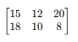
What was the order of the matrix? A. 2×2 B. 3×2 C. 2×3 D. 3×3
- A rectangular garden has a length of 12 meters and a width of 9 meters. A path runs diagonally across the garden. Which of the following calculations will give the length of the path? A. (12+9)2 ​ B. (122+92) C. (122−92)​ D. (122+92)​

- A circular swimming pool has a radius of 3.5 meters.

3.5M

What is the circumference of the pool? (Take π=722​) A. 11 m B. 22 m C. 38.5 m D. 77 m

- A cylindrical water tank has a diameter of 14 meters and a height of 5 meters. How many litres of water can it hold when full? (Take π=22/7 ) A. 770 litres B. 770,000 litres C. 1,540 litres D. 1,540,000 litres
- A cyclist travelled from Town A to Town B at an average speed of 20 km/h and took 1.5 hours. On the return journey, due to traffic, she took 2 hours. What was her average speed on the return journey? A. 10 km/h B. 15 km/h C. 25 km/h D. 30 km/h
- The temperature of a freezer is set at -15°C. Which of the following calculations gives the correct temperature in Kelvin? A. 273+15 B. 273−15 C. 15−273 D. 273×15
- An electronics store offered a 15% discount on a television set. If a customer paid Ksh 34,000 for the television, which calculation gives the original marked price of the television? A. Ksh 34,000×0.15 B. Ksh 34,000÷0.85 C. Ksh 34,000×0.85 D. Ksh 34,000÷1.15
- The top of a monument is in the shape of a regular hexagon. Determine the size of one interior angle of the hexagon. A. 60° B. 90° C. 120° D. 180°
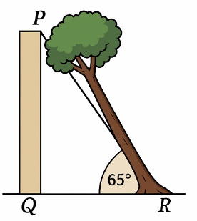
- A tree is leaning against a vertical wall, forming an angle PQR with the ground as shown.

What is the size of the angle the tree makes with the wall? A. 25° B. 35° C. 45° D. 65°
Working space.

- Kevin plotted different lines on a graph. Which line has a zero gradient?
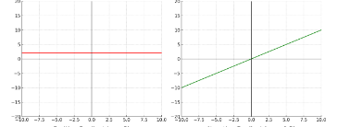
A
B

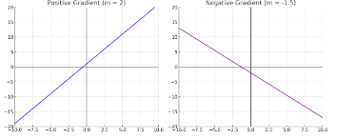
D
C

- A map has a scale of 1:5000. If the actual distance between two towns is 2.5 km, what is the distance between the two towns on the map in cm? A. 5 cm B. 50 cm C. 500 cm D. 5000 cm
- A flagpole is held by a wire that is anchored to the ground 4 meters away from the base of the pole. The wire makes an angle of 60° with the ground. What is the length of the wire? A. 8 m B. 43​ m C. 4/3​ m D. 2 m
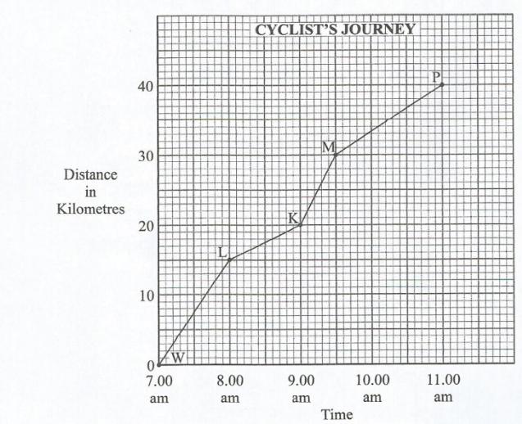
- Mwangi cycled from O to Calculate his speed

A. 11km/h B.40km/h C.2.63km/h D.3.6km/h

Working space.
SECTION B (80 marks)
Answer all the questions in the spaces provided.
21. A bakery produced 2,750,916 loaves of bread in a month. How many times is the total value of digit 7 greater than the total value of digit 5 in the number? (4 marks)

22. A submarine is at a depth of 150 m below sea level. A helicopter is flying vertically above it at a height of 800 m above sea level. Use a number line to determine the vertical distance between the submarine and the helicopter. (3 marks)

23. A construction company had a batch of cement. On the first day, they used $¼​$ of the cement. On the second day, they used $\frac{2}{3}$ ​ of the remaining cement. The rest of the cement was used equally over the next 3 days. On the last of these 3 days, they used 200 kg of cement.
Determine:
(a) The fraction of cement that was used equally over the last 3 days; (2 marks)

(b) The total mass of cement the company had initially. (3 marks)

24. A rectangular floor measures 12 metres by 9 metres. It is to be covered with square tiles, each with a side length of 30 cm. Determine the number of tiles needed to cover the floor. (5 marks)

25. 6 workers can complete a task in 10 days. If the task needs to be completed in 4 days, determine the number of additional workers required. (3 marks)

26. Sarah shared some money among her three siblings, John, Mary, and Peter. John received twice the amount Mary received. Peter received sh 5,000 less than Mary. If Mary received sh y, write a simplified expression for the total amount of money Sarah shared. (3 marks)

27. A fruit seller sold 5 apples and 2 oranges for sh 340. Another customer bought 3 apples and 4 oranges for sh 300 from the same seller. Determine the cost of one apple and the cost of one orange. (5 marks)

28. The temperature (T) in a certain city is always above −5∘C but never exceeds 10∘C. Write a compound inequality to represent this information. (2 marks)

29. A marathon race is 42.195 km long. A runner has covered a distance of 35,500 metres.
(a) What distance, in kilometres, was remaining for the runner to complete the race? (2 marks)

(b) What distance, in hectometres, had the runner covered? (3 marks)

30. The base of a swimming pool is designed as a rectangle with a semi-circle attached to one of its longer sides. The rectangular part measures 20 m by 14 m. Determine the area covered by the base of the swimming pool. (Take π=22​/7) (5 marks)

31. A cylindrical water tank has a radius of 3.5 m and contains water to a height of 4 m. The water is then transferred to a rectangular tank with a length of 7 m and a width of 5 m. What will be the height of the water in the rectangular tank? (Take π=22/7​) (4 marks)

32. A train travels a distance of 360 km in 2 hours and 30 minutes. Determine the train's average speed in m/s. (4 marks)

33. A sales agent earns a commission of 3.5% on all sales made. In a particular week, the agent sold goods worth sh 450,000. Calculate the commission earned by the agent that week. (4 marks)

34. Study the angles below.

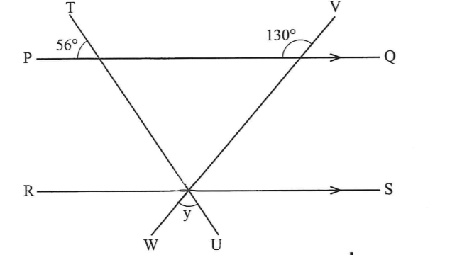

X

Giving reasons, determine the sizes of angles x and y. (4 marks)

35. A designer is creating a triangular logo. A model of the logo is a triangle XYZ such that XY=8 cm, YZ=10 cm, and angle XYZ=75∘.
(a) Using a ruler and a pair of compasses only, construct triangle XYZ. (3 marks)

(b) (i) Measure the size of angle XZY. (1 mark)

(ii) Measure the length XZ. (1 mark)

36. A surveyor recorded the measurements of a plot of land in a field book as shown below.
To Y
35
20 to B (10)
15 to A (8)
From X
The measurements were given in metres. Using a scale of 1 cm to represent 5 m, draw the map of the plot of land. (4 marks)

37. Grade 8 learners were learning about geometric solids. The teacher showed them a model of a rectangular prism (cuboid) with dimensions 5 cm by 4 cm by 3 cm.
(a) Draw the net of the rectangular prism. (2 marks)

(b) Use the net to work out the surface area of the rectangular prism. (2 marks)

- Two shapes, M and N, are drawn on a Cartesian plane. Shape N is an enlargement of shape M.
(a) Determine the scale factor of the enlargement. (2 marks)

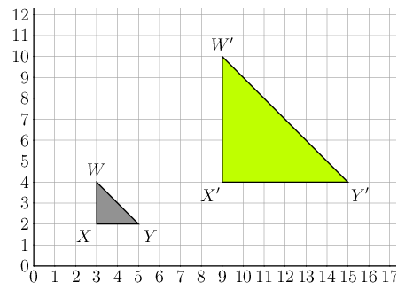

(b) On the grid, mark point O, the centre of the enlargement. (1 mark)

39. The number of students participating in various clubs at a school was recorded as shown in the table below.
Club | Number of Students
Debating | 25
Drama | 15
Music | 20
Science | 10
Chess | 10
Represent the number of students selected for each club on a pie chart. (5 marks)

40. A teacher wrote the numbers from 1 to 15 on separate cards and asked a Grade 9 learner to select a card at random. Determine the probability that the number of the card picked is:
(a) a multiple of 3; (2 marks)

(b) a factor of 12. (1 mark)

THIS IS THE LAST PRINTED PAGE.

