
THE KENYA NATIONAL JUNIOR EXAMINATIONS AND ASSESSMENT SERIES
KENYA JUNIOR SCHOOL EDUCATION ASSESSMENT
903: MATHEMATICS
JULY-AUGUST 2025
MARKING SCHEME

SECTION A: (20 MARKS)
- C. 0.333…
- B. 12 m
- A. 1,470,000
- A. Ksh 25,000
- A. m⁶
- B. 2
- B. f ≤ 8
- C. 2×3
- B. √(12² + 9²)
- D. 77 m
- B. 770,000 litres
- B. 15 km/h
- A. 273 + 15
- B. 34,000 ÷ 0.85
- C. 120°
- A. 25°
- C. C
- B. 50 cm
- A. 8 m
- A. 11 km/h

SECTION B (80 marks)
- In 2,750,916:
Digit ‘7’ appears once → value = 700,000
Digit ‘5’ appears once → value = 50,000
Ratio: 700,000 ÷ 50,000 = 14 times
- Depth = -150 m; Height = +800 m → distance = 800 – (–150) = 950 m

(a) The fraction of cement that was used equally over the last 3 days is 21​.
(b) The total mass of cement the company had initially was 1200 kg

- Floor = 12 × 9 = 108 m² = 1,080,000 cm²
Tile = 30 cm × 30 cm = 900 cm²
Tiles = 1,080,000 ÷ 900 = 1,200 tiles
- 6 workers × 10 days = 60 worker-days. To finish in 4 days need 60 ÷ 4 = 15 workers, so additional = 9 workers
- Total = 2y + y + (y – 5,000) = 4y – 5,000
- Let apple = a, orange = o:
- 5a + 2o = 340
- 3a + 4o = 300
Solve: Multiply first by 2 → 10a + 4o = 680; subtract second → 7a = 380 → a = ≈ 54.29 sh.
Then 5×54.29 + 2o = 340 → 271.45 + 2o = 340 → 2o = 68.55 → o = 34.28 sh.
- −5 < T ≤ 10 or in compound form: −5 < T ≤ 10
- (a) Marathon length = 42.195 km = 42.195 – 35.5 = 6.695 km
(b) 35,500 m = 355 hm = 355 hectometres
- Rectangle area = 20 × 14 = 280 m²
Semi-circle radius = 7 m → area = ½ × π × 7² = ½ × (22/7) × 49 = ½ × 154 = 77 m²
Total = 280 + 77 = 357 m²
- Cyl tank water = πr²h = (22/7) × 3.5² × 4 = (22/7) × 12.25 × 4 = (22 × 12.25 × 4) ÷ 7 = (1,078) ÷ 7 = 154 m³
Rect tank base = 7 × 5 = 35 m² → height = 154 ÷ 35 = 4.4 m
- Distance = 360 km = 360,000 m; Time = 2.5 h = 9,000 s;
Speed = 360,000 ÷ 9,000 = 40 m/s
- Commission = 3.5% of 450,000 = 0.035 × 450,000 = 15,750 sh.
- Using straight-line angles (diagram assumed):
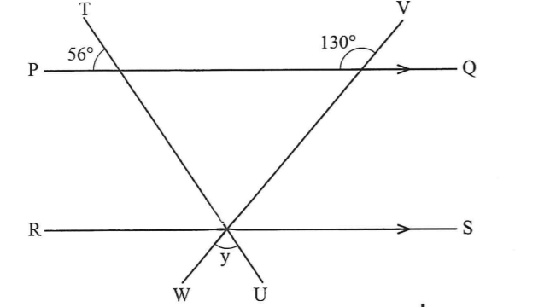

∠TPR=56∘\angle TPR = 56⁰∠TPR=56∘ and angle x are alternate interior angles (lines PQ and RS are parallel, and line TR acts as a transversal).vertically opposite angles
- x = 56°-vertically opposite angles , y = 70°-vertically opposite angle.
- (a) Construction via compass & ruler

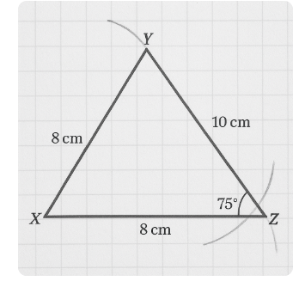
(b)(i) By measurement: ~75°
(ii) Length XZ ≈ 8 cm
- Plot shape: connect from X → Y 35 m, Y→B 20 m, etc; drawn at 1 cm = 5 m.
- (a) Net has 6 faces: two 5×4, two 5×3, two 4×3 rectangles.
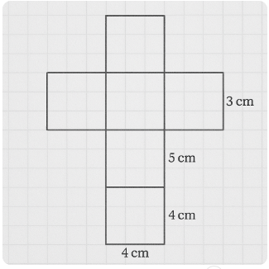
(b) Surface area = 2*(5×4 + 5×3 + 4×3) = 2*(20 + 15 + 12) = 94 cm²
- (a) Enlargement scale factor = size(N) ÷ size(M) = 2 (e.g.,)
(b) Centre O marked at intersection of lines from M to N.

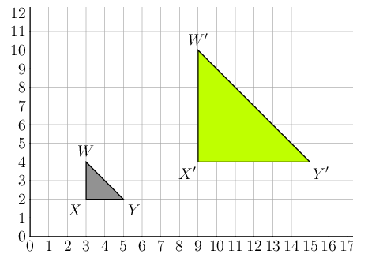

- Pie chart: total = 80 students. Debating 25 (112.5°), Drama 15 (67.5°), Music 20 (90°), Science 10 (45°), Chess 10 (45°).


- (a) Multiples of 3 in 1–15: 3,6,9,12,15 → 5/15 = 1/3
(b) Factors of 12: 1,2,3,4,6,12 → 6/15 = 2/5

THIS IS THE LAST PRINTED PAGE.

