Candidate’s Name |  | Assessment Number
School Name |  | School Code
Candidate’s Signature |  |  | Date

THE KENYA NATIONAL JUNIOR EXAMINATIONS AND ASSESSMENT SERIES
905/1: INTEGRATED SCIENCE (Theory)
Time: 1 hour 50 minutes
INSTRUCTIONS TO CANDIDATES
- Write your name and assessment number in the spaces provided above.
- Write the name and code of your school in the spaces provided above.
- Sign and write the date of the assessment in the spaces provided above.
- This paper consists of two sections: A and B.
- Section A comprises Multiple Choice Questions numbered 1 to 30.
- Section B comprises short, structured questions number 31 to 40.
-INTEGRATED SCIENCE-
- Answer ALL the questions in section A on the separate ANSWER SHEET provided.
- Answer ALL the questions in section B in the spaces provided in this QUESTION PAPER.
- Do NOT remove any page from this question paper.
- Answer ALL the questions in English.
For official use only
Task | Question | Score per Question | Maximum Score | Candidate’s Score per Task
 | 31 | 03 | 03
 | 32 | 03 | 03
 | 33 | 04 | 04
 | 34 | 06 | 06
 | 35 | 06 | 06
 | 36 | 05 | 05
 | 37 | 03 | 03
 | 38 | 02 | 02
 | 39 | 05 | 05
 | 40 | 03 | 03
 | TOTAL |  | 40
This paper consists of 9 printed pages. Candidates should check the question paper to ascertain that all the pages are printed as indicated and that no questions are missing. © 2025 The Kenya Junior School Examinations and Assessment Series. Turn over

SECTION A (30 marks)
Answer ALL the questions in this section.

- A group of learners is studying how to recycle waste materials. They learn about the biological decomposition of organic waste (Biology), the chemical processes involved in breaking down plastics (Chemistry), and the mechanical sorting of different materials (Physics). This approach exemplifies the interdisciplinary nature of: A. Pure science. B. Integrated Science. C. Social studies. D. Environmental art.
- When a local community faces a problem like water pollution, they need to understand the source of pollutants (Chemistry), their effect on aquatic life (Biology), and how to build filtration systems (Physics). This scenario highlights the importance of Integrated Science in: A. Specializing in one field. B. Solving complex real-world issues. C. Developing abstract theories. D. Conducting isolated experiments.
- While working in the laboratory, a student handled an apparatus known as conical flask.which one of the following is a conical flask?
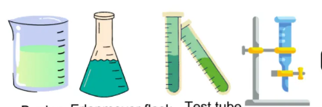

A B C D
- A tailor is measuring the length of fabric to cut a dress. Which SI unit is most appropriate for this measurement? A. Kilogram B. Second C. Metre D. Litre
- A gardener has a mixture of small stones and dry leaves in his compost pile. Which method would be best to separate the stones from the leaves? A. Evaporation B. Decantation C. Sieving D. Filtration
- During a science fair, a student demonstrates that when purple cabbage juice is added to a solution, it turns green. This indicates that the solution is: A. Acidic. B. Neutral. C. Basic. D. A solid.
- A group of teenagers noticed that their voices were changing, and some were experiencing increased oiliness of the skin leading to acne. These are common physical changes associated with: A. Childhood. B. Adulthood. C. Adolescence. D. Infancy.
- A technician is troubleshooting a faulty electrical appliance. He finds that the circuit is incomplete, preventing the flow of current. This is referred to as an: A. Closed circuit. B. Short circuit. C. Open circuit. D. Parallel circuit.
- When installing a new light bulb, a person ensures their hands are dry and they are standing on a dry surface. This precaution helps prevent which electrical hazard? A. Overheating of the bulb. B. Short circuit. C. Electric shock. D. Power outage.
- A child's toy car uses small magnets to hold its parts together. This is an application of the property of magnets to: A. Generate heat. B. Attract specific materials. C. Conduct electricity. D. Produce light.
- A student is learning about the element commonly known as the "building block of life" and the basis of organic chemistry, with the symbol 'C'. Which element is it? A. Calcium B. Carbon C. Cobalt D. Copper

- On a cold morning, dew drops form on grass, which then disappear as the sun warms up. The process of the liquid dew turning into a gas is called: A. Condensation. B. Freezing. C. Melting. D. Evaporation.
- A chef prepares a salad by cutting vegetables into smaller pieces. This action changes the appearance of the vegetables but does not create new substances. This is an example of a: A. Chemical change. B. Irreversible change. C. Physical change. D. Permanent change.
- During a fire safety drill, the fire marshal explains that removing any one component of the fire triangle will extinguish a fire. To put out a small fire, spraying carbon dioxide aims to remove: A. Fuel. B. Heat. C. Oxygen. D. Ignition source.
- A doctor explains that excessive sugar intake can draw water out of body cells, leading to dehydration. This movement of water across cell membranes is primarily due to: A. Diffusion. B. Active transport. C. Osmosis. D. Phagocytosis.
- While observing a prepared slide, a student notices a cell containing a nucleus, cytoplasm, and a cell membrane, but no cell wall or chloroplasts. This cell is most likely a(n): A. Plant cell. B. Animal cell. C. Fungal cell. D. Bacterial cell.
- A jeweller uses a powerful magnifying glass to inspect intricate details on tiny gemstones. This tool works on the same principle as the lenses in a: A. Telescope. B. Microscope. C. Camera. D. Binoculars.
- To prepare a temporary slide of a plant tissue, after placing the specimen and adding a drop of water, the next crucial step is to carefully place a: A. Lens paper on top. B. Coverslip over the specimen. C. Piece of blotting paper. D. Hot plate under the slide.
- A worker in a scrapyard uses a large electromagnet to lift and move scrap metal. This demonstrates the ability of a magnet to: A. Repel all metals. B. Generate sound. C. Attract only non-magnetic materials. D. Exert a force on magnetic materials.
- When a student accidentally pricks their finger with a pin, they quickly withdraw their hand. This rapid, involuntary action is known as a: A. Voluntary response. B. Reflex action. C. Conditioned response. D. Conscious decision.
- A patient suffering from excessive accumulation of waste products in their blood is diagnosed with kidney failure. This condition highlights the critical role of the kidneys in the human: A. Digestive system. B. Respiratory system. C. Excretory system. D. Circulatory system.
- A rural community is considering different energy sources for their homes. They decide to install a small turbine in a nearby river to generate electricity. This is an example of using which type of energy source? A. Non-renewable. B. Fossil fuel. C. Hydroelectric. D. Geothermal.
- A teenage boy expresses frustration over his changing voice and the growth of facial hair. These are normal biological changes that occur during: A. Childhood. B. Adolescence. C. Early adulthood. D. Infancy.
- A public health officer warns against sharing personal items like razors and toothbrushes as this can contribute to the spread of certain infections. Some of these infections can also be sexually transmitted, known as: A. Viral colds. B. Foodborne diseases. C. Sexually Transmitted Infections (STIs). D. Skin allergies.
- A student is instructed to use a Bunsen burner to gently warm a liquid. To obtain a luminous, yellow flame suitable for gentle heating, which part of the Bunsen burner should be adjusted? A. The gas tap. B. The air hole should be closed. C. The barrel should be shortened. D. The base should be rotated.

- A scientist wants to measure the mass of a chemical compound very accurately. Which SI unit is most appropriate for this measurement? A. Litre B. Metre C. Second D. Gram
- A student draws a diagram of a typical plant cell, including a rigid outer layer that provides structural support and protection to the cell. This specific part is the: A. Cell membrane. B. Cytoplasm. C. Nucleus. D. Cell wall.
- A gardener notices that plant roots absorb water from the soil. This movement of water into the plant cells, against a concentration gradient, is a vital process involving: A. Evaporation. B. Photosynthesis. C. Diffusion. D. Osmosis.
- A science teacher demonstrates that when a solid block of ice is heated, it first turns into liquid water, and upon further heating, it turns into steam (a gas). This demonstrates the different: A. Chemical compositions. B. States of matter. C. Atomic structures. D. Magnetic properties.

During a science trip, a student accidentally gets a splinter in their finger. What should be the immediate first aid action? A. Try to squeeze it out forcefully. B. Leave it to come out on its own. C. Wash the area and gently remove with sterile tweezers. D. Cover it with a plaster without cleaning

SECTION B: (40 Marks)

Answer all questions.
- (a) A farmer observes that the soil in his garden is too acidic, affecting plant growth. He decides to apply lime to the soil. (i) What is the chemical nature of lime (acid, base, or neutral)? (1 mark)
_______________________________________________________________________________________________
(ii) Explain how applying lime helps improve the soil for plant growth. (1 mark)
________________________________________________________________________________________________
_______________________________________________________________________________________________
(b) During a titration experiment, a student uses phenolphthalein indicator. Describe the color change observed when phenolphthalein is added to an acidic solution. (1 mark)
_______________________________________________________________________________________________
______________________________________________________________________________________________

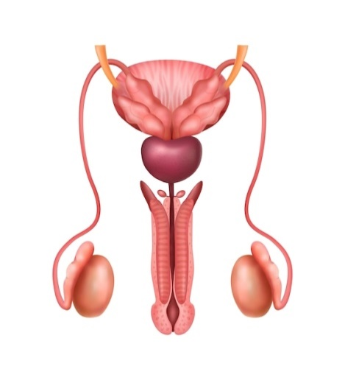
- (a) A young couple is discussing family planning. They are learning about the male reproductive system. (i)

Name the tube that transports sperm from the epididymis to the ejaculatory duct. (1 mark)

_____________________________________________________________________________________________
(ii) State one major challenge faced by adolescents during puberty related to emotional changes. (1 mark)
____________________________________________________________________________________________
(b) Explain one way good personal hygiene can help manage challenges during adolescence. (1 mark)
____________________________________________________________________________________________
___________________________________________________________________________________________
- (a) A patient experiences swelling in their ankles and feet, and their doctor suspects a problem with their kidneys.
(i) Name the main excretory product filtered by the kidneys from the blood. (1 mark)
____________________________________________________________________________________________
(ii) Besides swelling, state one other common symptom of kidney disorders. (1 mark)
____________________________________________________________________________________________
(b) Explain the function of the glomerulus in the human kidney. (2 marks)
____________________________________________________________________________________________
___________________________________________________________________________________________
- (a) A student is setting up a circuit to light a bulb using a battery and wires. (i) Name the form of energy stored in the battery. (1 mark)
_________________________________________________________________________________________
(ii) Draw a simple circuit diagram showing a battery, a switch, and a light bulb connected in series. (2 marks)

(b) Mr. Otieno is using an electric kettle to boil water. (i) State one common electrical appliance used for heating. (1 mark)
_____________________________________________________________________________________________
(ii) Explain why the inner surface of an electric kettle often becomes coated with limescale in areas with hard water. (2 marks)
_______________________________________________________________________________________________
_______________________________________________________________________________________________
- (a) A child is playing with toy cars that have small magnets embedded in their wheels. (i) Name two materials that are strongly attracted by a magnet. (2 marks)
________________________________________________________________________________________________
________________________________________________________________________________________________
(ii) State one common property of magnets. (1 mark)
_______________________________________________________________________________________________
(b) Describe one application of magnets in everyday life, other than in toys or scrapyards. (1 mark)
_______________________________________________________________________________________________
_______________________________________________________________________________________________
(c) Explain the difference between a temporary magnet and a permanent magnet. (2 marks)
_______________________________________________________________________________________________
_______________________________________________________________________________________________
- (a) A scientist is observing a sample of pure water at room temperature. (i) Describe the arrangement and movement of water molecules according to the Kinetic Theory of Matter. (2 marks)
_______________________________________________________________________________________________
_______________________________________________________________________________________________
______________________________________________________________________________________
(ii) What effect would adding salt have on the boiling point of water? (1 mark)
_____________________________________________________________________________________________
(b) During a school cooking lesson, a student bakes bread. (i) Is the process of baking bread a physical or chemical change? (1 mark)
_______________________________________________________________________________________________
(ii) Give a reason for your answer in (b) (i). (1 mark)
_______________________________________________________________________________________________
______________________________________________________________________________________________
- (a) A small electrical fire starts in a laboratory. 
- (i) Which class of fire does this belong to? (1 mark)
______________________________________________________________________________________________
(ii) Name one appropriate fire extinguisher that should be used for this type of fire. (1 mark)
______________________________________________________________________________________________
(b) Why is it important to ensure proper ventilation when dealing with fire, especially indoors? (1 mark)
_______________________________________________________________________________________________
_______________________________________________________________________________________________
- Mr. Kimani is a teacher who uses a microscope to show his students various cells.
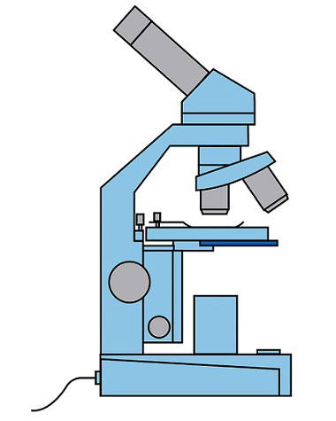
(a) Name one major component of the microscope that magnifies the image of the specimen. (1 mark)
__________________________________________________________________________________________
(b) Why is it important to clean microscope lenses only with lens paper? (1 mark)
__________________________________________________________________________________________
- (a) A gardener notices that water moves from the soil into the roots of a plant. This process is primarily driven by: (i) What is the term for the movement of water across a semi-permeable membrane from a region of higher water concentration to a region of lower water concentration? (1 mark)
_________________________________________________________________________________________
(ii) Describe the role of the cell wall in a plant cell during this process. (2 marks)
_______________________________________________________________________________________________
______________________________________________________________________________________________
(b) A health professional advises a pregnant woman that adequate iron intake is crucial for both her and the developing foetus. (i) Name the female reproductive organ where fertilization typically occurs. (1 mark)
______________________________________________________________________________________________
(ii) State one challenge a woman might face during menstruation. (1 mark)
_______________________________________________________________________________________________
- (a) A factory is upgrading its energy system and considers installing geothermal power. (i) Is geothermal energy a renewable or non-renewable energy source? (1 mark)
________________________________________________________________________________________________
(ii) State one safety precaution to take when dealing with electrical energy in the home. (1 mark)
________________________________________________________________________________________________
(b) Explain why an uninflated balloon placed in a freezer will appear to shrink. (1 mark)
_______________________________________________________________________________________________
_______________________________________________________________________________________________

THIS IS THE LAST PRINTED PAGE.

