Candidate’s Name |  | Assessment Number
School Name |  | School Code
Candidate’s Signature |  | Date

THE KENYA NATIONAL JUNIOR EXAMINATIONS AND ASSESSMENT SERIES
KENYA JUNIOR SCHOOL EDUCATION ASSESSMENT
911/2: CREATIVE ARTS AND SPORTS (Theory)
Time: 1 hour 40 minutes
INSTRUCTIONS TO CANDIDATES
- Write your name and assessment number in the spaces provided above.
- Write the name and code of your school in the spaces provided above.
- Put your signature and write the date of the assessment in the spaces provided above.
- This paper consists of two sections A and B.
- Each section has THREE parts: Part I - Performing Arts, Part II - Sports, Part III -Visual Arts.
- Section A comprises Multiple Choice Questions number: 1 to 40.
- Section B comprises short structured and analysis questions number: 41 to 52.
- Answer ALL the questions in section A on the separate ANSWER SHEET provided.
- Answer ALL the questions in section B in the spaces provided on this question paper for Part I - Performing Arts and Part III - Visual Arts.
- For Part II - Sports, questions 45 and 46 are COMPULSORY. Choose EITHER question 47 or 48.
-CREATIVE ARTS AND SPORTS-
- Do not remove any page from this question paper.
- Answer all questions in English.
For official use only: SECTION B
Part | Task Number | Question Number | Maximum Score | Candidate’s Score
Part I: Performing Arts | 1 | 41 | 04
 | 2 | 42 | 04
 | 3 | 43 | 10
 | 4 | 44 | 06
Part II: Sports | 5 | 45 | 04
 | 6 | 46 | 04
OPTIONAL | 7 | 47 | 10
 | 8 | 48 | 10
Part III: Visual Arts | 9 | 50 | 04
 | 10 | 51 | 04
 | 11 | 52 | 10
Total per section |  |  | 40
This paper consists of 9 printed pages. Candidates should check the question paper to ascertain that all the pages are printed as indicated and that no questions are missing.
© 2025 The Kenya Junior School Examinations and Assessment Series. Turn over

SECTION A: (40 Marks)
Read the instructions carefully.

PART I: PERFORMING ARTS
- Which of the following refers to the speed at which a piece of music is performed? A. Dynamics B. Timbre C. Tempo D. Rhythm
- A musical note that lasts for two beats in 4/4 time is called a: A. Semibreve B. Minim C. Crotchet D. Quaver
- Which of the following musical instruments is classified as an Descant recorder? A. Drum B. Guitar C. Shaker D. Flute
- When a singer uses their diaphragm to push air out for a strong sound, they are demonstrating good: A. Diction B. Phrasing C. Breathing D. Articulation
- Which of the following best describes the sound quality of a musical instrument? A. Pitch B. Timbre C. Volume D. Duration
- A traditional folksong is sung in a call and response pattern. This pattern describes which element of music? A. Harmony B. Melody C. Form D. Texture
- A group of Grade 7 learners are preparing to sing a song. Their teacher advises them to ensure their words are clear and understandable. This advice relates to which vocal technique? A. Projection B. Diction C. Expression D. Phrasing
- Which of the following accurately represents the notes of a C major scale in ascending order? A. C, D, E, F, G, A, B, C B. C, D, E, F#, G, A, B, C C. C, D, Eb, F, G, A, Bb, C D. C, D, E, F, G, A, B, D
- In drama, the sequence of events that makes up a story is known as the: A. Theme B. Character C. Plot D. Setting
- A storyteller uses varying speeds and tones of voice to keep the audience engaged. This technique is primarily focused on: A. Dialogue B. Facial expressions C. Pacing D. Gestures
- Which of the following is a common function of Kenyan folksongs in society? A. To teach mathematics. B. To provide historical information. C. To promote academic excellence. D. To predict weather patterns.
- A character in a play is wearing ragged clothes and has a dirty face. This use of costume helps to reveal the character's: A. Dialogue B. Role C. Plot D. Setting
- Which of the following is an element of drama that refers to the message or main idea of a play or story? A. Plot B. Theme C. Character D. Setting
- During a choral verse performance, the learners deliver lines together, creating a unified sound. This technique is known as: A. Solo speaking B. Call and response C. Group speaking D. Whispering
- What is the primary purpose of using props in a drama performance? A. To distract the audience. B. To make the stage look crowded. C. To help characters interact with their environment and enhance the story. D. To replace actors.
- Which of the following is a key quality of a good story that makes it memorable and easy to follow? A. Complex plot B. Unclear ending C. Engaging characters D. Minimal dialogue

PART II: SPORTS
- A short-distance race where athletes run on a straight section of the track is typically the: A. 400 meters B. 800 meters C. 100 meters D. 1500 meters
- In football, which skill involves moving the ball forward while maintaining control with your feet?
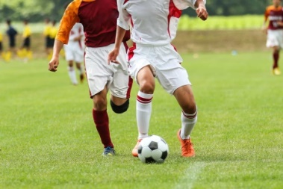
A. Passing B. Shooting C. Dribbling D. Kicking
- Before starting any physical activity, it is important to warm up to: A. Get tired quickly. B. Prevent injuries. C. Increase muscle stiffness. D. Make the activity longer.
- Which of the following is a common method of water entry used in swimming, where the swimmer takes a small jump into the water? A. Dive entry B. Front flip C. Stride jump D. Back entry
- In a game of volleyball, the skill demonstrated below is called:
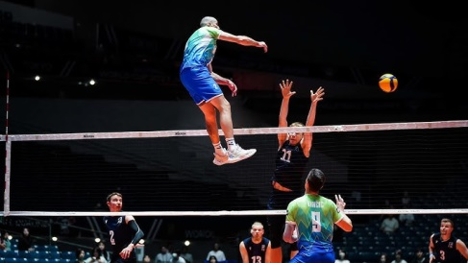
A. Volleying B. Passing C. Serving D. Spiking
- What is the primary safety rule to observe when performing throwing events like shot put or javelin? A. Throw as far as possible. B. Ensure the landing area is clear of people. C. Throw immediately after picking up the equipment. D. Throw only when the coach is not watching.
- Which of the following is a benefit of participating in tagging games? A. It discourages social interaction. B. It improves physical fitness and agility. C. It leads to isolation. D. It teaches complex sports rules.
- A team demonstrates good sportsmanship when they: A. Argue with the referee's decisions. B. Celebrate exce ssively after scoring. C. Shake hands with opponents after a game, win or lose. D. Blame teammates for mistakes.
- Angela was asked to identify a volleyball ball, which one is it?
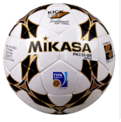
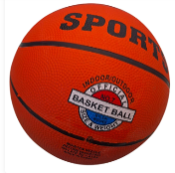
A. B.



C. D.

- Why is it important to use clean sports equipment? A. To make them look new. B. To prevent the spread of germs and skin infections. C. To increase their weight. D. To make them less durable.
- During a relay race, the most crucial moment is the: A. Starting position. B. Exchange of the baton. C. Final sprint. D. Warm-up.
- Which of the following is a negative consequence of drug abuse in sports? A. Improved athletic performance. B. Enhanced team spirit. C. Serious health problems and disqualification. D. Increased popularity among peers.

PART III: VISUAL ARTS
- A teacher asked a learner to identify primary colours. Which one is not? A. Blue B. Yellow C. Red D. Green
- The two colours created by mixing a primary colour with another primary colour are called: A. Tertiary colours B. Complementary colours C. Warm colours D. Secondary colours
- In a drawing, the empty space surrounding objects or figures is known as: A. Positive space B. Negative space C. Depth D. Form
- Which principle of design is achieved when an artist creates a sense of visual interest by making parts of the artwork different from each other? A. Unity B. Harmony C. Contrast D. Rhythm
- Which of the following materials is most commonly used for a coil pottery technique? A. Wood B. Metal C. Clay D. Glass
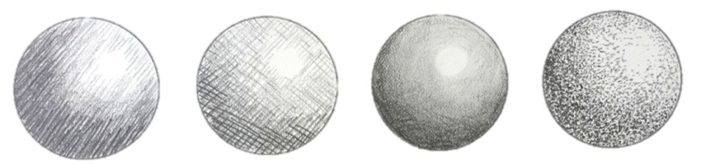
- A drawing technique that represents stippling is?

A. B C. D.
- What is the primary purpose of a 'still life' drawing? A. To draw human figures. B. To depict natural outdoor scenes. C. To represent inanimate objects arranged by an artist. D. To draw animals in their natural habitat.
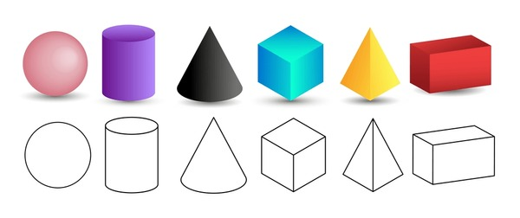
- Learners were asked to draw different shapes for a certain project. Which one is called a cone?

A. B. C. D.
- If you mix yellow and blue paint, what colour do you get? A. Orange B. Purple C. Green D. Brown

- The lightness or darkness of a colour is referred to as its: A. Hue B. Saturation C. Value D. Intensity
- Which of the following crafts involves arranging small pieces of coloured material (like glass or tile) to create an image or pattern? A. Batik B. Collage C. Mosaic D. Tie-dye
- When displaying an artwork, what is the main purpose of mounting or framing it? A. To make it more expensive. B. To protect it and enhance its presentation. C. To make it heavier. D. To hide parts of the artwork.

SECTION B: (60 marks)

Answer questions in the spaces provided.

PART I: PERFORMING ARTS
Answer ALL the questions in the spaces provided after each question

- During a music lesson, learners were required to name musical notes. Write the names for each of the notes .(4 marks)
A ______________________________

B ______________________________

C ______________________________

D _______________________________

- Write the missing letters on the treble clef notes below.
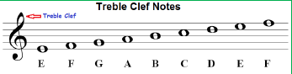
- A Grade 7 class is preparing a traditional folksong for a cultural event. (a) Outline five characteristics of Kenyan folksongs that make them unique. (5 marks)
__________________________________________________________________________________________
__________________________________________________________________________________________
__________________________________________________________________________________________
__________________________________________________________________________________________
__________________________________________________________________________________________

(b) Identify five ways movement can be incorporated into the performance of a folksong to enhance its message. (5 marks) __________________________________________________________________________________________
__________________________________________________________________________________________
__________________________________________________________________________________________
__________________________________________________________________________________________
__________________________________________________________________________________________
- Learners are performing a short story for their class. (a) Identify two ways a storyteller can use their voice to express different characters. (2 marks) __________________________________________________________________________________________
__________________________________________________________________________________________
__________________________________________________________________________________________
__________________________________________________________________________________________
__________________________________________________________________________________________
(b) Suggest two simple props that could be used to represent a rural homestead setting in a story performance. (2 marks)
__________________________________________________________________________________________
__________________________________________________________________________________________
(c) Outline two ways in which the audience can show appreciation for a story performance. (2 marks) __________________________________________________________________________________________
__________________________________________________________________________________________

PART II: SPORTS
Answer questions 45 and 46. For question 47 and 48, answer only ONE of them.
During a 100-meter sprint race, athletes typically use a crouch start. (a) Give two reasons why athletes use a crouch start for sprints. (2 marks) __________________________________________________________________________________________
__________________________________________________________________________________________
(b) Outline two safety precautions that should be observed during a sprint race. (2 marks) __________________________________________________________________________________________
__________________________________________________________________________________________
__________________________________________________________________________________________
- Grade 7 learners are playing football. Identify four instances when a free kick might be awarded during a game of football. (4 marks) __________________________________________________________________________________________
__________________________________________________________________________________________
__________________________________________________________________________________________
__________________________________________________________________________________________
__________________________________________________________________________________________
- A teacher is introducing basic swimming skills to learners. i. What is floating in swimming? (2 marks)
__________________________________________________________________________________________
__________________________________________________________________________________________
ii. Describe two types of floating a learner can perform. (4 marks) ……………………………………………………………………………………………….....…… ………………………………………………………………………………………………..…...… ………………………………………………………………………………………………..…...…
iii. Explain how the front crawl (freestyle) swimming style is performed. (4 marks) ……………………………………………………………………………………………….....…… ………………………………………………………………………………………………..…...… ………………………………………………………………………………………………..…...…
- During a sports lesson, learners played a game of "Tag the Leader." i. What is the objective of "Tag the Leader" or similar tagging games? (2 Marks) …………………………………………………………………………….………………… …………………………………………………………………………………….…………
ii. Describe how a game of "Tag the Leader" is typically played. (4 marks) …………………………………………………………………………….………………… …………………………………………………………………………………….………… …………………………………………………………………………………….…………
iii. Explain two physical benefits a learner gains from participating in tagging games. (2 marks) …………………………………………………………………………….………………… …………………………………………………………………………………….…………
iv. Outline two social benefits gained from participating in tagging games. (2 marks) …………………………………………………………………………….………………… …………………………………………………………………………………….…………

PART III: VISUAL ARTS
Answer ALL the questions in the spaces provided after each question
- (a) artists displayed different pictures as shown below:
Identify the type of balance demonstrated
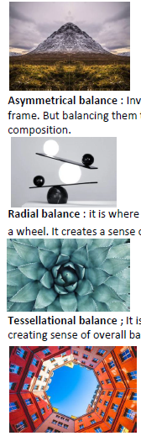
A B

(b) Learners are setting up a display of their artworks for parents' day. Describe two ways they can use lighting to enhance their art display. (2 marks)
………………………………………………………………………………………………………...… ……………………………………………………………………………….…………………..…....…
- During an art lesson, learners made a collage using various materials. Outline four steps they followed to create their collage artwork. (4 marks) ………………………………………………………………………………………………………...… ……………………………………………………………………………….…………………..…....… ………………………………………………………………………………………………..……….… ……………………………………………………………………………………………………...……
- Learners in an art appreciation lesson analyzed different sculptures and paintings.
  - Mention three items that can be used to make sculptures. (3 marks)
………………………………………………………………………………………………………...… ……………………………………………………………………………….…………………..…....… ………………………………………………………………………………………………..……….… ……………………………………………………………………………………………………...……

b) name two warm colours likely used to decorate sculptures. ( 2 marks) ……………………………………………………………………………………………………...…… ……………………………………………………………………………………………………...…… ……………………………………………………………………………………………………...…… ………………………………………………………………………………………………………...… c) describe the following art work. (5 marks)
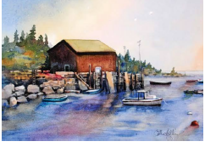

……………………………………………………………………………….…………………..…....… ………………………………………………………………………………………………..……….… ……………………………………………………………………………………………………...…… ……………………………………………………………………………………………………...…… ……………………………………………………………………………………………………...…… ……………………………………………………………………………………………………...……
THIS IS THE LAST PRINTED PAGE.

