Candidate’s Name |  | Assessment Number
School Name |  | School Code
Candidate’s Signature |  | Date

THE KENYA NATIONAL JUNIOR EXAMINATIONS AND ASSESSMENT SERIES
KENYA JUNIOR SCHOOL EDUCATION ASSESSMENT
803: MATHEMATICS
JULY AUGUST 2025
Time: 2 hours
INSTRUCTIONS TO CANDIDATES
- Write your name and assessment number in the spaces provided above.
- Write the name and code of your school in the spaces provided above.
- Sign and write the date of the assessment in the spaces provided above.
- This question paper consists of TWO sections: A and B.
- Answer ALL the questions in section A on the separate ANSWER SHEET provided.
- Answer ALL the questions in section B in the spaces provided in this QUESTION PAPER.
- Show all the workings in section B in the spaces provided.
- Non-programmable calculators may be used, except where stated otherwise.
- Give non-exact numerical answers, correct to 3 significant figures, and one decimal place for angles in degrees, unless a different level of accuracy is specified in the question.
-MATHEMATICS-
- For π, use either the calculator value or 3.142.
- Do NOT remove any page from this question paper.
- Answer ALL the questions in English.
For official use only SECTION B
SECTION | Task | Question Numbers | Max. Score | Candidate's Score
A |  | 1 – 20 | 20
B | Task 1 | 21, 22, 23, 24, 25 | 20
 | Task 2 | 26, 27, 28 | 10
 | Task 3 | 29, 30, 31, 32, 33 | 22
 | Task 4 | 34, 35, 36, 37 | 20
 | Task 5 | 38, 39, 40 | 8
TOTAL |  |  | 100
This paper consists of 10 printed pages. Candidates should check the question paper to ascertain that all the pages are printed as indicated and that no questions are missing.
© 2025 – The Kenya Junior School Examination and Assessment Series Turn over
SECTION A: (20 marks)
Answer all questions.

- What is the place value of the digit 9 in the number 4,912,503? A. Thousands B. Ten Thousands C. Hundred Thousands D. Millions
- Which of the following is the next prime number after 31? A. 33 B. 37 C. 39 D. 41
- What is the GCD of 24, 36, and 48? A. 6 B. 12 C. 72 D. 144
- Evaluate: 0.75+41​×0.2 A. 0.8 B. 0.85 C. 0.95 D. 1.0
- Convert 253​ to a decimal. A. 2.3 B. 2.5 C. 2.6 D. 2.75
- A shopkeeper bought a bag for KSh 1200 and sold it for KSh 1080. Calculate the percentage loss. A. 10% B. 12% C. 15% D. 20%
- A circular garden has a radius of 7 m. What is its circumference? (Take π=722​) A. 22 m B. 44 m C. 154 m D. 308 m
- Simplify the expression: 3a+4b−a−2b A. 2a+2b B. 4a+6b C. 2a−2b D. 4a−6b
- How many vertices does a square-based pyramid have? A. 4 B. 5 C. 6 D. 8

Working Space.

- The temperature in Nyeri dropped from 15∘C to −2∘C. What was the change in temperature? A. 13∘C B. 17∘C C. −13∘C D. −17∘C
- What is the value of x in the equation 2x+5=17? A. 6 B. 8 C. 11 D. 12
- Which of the following numbers is divisible by both 3 and 5? A. 135 B. 140 C. 145 D. 152
- What is the area of a triangle with a base of 10 cm and a height of 8 cm? A. 40 cm² B. 80 cm² C. 18 cm² D. 36 cm²
- What are the coordinates of point P?
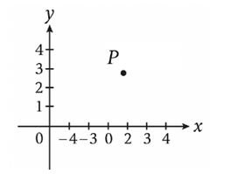

A. (-2, -3) B. (3, -4) C. (-4, 3) D. (2, 3)
- Look at the matrix below.
​5 0 8 0 1 2​​
What was the order of the matrix? A. 1×3 B. 3×2 C. 3×3 D. 3×1
- A car travelled at a speed of 60 km/h for 2.5 hours. What distance did it cover? A. 120 km B. 150 km C. 24 km D. 125 km
- The equation of a line is given as 2x+5y−10=0. What is the gradient of the line? A. 52​ B. −52​ C. 25​ D. −25​
- A survey of favourite fruits among students showed that 15 liked mangoes, 10 liked bananas, and 5 liked oranges. If this information was to be represented in a pie chart, what angle would represent mangoes? A. 180∘ B. 150∘ C. 90∘ D. 120∘
- Which inequality represents "A number y is at most 10"? A. y<10 B. y>10 C. y≤10 D. y≥10
- Which one of the following is Two million six hundred and three thousand and three.
A.2,000,000 B: 2,600,300 C. 2,306,003 D.2,603,003

Working Space.

SECTION B: (80 MARKS)
Answer all questions. Show all working.
- (a) Write 3.456 in simplified fractional form. (2 marks)

(b) A number is divisible by both 3 and 4. Give the smallest 3-digit number that meets this condition. (2 marks)

- A school has 960 pupils. If 3/5 are boys, how many girls are there? (2 marks)

- Round off 78.456 to:
(a) The nearest whole number (1 mark)

(b) One decimal place (1 mark)

- Work out:
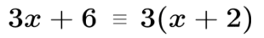 (2 marks)

- Express 0.375 as a fraction in simplest form. (2 marks)

- A bag has red, green and blue marbles in the ratio 2:3:5. If there are 100 marbles, how many are green? (2 marks)

- What is ¼(24x+ 28y)+ ⅓(9x-6y) expressed in its simplest form? ( 4 marks)

- Solve:
2(3x−1)=10 (2 marks)

- In the figure below PQRS is a parallelogram. Lines QP and RT are parallel. Lines RQ and SP are parallel. Angle QRS = 50° and angle RQT = 70°.What is the size of angle PQV? (2 marks)

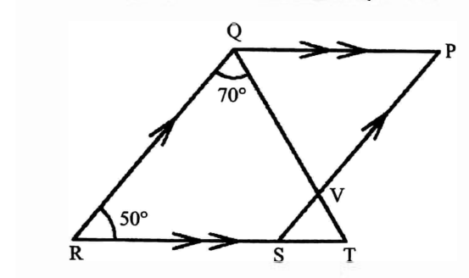

- The graph below shows a journey of a motor cyclist from home to town. On the way, he got a puncture and stopped to repair it. He then continued with the journey to town. (2 marks)

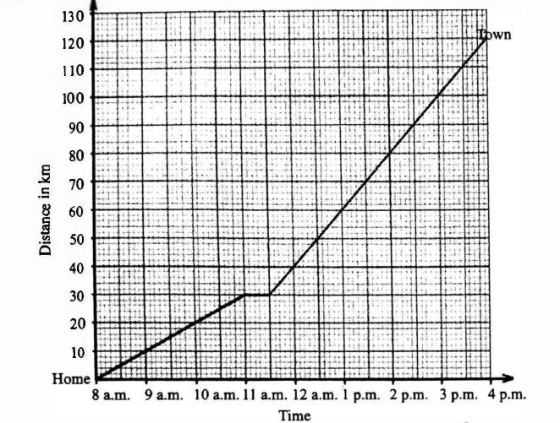
Calculate his average speed for the journey

- Make the subject: y=3x+5y (2 marks)

- A rectangular garden is 15 m long and 8 m wide.
  - Find its area. (2 marks)

  - Find its perimeter. (2 marks)

- Convert 3.2 kg to grams. (1 mark)

- A car travels 180 km in 3 hours. Find its average speed. (2 marks)

- A cylindrical water tank has a diameter of 1.4 m and a height of 2 m. Calculate its volume. Use π = 3.14. (4 marks)

- Convert 4500 mL to litres. (1 mark)

- A builder mixes cement and sand in the ratio 1:3. If he uses 12 kg of cement, how much sand does he need? (2 marks)

- Draw a triangle ABC with sides 6 cm, 7 cm, and 8 cm. Measure and write down angle B. (5 marks)

- Name 3 types of quadrilaterals. (3 marks)

- The exterior angle of a regular polygon is 60°. How many sides does the polygon have? (2 marks)

- Construct a perpendicular bisector of a line AB = 6 cm. Show all steps. (3 marks)

- A cube has a volume of 64 cm³. Find the length of one side. (3 marks)

- The table below shows marks of 5 students:
Student | Mark
A | 80
B | 60
C | 75
D | 85
E | 70
(a) Find the mean mark. (2 marks)

(b) Find the median mark. (2 marks)

(c) Draw a bar graph to represent the marks. (4 marks)

(d) If the highest possible mark is 100, what is the mode? (2 marks)

(e) What is the range of the marks? (2 marks)

THIS IS THE LAST PRINTED PAGE.

