Candidate’s Name |  | Assessment Number
School Name |  | School Code
Candidate’s Signature |  |  | Date

THE KENYA NATIONAL JUNIOR EXAMINATIONS AND ASSESSMENT SERIES
805/1: INTEGRATED SCIENCE (Theory)
Time: 1 hour 50 minutes
INSTRUCTIONS TO CANDIDATES
1. Write the required details above.
2. This paper consists of two sections: A and B.
3. Section A comprises Multiple Choice Questions numbered 1 to 30.
4. Section B comprises short, structured questions numbered 31 to 41.
5. Answer ALL the questions in section A on the separate ANSWER SHEET provided.
-INTEGRATED SCIENCE-
6. Answer ALL the questions in section B in the spaces provided in this QUESTION PAPER.
7. Do NOT remove any page from this question paper.
8. Answer ALL the questions in English.
For official use only: SECTION B
Task | Question No. | Max Score | Candidate’s Score
Task 1 | 31 (a)(i), (a)(ii), (b) | 4
Task 2 | 32 (a), (b), (c) | 6
Task 3 | 33 (a), (b) | 5
Task 4 | 34 (a)(i), (a)(ii), (b) | 5
Task 5 | 35 (a), (b) | 4
Task 6 | 36 (a), (b) | 7
Task 7 | 37 (a), (b) | 3
Task 8 | 38 | 2
Task 9 | 39 (a), (b) | 5
Task 10 | 40 (a)(i), (a)(ii) | 2
Task 11 | 41 (a), (b) | 5
This paper consists of 9 printed pages. Candidates should check the question paper to ascertain that all the pages are printed as indicated and that no questions are missing.
© 2025 The Kenya Junior School Examinations and Assessment Series. Turn over

SECTION A: (30 Marks)
Choose the best answer for each question.
- Which of the following describes the study of Integrated Science? A. It focuses exclusively on the study of living organisms. B. It combines knowledge from physics, chemistry, and biology. C. It primarily deals with the history of scientific discoveries. D. It is only concerned with conducting practical experiments.

- What is the main importance of studying Integrated Science in daily life? A. To memorize complex scientific formulas. B. To become professional scientists only. C. To understand and solve real-world problems. D. To learn about historical events and figures.
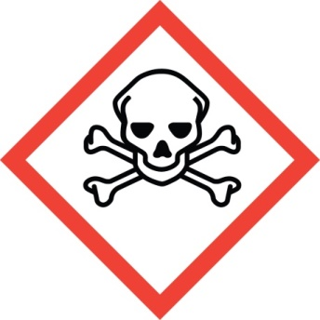
- Observe the laboratory hazard symbol below:

This symbol indicates that a substance is: A. Flammable B. Corrosive C. Toxic D. Explosive
- Which of the following is the SI unit for mass? A. Metre B. Kilogram C. Second D. Ampere
- A learner mixes sand and salt in a beaker. This combination represents a: A. Pure element B. Compound C. Homogeneous mixture D. Heterogeneous mixture
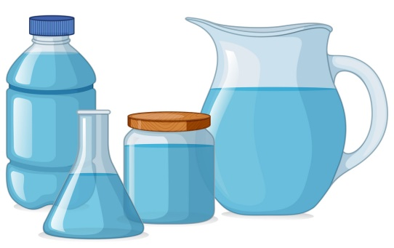
- You pour a glass of juice. The juice takes the shape of the glass, but it always fills the same amount of space, regardless of the container's shape.

Which state of matter does the juice represent? A) Solid B) Liquid C) Gas D) Plasma
- Your science teacher is giving a safety lesson on using electrical appliances in the home. They emphasize inspecting cords and plugs regularly. Which of the following is a common precaution that should always be taken to ensure electrical safety? A) Touching switches with wet hands B) Overloading power sockets C) Checking for frayed wires D) Using damaged plugs
- On the projector the teacher displays this type of a cell.

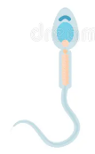
It is called a? A) White blood cell B) Root hair cell C) Epidermal cell D)Sperm cell
- Which method would be most effective in separating insoluble chalk powder from water? A. Distillation B. Evaporation C. Filtration D. Chromatography
- A solution turns blue litmus paper red. This indicates the solution is: A. A base B. An acid C. Neutral D. A salt
- In the male reproductive system, which organ is responsible for producing sperm? A. Urethra B. Vas deferens C. Epididymis D. Testis
- During adolescence, a significant physical change in boys is the: A. Widening of hips B. Development of breasts C. Deepening of the voice D. Onset of menstruation
- The excretory organ responsible for filtering waste products like urea from the blood is the:
A. Lung B. Skin C. Kidney D. Liver
- Which of the following is a common cause of kidney disorders? A. Drinking excessive amounts of water. B. Regularly consuming balanced meals. C. Uncontrolled high blood pressure. D. Engaging in regular physical exercise.
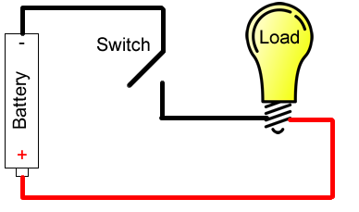
- Look at the simple electric circuit diagram below:

For the bulb to light up as shown, the switch must be: A. Open B. Broken C. Closed D. Removed
- Which of these household appliances primarily converts electrical energy into mechanical energy? A. Toaster B. Electric kettle C. Blender D. Television
- Which of the following materials is magnetic? A. Copper B. Plastic C. Iron D. Glass
- What happens when the North pole of one magnet is brought near the South pole of another magnet? A. They repel each other. B. They attract each other. C. No interaction occurs. D. They become demagnetized.
- During a science experiment, Sarah mixes baking soda and vinegar in a beaker. She observes fizzing, bubbling, and the beaker feels cooler to the touch. Which of the following describes the change Sarah observed? A) Melting ice B) Dissolving sugar in water C) Burning wood D) Tearing paper
- David is observing a houseplant that seems to be growing well near a sunny window. He notices its leaves are a vibrant green. Which part of the plant is primarily responsible for converting sunlight into food for the plant, giving it that green color? A) Root B) Stem C) Flower D) Leaf
- Imagine you're helping your friend push a broken-down car. You have to apply a certain amount of push to get it moving. What is the standard unit used to measure the strength of the push or pull you apply? A) Kilogram (kg) B) Meter (m) C) Newton (N) D) Joule (J)
- The local community is discussing ways to generate electricity without harming the environment or running out of resources. Which of the following energy sources would be considered the most sustainable option for long-term use? A) Coal B) Natural Gas C) Solar power D) Petroleum
- One morning, you wake up and notice tiny water droplets clinging to the grass outside, even though it didn't rain overnight. You also see mist forming over the fields. What process is responsible for the water vapor in the air turning back into those liquid water droplets? A) Evaporation B) Condensation C) Precipitation D) Transpiration
- Doctor is explaining how different parts of the blood help keep us healthy. They mention the part that carries vital gases throughout our bodies. Which component of blood is responsible for transporting oxygen from the lungs to all the cells in the body? A) White blood cells B) Platelets C) Red blood cells D) Plasma
- At the playground, two children of different weights are trying to balance on a seesaw. They need to adjust their positions to make it work. What type of simple machine are they using? A) Pulley B) Inclined plane C) Lever D) Wheel and axle
- Which statement best describes Lead? A. Mg B. Ag C. Pb D. Na
- The process of a liquid changing into a gas below its boiling point is called: A. Condensation B. Melting C. Freezing D. Evaporation

- In the fire triangle, which three components are necessary for a fire to start and continue? A. Wood, water, and air B. Fuel, heat, and oxygen C. Carbon dioxide, fuel, and heat D. Water, carbon dioxide, and oxygen
- Which part of an animal cell is responsible for controlling all cell activities? A. Cell membrane B. Cytoplasm C. Nucleus D. Mitochondrion.

- What kind of change occurs when a piece of paper is burnt, forming ash and smoke? A. Physical change, as the paper's form changes. B. Chemical change, as new substances are formed. C. Temporary change, as it can be reversed. D. State change, as it goes from solid to gas directly.

SECTION B: (50 Marks)

Answer all questions
- (a) A learner accidentally spills a small amount of dilute acid on their hand in the laboratory. (i) State the immediate first aid measure to take. (1 mark)
_____________________________________________________________________________________________
(ii) Explain why this specific measure is important. (1 mark)
_____________________________________________________________________________________________
(b) Describe two safety precautions that should always be observed when using a Bunsen burner in the laboratory. (2 marks)
_______________________________________________________________________________________________
_______________________________________________________________________________________________
- (a) Define a mixture. (1 mark)
_______________________________________________________________________________________________
(b) Give two differences between a compound and a mixture. (2 marks)
______________________________________________________________________________________
_____________________________________________________________________________________
(c) Describe how you would separate a mixture of common salt and iron filings. (3 marks)
______________________________________________________________________________________
_____________________________________________________________________________________
_____________________________________________________________________________________
- (a) Name two common laboratory instruments used to measure volume. (2 marks)
______________________________________________________________________________________
_____________________________________________________________________________________
(b) Explain, in terms of the kinetic theory of matter, why gases are easily compressible while solids are not. (3 marks)
______________________________________________________________________________________
_____________________________________________________________________________________
_____________________________________________________________________________________
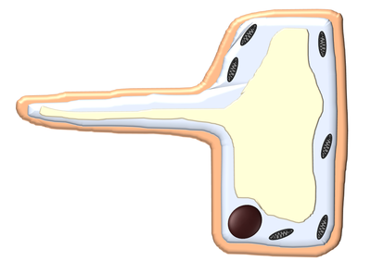
- (a) A Grade 8 learner observes different types of cells as shown below.
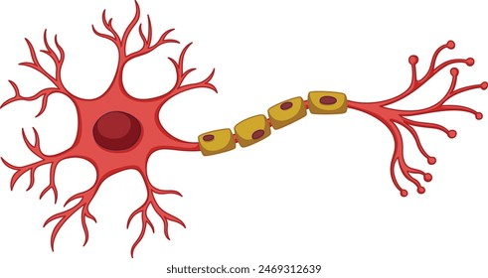
A B
Name the two cells labelled A and B. (2 marks)
A: ____________________________________________________________
B: _____________________________________________________________
(ii) State the function of the chloroplasts in a plant cell. (1 mark)
______________________________________________________________________________________
_____________________________________________________________________________________
(b) Explain the difference between diffusion and osmosis. (2 marks)
______________________________________________________________________________________
_____________________________________________________________________________________
- (a) List two challenges that adolescents may face during their developmental stage. (2 marks)
______________________________________________________________________________________
_____________________________________________________________________________________
(b) Explain two ways of preventing Sexually Transmitted Infections (STIs). (2 marks)
______________________________________________________________________________________
_____________________________________________________________________________________
- (a) Give two examples of renewable energy sources. (2 marks)
______________________________________________________________________________________
_____________________________________________________________________________________
(b) Explain the importance of using circuit breakers or fuses in household electrical circuits. (2 marks)
______________________________________________________________________________________
_____________________________________________________________________________________

37. (a) different plant cells were placed in different concentrations as shown blow.
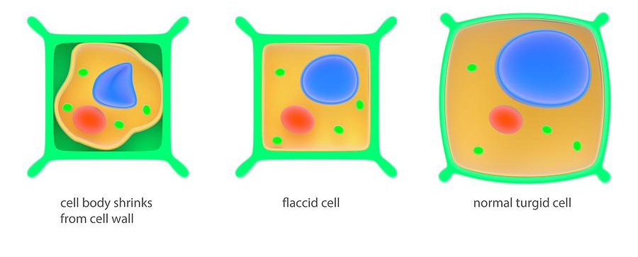
A B C

Name the type of solutions in which cell A,B and C were place.. (3 marks)
A_________________________________________________________________________________________________
B___________________________________________________________________________________________________
C____________________________________________________________________________________________________
(b) A Member of Parliament (MP) donated sanitary towels which were only given to girls in Grade 9 and not those in Grade 2. Explain why only the Grade 9 girls were given the sanitary towels. (2 marks)
______________________________________________________________________________________________________
______________________________________________________________________________________________________
- During a lesson, Grade 8 learners were asked to identify the parts of a cell.
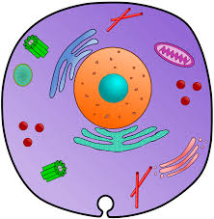

X

(a) What is he name of the part labelled X? (1 mark)
___________________________________________________________________________________________________

(b) State two components of the cell present only in plant cell. (2 marks)
_______________________________________________________________________________________________________
______________________________________________________________________________________________________
- A boy suffered a severe cut while working in the laboratory. Describe two first aid measures that should be taken immediately. (2 marks)
_______________________________________________________________________________________________________
_______________________________________________________________________________________________________
______________________________________________________________________________________________________
40. (a) During an activity to investigate sources of sound waves in the environment, learners produced sound waves by plucking a guitar string. List two other sources of waves that belong to the same group of waves as sound waves. (2 marks)
_______________________________________________________________________________________________________
_______________________________________________________________________________________________________
(b) During a lesson, learners observed images formed by convex mirrors with objects at different points. State the characteristics of an image formed by a convex mirror. (3 marks)
_______________________________________________________________________________________________________
_______________________________________________________________________________________________________
_______________________________________________________________________________________________________
- (a) Allan was browsing on different forms of energy using his laptop.

(i) Identify one form of energy. (1 mark)
__________________________________________________________________________________________________
(ii) A student rides a bicycle up a hill and then comes down freely. Describe the energy changes involved. (1 mark)
________________________________________________________________________________________________

- A rectangular block has a weight of 120 N. Its base measures 0.4 m long and 0.2 m wide.
  - Calculate the area of the base of the block in square meters (m2). (2 marks)

  - Calculate the pressure exerted by the block on the surface it is resting on. (3 marks)

THIS IS THE LAST PRINTED PAGE.

