Candidate’s Name |  | Assessment Number
School Name |  | School Code
Candidate’s Signature |  | Date

THE KENYA NATIONAL JUNIOR EXAMINATIONS AND ASSESSMENT SERIES
KENYA JUNIOR SCHOOL EDUCATION ASSESSMENT
811/2: CREATIVE ARTS AND SPORTS (Theory)
Time: 1 hour 40 minutes
INSTRUCTIONS TO CANDIDATES
- Write your name and assessment number in the spaces provided above.
- Write the name and code of your school in the spaces provided above.
- Put your signature and write the date of the assessment in the spaces provided above.
-CREATIVE ARTS AND SPORTS-
- This paper consists of two sections A and B.
- Each section has THREE parts: Part I - Performing Arts, Part II - Sports, Part III -Visual Arts.
- Section A comprises Multiple Choice Questions number: 1 to 40.
- Section B comprises short structured and analysis questions number: 41 to 52.
- Answer ALL the questions in section A on the separate ANSWER SHEET provided.
- Answer ALL the questions in section B in the spaces provided on this question paper for Part I - Performing Arts and Part III - Visual Arts.
- For Part II - Sports, questions 45 and 46 are COMPULSORY. Choose EITHER question 47 or 48.
- Do not remove any page from this question paper.
- Answer all questions in English.
For official use only: SECTION B
Part | Task Number | Question Number | Maximum Score | Candidate’s Score
Part I: Performing Arts | 1 | 41 | 04
 | 2 | 42 | 04
 | 3 | 43 | 10
 | 4 | 44 | 06
Part II: Sports | 5 | 45 | 04
 | 6 | 46 | 04
OPTIONAL | 7 | 47 | 10
 | 8 | 48 | 10
Part III: Visual Arts | 9 | 50 | 04
 | 10 | 51 | 04
 | 11 | 52 | 10
Total per section |  |  | 40
This paper consists of 9 printed pages. Candidates should check the question paper to ascertain that all the pages are printed as indicated and that no questions are missing.
© 2025 The Kenya Junior School Examinations and Assessment Series.
Turn over

SECTION A: (40 Marks)
Read the instructions carefully.

PART I: PERFORMING ARTS
- The simultaneous sounding of two or more musical notes that blend pleasingly together creates: A. Melody B. Rhythm C. Harmony D. Timbre
- Which of the following describes the texture of a song where a single melodic line is sung or played without any accompaniment? A. Homophonic B. Polyphonic C. Monophonic D. Binary
- The sign

in music notation indicates:
A. Quaver . B. Minim. C. Semiquaver. D. Demisemiquaver.
- Which of the following instruments is not classified as a percussion instrument? A. Marimba B. Guitar C. Flute D. Drum
- When a song is described as being in a minor key, what emotional quality does it most often evoke? A. Joyful and bright B. Sad or serious C. Energetic and fast D. Calm and peaceful
- A traditional Kenyan narrative song that uses a repeated phrase for the audience to join in is an example of: A. A lullaby B. Call and response C. Solo performance D. A work song
- Which of the following is a key element in drama that involves sudden changes in the story's direction, often leading to a resolution? A. Setting B. Conflict C. Climax D. Theme
- In stagecraft, what is the primary role of lighting in a drama production? A. To make the stage brighter. B. To highlight characters and create mood. C. To indicate the end of a scene. D. To obscure the set design.
- Which of the following vocal exercises is most beneficial for strengthening a singer's diaphragm and improving breath control? A. Humming B. Lip trills C. Deep breathing exercises D. Siren sounds
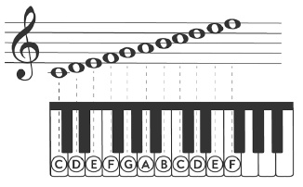
- Below is a keyboard and its relation on the treble clef. Which letter suits part labelled X:

X
A. A B. C C. F D. G
- What does the term key signature in music notation represent? A. The speed of the music. B. The loudness of the music. C. The sharps or flats that appear at the beginning of a piece of music. D. The number of beats in a measure.
- The dramatic element that refers to the geographical location and time period in which a story takes place is the: A. Plot B. Character C. Setting D. Dialogue
- Which of the following is a common challenge faced by learners when performing in a choral verse? A. Memorizing individual lines. B. Maintaining unison and clear articulation. C. Finding appropriate costumes. D. Selecting a suitable theme.
- When interpreting a dramatic script, understanding the subtext (unspoken meaning) primarily helps in: A. Designing the set. B. Developing believable character motivations. C. Choosing background music. D. Determining the duration of the play.
- What is the main purpose of improvisation in drama? A. To follow a script strictly. B. To develop spontaneity and creative thinking. C. To avoid audience interaction. D. To rehearse known lines.
- A composer wants to write a melody that sounds complete and resolves to the tonic. This concept relates to: A. Harmony B. Cadence C. Rhythm D. Dynamics

PART II: SPORTS
- In the high jump, which phase involves the athlete moving over the crossbar? A. Approach B. Take-off C. Flight D. Landing
- Which of the following ball games requires players to use their hands to throw the ball into the opponent's goal?
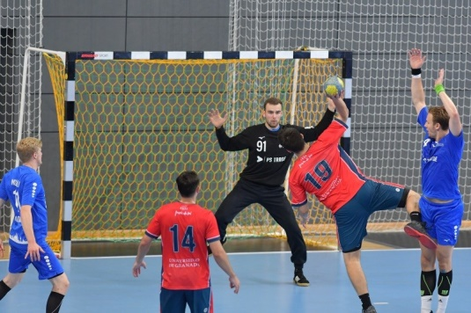
A. Football B. Basketball C. Handball D. Volleyball
- Why is it important for athletes to cool down after intense physical activity? A. To increase heart rate. B. To prevent muscle soreness and aid recovery. C. To warm up for the next activity. D. To make them feel more tired.
- In football, what is the 'offside' rule primarily designed to prevent? A. Players from scoring too easily by waiting near the opponent's goal. B. Too many players from entering the penalty area. C. Players from passing the ball backwards. D. Defenders from tackling attackers.
- Which of the following is a basic water rescue technique where a rescuer extends an object to help a distressed person in the water? A. Throwing assist B. Reaching assist C. Wading assist D. Diving assist
- A volleyball player is demonstrated a certain pass.
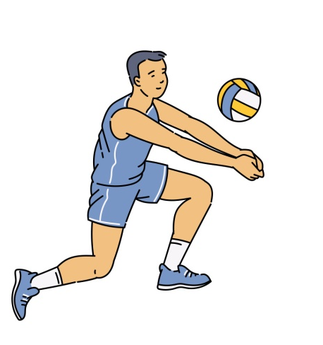
This skill is called: A. Chest pass B. dive pass C. overhand D. Bump pass
- When playing a traditional game like "Bao", what value is strongly emphasized among players? A. Individual strength B. Strategic thinking C. Physical endurance D. Aggression
- What is the immediate first aid action for a minor cut sustained during sports? A. Apply a bandage tightly. B. Clean the wound with soap and water. C. Ignore it and continue playing. D. Apply ice directly to the cut.
- In rugby (tag rugby variant), what is the primary method of stopping an opponent with the ball? A. Tackling them to the ground. B. Pulling off a tag from their belt. C. Intercepting the ball. D. Pushing them out of bounds.
- Which of the following is a role of a referee or umpire in a sports game? A. To coach one of the teams. B. To play alongside the athletes. C. To ensure fair play and enforce the rules. D. To cheer for the winning team.
- The ability of a basketball player to quickly change direction while dribbling is a demonstration of: A. Power B. Flexibility C. Agility D. Stamina
- Before attempting a forward dive into a swimming pool, which of the following is a crucial safety step? A. Running towards the diving board. B. Ensuring the water depth is sufficient for diving. C. Diving headfirst without looking. D. Holding your breath for a long time.

PART III: VISUAL ARTS
- In a painting, the visual device that creates the illusion of objects appearing smaller and less detailed as they recede into the distance is called: A. Texture B. Linear perspective C. Colour harmony D. Symmetrical balance
- Which of the following terms refers to the purity or intensity of a colour? A. Hue B. Value C. Saturation D. Tone
- An artist uses very thick applications of paint, creating a textured surface that stands out from the canvas. This technique is known as: A. Glazing B. Washing C. Impasto D. Stippling
- Which principle of design involves the consistent repetition of elements to create a sense of organized movement? A. Contrast B. Emphasis C. Balance D. Rhythm
- Which type of sculptural technique involves taking away material, such as chiseling wood or stone? A. Modelling B. Assembling C. Carving D. Casting
- An artwork that combines various materials like paper, fabric, and photographs glued onto a surface is known as a: A. Mosaic B. Print C. Collage D. Weaving
- What is the primary characteristic of an artwork from the Impressionism art movement? A. Highly realistic and detailed. B. Focus on capturing the fleeting effects of light and atmosphere. C. Geometric shapes and multiple viewpoints. D. Strong emphasis on religious themes.
- Which type of drawing aims to capture the full human figure in different poses? A. Still life drawing B. Portrait drawing C. Landscape drawing D. Figure drawing
- What is the purpose of using a key signature in music notation and art for colour palettes? A. To indicate the main theme. B. To establish consistency and predictable patterns. C. To show the loudest parts. D. To determine the duration.
- The principle of design that uses different sizes or positions of objects to create a focal point or suggest distance is: A. Unity B. Proportion C. Harmony D. Repetition
- Which traditional craft involves interlacing threads or strips of material to create fabric or baskets? A. Pottery B. Jewellery making C. Weaving D. Batik
- An artist's statement describing their artwork's meaning and inspiration is part of the process of: A. Creating art B. Marketing art C. Critiquing art D. Exhibiting art

SECTION B: STRUCTURED AND ANALYSIS QUESTIONS (60 marks)

PART I: PERFORMING ARTS
Answer ALL the questions in the spaces provided after each question
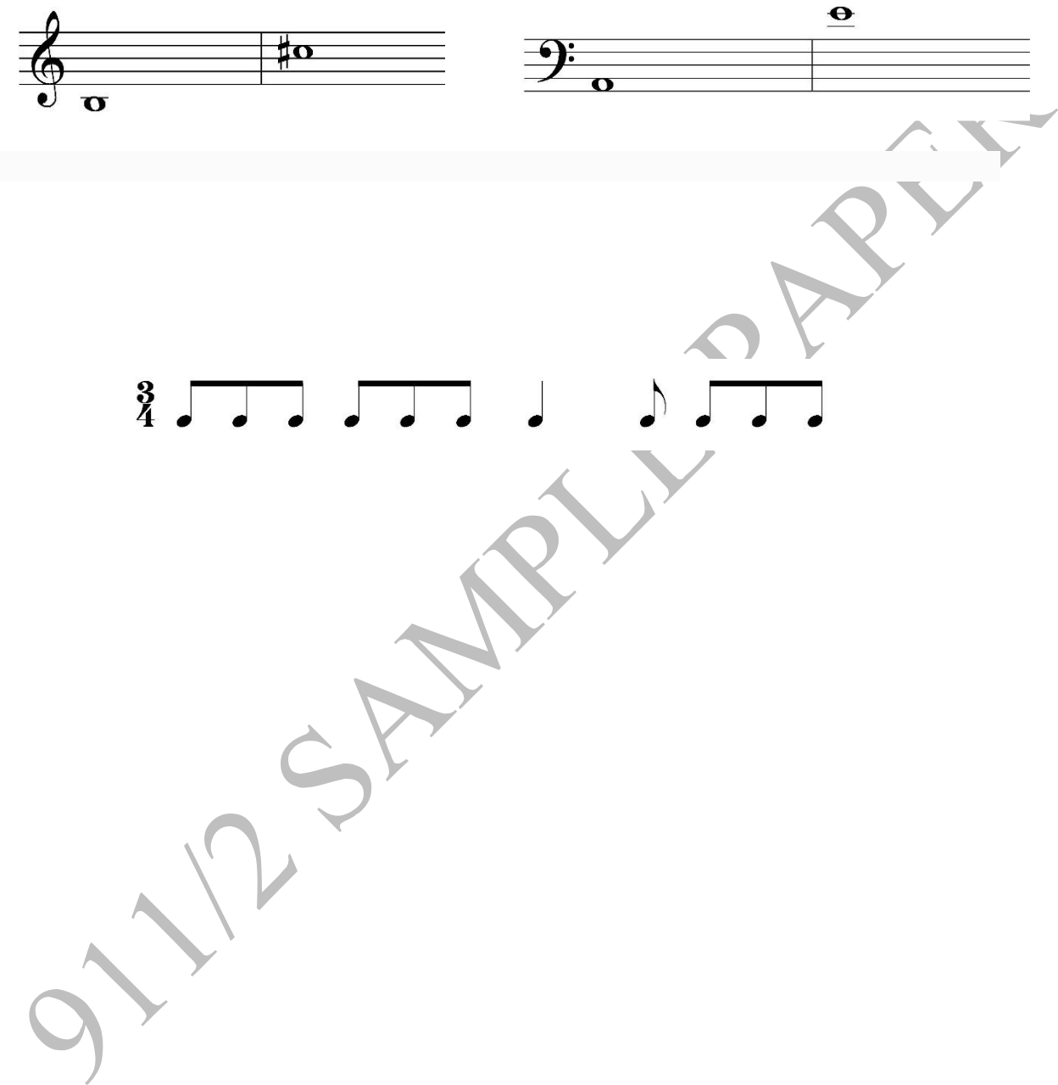
- Write the letter names for each of the notes on the staves below, considering the key signature. (4 marks)

(i) _________ (ii) __________ (iii) ___________ (iv) ___________
- Complete the following rhythm by adding appropriate rests to fill each bar in 3/4 time. (4 marks) (Image: Two bars of music in 3/4 time. Bar 1: Crotchet, two quavers, (empty space for 1 beat rest) Bar 2: Minim, (empty space for 1 beat rest) )

________________________________________________________________________________________
- Drama is a powerful tool for communication and entertainment. (a) Explain five ways in which a playwright uses dialogue to develop characters in a play. (5 marks) …………………………………………………………………………….…………………….....…… …………………………………………………………………………………….……………..…...… …………………………………………………………………………………….……………..…...… …………………………………………………………………………………….……………….…… ……………………………………………………………………………………….…………….……
(b) Describe five elements of stage design that contribute to creating a believable setting for a play. (5 marks) …………………………………………………………………………….…………………….....…… …………………………………………………………………………………….……………..…...… …………………………………………………………………………………….……………..…...… …………………………………………………………………………………….……………….…… ……………………………………………………………………………………….…………….……
- A Grade 8 music group is composing a simple melodic phrase. (a) Define "motif" in music composition. (2 marks) …………………………………………………………………………….…………………….....…… …………………………………………………………………………………….……………..…...…
(b) Suggest two ways a motif can be developed to create a longer melodic phrase. (2 marks) …………………………………………………………………………….…………………….....…… …………………………………………………………………………………….……………..…...…
(c) Explain two ways a vocalist can use dynamics to enhance the emotional impact of a song. (2 marks) …………………………………………………………………………….…………………….....…… …………………………………………………………………………………….……………..…...…

PART II: SPORTS
Answer questions 45 and 46. For question 47 and 48, answer only ONE of them.
- The long jump is a field event that requires a combination of speed and technique. (a) Outline the four main phases of a long jump in the correct order. (2 marks) …………………………………………………………………………….…………………….....…… …………………………………………………………………………………….……………..…...…
(b) Explain two common faults that an athlete might make during the take-off phase of a long jump. (2 marks) …………………………………………………………………………….…………………….....…… …………………………………………………………………………………….……………..…...…
- During a basketball match, a foul is committed. Identify four different types of fouls that can occur in a basketball game. (4 marks) ……………………………………………………………………………………………….....…… ………………………………………………………………………………………………..…...… ………………………………………………………………………………………………..…...… ………………………………………………………………………………………………….……
- Learning basic first aid is crucial for anyone participating in or overseeing sports activities. i. Define "sprain" and "strain" as common sports injuries. (2 marks) ……………………………………………………………………………………………….....…… ………………………………………………………………………………………………..…...…

ii. Describe the R.I.C.E. method for treating a sprain or strain. (4 marks) ……………………………………………………………………………………………….....…… ………………………………………………………………………………………………..…...… ………………………………………………………………………………………………..…...…
iii. Explain two ways in which sports promote positive values like discipline and perseverance. (4 marks) ……………………………………………………………………………………………….....…… ………………………………………………………………………………………………..…...… ………………………………………………………………………………………………..…...…
- Traditional games are an important part of cultural heritage and physical activity.
i. What is a traditional game? (2 Marks) …………………………………………………………………………….………………… …………………………………………………………………………………….…………
ii. Describe the rules of a specific traditional game played in your community, explaining how it is played. (4 marks) …………………………………………………………………………….………………… …………………………………………………………………………………….………… …………………………………………………………………………………….…………
iii. Explain two cultural significances of participating in traditional games. (2 marks) …………………………………………………………………………….………………… …………………………………………………………………………………….…………
iv. Outline two ways traditional games can be adapted to be more inclusive for learners with diverse abilities. (2 marks)
…………………………………………………………………………….………………… …………………………………………………………………………………….…………

PART III: VISUAL ARTS
Answer ALL the questions in the spaces provided after each question
- (a) A Grade 8 learner is creating a drawing of a rural landscape with distant hills and a nearby tree. In the space below, sketch a simple composition to demonstrate how you would use linear perspective to show depth in the drawing. (2 marks)

(b) Describe two ways an artist can achieve asymmetrical balance in a visual artwork. (2 marks) ………………………………………………………………………………………………………...… ……………………………………………………………………………….…………………..…....…
- a) Define the term "collage" as used in visual arts. (2 marks)
__________________________________________________________________
__________________________________________________________________
b) List two materials that can be used to make a photomontage. (2 marks)
i. ____________________________
ii. ____________________________
- You are asked to design a simple poster to promote cleanliness in school.
a) Briefly describe how you would organize your layout. (3 marks)
__________________________________________________________________
__________________________________________________________________
b) State any three visual elements you would include in your poster. (3 marks)
i. ____________________________
ii. ____________________________
iii. ____________________________
c) Name two colors you would use and explain why. (4 marks)
Color 1: ____________ – Reason: __________________________________
Color 2: ____________ – Reason: __________________________________

THIS IS THE LAST PRINTED PAGE.

