Candidate’s Name |  | Assessment Number
School Name |  | School Code
Candidate’s Signature |  | Date

THE KENYA NATIONAL EXAMINATION AND ASSESSMENT PREDICTION SERIES KENYA JUNIOR SCHOOL EDUCATION ASSESSMENT
907: SOCIAL STUDIES
Time: 1 Hour 30 Minutes
INSTRUCTIONS TO CANDIDATES
- Write your name and assessment number correctly.
- Write the name and code of your school in the spaces as indicated above.
- Write the date of the assessment.
- This paper consists of two sections: A and B.
- Section A comprises Multiple choice Questions.
- Section B comprises structured questions and essay questions.
- Answer ALL the questions in Section A on the separate ANSWER SHEET provided.
- Answer ALL the questions in Section B in the spaces provided on this question paper.
- Do NOT remove any page from this question paper.
- Answer the questions in English.
-SOCIAL STUDIES-
For official use only: SECTION B:
Task | Question | Candidate’s Score per Question | Maximum Score | Candidate’s Score per Task
Task 1 | 21 |  | 6
 | 22 |  | 5
 | 23 |  | 4
 | 24 |  | 5
 | 25 |  | 2
 | 26 |  | 3
 | 27 |  | 4
 | 28 |  | 5
 | 29 |  | 10
 | 30 |  | 5
 | 31 |  | 4
 | 32 |  | 9
 | 33 |  | 3
 | 34 |  | 10
TOTAL |  |  | 80
- You have been given this question paper and a separate answer sheet. Answer all the questions in Section A on the separate answer sheet provided.
- When you have chosen your answer, mark it on the ANSWER SHEET, not on this question paper.
This paper consists of 8 printed pages. Candidates should check the question paper to ascertain that all the pages are printed as indicated and that no questions are missing.
© 2025 The Kenya National Examination and Assessment Prediction Series Turn over
SECTION A (25 marks)
Answer ALL the questions in this section.

- Grade 7 learners were discussing on factors that led to the growth of ancient Egypt. They gave some factors. Which one was not correct? A. Presence of water for irrigation. B. Availability of labour force due to high population. C. Strong military leadership. D. Its location in the central part of Africa.
- Early African civilization has led to modern developments. Which one is not among the modern developments from early civilization? A. Improvement of building skills and designs. B. Modern irrigation technology developed from ancient irrigation methods. C. Use of stone tools developed from early civilization. D. Industrial development in the ancient kingdoms has greatly influenced the modern industrial development.

- According to the religious theories on the origin of man, on which day were human beings created? A. 6th day B. 5th day C. 1st day D. Last day
- Joseph was asked by his teacher to name peaceful ways of solving conflicts in the society. Which response was not correct? A. Through negotiation. B. Through reconciliation. C. Through forgiveness. D. Through confrontation.
- In the Community Service Learning, which is the first step to carry out the project? A. Designing the solution to the problem. B. Identifying the problem. C. Implementing the problem. D. Reporting the problem.
- Which one of the following is not a quality of a peaceful person? A. Loving. B. Caring. C. Forgiving. D. Discriminating.
- The following goods were obtained from West Africa during the Trans-Saharan trade except A. slaves B. gold C. salt D. kolanuts.
- Grade 7 learners were asked to identify three factors that led to the introduction of money. Which of the factors they gave was not correct? A. The coming of different visitors. B. Demand for more goods. C. Overproduction of goods. D. Introduction of barter trade.

- Human diversity is determined by the following aspects except A. religion B. language C. culture D. size.
- Which one of the following is not an interpersonal skill that enhances healthy interaction in a multi-cultural society? A. Empathy. B. Self-evaluation. C. Collaboration. D. Intolerance.
- Joseph and John had a disagreement. They later agreed to sit down and solve the problem amicably by themselves. The method of conflict resolution they used is called A. dialogue B. mediation C. arbitration D. litigation.
- Grace, a Grade 7 learner was asked to identify ways of managing stress in a multi-cultural society. Which answer was not correct? A. Engaging oneself in violent demonstrations. B. Joining church choir. C. Talking to a counsellor. D. Talking to a trusted person.
- Before the introduction of the medium of exchange, trade was conducted by exchanging goods for goods. Which one of the following was not a challenge of the trade? A. Lacked a standard of value for the goods. B. Lacked storage of value. C. Lacked goods for exchange. D. Lacked double coincidence of wants.
- Grade 7 learners planned to clean the nearby market and contributed money to buy garbage bins. This action of Grade 7 learners shows A. pride. B. responsibility. C. hard work. D. showing off.
- Which arm of government implements government policies in Kenya? A. Legislature. B. Judiciary. C. Executive. D. Police service.
- .Richard was asked to state factors that promote peaceful co-existence. Which factor was not correct? A. Love. B. Justice. C. Tolerance. D. Impatience.
- The term community in Community Service Learning refers to A. people living around the school B. a group of people living near you C. a group of people with a common interest D. people working together.
- Which one of the following is a negative emotion? A. Happiness. B. Love. C. Fear. D. Excitement.
- Kamau was told by his grandfather the story of the origin of the Agikuyu community. This story is an example of which theory of the origin of man? A. Mythical. B. Religious. C. Scientific. D. Evolution.
- Which one of the following is not an impact brought about by the introduction of money in Africa? A. Enhanced international trade. B. Increased the volume of trade. C. Led to the growth of the economies of African countries. D. Led to the introduction of slave trade

SECTION B (30 MARKS)
Answer ALL questions in this section.
- Use the map of Kiba Area to answer questions 21.
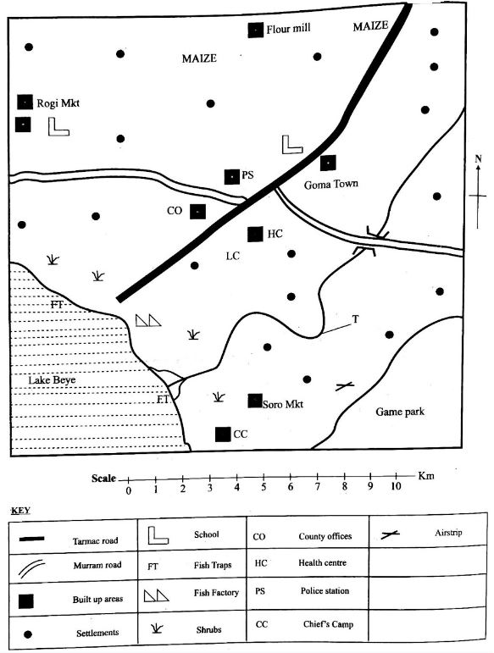
KIBA AREA

a) Determine the direction of the Goma town from the Lake Beye. (1mk)
_____________________________________________________________________________________
b) From the evidence provided in the map, which is the main economic activity in the area? (1mk)
____________________________________________________________________________________
c) Which type of climate is experienced to the South Western part of the map based on the features shown? (1mk)
_____________________________________________________________________________________
d) Measure the distance between the Police Station and the Health Centre, calculate the actual distance in kilometers. (2mks)
________________________________________________________________________________________
e) Name one type of transport infrastructure found in Kiba Area. (1mk)
______________________________________________________________________________________
- a) Define the term entrepreneurial opportunity. (1mk)
____________________________________________________________________________________
b) Name four entrepreneurial opportunities related to Social Studies. (4mks)
a) __________________________________________________________________________.
b) __________________________________________________________________________.
c) __________________________________________________________________________.
d) __________________________________________________________________________.
- Grade 7 learners were discussing on personal values for a steady personality. State any three personal values they discussed. (3mks)
a) __________________________________________________________________________.
b) __________________________________________________________________________.
c) __________________________________________________________________________.

- Calvin was asked by his teacher to point out four advantages of using a medium of exchange instead of barter trade in the current economy. Which was the correct responses? (4mks)
a) __________________________________________________________________________.
b) __________________________________________________________________________.
c) __________________________________________________________________________.
d) __________________________________________________________________________.
- a) Define the term self-exploration. (1mk)
________________________________________________________________________________________
_______________________________________________________________________________________
  - Mwadime is angry today


Identify three ways of managing anger in day-to-day life. (3mks)
a) __________________________________________________________________________.
b) __________________________________________________________________________.
c) __________________________________________________________________________.
- a) Define the term kingdom. (1mk)
_________________________________________________________________________________
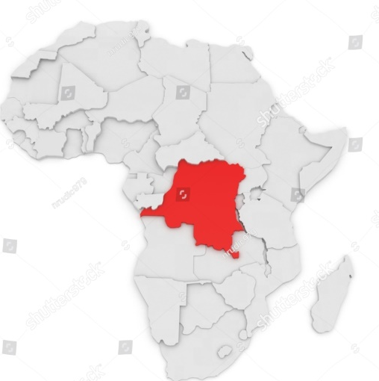
b) Identify the following ancient kingdom marked X. ( 1 mark)

X

X: ______________________________________________________________
c) Outline two common aspects found in both traditional and religious stories of human origin. (2mks)
a) __________________________________________________________________________.
b) __________________________________________________________________________.
- Grade 7 learners were learning about slavery and servitude. Their teacher asked them to explain the meaning of the following types of slavery. Which responses did they give? (3mks)
a) Chattel: __________________________________________________________________________
b) Military: _________________________________________________________________________
c) Domestic servitude: ________________________________________________________________
- Use the map of Africa below to answer question 28.
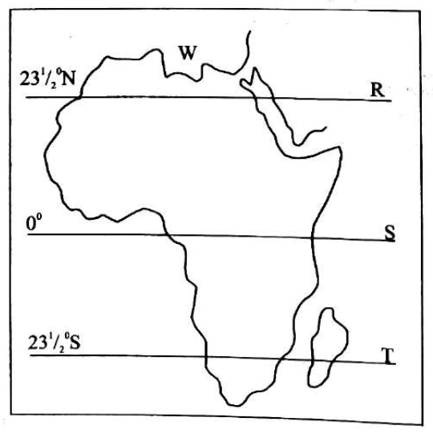
Name the Latitudes marked: (3mks)
a) R: ___________________________________________________________________
b) S: ___________________________________________________________________
c) T: ___________________________________________________________________

- Different African communities existed in different parts of Africa.
  - Outline the key features of the Ogiek social organization and traditional governance system.? (3 marks)
a) ____________________________________________________________________________________.
b) ___________________________________________________________________________________.
c) ___________________________________________________________________________________.
(b) Describe the social hierarchy and political structure of the Asante Empire. Explain the significance of the Golden Stool in their governance and religious beliefs. (3 marks)
a) ____________________________________________________________________________________.
b) ___________________________________________________________________________________.
c) ____________________________________________________________________________________.
- Outline two ways in which values promote national unity in Kenya. (2mks)
i) ____________________________________________________________________________________.
ii) ___________________________________________________________________________________.

b) Mention three arms of government in Kenya.(3 marks)
i) ____________________________________________________________________________________.
ii) ___________________________________________________________________________________.
iii) ____________________________________________________________________________________.

THIS IS THE LAST PRINTED PAGE.

