Candidate’s Name |  | Assessment Number
School Name |  | School Code
Candidate’s Signature |  | Date

THE KENYA NATIONAL JUNIOR EXAMINATIONS AND ASSESSMENT SERIES
KENYA JUNIOR SCHOOL EDUCATION ASSESSMENT
703: MATHEMATICS
JULY- AUGUST 2025
Time: 2 hours
INSTRUCTIONS TO CANDIDATES
- Write your name and assessment number in the spaces provided above.
- Write the name and code of your school in the spaces provided above.
- Sign and write the date of the assessment in the spaces provided above.
- This question paper consists of TWO sections: A and B.
- Answer ALL the questions in section A on the separate ANSWER SHEET provided.
- Answer ALL the questions in section B in the spaces provided in this QUESTION PAPER.
- Show all the workings in section B in the spaces provided.
- Non-programmable calculators may be used, except where stated otherwise.
- Give non-exact numerical answers, correct to 3 significant figures, and one decimal place for angles in degrees, unless a different level of accuracy is specified in the question.
- For π, use either the calculator value or 3.142.
-MATHEMATICS-
- Do NOT remove any page from this question paper.
- Answer ALL the questions in English.
For official use only SECTION B
Task | Question Numbers | Total score
Task 1 | 21, 22, 23, 24, 25 | Max. 20
Score
Task 2 | 26, 27, 28 | Max. 10
Score
Task 3 | 29, 30, 31, 32, 33 | Max. 22
Score
Task 4 | 34, 35, 36, 37, 38 | Max. 20
Score
Task 5 | 39, 40 | Max. 8
Score
This paper consists of 12 printed pages. Candidates should check the question paper to ascertain that all the pages are printed as indicated and that no questions are missing.
© 2025 – The Kenya Junior School Examination and Assessment Series Turn over

SECTION A: (20 marks)
Answer all questions in this section

- Which of the following numbers is a prime number? A. 9 B. 13 C. 21 D. 27
- What is the least number of mangoes that can be shared among 3, 4, or 6 children without a remainder? A. 12 B. 18 C. 24 D. 36
- A county government allocated Ksh 12,548,700 for a development project. What is this amount rounded off to the nearest million? A. Ksh 12,000,000 B. Ksh 12,500,000 C. Ksh 13,000,000 D. Ksh 10,000,000
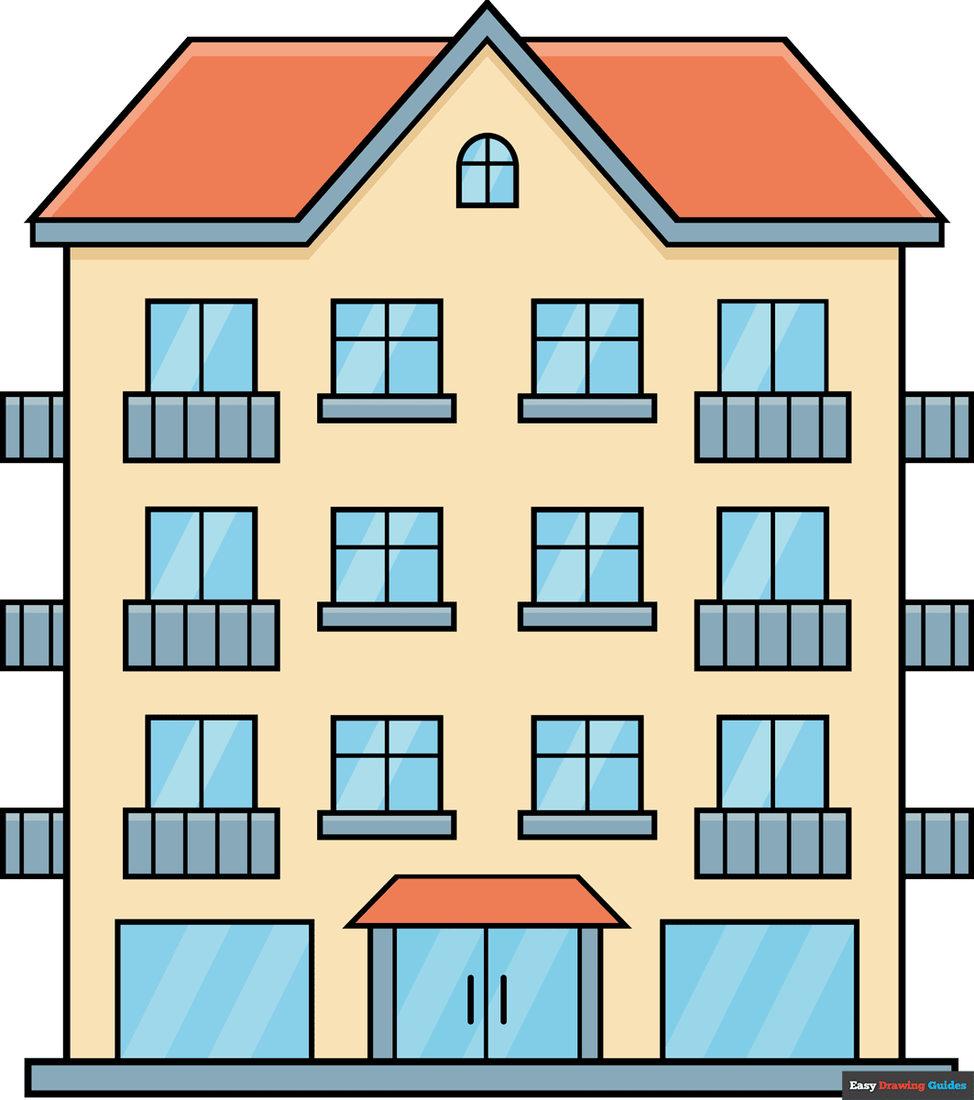
- The height of a building is 25.67 meters.

What is this height to 3 significant figures? A. 25.6 m B. 25.7 m C. 26.0 m D. 25.670 m
- Which of the following is equivalent to y⁶? A. y³×y³ B. y¹²÷y² C. (y²)³ D. y⁸−y²
- A student needs to score more than 75 marks to get an EE. Let 'm' represent the marks scored by the student. Which of the following inequalities represents the marks for an EE? A. m<75 B. m≤75 C. m>75 D. m≥75
- A pole is standing vertically on a flat ground. A wire is attached from the top of the pole to a point on the ground 8 meters away from the base of the pole. If the height of the pole is 6 meters, which of the following calculations will give the length of the wire? A. (82+62) B. (8+6)2 C. 82−62​ D. 82+62​
Working space

- A circular swimming pool has a diameter of 14 meters. A safety rope is placed around its circumference. What is the length of the rope used? (π=722​) A. 22 m B. 44 m C. 88 m D. 154 m
- A factory produces bottled juice in cylindrical bottles. Each bottle has a diameter of 6 cm and a height of 15 cm. The factory produced 141,300 cm³ of juice. How many bottles were filled? (Use π=3.142) A. 500 B. 1000 C. 2000 D. 5000
- A car traveled a distance of 180 km in 3 hours. On its return journey, it took 2 hours to cover the same distance. What was the car's speed on its return journey? A. 60 km/h B. 90 km/h C. 120 km/h D. 180 km/h
- The boiling point of water is 100°C. Which of the following calculations gives the correct temperature in Kelvin? A. 100−273 B. 273−100 C. 100+273 D. 100×273
- A shop offered a 20% discount on all electronics. A television set was sold for sh 16,000 after the discount. Which calculation gives the marked price of the television set? A. sh 16000×0.8 B. sh 16000÷0.8 C. sh 16000×1.2 D. sh 16000÷1.2
- The top of a monument is in the shape of a regular hexagon. Determine the size of one interior angle of the hexagon. A. 60° B. 90° C. 120° D. 150°
- A shopkeeper bought a bag for KSh 1200 and sold it for KSh 1080.
Calculate the percentage loss.
A. 10% B. 12% C. 15% D. 20%

Working space.

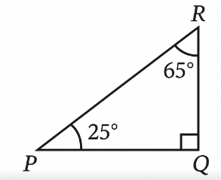
- A ramp is built to access a raised platform. The ramp makes an angle PQR with the ground, as shown.

what is the size of angle PQR? A. 25° B. 35° C. 65° D. 90°
- A map is drawn to a scale of 1:50,000. If the distance between two towns on the map is 5 cm, what is the actual distance between the towns in kilometers? A. 2.5 km B. 25 km C. 250 km D. 2500 km
- Which inequality represents "A number y is at most 10"? A. y<10
B. y>10
C. y≤10
D. y≥10
- What is the GCD of 24, 36, and 48?
A. 6
B. 12
C. 72
D. 144

Working space

- A ladder leaning against a wall makes an angle of 45° with the ground. If the base of the ladder is 3 meters away from the wall, what is the length of the ladder? A. 3 m B. 32​ m C. 6 m D. 62​ m
- The number of students who visited a library each day of the week was represented in a bar graph as shown.
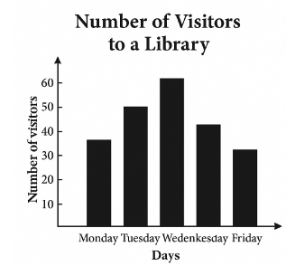
On which two consecutive days did the library receive the fewest visitors? A. Monday and Tuesday B. Tuesday and Wednesday C. Wednesday and Thursday D. Thursday and Friday

Working space

SECTION B (80 marks)
Answer all the questions in the spaces provided.
- a) Write the number 'Six hundred and four million, seventy-two thousand, five hundred and one' in figures. (2 Marks)

b) Round off 34,789,123 to the nearest ten thousand. (2 Marks)

c) Arrange the following numbers in ascending order: 0.303,0.3,0.033,0.33 (2 Marks)

d) Find the square root of (3 x (28 x 1)) (3 Marks)

- a) A rectangular field measures 150 m by 80 m. Calculate its area in hectares. (3 Marks)

b) A water tank has a capacity of 2000 litres. If water is pumped into it at a rate of 25 litres per minute, how long will it take to fill the tank completely? (3 Marks)

c) Convert 3.5 kg into grams. (1 Mark)

d) A journey of 240 km took 3 hours. Calculate the average speed in m/s. (3 Marks)

- a) If a=5,b=3, and c=2, evaluate: 2a+3b−c2 (3 Marks)

b) Solve the equation: 4x−7=13 (2 Marks)

c) Factorize completely: 6xy+9x (2 Marks)

d) A father is twice as old as his son. If the sum of their ages is 45 years, how old is the son? (3 Marks)

- a) What is the sum of the interior angles of a hexagon? (2 Marks)

b) Construct a triangle PQR where PQ=7 cm, QR=6 cm, and ∠PQR=90∘. Measure the length of PR. (4 Marks)

c) A cube has a side length of 5 cm. Calculate its volume. (2 Marks)

d) Identify the type of angle shown below: 1 Mark)
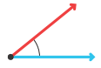________________________________
- a) A bicycle costs KSh 7,500. If it is sold at a discount of 10%, what is the selling price? (3 Marks)

b) Mwangi deposited KSh 12,000 in a bank that offers a simple interest rate of 8% per annum. Calculate the total amount he will have after 3 years. (4 Marks)

c) A trader bought 50 mangoes for KSh 400. He sold each mango for KSh 10. Calculate his profit or loss. (3 Marks)

- a) The marks obtained by 10 students in a mathematics test were: 60,75,80,65,70,80,55,70,75,80
i) What is the mode? (1 Mark)

ii) Calculate the mean mark. (3 Marks)

iii) What is the range of the marks? (1 Mark)

- The table below shows the favourite colours of students in a class.

Colour | Number of Students
Blue | 10
Red | 8
Green | 12
Yellow | 6

Present this data on a bar graph. (Use the grid provided) (5 Marks)
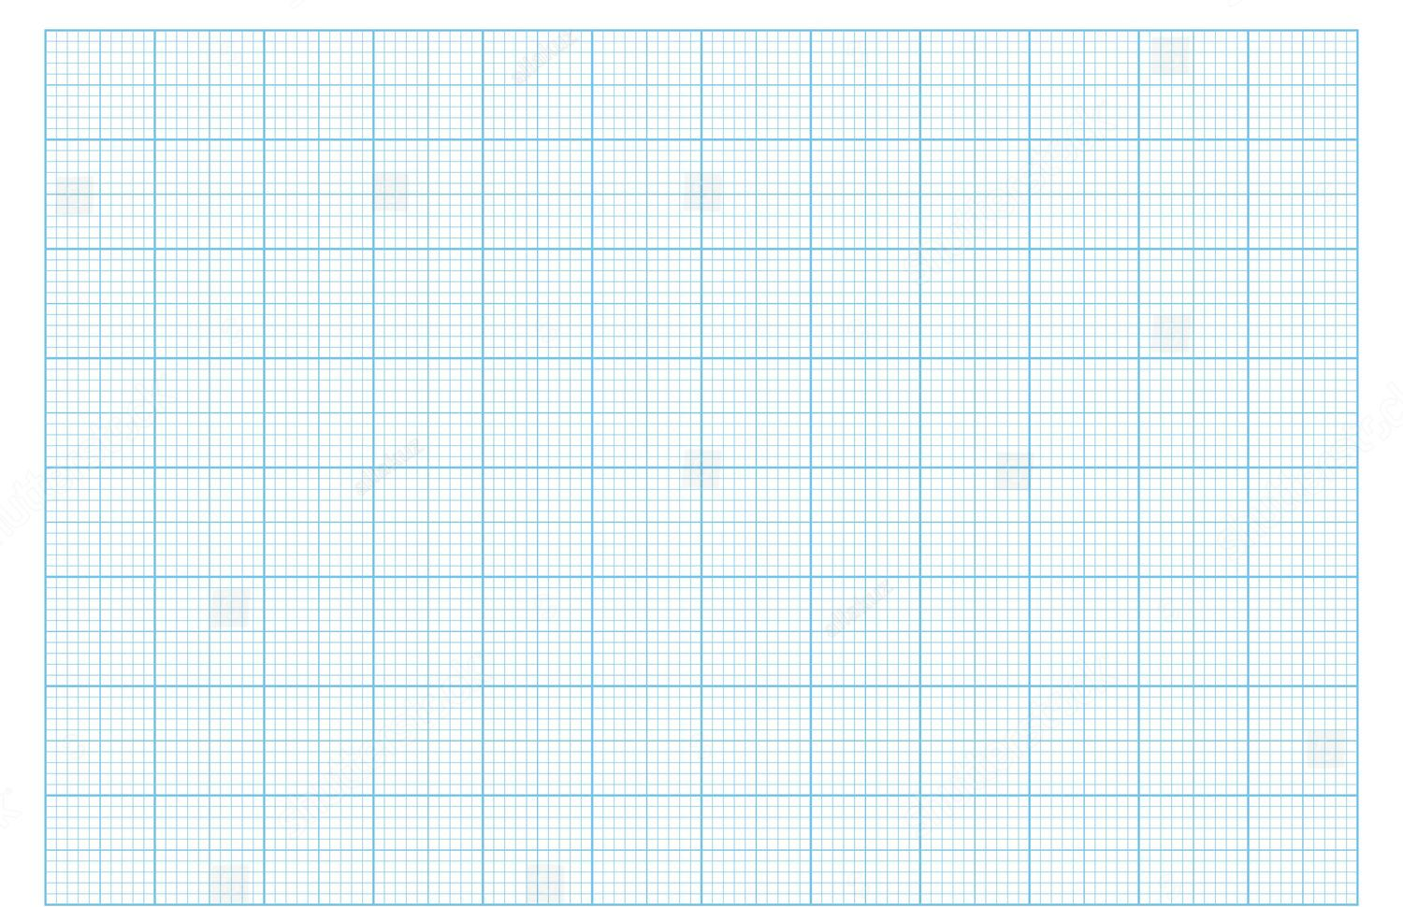

- a) Complete the pattern: 2,5,8,11,…,… (2 Marks)

b) Find the 10th term in the sequence: 3,7,11,15,… (3 Marks)

- A number is multiplied by 3 and then 5 is added to the result. If the final answer is 20, what is the number? (3 Marks)

- a) A family uses 50 litres of milk in a week. If milk costs KSh 60 per litre, how much does the family spend on milk in a month (4 weeks)? (3 Marks)

b) Prepare a simple budget for a student who receives KSh 500 pocket money as follows:
Snacks: KSh 200
Transport: KSh 150
Savings: KSh 100
Stationery: KSh 50 (4 Marks)
c) Identify two types of taxes paid by citizens in Kenya. (2 Marks)

  - _________________________________________________.
  - _________________________________________________.

THIS IS THE LAST PRINTED PAGE.

