
THE KENYA NATIONAL JUNIOR EXAMINATIONS AND ASSESSMENT SERIES
KENYA JUNIOR SCHOOL EDUCATION ASSESSMENT
703: MATHEMATICS
MARKING SCHEME

SECTION A: (20 marks)
- B.
- A.
- C.
- B.
- C.
- C.
- D.
- B.
- A.
- B.
- C.
- B.
- C.
- A.
- D.
- A.
- C.
- B.
- B.
- C.

Section B:
- a) 604,072,501
b) 34,790,000
c) 0.033, 0.3, 0.303, 0.33
d) 9.
- a) 1.2 hectares
b) 80 minutes
c) 3500 g
d) 22.2 m/s
- a) 15
b) x = 5
c) 3x (2y+3)
d) 15 years
- a) 720°
b) PR ≈ 9.2 cm (requires physical construction for precise measurement)
c) 125 cm³
d) Acute angle.
- a) KSh 6,750
b) KSh 14,880
c) KSh 100 profit
- a) i) Mode: 80
ii) Mean mark: 71
iii) Range: 25
b)
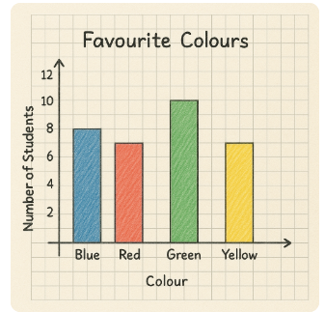

- a) 14, 17
b) 39
c) 5
- a) KSh 12,000 b)
Snacks: KSh 200
Transport: KSh 150
Savings: KSh 100
Stationery: KSh 50
c) i. Income Tax (PAYE - Pay As You Earn)
ii. Value Added Tax (VAT)
(Other valid answers include: Customs Duty, Excise Duty, Property Tax, Corporation Tax, etc.)

THIS IS THE LAST PRINTED PAGE.

