Candidate’s Name |  | Assessment Number
School Name |  | School Code
Candidate’s Signature |  | Date

THE KENYA NATIONAL JUNIOR EXAMINATIONS AND ASSESSMENT SERIES
JULY-AUGUST 2025
705/1: INTEGRATED SCIENCE (Theory)
Time: 1 hour 50 minutes

INSTRUCTIONS TO CANDIDATES
- Write your name and assessment number in the spaces provided above.
- Write the name and code of your school in the spaces provided above.
- Sign and write the date of the assessment in the spaces provided above.
- This paper consists of two sections: A and B.
-INTEGRATED SCIENCE-
- Section A comprises Multiple Choice Questions numbered 1 to 30.
- Section B comprises short, structured questions numbered 31 to 40.
- Answer ALL the questions in Section A on the separate ANSWER SHEET provided.
- Answer ALL the questions in Section B in the spaces provided in this QUESTION PAPER.
- Do NOT remove any page from this question paper.
- Answer ALL the questions in English.

For Official Use Only
SECTION B | Task | Task 1 |  | Task 2 |  |  | Task 3 |  | Task 4
Question | 31 | 32 | 33 | 34 | 35 | 36 | 37 | 38 | 39
Score
Max Score | 03 | 13 |  | 16 |  |  |  | 08
This paper consists of 6 printed pages. Candidates should check the question paper to ascertain that all the pages are printed as indicated and that no questions are missing.
© 2025 The Kenya Junior School Examinations and Assessment Series. Turn over
SECTION A: (30 Marks)
Answers all questions in this section.

- Which of the following best describes integrated science? A) The study of only biology. B) The study of only chemistry and physics. C) The study of science by combining different subjects like biology, chemistry, and physics. D) The study of scientific theories without practical application.

- Why is it important to study integrated science? A) To understand only one specific area of science in detail. B) To see how different areas of science are connected and apply to the real world. C) To avoid studying certain science subjects. D) Because it is a compulsory subject in school.
- What is the first and most important rule to follow when working in a science laboratory? A) Taste all chemicals to identify them. B) Run around the laboratory to stay active. C) Follow all instructions given by the teacher. D) Mix any chemicals you find interesting.

- Which of the following safety symbols warns you about flammable materials? A) A skull and crossbones. B) A flame. C) A corrosive liquid spilling on a hand. D) An exploding bomb.
- Your lab partner accidentally spills a small amount of acid on their skin. What is the first aid procedure you should follow? A) Immediately apply a bandage. B) Neutralize the acid with another chemical. C) Wash the affected area with plenty of running water. D) Rub the area vigorously with a cloth.
- What should you do if you get a minor cut in the laboratory? A) Ignore it and continue with the experiment. B) Apply any available chemical to stop the bleeding. C) Inform the teacher immediately and wash the cut with water. D) Hide it from the teacher to avoid getting into trouble.
- Which first aid procedure is most appropriate for a suspected bone fracture? A) Encourage the person to move the injured limb to check if it's broken. B) Apply heat to reduce swelling. C) Immobilize the injured limb and seek medical help. D) Massage the injured area gently
- Which of the following is a common laboratory hazard? A ) Properly labeled containers. B ) Clean and organized workspace. C ) Broken glassware. D ) Students wearing safety goggles.
- Which of the following laboratory instruments is used to accurately measure the volume of a liquid? A) Beaker B) Flask C) Measuring cylinder D) Test tube
- What is the SI unit for measuring length? A) Kilogram (kg) B) Second (s) C) Meter (m) D) Liter (L)
- Air is an example of a: A) Pure substance B) Compound C) Element D) Mixture
- Salt dissolved in water is an example of a: A) Suspension B) Colloid C) Homogeneous mixture D) Heterogeneous mixture
- Which method would be most suitable for separating sand and water? A) Evaporation B) Distillation C) Filtration D) Chromatography
- Which of the following is a property of an acid? A) Feels slippery to the touch. B) Tastes bitter. C) Turns blue litmus paper red. D) Has a pH value above 7.
- Litmus paper is an example of a/an:
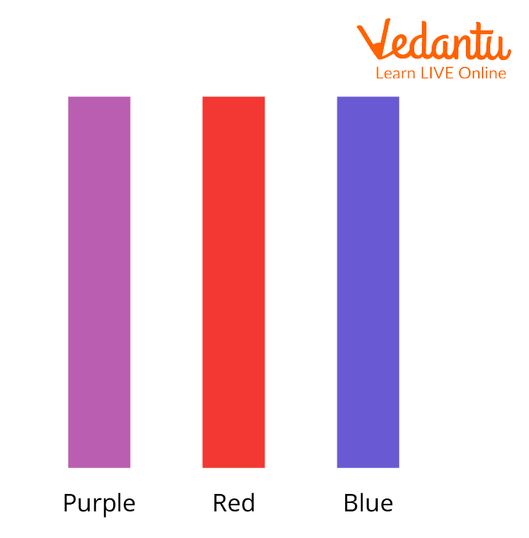
A) Acid B) Base C) Indicator D) Salt
- Which part of the human reproductive system produces sperm cells?
A) Ovaries B) Uterus C) Testes D) Fallopian tubes
- The period of physical and emotional changes that occurs during the transition from childhood to adulthood is called: A) Infancy B) Childhood C) Adolescence D) Old age
- Which of the following is a common physical change that occurs during adolescence in both boys and girls? A) Decrease in height. B) Loss of hair. C) Growth spurt. D) Weakening of bones.
- The main function of the human excretory system is to: A) Digest food. B) Transport oxygen. C) Remove waste products from the body. D) Control body movements.
- Which of the following organs is part of the human excretory system? A) Heart B) Lungs C) Kidneys D) Stomach
- Which of the following is a common kidney disorder? A) Asthma B) Diabetes C) Kidney stones D) Malaria
- What is electrical energy? A) Energy possessed by moving objects. B) Energy stored in chemical substances. C) Energy resulting from the flow of electric charge. D) Energy radiated in the form of waves.
- A simple electric circuit must contain: A) A switch and a bulb only. B) A battery, wires, and a switch only. C) A source of energy, a conducting path, and a load. D) A bulb and wires only.
- Which of the following common electrical appliances converts electrical energy into heat energy? A) Electric fan B) Television C) Electric kettle D) Refrigerator
- Magnetism is the property of certain materials to: A) Conduct electricity. B) Attract or repel other magnetic materials. C) Produce light. D) Dissolve in water.
- Which of the following is an example of a magnetic material? A) Wood B) Plastic C) Iron D) Glass
- Which part of a magnet has the strongest magnetic force? A) The middle B) The sides C) The poles D) The entire magnet has equal strength.
- If you suspend a bar magnet freely, it will align itself in which direction? A) East-West B) North-South C) Up-Down D) Any random direction
- Which of the following is an application of magnets? A) Burning fuel in a car engine. B) Generating electricity in a dynamo. C) Filtering water using sand. D) Cooking food on a stove.
- Where does the natural magnetism of the Earth originate from, acting like a giant bar magnet? A) The Earth's atmosphere. B) The Earth's crust. C) The Earth's mantle. D) The Earth's core.

SECTION B: (40 Marks)
- During a science lesson, Sarah and John were conducting an experiment. Sarah was heating a liquid in a test tube, but she forgot to point the open end away from herself and others. Suddenly, some hot liquid splashed out and slightly burned her hand. John rushed to help.
  - Identify two unsafe actions that Sarah committed. (2 marks)
(i) _________________________________________________________________________
(ii) _________________________________________________________________________
  - Describe the immediate first aid procedure that John should follow to help Sarah. (3 marks)
________________________________________________________________________________________________________________________________________________________________________________________________________________________________________________________________________________________________
  - Besides burns, list two other common accidents that can occur in a science laboratory and state one relevant first aid measure for each. (8 marks)
Accident | First Aid Measure
(i)
(ii)
- In the school kitchen, the cook accidentally mixed sugar, salt, and iron filings in a container of flour. They need to separate these components.
  - Classify the initial mixture of flour, sugar, salt, and iron filings as either a homogeneous or heterogeneous mixture. Give a reason for your answer. (3 marks)
Classification: _________________________
Reason: _________________________________________________________________________
  - Describe a step-by-step procedure the cook could use to separate the iron filings from the rest of the mixture. Name the separation technique used in this step. (4 marks)
Procedure:
(i) _________________________________________________________________________
(ii) _________________________________________________________________________
Technique: _________________________
  - After removing the iron filings, the cook has a mixture of flour, sugar, and salt. Describe how they could separate the sugar and salt from the flour. Name the separation technique used. (4 marks) Procedure:
(i) _________________________________________________________________________
(ii) _________________________________________________________________________
Technique: _________________________
  - Finally, the cook has a solution of sugar and salt in water (after dissolving the mixture). Explain how they can separate the sugar from the salt. Name the separation technique used. (5 marks)
Explanation:
____________________________________________________________________________________________________________________________________________________________________
Technique: _________________________
- During a health science lesson, the teacher was explaining the human reproductive and excretory systems.
  - Draw a simple labeled diagram of either the male or female reproductive system. Label at least three main parts. (4 marks)

  - Explain two ways in which the human excretory system helps to maintain homeostasis (balance) in the body. (4 marks)
(i) _________________________________________________________________________
(ii) _________________________________________________________________________
- James is learning about simple electric circuits and magnetism in his science class. He sets up a simple circuit with a battery, a switch, and a light bulb. He also has a coiled naked copper wire around an iron nail.
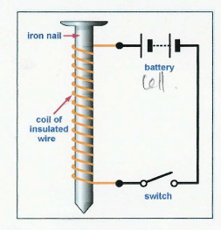
He places some iron fillings around the set up.

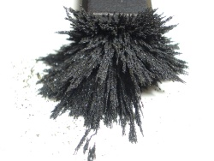
Iron fillings

Explain what will happen to the light bulb when James closes the switch in his simple circuit. Why does this happen? (3 marks)
______________________________________________________________________________________________________________________________________________________________________________________________________________________________________________________________________________________________________________________________________________________________________________________________
THIS IS THE LAST PRINTED PAGE.

