
THE KENYA NATIONAL JUNIOR EXAMINATIONS AND ASSESSMENT SERIES
JULY-AUGUST 2025
705/1: INTEGRATED SCIENCE (Theory)

MARKING SCHEME

Section A:
- C
- B
- C
- B
- C
- C
- C
- C
- C
- C
- D
- C
- C
- C
- C
- C
- C
- C
- C
- C
- C
- C
- C
- C
- B
- C
- C
- B
- B
- D

Section B:

Question 31: Laboratory Safety and First Aid
a. Identify two unsafe actions that Sarah committed. (2 marks)
(i) Sarah forgot to point the open end of the test tube away from herself and others while heating the liquid. This is crucial to prevent splashes of hot liquid from causing burns or injuries. (ii) Sarah did not wear appropriate safety gear such as safety goggles, which would have protected her eyes, and possibly a lab coat or gloves to protect her skin from splashes.
b. Describe the immediate first aid procedure that John should follow to help Sarah. (3 marks) The immediate first aid procedure for a minor burn from hot liquid is:
- Cool the burn: John should immediately guide Sarah to place the burned hand under cool (not cold or icy) running water for at least 10-20 minutes. This helps to stop the burning process, reduce pain, and prevent further tissue damage.
- Remove any restrictive items: If there are any rings, watches, or tight clothing around the burned area, John should help Sarah gently remove them before swelling occurs.
- Cover the burn loosely: After cooling, John should loosely cover the burn with a clean, non-stick dressing (like sterile gauze or a clean plastic wrap). He should avoid applying any creams, oils, or home remedies to the burn.
- Seek medical attention: For any burn, even a minor one, it's important to inform the teacher or supervisor immediately so that proper medical evaluation and care can be sought if necessary.
c. Besides burns, list two other common accidents that can occur in a science laboratory and state one relevant first aid measure for each. (8 marks)
Accident | First Aid Measure
(i) Chemical Spills on Skin/Eyes | If a chemical spills on the skin, immediately wash the affected area with copious amounts of running water for at least 15-20 minutes. Remove any contaminated clothing. If chemicals get into the eyes, immediately flush the eyes thoroughly with water using an eyewash station for at least 15-20 minutes, holding the eyelids open. Always inform the teacher or supervisor immediately after starting first aid and seek medical attention.
(ii) Cuts from Broken Glassware | For a minor cut, rinse the wound thoroughly with clean running water to remove any glass fragments and dirt. Apply gentle pressure with a clean cloth or sterile gauze to stop the bleeding. Once bleeding stops, clean the wound with mild soap and water, then apply an antiseptic and a sterile dressing. For deeper or profusely bleeding cuts, apply firm pressure to the wound, elevate the injured limb if possible, and seek immediate medical attention (e.g., call for a teacher/first aid attendant). Ensure all broken glass is safely disposed of.
(iii) Inhalation of Fumes | If someone inhales harmful fumes, immediately move the affected person to fresh air. Loosen any tight clothing around their neck or chest. If the person is unconscious or experiencing difficulty breathing, place them in the recovery position and seek urgent medical help. Always inform the teacher or supervisor immediately.
(iv) Ingestion of Chemicals | If a chemical is accidentally swallowed, do NOT induce vomiting unless instructed by medical personnel or poison control. Immediately seek urgent medical attention and provide details of the chemical ingested (e.g., by showing the container or MSDS). If the person is conscious, they may be given a small amount of water to dilute the chemical, but only if instructed.
(v) Fire (Small, Contained) | For a small, contained fire (e.g., in a beaker), suffocate the flames by covering it with a watch glass, beaker, or fire blanket. If it's a larger but still manageable fire, use the nearest fire extinguisher (e.g., CO2 for electrical fires, water for paper fires, etc.), aiming at the base of the flames. For any fire, immediately alert everyone in the laboratory and the teacher, and be prepared to evacuate if the fire cannot be safely controlled. Always know the location of fire safety equipment.

Question 32: Separation Techniques
a. Classify the initial mixture of flour, sugar, salt, and iron filings as either a homogeneous or heterogeneous mixture. Give a reason for your answer. (3 marks)
Classification: Heterogeneous mixture
Reason: A heterogeneous mixture is one in which the components are not uniformly distributed throughout and can be easily distinguished visually or by simple means. In this mixture, you can visually see the separate components like the dark iron filings, and possibly clumps of sugar/salt mixed with the flour, showing distinct phases. They do not form a single, uniform phase.
b. Describe a step-by-step procedure the cook could use to separate the iron filings from the rest of the mixture. Name the separation technique used in this step. (4 marks)
Procedure:
(i) Spread the mixture thinly on a flat surface, such as a tray or a large piece of paper.
(ii) Pass a strong magnet over the mixture. The iron filings, being magnetic, will stick to the magnet, while the non-magnetic flour, sugar, and salt will be left behind. Repeat this several times to ensure all iron filings are removed.
Technique: Magnetic Separation / Magnetism
c. After removing the iron filings, the cook has a mixture of flour, sugar, and salt. Describe how they could separate the sugar and salt from the flour. Name the separation technique used. (4 marks)
Procedure:
(i) Add water to the mixture of flour, sugar, and salt and stir thoroughly. The sugar and salt are soluble in water and will dissolve to form a solution, while the flour is insoluble and will remain suspended in the water.
(ii) Pour the mixture through a filter paper in a funnel. The insoluble flour will be trapped by the filter paper (residue), and the sugar-salt solution (filtrate) will pass through. The flour can then be dried. Technique: Filtration
d. Finally, the cook has a solution of sugar and salt in water (after dissolving the mixture). Explain how they can separate the sugar from the salt. Name the separation technique used. (5 marks)
Explanation: To separate sugar from salt in a solution, a technique called fractional crystallization or evaporation followed by controlled cooling and crystallization can be used, exploiting their different solubilities at varying temperatures.
Since sugar and salt have different solubility at different temperatures, one can exploit this.
- Evaporate the solution to near dryness. Both sugar and salt will be left as solids.
- Add a specific solvent in which one substance is soluble and the other is not (e.g., ethanol can dissolve sugar more readily than salt, or vice versa depending on conditions, although this is more advanced). A simpler approach is to use the principle of different crystallization rates.
- Controlled cooling: Heat the solution to dissolve both completely, then allow it to cool slowly. Often, one component (e.g., salt) will crystallize out first if its solubility changes more rapidly with temperature, or if its saturation point is reached earlier. The other component (sugar) can then be recovered by further evaporation or cooling.
Technique: Fractional Crystallization / Evaporation (and subsequent controlled crystallization based on solubility differences).

Question 33: Human Reproductive and Excretory Systems
a. Draw a simple labeled diagram of either the male or female reproductive system. Label at least three main parts. (4 marks)
Option 1: Male Reproductive System Diagram
- Drawing: A simplified diagram showing the general layout.
- Labels (at least three):
  - Testis/Testes: (Primary reproductive organ, produces sperm and hormones)
  - Scrotum: (Sac holding the testes outside the body)
  - Epididymis: (Where sperm mature and are stored)
  - Vas Deferens (Sperm Duct): (Tube that transports sperm)
  - Seminal Vesicle: (Produces fluid for semen)
  - Prostate Gland: (Produces fluid for semen)
  - Urethra: (Carries urine and semen out of the body)
  - Penis: (External organ for copulation and urination)

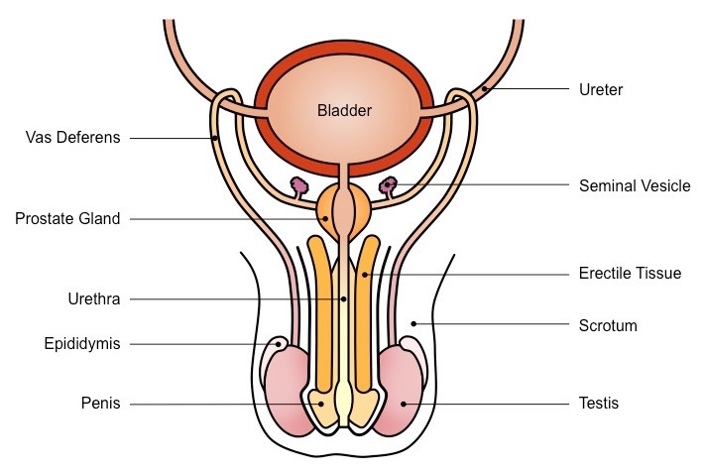
Option 2: Female Reproductive System Diagram
- Drawing: A simplified diagram showing the general layout.
- Labels (at least three):
  - Ovary/Ovaries: (Primary reproductive organs, produce eggs and hormones)
  - Fallopian Tube (Oviduct): (Tube connecting ovary to uterus, where fertilization often occurs)
  - Uterus: (Womb, where a fertilized egg implants and develops)
  - Cervix: (Narrow opening at the bottom of the uterus)
  - Vagina: (Birth canal and passage for menstrual flow)

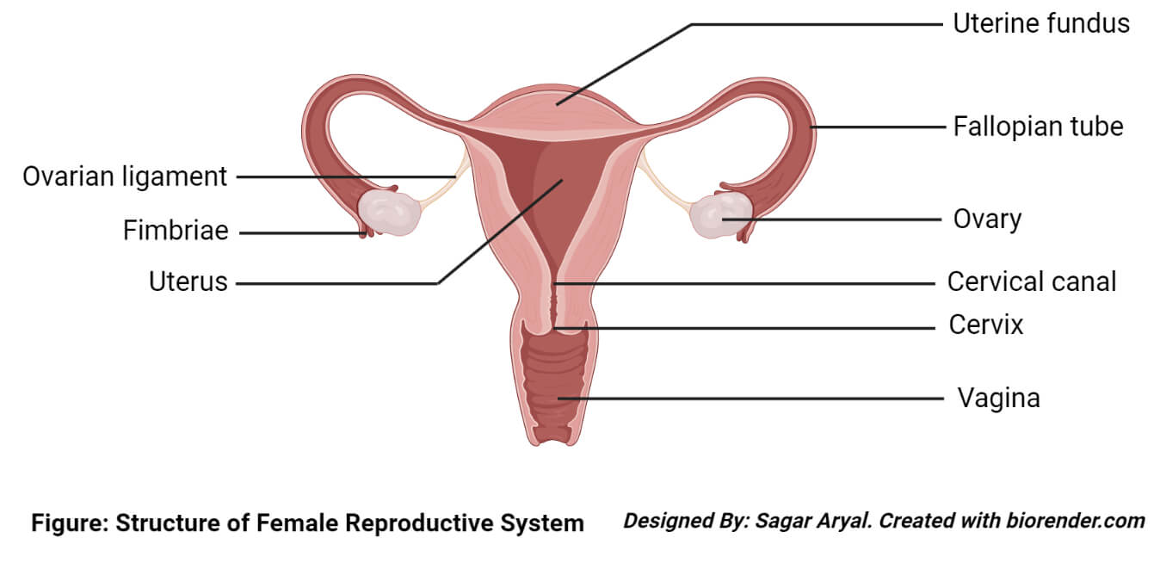

b. Explain two ways in which the human excretory system helps to maintain homeostasis (balance) in the body. (4 marks)
(i) Regulation of Water and Salt Balance (Osmoregulation): The kidneys, as part of the excretory system, play a crucial role in maintaining the body's water and salt balance. They filter blood and selectively reabsorb or excrete water and various salts (like sodium, potassium, chloride). If the body has too much water, the kidneys produce more dilute urine to remove excess water. If the body is dehydrated, they conserve water by producing concentrated urine. This precise regulation prevents swelling or dehydration of cells and maintains the proper concentration of electrolytes, which is vital for nerve and muscle function.
(ii) Removal of Metabolic Waste Products: The excretory system removes harmful metabolic waste products from the blood, such as urea (from protein metabolism), uric acid, creatinine, and other toxins. If these waste products accumulated in the body, they would become toxic and disrupt normal cellular functions, leading to serious health issues. The kidneys filter these substances out of the blood, and they are then expelled from the body primarily in urine. This ensures the body's internal environment remains clean and free from harmful substances, supporting optimal physiological functioning.
(iii) Regulation of Blood pH: The kidneys also help maintain the body's acid-base balance (pH homeostasis). They can excrete excess hydrogen ions (acids) and reabsorb bicarbonate ions (bases) as needed. This ensures that the blood pH stays within a narrow, healthy range, which is critical for enzyme function and overall cellular processes.

Question 34: Simple Electric Circuits and Electromagnetism
Regarding the coiled naked copper wire around an iron nail and the iron filings: When the switch is closed, the current flowing through the coiled copper wire around the iron nail will also create a temporary magnet (an electromagnet). This electromagnet will then attract the iron filings placed around the setup. This demonstrates the relationship between electricity and magnetism, where an electric current can produce a magnetic field.
THIS IS THE LAST PRINTED PAGE.

