
THE KENYA NATIONAL JUNIOR EXAMINATIONS AND ASSESSMENT SERIES
JULY-AUGUST 2025
711/2: CREATIVE ARTS AND SPORTS (Theory)

MARKING SCHEME

SECTION A:
- C. Line
- B. Rhythm
- C. 4/4
- B. Collage
- A. Percussion
- C. Storyboard
- C. Pivoting
- C. Freestyle
- C. Bump
- C. Catchy and memorable
- B. Audibility
- C. Aural training
- C. A visual composition of cut-out photos
- C. Proportion
- C. Piano
- B. Flipbook animation
- C. To cooperate with teammates
- B. Storytelling
- B. Balanced rhythm and harmony
- B. Colour theory
- C. 3
- B. Luo
- C. Theme
- B. To keep time and rhythm
- C. Value
- A. Long-distance running
- D. Occupational dance
- C. To prepare muscles for movement
- B. Facial proportion
- A. Trick an opponent
- C. To defend against opponents
- B. Violin
- C. Metronome
- D. Breaststroke
- B. Picture made by assembling different materials
- A. Musical notation
- C. Type and size of the instrument
- B. To promote cooperation and success
- B. Monologue
- C. Emphasis

SECTION B:

PART I: VISUAL ARTS
41. Your school is organizing an environmental awareness campaign. You are asked to design a poster to encourage students to keep the environment clean.
a) Name two elements of art you would use in your poster design. (2 marks)
i. Line
ii. Color (Other valid answers include: Shape, Form, Value, Texture, Space)
b) Define collage as a visual art technique. (2 marks)
Collage is a visual art technique where an artwork is created by assembling and gluing various materials onto a surface. These materials can include paper, fabric, photographs, and other objects, often to create a new whole or convey a specific message.
c) List two materials you would need to make a collage about nature. (2 marks)
i. Magazine clippings or printed images of natural elements (e.g., leaves, flowers, animals, landscapes)
ii. Glue or adhesive (Other valid answers include: Scissors, Construction paper/cardboard for background, Natural elements like dried leaves or twigs)
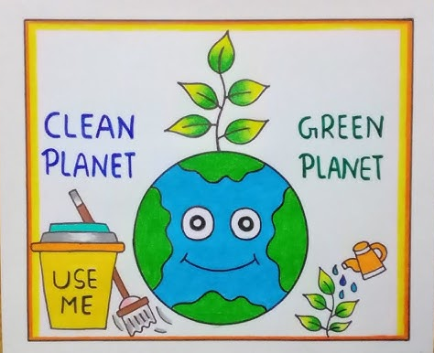
d) Draw and label a simple poster layout promoting cleanliness. Include a slogan. (4 marks)

- Top Center: A clear, bold slogan like "KEEP OUR EARTH GREEN & CLEAN!"
- Middle Section: A central image depicting a clean environment (e.g., a hand putting trash in a bin, a sparkling clean park, a healthy tree). This could be a simple drawing or a representation of a collage.
- Bottom Section: Two or three small, simple illustrations showing actions that promote cleanliness (e.g., a recycling symbol, a broom, a plant being watered).
- Overall: Use bright, appealing colors. The text should be legible and impactful.

PART II: PERFORMING ARTS (Music, Dance, Drama)
42. Your class is preparing a short musical performance about peace in the community.
a) Write the symbols for the following note values: (4 marks)
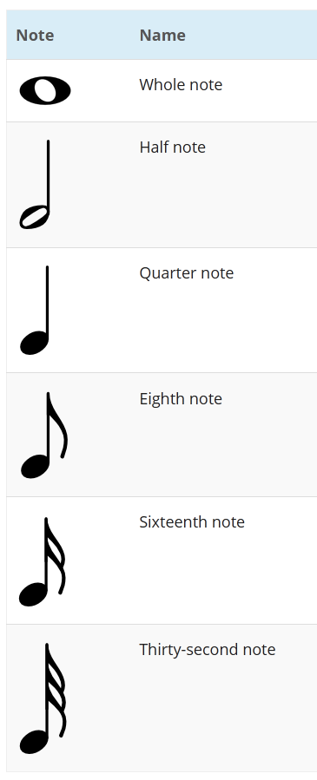

b) Name two time signatures you could use in your peace song. (2 marks)
i. 4/4 (Common time)
ii. 2/4 (Other valid answers include: 3/4)
c) Mention two traditional musical instruments you could include in the performance and state the Kenyan community that uses each. (4 marks)
i. Instrument: Nyatiti - Community: Luo
ii. Instrument: Kayamba - Community: Mijikenda (or generally coastal communities) (Other valid answers include: Orutu - Luo; Isukuti - Luhya; Wandindi - Kamba; Chepkong' - Kalenjin/Nandi)
d) State two roles of music in promoting peace and unity in society. (2 marks)
i. Music can bring people together through shared experiences like singing or dancing, fostering a sense of community and common identity.
ii. Music can convey powerful messages of reconciliation, understanding, and hope, inspiring listeners to overcome differences and work towards a peaceful coexistence.
e) Write a 4-bar rhythm using crotchets and minims in 4/4 time. (4 marks)
| q q q q | d q q | q d q | d d |
(Explanation: Each bar represents 4 beats in 4/4 time. 'q' represents a crotchet (1 beat), and 'd' represents a minim (2 beats). The example above provides a valid 4-bar rhythm.)
f) Give one way storytelling is used in drama. (1 mark)
Storytelling in drama is used to develop the plot and reveal character motivations, guiding the audience through the narrative and helping them understand the characters' actions and feelings.
g) Why is teamwork important in performing a dance as a group? (1 mark)
Teamwork is crucial in group dance to ensure synchronized movements, shared understanding of choreography, and a cohesive performance, leading to a visually appealing and impactful presentation.

PART III: SPORTS AND PHYSICAL EDUCATION
42. Your school is hosting a friendly sports competition. You are part of the organizing team.
a) Name two types of passes used in handball during the competition. (2 marks)
i. Overhead pass ii. Bounce pass (Other valid answers include: Chest pass, Underhand pass)
b) Describe pivoting and explain why it is important in netball. (2 marks)
Pivoting in netball is the act of turning on the ball of one foot while keeping the other foot stationary, allowing a player to change direction without moving offside. It is important because it enables a player to evade defenders, find space, and make passes effectively, all while staying within the rules of the game.
c) List two safety rules to follow when throwing a javelin. (2 marks)
i. Ensure the throwing area is clear of people and obstructions before throwing. ii. Always retrieve the javelin from the point first, walking towards it carefully, and never throwing it back. (Other valid answers include: Throw only when instructed by a coach; Never turn your back on a thrown javelin; Hold the javelin correctly.)
d) Name three swimming styles you would demonstrate during the inter-house swimming gala. (3 marks)
i. Freestyle (Crawl stroke)
ii. Breaststroke
iii. Backstroke (Other valid answers include: Butterfly)
e) Explain one reason why warming up before playing football is necessary. (2 marks) Warming up before playing football is necessary to gradually increase muscle temperature and blood flow, which helps to prepare the muscles for intense activity, improve flexibility, and significantly reduce the risk of injuries like strains or pulls.
f) Mention one way sports promote discipline among learners. (1 mark)
Sports promote discipline by requiring adherence to rules, consistent practice, and respect for teammates, opponents, and officials, fostering self-control and a sense of order.
g) During the race, Mary showed endurance and agility. Define each of the two terms. (4 marks)
Endurance refers to the ability of an athlete to sustain prolonged physical effort without undue fatigue. In the context of a race, it means Mary could maintain her pace and effort over a long distance or duration.
Agility is the ability to change the direction and position of the body quickly and efficiently while maintaining balance. In a race, this would allow Mary to respond rapidly to changes in the terrain or to avoid obstacles.
h) What is the correct body posture when serving a volleyball? (2 marks)
When serving a volleyball, the correct body posture generally involves standing with the non-hitting shoulder facing the net, a slight bend in the knees, and the body weight shifted from the back foot to the front foot as the arm swings to contact the ball. The non-hitting arm typically holds the ball out in front.
i) State one reason why players wear appropriate sports gear during games. (1 mark) Players wear appropriate sports gear during games primarily for safety and protection against injuries (e.g., helmets, pads, supportive footwear) and to enhance performance (e.g., lightweight clothing, specialized shoes for grip).

THIS IS THE LAST PRINTED PAGE.

