

COMPETENCE BASED EDUCATION
Every learner counts
Values and competencies
GRADE 6
SOCIAL STUDIES
Name: .....................................................................................................................
School: ................ ..................................................... .............................................
Date: ................................................Assessment number: ...............................
INSTRUCTIONS FOR THIS EXAMINATION
Before the Examination Begins:
- Do not open this question paper until you are told to do so.
- Ensure that you have the correct question paper for the subject and level you are registered for.
- Write your Name, school, date and assessment Number clearly in the spaces provided on the answer sheet and the question paper (if applicable).
- Listen carefully to any instructions given by the invigilator.
- Ask the invigilator if you have any questions about the instructions or the question paper before you begin.
During the Examination:
- Read each question carefully before attempting to answer it. Understand what is being asked.
- Answer all questions unless instructed otherwise.
- For multiple-choice questions:
  - Choose the one correct answer from the options provided.
  - Indicate your choice clearly on the answer sheet by shading the letter corresponding to the correct answer.
  - If you make a mistake, erase your previous answer completely before marking a new one.
  - Do not make any stray marks on the answer sheet.
- For questions requiring written answers (if applicable in other formats):
  - Write your answers clearly and concisely in the spaces provided.
  - Ensure your handwriting is legible.
  - Show your working where necessary, as marks may be awarded for correct steps.
  - Use a blue or black pen for writing your answers. Do not use pencil unless specifically instructed.
- Manage your time effectively. Allocate your time according to the number of questions and the marks allocated to each question.
- If you are unsure of an answer, move on to the next question and come back to it later if you have time.
- Do not spend too much time on any one question.
- Do not talk to or communicate with other candidates during the examination. Any form of cheating or collusion will result in disqualification.
- Keep your eyes on your own work.
- Raise your hand if you need assistance from the invigilator.

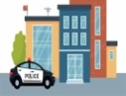
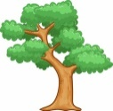
Answer all question Study the map of Nyasita Area and answer the questions thst follow
F.T-FISH TRAP
LAKE
SETTLEMENT
FOREST
RIVER
SUGARCANE PLANTATION
BRIDGE
TARMAC ROAD
CHIEFS CAMP
MARKET
CHURCH

CHIEF’S CAMP
River Nyasita

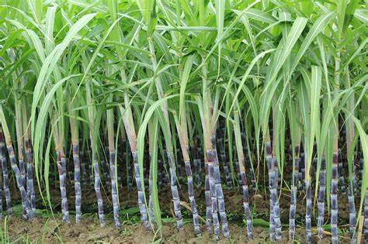

FT FT Nyasita school

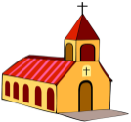
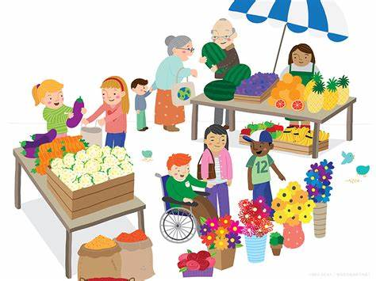
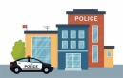
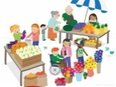
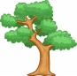
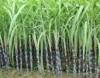
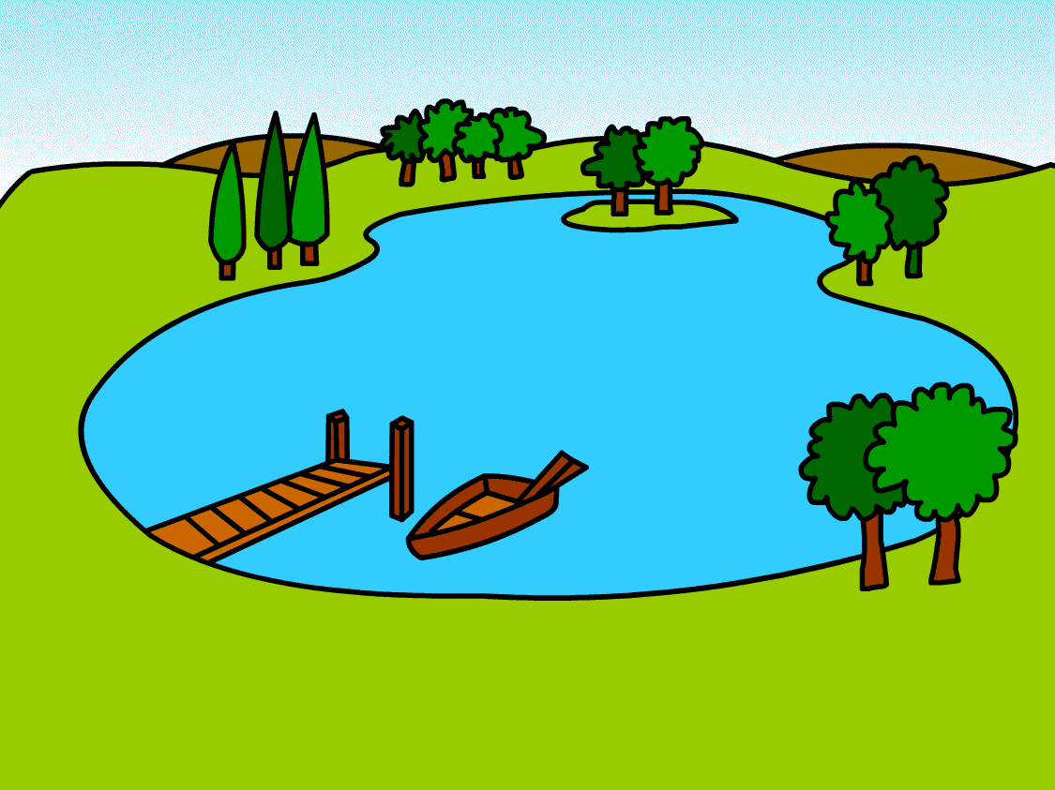
CV
CV
CV
CV
CV
CV
CV
CV
CV
CV
CV
CV

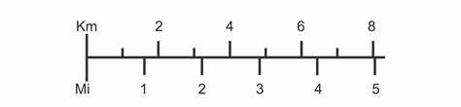
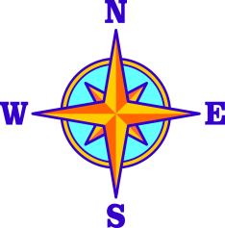

QUESTIONS

- What type of settlement is shown on the map?
A.dispersed B. linear
C. nuclear D. clustered
- The map shows a river flowing through the area. What is its name?
A. River Tana B. River Athi
C. River Nyasita D. River Nile
- The Chief's Camp is located close to which natural feature, based on the text layout?
A. The Forest B. The Lake C. River Nyasita D. The Sugarcane Plantation
- How do people likely cross the River in the Nyasita area?
A. By boat only B. By swimming C. Using a Bridge D. They cannot cross
- What do the letters "FT" on the map stand for?
A. Forest Trail B. Fishing Town C. Fish Trap D. Factory Tower
- What is the name of the school found in the Nyasita area?
A. Nyasita University B. Nyasita Primary C. Nyasita School D. Nyasita Academy
- The presence of Fish Traps (FT) suggests that people in Nyasita practice which activity?
A. Hunting B. Farming C. Fishing D. Mining
- Besides the river and lake, what other major natural area is shown on the map? A. Mountains B. Desert C. Swamp D. Forest

- Amina is a 12-year-old girl who loves reading and wants to become a teacher. Her parents believe girls should not go to school and want her to stay home. Which basic right of Amina is being denied? A. The right to play B. The right to education C. The right to health D. The right to protection
- The children in Mawingu Village have noticed that the local stream where they fetch water is getting dirty because people are throwing rubbish into it. As responsible citizens, what should they do first? A. Go to the next village to fetch water B. Organize a clean-up and report to the local chief C. Start throwing their own rubbish into the stream D. Wait for someone else to clean the stream
- During a school trip, learners saw the following symbol o the road. What does this symbol most likely represent?
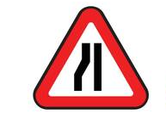

A. A narrow road ahead
B. A school ahead
C. A market ahead
D. A river ahead
- Musa is using a map to find his way from his home to the market. The sun rises in front of him as he starts his journey. In which cardinal direction is the market located from his home? A. North B. South C. East D. West
- Which physical feature is a large natural stream of water flowing across the land? A. Mountain B. Plain C. River D. Lake
- In a traditional Maasai community before colonial times, wealth and social status were mainly measured by the number of cattle a family owned. What was the primary economic activity of the Maasai people? A. Crop farming B. Fishing C. Pastoralism (livestock keeping) D. Trade
- The Mijikenda community lived along the coast and engaged in farming and trade. They had a system where elders ruled their different groups. What was a common name for the council of elders who made decisions in many pre-colonial Kenyan societies? A. Parliament B. Cabinet C. Council of Elders D. Village Committee
- Who were the first European visitors to the East African coast, primarily seeking trade routes to Asia? A. Germans B. British C. Portuguese D. French
- During the holy month of Ramadhan, Muslims around the world fast from dawn till sunset. This is a pillar of Islam. What is the name of this holy month? A. Hajj B. Eid al-Fitr C. Ramadan D. Zakat
- Christians gather on Sunday mornings to worship God, listen to sermons, and sing hymns. What is their place of worship called? A. Mosque B. Temple C. Church D. Shrine
- In some African Traditional Religions, people offer sacrifices and prayers to a supreme being through intermediaries like ancestral spirits. Who are often highly respected in these religions and play a key role in communicating with spirits? A. Prophets B. Imams C. Pastors D. Elders and traditional healers
- The government and local community in Kibwezi are working together to stop trees from being cut down carelessly and are planting new ones to replace those that are lost. What is this effort called? A. Deforestation B. Urbanization C. Conservation D. Pollution
- Factories releasing smoke into the air and vehicles emitting fumes are causing the air quality to be poor in Nairobi city. What type of pollution is affecting Nairobi? A. Water pollution B. Noise pollution C. Air pollution D. Soil erosion
- Who is the elected head of the county government in Kenya? A. Member of Parliament (MP) B. Senator C. Governor D. President
- The Kenyan national flag has different colours and symbols. The black colour represents the people of Kenya. What does the red colour on the flag represent? A. Peace and unity B. Fertility of the land C. Struggle for freedom / Blood shed D. Natural wealth
- On a map, you see a ratio like 1:50,000. What does this ratio represent on the map? A. The direction to a place B. The height of a mountain C. The scale of the map D. A type of symbol used
- Before the colonial period, how did many communities in Kenya interact with each other? A. Only through conflict and warfare B. Only through peaceful trade C. Through a mix of trade, cultural exchange, and sometimes conflict D. They did not interact with each other at all
- Peter found a lost wallet belonging to his neighbour. He returned it without taking anything from it. Which important value did Peter show? A. Disrespect B. Dishonesty C. Responsibility D. Greed
- Which body in the Kenyan government makes laws for the country? A. The Judiciary B. The Executive C. The Parliament D. The Cabinet
- An area receives heavy rainfall throughout the year and has dense trees and vegetation. What type of natural vegetation is likely found there? A. Desert plants B. Grasslands C. Forests D. Savannah
- Muslims celebrate Eid al-Fitr after the month of fasting. What does Eid al-Fitr mark the end of? A. The Hajj pilgrimage B. The month of Ramadan C. The prayer times D. The giving of Zakat
- Imagine you are looking at a map, and you see the symbol 'H'. What does this symbol commonly represent on a map? A. Hotel B. Home C. Hospital D. Hill
- What is the term for a large body of water surrounded by land? A. River B. Ocean C. Lake D. Swamp
- Sarah is a child who is being forced to work long hours instead of attending school. Which organization in Kenya is specifically responsible for protecting children's rights and well-being? A. Kenya Police Service B. Teachers Service Commission (TSC) C. National Council for Children Services (NCCS) D. Kenya National Union of Teachers (KNUT)
- Which group of early visitors were mainly involved in the slave trade from the East African coast? A. Chinese and Indians B. Arabs and Europeans C. Africans from the interior D. Persians and Turks
- Sarah and her family are planning a trip to visit their relatives in Uganda. They live near Kisumu, Kenya, which is close to a very large lake that borders Kenya, Uganda, and Tanzania. Which major lake will they be close to before crossing the border? A. Lake Turkana B. Lake Victoria C. Lake Nakuru D. Lake Tanganyika
- You are looking at a map of Eastern Africa. You see the country located directly to the north of Kenya. Which country is this? A. Tanzania B. Somalia C. Ethiopia D. Sudan
- What geological process involves the movement of molten rock (magma) from beneath the earth's crust to the surface, sometimes forming mountains or causing eruptions? A. Erosion B. Faulting C. Folding D. Volcanicity
- Farmers in areas surrounding Mount Kenya and Mount Kilimanjaro often find the soil is very good for growing crops, even though these are volcanic mountains. What is a key benefit of volcanic soils for farming? A. They are very sandy and drain quickly. B. They contain many fertile minerals. C. They are always wet. D. They prevent pests from growing.
- Heavy rains have caused the River Tana to swell. The water level rises rapidly and spreads over the surrounding plains, covering houses and farms. What natural event is described in this scenario? A. Drought B. Earthquake C. Flooding D. Landslide
- Which major geological feature in Eastern Africa was formed by the process of faulting, where large blocks of the earth's crust dropped down? A. Mount Kenya B. Lake Victoria C. The Great Rift Valley D. The Indian Ocean
- Workers in a mining area in Kajiado are extracting a mineral that is used to make cement and plaster. What mineral are they most likely mining? A. Gold B. Fluorspar C. Soda Ash D. Gypsum
- Kenya is known for mining soda ash, which is used to make glass and detergents. In which lake is soda ash primarily mined in Kenya? A. Lake Nakuru B. Lake Turkana C. Lake Victoria D. Lake Magadi
- Stephen is a Kenyan citizen who turned 18 years old last month. He is excited because he can now exercise a very important right. Which right did he gain when he turned 18? A. The right to primary education B. The right to drive a car C. The right to vote in elections D. The right to own property
- How many counties does Kenya have, each with its own county government? A. 47 B. 52 C. 38 D. 29
- Mombasa is a major city on the coast of Kenya, important for trade and tourism. In which county is Mombasa city located? A. Nairobi County B. Kilifi County C. Kwale County D. Mombasa County
- In pre-colonial Uganda, there was a powerful kingdom whose ruler was called the 'Kabaka'. What was the name of this famous kingdom? A. Ankole Kingdom B. Toro Kingdom C. Bunyoro Kingdom D. Buganda Kingdom
- In the traditional Ameru community of Kenya, important cultural, social, and judicial matters were decided by a respected council of elders known for upholding justice and traditions. What was the name of this council? A. Iteso Council B. Njuri Ncheke C. Council of 40 D. Kiru Commission
- What is the main purpose of the 'key' or 'legend' on a map? A. To show the direction North B. To indicate the scale of the map C. To explain the meaning of symbols used on the map D. To show the title of the map
- A community living near a protected forest has formed a group to help the Kenya Forest Service patrol the area, plant new trees, and educate people about the importance of trees. What is this community group participating in? A. Deforestation B. Environmental Conservation C. Urban Development D. Industrialization
- Which economic activity involves the rearing of animals like cattle, sheep, and goats for milk, meat, and other products? A. Crop farming B. Fishing C. Pastoralism D. Mining
- If you want to raise an issue about poor roads or lack of water in your ward (a smaller area within a county), who is the elected representative responsible for your ward at the county level? A. Governor B. Senator C. Woman Representative D. Member of County Assembly (MCA)

ANSWER KEY
  - B
  - C
  - C
  - C
  - C
  - C
  - C
  - D
  - B
  - B
  - A
  - D
  - C
  - C
  - C
  - C
  - C
  - C
  - C
  - C
  - C
  - C
  - C
  - B
  - D
  - C
  - A
  - B
  - C
  - D
  - C
  - C
  - B
  - B
  - C
  - D
  - B
  - C
  - C
  - D
  - D
  - D
  - C
  - A
  - C
  - B
  - C
  - C
  - C
  - D

