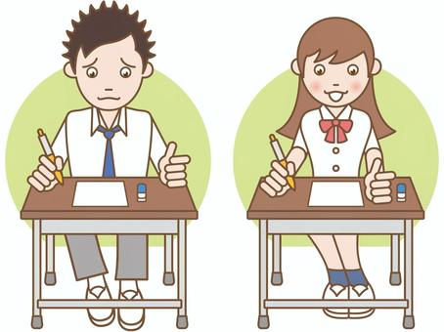

COMPETENCE BASED EDUCATION
Every learner counts
Values and competencies
GRADE 6
SCIENCE AND TECHNOLOGY
Name: ....................................................................................................................
School: ....................................................................................................................
Date: ................................................Assessment number: ...............................
INSTRUCTIONS FOR THIS EXAMINATION TIME: 1 Hour 30 Minutes
Before the Examination Begins:
- Do not open this question paper until you are told to do so.
- Ensure that you have the correct question paper for the subject and level you are registered for.
- Write your Name, school, date and assessment Number clearly in the spaces provided on the answer sheet and the question paper (if applicable).
- Listen carefully to any instructions given by the invigilator.
- Ask the invigilator if you have any questions about the instructions or the question paper before you begin.
During the Examination:
- Read each question carefully before attempting to answer it. Understand what is being asked.
- Answer all questions unless instructed otherwise.
- For multiple-choice questions:
  - Choose the one correct answer from the options provided.
  - Indicate your choice clearly on the answer sheet by shading the letter corresponding to the correct answer.
  - If you make a mistake, erase your previous answer completely before marking a new one.
  - Do not make any stray marks on the answer sheet.
- For questions requiring written answers (if applicable in other formats):
  - Write your answers clearly and concisely in the spaces provided.
  - Ensure your handwriting is legible.
  - Show your working where necessary, as marks may be awarded for correct steps.
  - Use a blue or black pen for writing your answers. Do not use pencil unless specifically instructed.
- Manage your time effectively. Allocate your time according to the number of questions and the marks allocated to each question.
- If you are unsure of an answer, move on to the next question and come back to it later if you have time.
- Do not spend too much time on any one question.
- Do not talk to or communicate with other candidates during the examination. Any form of cheating or collusion will result in disqualification.
- Keep your eyes on your own work.
- Raise your hand if you need assistance from the invigilator.
Important Reminders:
  - Be honest and do your own work.
  - Follow all instructions given by the invigilator.
  - Attempt all questions to the best of your ability.
Answer all questions

- Sarah observed different animals in her local environment. She saw a chameleon that changes colour, a frog that lives in water and on land, a bird that flies, and a fish that swims. Which of these animals belongs to the amphibian group? A. Chameleon B. Frog C. Bird D. Fish
- Mwangi visited a forest and observed various plants. He saw some plants that produce cones instead of flowers or fruits. What group of plants do these belong to? A. Flowering plants B. Non-flowering plants C. Ferns D. Conifers
- A farmer noticed that his crops were not growing well. A science expert visited the farm and explained that some small living things in the soil help break down dead plants and animals, making the soil fertile. What are these small living things called? A. Insects B. Fungi and bacteria C. Worms D. Algae
- During a health lesson, the teacher explained how our bodies take in oxygen and release carbon dioxide. Which human body system is responsible for this exchange of gases? A. Digestive system B. Circulatory system C. Respiratory system D. Nervous system
- Tom felt his heart beating in his chest. The teacher explained that the heart is part of the system that transports blood, oxygen, and nutrients around the body. What is this system called? A. Digestive system B. Circulatory system C. Respiratory system D. Excretory system
- A community experienced an outbreak of a disease spread through contaminated water. What type of disease is this? A. Airbone disease B. Waterborne disease C. Vector-borne disease D. Deficiency disease
- Lisa's mother mixed sugar in warm water until it disappeared completely. What is the mixture called when a substance dissolves completely in a liquid? A. Suspension B. Solution C. Mixture D. Emulsion
- James was given a mixture of sand and iron filings. He was asked to separate them. Which property of iron filings can be used to separate them from the sand? A. Size B. Colour C. Magnetism D. Density
- Amani observed that when he leaves a glass of juice in the sun, the juice becomes warm. What method of heat transfer is mainly responsible for warming the juice in this case? A. Conduction B. Convection C. Radiation D. Insulation
- David was lifting a heavy bucket of water from a well using a rope and a wheel at the top. What simple machine is he using?
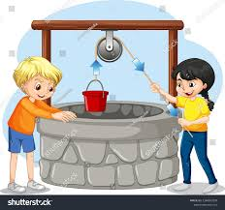
A. Lever B. Inclined plane C. Pulley D. Screw
- Mary used a ramp to push a heavy box into a truck. What simple machine is the ramp? A. Lever B. Pulley C. Wheel and axle D. Inclined plane
- During a science experiment, the teacher shone a beam of light onto a mirror, and the light bounced back. What do we call the bouncing back of light from a surface?
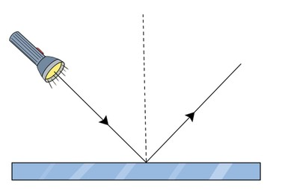

A. Refraction B. Reflection C. Absorption D. Transmission
- Omar placed a spoon in a glass of water and noticed that the spoon appeared bent at the point where it entered the water. What property of light causes this effect? A. Reflection B. Refraction C. Diffraction D. Scattering
- The school bell rang loudly, signaling the end of the lesson. Sound travels through different materials. Through which state of matter does sound travel fastest? A. Solid B. Liquid C. Gas D. Vacuum
- The teacher played a musical instrument that produced a high-pitched sound. Which property of sound refers to how high or low a sound is? A. Volume B. Loudness C. Pitch D. Echo
- On a hot day, Sarah wore light-coloured clothes and felt cooler than when she wears dark-coloured clothes. This is because light colours: A. Absorb more heat B. Reflect more heat C. Conduct heat better D. Insulate against heat
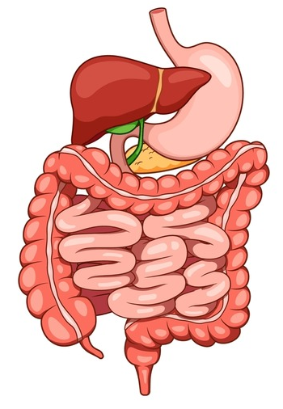
- Name the part marked T?

T

A. stomach B. colon C. ileum D. mouth
- James was learning about circulatory system. Which one of the following is not a blood vessel?
A.blood B.pulmonary artery C. aorta D. venacava
- The teacher explained that some human activities harm the environment, such as cutting down trees without planting new ones. What is the cutting down of trees over a large area called? A. Conservation B. Reforestation C. Deforestation D. Preservation
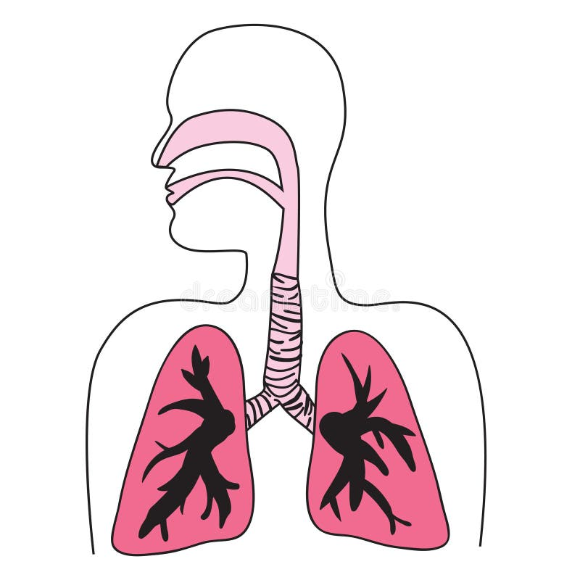
- A grade 5 learner was asked to identify a part of a breathing system.Name the area marked Z?

z

A. trachea B. Alveoli C. diaphragm D. bronchus
- Tom was using a computer to type a story. Which part of the computer displays the information he is typing and the results of his actions?


A. Keyboard B. Mouse C. Monitor D. Printer
- Lisa wanted to save her drawing on the computer so she could open it later. Which part of the computer is used for storing information? A. Monitor B. Keyboard C. Printer D. Hard drive
- David was using a device to click on icons and open files on the computer screen. What is this input device called? A. Keyboard B. Monitor C. Mouse D. Speaker
- Amina was researching online for her science project. What is the global network that connects computers and allows access to a vast amount of information called? A. Intranet B. Extranet C. Internet D. Network
- The teacher warned the learners about sharing personal information online. What is the practice of protecting yourself and your information while using the internet called? A. Online gaming B. Online shopping C. Online safety D. Online chatting
- Mwangi was following a set of step-by-step instructions to build a simple circuit. In technology, what do we call a set of instructions to solve a problem or perform a task? A. Data B. Program C. Algorithm D. Code
- Which of the following is an example of a harmful plant? A. Cabbage B. Tomato C. Poison Ivy D. Maize
- A student is observing different materials. Which of the following materials is an insulator of heat? A. Copper wire B. Aluminium foil C. Wooden stick D. Iron rod
- What phase of the moon is observed when the entire face of the moon is lit up? A. New moon B. Half moon C. Crescent moon D. Full moon
- Which of the following is a way to conserve water? A. Leaving the tap running while brushing teeth B. Fixing leaky pipes C. Watering plants during the hottest part of the day D. Using a hosepipe to wash the car

THIS IS THE LAST PRINTED PAGE

Answer Key:
- B
- D
- B
- C
- B
- B
- B
- C
- C
- C
- D
- B
- B
- A
- C
- B
- B
- A
- C
- A
- C
- D
- C
- C
- C
- C
- C
- C
- D
- B
SCRUTINISE THE MARKING SCHEME BEFORE MARKING LEARNER’S WORK

