

COMPETENCE BASED EDUCATION
Every learner counts
Values and competencies
GRADE 6
CREATIVE ARTS
Name: .....................................................................................................................
School: .......................................................................................................................
Date: ................................................Assessment number: ...............................
INSTRUCTIONS FOR THIS EXAMINATION
Before the Examination Begins:
- Do not open this question paper until you are told to do so.
- Ensure that you have the correct question paper for the subject and level you are registered for.
- Write your Name, school, date and assessment Number clearly in the spaces provided on the answer sheet and the question paper (if applicable).
- Listen carefully to any instructions given by the invigilator.
- Ask the invigilator if you have any questions about the instructions or the question paper before you begin.
During the Examination:
- Read each question carefully before attempting to answer it. Understand what is being asked.
- Answer all questions unless instructed otherwise.
- For multiple-choice questions:
  - Choose the one correct answer from the options provided.
  - Indicate your choice clearly on the answer sheet by shading the letter corresponding to the correct answer.
  - If you make a mistake, erase your previous answer completely before marking a new one.
  - Do not make any stray marks on the answer sheet.
- For questions requiring written answers (if applicable in other formats):
  - Write your answers clearly and concisely in the spaces provided.
  - Ensure your handwriting is legible.
  - Show your working where necessary, as marks may be awarded for correct steps.
  - Use a blue or black pen for writing your answers. Do not use pencil unless specifically instructed.
- Manage your time effectively. Allocate your time according to the number of questions and the marks allocated to each question.
- If you are unsure of an answer, move on to the next question and come back to it later if you have time.
- Do not spend too much time on any one question.
- Do not talk to or communicate with other candidates during the examination. Any form of cheating or collusion will result in disqualification.
- Keep your eyes on your own work.
- Raise your hand if you need assistance from the invigilator.
Important Reminders:
- Be honest and do your own work.
- Follow all instructions given by the invigilator.
- Attempt all questions to the best of your ability.
Answer all questions

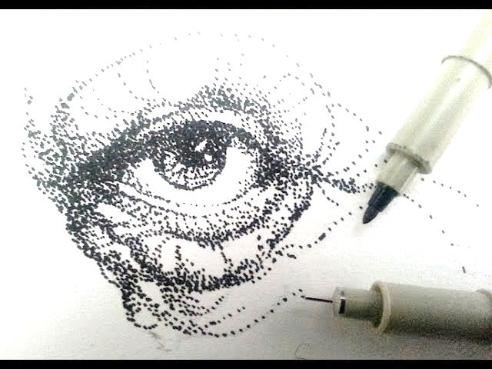
- Sarah was drawing a picture of a tree. She used small dots to create shades and textures. What drawing technique was Sarah using?

A. Smearing B. Stippling C. Hatching D. Scribbling
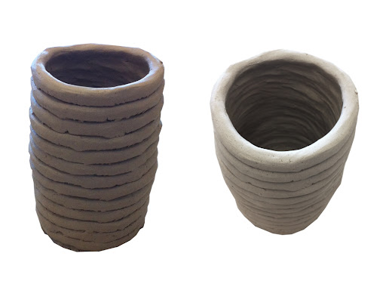
- Mwangi's class was making pots using clay. They rolled the clay into long ropes and joined them by coiling one on top of the other. What pottery technique were they using?

A. Pinching B. Slab technique C. Coiling D. Modelling
- A group of learners collected old magazines and newspapers. They cut out different pictures and words and pasted them onto a cardboard to create a new image. What art technique did they use? A. Painting B. Montage C. Collage D. Drawing
- Lisa was mixing colours for her painting. She mixed blue and yellow and got green. What type of colours are red, blue, and yellow? A. Secondary colours B. Tertiary colours C. Primary colours D. Complementary colours
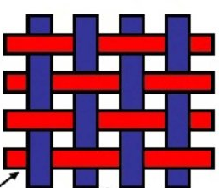
- James was weaving a small mat using flexible fibres. What are the threads marked S that run vertically down on the weaving frame called?

S
A. Weft B. Loom C. Warp D. Shuttle
- During a music lesson, the teacher played a fast song. What element of music refers to the speed of the song? A. Pitch B. Rhythm C. Tempo D. Volume
- Omar was practicing singing a song with a high and low notes. What element of music refers to the highness or lowness of a sound? A. Tempo B. Pitch C. Rhythm D. Melody
- The school choir was practicing a song for the upcoming music festival. What is a song sung by a group of people together called?
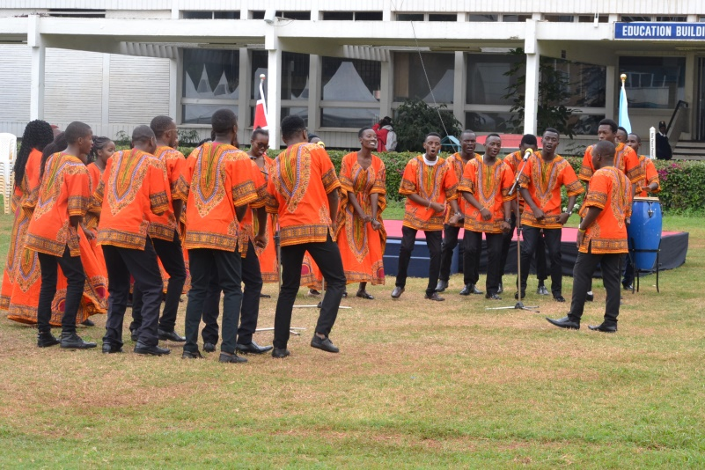
A. Solo B. Duet C. Choir D. Band
- Amina was listening to the Kenya National Anthem. What type of song expresses patriotism and loyalty to one's country? A. Folk song B. Lullaby C. Patriotic song D. Topical song
- David was learning to play a traditional musical instrument that is blown into to produce sound. Which of the following is a wind instrument? A. Drum B. Guitar C. Flute D. Shaker
- Mary's class was preparing a short play without using any words, only movements and facial expressions. What type of performance is this? A. Play B. Mime C. Puppet show D. Musical
- Tom was making a puppet using a stick to control its movements from below. What type of puppet was he making?
A. Hand puppet B. Marionette C. Rod puppet D. Finger puppet

- Sarah's drama group was assigning roles to each member, like director, actors, and stage manager. What is the process of assigning roles in a play production called? A. Rehearsal B. Casting C. Scripting D. Performance
- Mwangi was creating a background scene for his puppet show using coloured paper and paint. What is the painted cloth or board that forms the background on a stage called? A. Costume B. Prop C. Scenery D. Curtain
- Omar's teacher showed him how to make a simple musical instrument using recycled materials like plastic bottles and beans. This activity encourages: A. Buying new instruments B. Breaking old items C. Creativity and resourcefulness D. Making noise
- Lisa was practicing throwing a small heavy ball in athletics. What is this athletic event called? A. Javelin throw B. Discus throw C. Shot put D. High jump
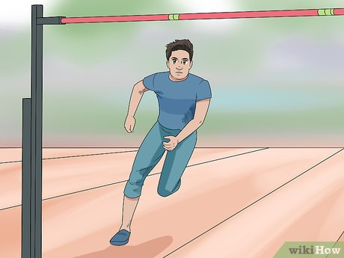
- James was practicing jumping over a bar placed at a certain height in athletics. What is this event called?

A. Long jump B. Triple jump C. High jump D. Hurdling
- Amina was playing a game where two teams of seven players try to tag players from the opposing team in their half. What game is this?
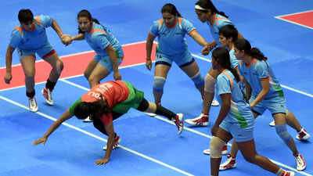
A. Handball B. Netball C. Kabaddi D. Volleyball

- David was learning to pass the ball to his teammates using his hands in a game played on a rectangular court with hoops at each end. What game is he playing? A. Football B. Basketball C. Netball D. Rugby
- Mary was practicing hitting a ball with a bat and running around bases. What game is this, commonly played with a larger, softer ball than baseball? A. Cricket B. Rounders C. Softball D. Baseball
- Tom was learning how to serve the ball over the net in a game played by two teams on a court divided by a net. What game is he playing? A. Badminton B. Tennis C. Volleyball D. Table tennis
- Sarah was practicing a swimming stroke where she lies on her back and moves her arms and legs to propel herself through the water. What stroke is this? A. Freestyle B. Breaststroke C. Backstroke D. Butterfly
- Mwangi was learning about safety around water. What is the most important rule to remember when swimming in a pool or open water? A. Swim alone to be faster B. Dive into shallow water C. Always swim in a supervised area
- Omar was participating in a race on the school track. Which of the following is a track event? A. Shot put B. Long jump C. Sprinting D. Javelin throw
- Lisa was practicing dribbling the ball with her feet in a game played on a field with goals at each end. What game is she playing? A. Handball B. Basketball C. Hockey D. Soccer
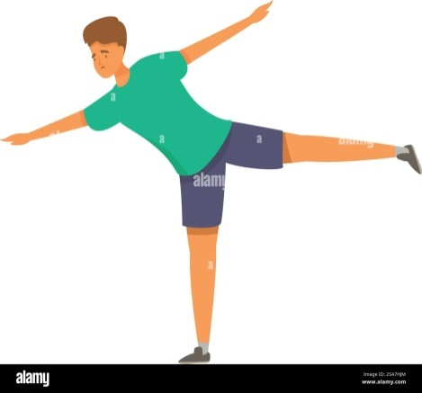
- James was doing exercises that involve balancing on one leg and stretching his body. These activities are part of:

A. Team games B. Athletics C. Gymnastics D. Water sports
- Amina was learning different ways to jump and land safely. Proper landing technique in activities like jumping helps to prevent: A. Getting tired easily B. Injuries C. Sweating D. Falling
- David's class was doing warm-up exercises before playing a game. Why is warming up important before physical activity? A. To make you tired quickly B. To prepare your muscles and prevent injuries C. To make you feel cold D. To end the activity
- Mary was practicing throwing a ball to a target. What is the skill of throwing accurately called? A. Running B. Jumping C. Aiming D. Catching
- Tom was participating in a relay race where team members take turns running a part of the distance, passing a baton to the next runner. What is the object passed from one runner to another in a relay race called? A. Ball B. Stick C. Baton D. Flag

THIS IS THE LAST PRINTED PAGE

ANSWERS
- B
- C
- C
- C
- C
- C
- B
- C
- C
- C
- B
- C
- B
- C
- C
- C
- C
- C
- B
- C
- C
- C
- C
- C
- D
- C
- B
- B
- C
- C

