

COMPETENCE BASED EDUCATION
Every learner counts
Values and competencies
GRADE 6
AGRICULTURE AND NUTRITION
Name: .....................................................................................................................
School: .................................................................................................................
Date: ................................................Assessment number: ...............................
INSTRUCTIONS FOR THIS EXAMINATION
Before the Examination Begins:
- Do not open this question paper until you are told to do so.
- Ensure that you have the correct question paper for the subject and level you are registered for.
- Write your Name, school, date and assessment Number clearly in the spaces provided on the answer sheet and the question paper (if applicable).
- Listen carefully to any instructions given by the invigilator.
- Ask the invigilator if you have any questions about the instructions or the question paper before you begin.
During the Examination:
- Read each question carefully before attempting to answer it. Understand what is being asked.
- Answer all questions unless instructed otherwise.
- For multiple-choice questions:
  - Choose the one correct answer from the options provided.
  - Indicate your choice clearly on the answer sheet by shading the letter corresponding to the correct answer.
  - If you make a mistake, erase your previous answer completely before marking a new one.
  - Do not make any stray marks on the answer sheet.
- For questions requiring written answers (if applicable in other formats):
  - Write your answers clearly and concisely in the spaces provided.
  - Ensure your handwriting is legible.
  - Show your working where necessary, as marks may be awarded for correct steps.
  - Use a blue or black pen for writing your answers. Do not use pencil unless specifically instructed.
- Manage your time effectively. Allocate your time according to the number of questions and the marks allocated to each question.
- If you are unsure of an answer, move on to the next question and come back to it later if you have time.
- Do not spend too much time on any one question.
- Do not talk to or communicate with other candidates during the examination. Any form of cheating or collusion will result in disqualification.
- Keep your eyes on your own work.
- Raise your hand if you need assistance from the invigilator.
Important Reminders:
- Be honest and do your own work.
- Follow all instructions given by the invigilator.
- Attempt all questions to the best of your ability.
Answer all questions

- Your class is visiting a research station and learns about different types of maize that yield more grain and are resistant to certain diseases. What are these types of crops that have been improved through science called?
A. Traditional varieties B. Wild crops
C. Improved varieties D. Ornamental crops
- You notice that the bean plants in your school garden are being attacked by small green insects that suck sap from the leaves. What type of crop pest is most likely causing this damage?

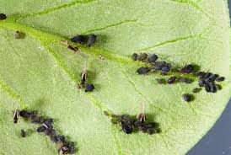
A. caterpillars
B. aphids
C. Weevils
D. Birds
- The potato plants in your farm are showing signs of blight, a common potato disease. Your father decides to spray the plants with a chemical to kill the fungi causing the disease. What is this chemical called?

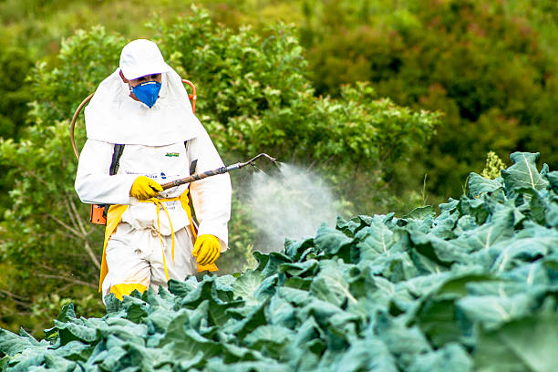
A. Pesticide B. Herbicide
C. Fungicide D. Fertilizer
- To manage soil fertility and control pests naturally, your school farm practices rotating the crops planted in a particular section each season (e.g., planting maize after beans). What is this farming practice called?
A. Monoculture
B. Intercropping
C. Crop rotation
D. Shifting cultivation
- Your family has harvested tomatoes, and some are ready to eat, while others are still green. What indicates that a fruit like a tomato is ripe and ready for harvesting?
A. It is still green and hard.
B. It has reached its full size and developed its characteristic colour and softness.
C. It has fallen off the plant.
D. Insects are feeding on it.
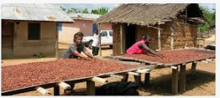
- To store the harvested beans for a long time without being attacked by weevils, Agnes dries them properly and stores them in airtight containers. What is the main reason for drying crops before storage?

A. To increase their weight.
B. To prevent spoilage by reducing moisture content.
C. To change their color.
D. To make them easier to count.
- Your neighbour keeps different types of livestock. He has Sahiwal cattle (known for milk), and Boran cattle (known for meat). What does "breed" refer to in livestock farming?
A. The age of the animal.
B. A specific type or variety of animal with distinct characteristics.
C. The food the animal eats.
D. The place where the animal is kept.
- Your school keeps improved breeds of chickens for egg production. What is important to provide for these chickens in their housing to ensure good egg laying?
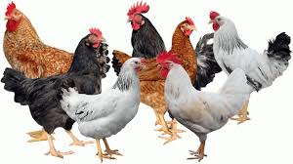

A. A dark and cold environment.
B. Enough space, clean water, and appropriate nesting boxes.
C. A noisy environment.
D. Only male chickens.
- A farmer observes that some of his cows are losing weight and have dull coats, which might be a sign of internal parasites like worms. What is a common way to control internal parasites in livestock?
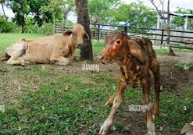
A. Spraying the animals.
B. Providing extra food.
C. Deworming the animals regularly.
D. Keeping the animals in a crowded place.
- You are helping to feed the calves on your farm. Your teacher emphasizes the importance of providing the right type and amount of food for different animals at different stages. What do we call the practice of giving animals the correct food for their needs?
A. Watering
B. Grazing
C. Feeding (Nutrition)
D. Dipping
- To prevent the spread of diseases among chickens, the farmer maintains cleanliness in the chicken coop and vaccinates the chickens. What is maintaining cleanliness in livestock housing important for?
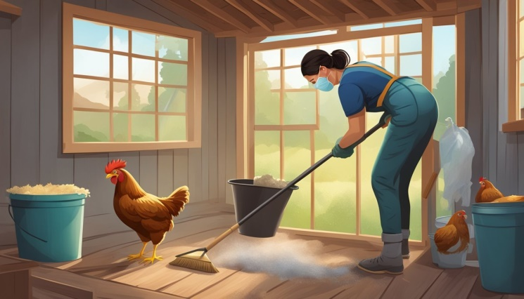
A. To make the housing look nice.
B. To prevent diseases and parasites.
C. To make the animals bigger.
D. To attract visitors.
- Your teacher explains that handling livestock requires care and knowledge. What is one important safety measure when handling a bull?
A. Approach it from the front without caution.
B. Shout loudly to make it move.
C. Handle it calmly and be aware of its behavior.
D. Poke it with a stick.
- To prevent a gully from forming on a slopy part of the school farm due to fast-flowing rainwater, your class builds structures made of wire mesh filled with stones across the gully. What are these structures called?

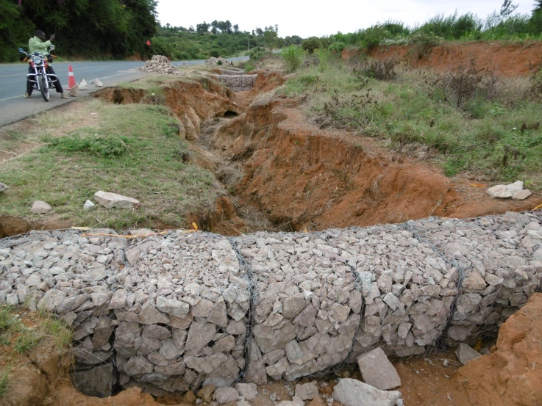

A. Terraces B. Gabions
C. Check dams D. Contour lines
- During the dry season, the water level in the school well is low, and there is not enough water for irrigation. Your teacher explains methods to collect and store water during the rainy season. What is this practice called?
A. Water purification
B. Water harvesting
C. Drainage
D. Irrigation
- To improve the fertility of the soil in your school garden, your class adds well-rotted manure and compost. What type of fertilizer is manure and compost?
A. Inorganic fertilizer
B. Chemical fertilizer
C. Organic fertilizer
D. Liquid fertilizer
- You are helping to test the soil pH in different parts of the farm using a simple test kit. What does soil pH tell you about the soil?
A. Its texture (how gritty or smooth it is).
B. Its colour.
C. Its acidity or alkalinity.
D. Its water content.
- You need to cut tall grass and small bushes on the edge of the farm. Which farm tool with a long handle and a curved blade is commonly used for this purpose?
A. Jembe B. Fork jembe
C. Slasher D. Wheelbarrow

- To prepare a fine seedbed after ploughing, the farmer uses an implement that breaks up soil clods and levels the soil surface. What is this implement, often pulled by a tractor or oxen, called?
A. Plough B. Harrow
C. Sprayer D. Cultivator
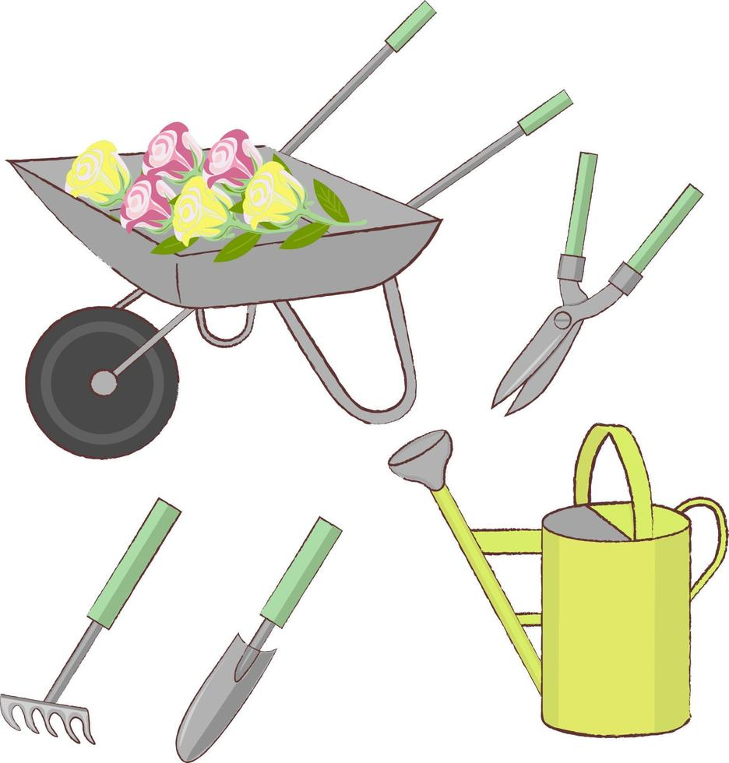
- Your teacher is demonstrating how to apply fertilizer to the crops. Which equipment is used to carry fertilizers to the farm?

A B

C D

- After using the farm tools, your teacher reminds you to clean them and store them properly in the tool shed. Why is proper storage of farm tools important?
A. To make the shed look tidy.
B. To prevent them from getting lost or damaged and to ensure safety.
C. To make them rust faster.
D. To make them heavier.
- Your teacher explains that different age groups have different nutritional needs. Which food group is particularly important for the growth and development of children?
A. Energy-giving foods
B. Body-building foods
C. Protective foods
D. All food groups
- Your class is discussing common nutritional deficiencies. What illness can be caused by a lack of Vitamin A in the diet, affecting eyesight?
A. Kwashiorkor
B. Marasmus
C. Night blindness
D. Anaemia

- To preserve surplus milk, your mother boils it and then stores it in a clean container in a cool place. What is the purpose of boiling milk as a preservation method?
A. To make it taste better.
B. To kill harmful microorganisms.
C. To make it thicker.
D. To change its colour.
- You are preparing a salad with fresh vegetables from the garden. What is a crucial step in ensuring the salad is safe to eat?
A. Adding a lot of salt.
B. Washing the vegetables thoroughly with clean water.
C. Eating the vegetables immediately after picking.
D. Leaving the vegetables in the sun.
- Some food can make you sick if it is not prepared or stored properly. What are illnesses caused by eating contaminated food called?
A. Airborne diseases
B. Waterborne diseases
C. Foodborne illnesses
D. Deficiency diseases
- Your school farm plans to sell some of the harvested vegetables to the local market. Keeping a record of how much was spent on seeds, tools, and labour, and how much was earned from selling the vegetables is important. What is this process of keeping track of income and expenses on a farm called?
A. Harvesting
B. Marketing
C. Record keeping
D. Planting
- Farmers often sell their produce through different ways, such as selling directly to consumers at the market or selling to middlemen who transport the produce to other places. What do we call the different ways agricultural products reach the consumers?
A. Farming methods
B. Storage techniques
C. Marketing channels
D. Harvesting methods
- When your school sells vegetables at the market, the price might change depending on how many other farmers are also selling vegetables and how many people want to buy them. What factor is influencing the price of the vegetables in this scenario?
A. The colour of the vegetables.
B. The height of the farmer.
C. Supply and demand.
D. The time of day.
- Farmers often form groups or cooperatives to help each other with farming and marketing. What is one advantage of farmers working together in a cooperative?
A. They compete with each other more.
B. They can share knowledge, resources, and get better prices for their produce.
C. They have to farm the same crops.
D. They pay more taxes.
- Why is it important for farmers to produce high-quality agricultural products?
A. Low-quality products are easier to sell.
B. High-quality products are more likely to be bought and can fetch better prices.
C. Quality does not matter in farming.
D. High-quality products require less effort to grow.

THIS IS THE LAST PRINTED PAGE

ANSWERS
  - C
  - B
  - C
  - C
  - B
  - B
  - B
  - B
  - C
  - C
  - B
  - C
  - B
  - B
  - C
  - C
  - C
  - B
  - A
  - B
  - B
  - C
  - B
  - B
  - C
  - C
  - C
  - C
  - B
  - B

