

COMPETENCE BASED EDUCATION
Every learner counts
Values and competencies
GRADE 5
SOCIAL STUDIES
Name: .....................................................................................................................
School: ................ ..................................................... .............................................
Date: ................................................Assessment number: ...............................
INSTRUCTIONS FOR THIS EXAMINATION
Before the Examination Begins:
  - Do not open this question paper until you are told to do so.
  - Ensure that you have the correct question paper for the subject and level you are registered for.
  - Write your Name, school, date and assessment Number clearly in the spaces provided on the answer sheet and the question paper (if applicable).
  - Listen carefully to any instructions given by the invigilator.
  - Ask the invigilator if you have any questions about the instructions or the question paper before you begin.
During the Examination:
  - Read each question carefully before attempting to answer it. Understand what is being asked.
  - Answer all questions unless instructed otherwise.
  - For multiple-choice questions:
  - Choose the one correct answer from the options provided.
  - Indicate your choice clearly on the answer sheet by shading the letter corresponding to the correct answer.
  - If you make a mistake, erase your previous answer completely before marking a new one.
  - Do not make any stray marks on the answer sheet.
  - For questions requiring written answers (if applicable in other formats):
  - Write your answers clearly and concisely in the spaces provided.
  - Ensure your handwriting is legible.
  - Show your working where necessary, as marks may be awarded for correct steps.
  - Use a blue or black pen for writing your answers. Do not use pencil unless specifically instructed.
  - Manage your time effectively. Allocate your time according to the number of questions and the marks allocated to each question.
  - If you are unsure of an answer, move on to the next question and come back to it later if you have time.
  - Do not spend too much time on any one question.
  - Do not talk to or communicate with other candidates during the examination. Any form of cheating or collusion will result in disqualification.
  - Keep your eyes on your own work.
  - Raise your hand if you need assistance from the invigilator.
Important Reminders:
- Be honest and do your own work.
- Follow all instructions given by the invigilator.
- Attempt all questions to the best of your ability.

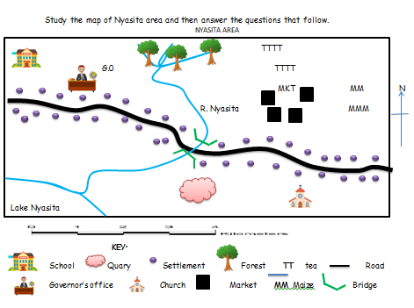
Answer all questions

- Who is the head in Nyasita area?

- Chief
- Senator
- Governor
- MCA

- River Nyasita flows towards?

- North
- South
- South-East
- South-West

- What is the settlement pattern in Nyasita area?

- Linear
- Nucleated
- Clustered
- Scattered

- Which economic activity is not practiced in Nyasita area?

- Lumbering
- Mining
- Trading
- Farming

- The food crop grown in Nyasita area is?

- Tea
- Coffee
- Mangoes
- Maize

- Which element of a map is used to show direction?

- Key
- Scale
- Compass
- Title

- The following are characteristic of a certain climatic region:
- Rainfall is well distributed
- It experiences heavy convectional rainfall
- The region is hot and wet
The climatic region described above is?

- Mountain climate
- Desert climate
- Modified equatorial climate
- Tropical climate

- Which one of the following is the main horticultural cetre in Kenya?

- Nairobi
- Kisii
- Naivasha
- Narok

- The council of elders among the Ameru is called?

- Mugwe
- Olaiguanani
- Njuri njeke
- Kiriyaga

- What is the meaning of the following road sign?
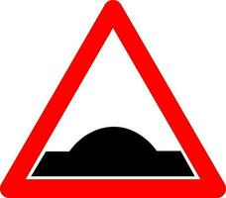

- No entry
- Bumps ahead
- Zebra crossing
- No passing

- Which one of the following is the main means of transport in Kenya?

- Water
- Road
- Railway
- Air

- Which one of the following IS NOT an element of weather?

- Temperature
- Rainfall
- Ocean current
- Cloud cover

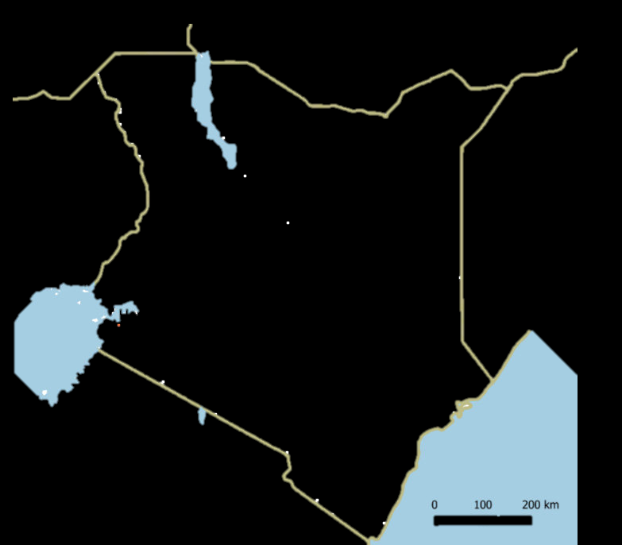
Use the map below to answer questions 19 and 20.

P

X

- The country marked p is called?

- Rwanda
- Ethiopia
- Burundi
- Tanzania

- The physical feature marked x is?

- Rift Valley
- Nyika Plateau
- Lake Victoria
- Mt. Kenya

- Who among the following IS NOT art of the school administration?

- Head teacher
- Deputy head teacher
- Senior teacher
- Area MCA

- How many colours does our National Flag have?

- 5
- 4
- 12
- 3

- Which one is a desert in Kenya?

- Chalbi
- Sahara
- Namib
- Kalahari

- How many counties do we have in the republic of Kenya?

- 8
- 12
- 47
- 290

- The following are dairy breed of cattle. Which ONE IS NOT?
- Zebu
- Fresian
- Jersey
- Guernsey
- Which one of the following consists of bantu speakers only
- Abaluhya, Abakuria, Kalenjin
- Abagusii, Turkana, Samburu
- Ameru, Aembu, Akamba
- Chinese, Japanese,Koreans

- Sarah's class was studying the population of their county. They learned that some areas have many people living close together, while other areas have very few people spread out. What term describes how people are spread out over an area? A. Population growth B. Population density C. Population count D. Population movement
- Mwangi's uncle moved from their rural village to Nairobi city to look for a job. What type of movement is this, from a rural area to an urban area? A. International migration B. Rural-urban migration C. Internal migration D. Seasonal migration
- Omar's teacher showed the class a chart about the people in their community, grouped by age and whether they are male or female. What is the study of the characteristics of a population, like age and gender, called? A. Population distribution B. Population census C. Population composition D. Population density
- Lisa's community has a large forest nearby. The forest provides timber, fruits, and traditional medicines. What type of resource is the forest? A. Human resource B. Capital resource C. Natural resource D. Financial resource
- James's father is a fisherman at Lake Victoria. He catches fish to sell at the market. What type of economic activity is fishing? A. Agriculture B. Manufacturing C. Service industry D. Extracting
- Amani visited a factory where maize is processed into flour. What economic activity involves changing raw materials into finished goods? A. Agriculture B. Trade C. Industry D. Transport
- David's mother sells vegetables in the local market. Buying and selling goods and services is an economic activity called: A. Farming B. Industry C. Trade D. Tourism
- Mary's teacher discussed how communities depend on each other. For example, farmers provide food for people in towns, and people in towns provide manufactured goods for farmers. What is this mutual reliance between communities called? A. Conflict B. Competition C. Isolation D. Interdependence
- Tom's class learned about the different levels of government in Kenya. Which level of government is headed by a Governor? A. National government B. County government C. Local government D. Village administration
- Sarah's school held an election to choose class prefects. What is the process where people choose their leaders by voting called? A. Appointment B. Selection C. Nomination D. Election
- Mwangi learned that every Kenyan citizen has the right to vote once they reach the required age. The ability of citizens to participate in the affairs of their country is called: A. Passivity B. Citizenship participation C. Obedience D. Observation
- Omar's teacher discussed the importance of national unity and respecting people from all communities in Kenya. What term refers to the process of bringing different groups of people together to live in harmony as one nation? A. Tribalism B. Segregation C. National integration D. Discrimination
- Lisa's class is recording the weather every day, noting the temperature, rainfall, and wind. What weather instrument is used to measure the amount of rainfall? A. Thermometer B. Wind vane C. Anemometer D. Rain gauge
- James lives near the coast of Kenya, which is hot and humid throughout the year. This description refers to the long-term weather pattern of the area. What is this called? A. Weather B. Season C. Climate D. Temperature
- Amina's teacher showed the class a map of Kenya and pointed out the large flat areas of land, usually at low altitudes. What is this physical region called? A. Highlands B. Coast C. Lowlands D. Rift Valley
- David's class visited a protected area with many different types of wild animals. Protecting plants, animals, and natural resources is called: A. Development B. Exploitation C. Conservation D. Pollution
- Mary's teacher explained that cutting down too many trees can lead to soil being washed away by rain. What environmental problem is caused by the removal of trees and exposes the soil? A. Air pollution B. Water pollution C. Soil erosion D. Climate change
- Tom's community experienced a severe flood after very heavy rainfall. What do we call a sudden event caused by natural forces, like a flood or earthquake that can cause damage and harm? A. Development B. Disaster C. Weather D. Climate
- Sarah's class used a map to find the location of their school. They learned that symbols on the map represent real features on the ground. What part of the map explains what these symbols mean? A. Title B. Scale C. Compass direction D. Key
- Mwangi's teacher showed him a map and asked him to find the direction of the river from the hill. What map element is used to show directions like North, South, East, and West? A. Scale B. Key C. Compass rose D. Frame
- Omar learned about the history of Kenya's independence. Who was the first President of Kenya? A. Daniel Moi B. Mwai Kibaki C. Jomo Kenyatta D. Uhuru Kenyatta
- Lisa's class visited a historical site where important events in Kenya's history took place. What are places like Fort Jesus or the National Museum examples of? A. Natural environments B. Modern structures C. Historical built environments D. Entertainment centres
- James's family has a tradition of celebrating harvests with singing and dancing. These practices are passed down from ancestors and are part of their: A. Economy B. Government C. Culture D. Geography
- Amina's teacher discussed the importance of cultural diversity in Kenya, with many different communities having their own languages, food, and dress. What term describes the variety of cultures within a society? A. Cultural conflict B. Cultural uniformity C. Cultural exchange D. Cultural diversity
- David's parents taught him the importance of honesty and hard work. These are beliefs about what is right and wrong that guide behavior. What are these beliefs called? A. Rules B. Laws C. Values D. Norms
- Mary observed that some people have moved to her town recently. This movement of people from one place to another to live is called: A. Population count B. Birth rate C. Migration D. Death rate
- Tom's class learned about different types of resources. Sunlight, water, and air are examples of resources provided by nature. What type of resources are these? A. Human resources B. Capital resources C. Natural resources D. Renewable resources
- Sarah's community is resolving a disagreement between two groups using elders to talk and find a solution. What is the process of finding a peaceful solution to a disagreement called? A. Conflict B. Competition C. Conflict resolution D. Argument
- Mwangi's teacher showed the class a map of East Africa. Kenya shares borders with several countries. Which country borders Kenya to the South?
A. Uganda
B. Tanzania
C. Ethiopia
D. Somalia
- Omar's class learned that some areas in Kenya receive very little rainfall and are very dry. What type of climate zone is characterized by very low rainfall and high temperatures?
A. Tropical climate
B. Mountain climate
C. Modified Equatorial climate
D. Arid and Semi-arid climate

Answer Key:
- A. Chief
- C. South-East (Assuming a typical flow based on Kenyan geography, rivers generally flow from highlands towards the Indian Ocean or Lake Victoria, which would be generally south-easterly for a river in a central/western area like Nyasita might imply).
- D. Scattered (This is a common settlement pattern in rural areas where farming is dominant).
- B. Mining (Among the options, mining is less likely to be a universal economic activity in a typical rural Kenyan area compared to the others).
- D. Maize (Maize is a staple food crop across most of Kenya).
- C. Compass
- C. Modified equatorial climate (Well-distributed, heavy convectional rainfall, hot and wet are characteristics of this climate, found in areas like the Lake Victoria Basin).
- C. Naivasha (Naivasha is a major center for horticulture, especially floriculture, in Kenya).
- C. Njuri njeke
- C. Zebra crossing
- B. Road
- C. Ocean current (Ocean currents influence climate, but are not direct elements of weather as measured daily).
- B. Ethiopia
- C. Lake Victoria
- D. Area MCA (An MCA is a political representative at the county level, not part of the internal school administration).
- B. 4 (Black, Green, Red, White).
- A. Chalbi
- C. 47
- A. Zebu (Zebu are primarily beef cattle, while Fresian, Jersey, and Guernsey are well-known dairy breeds).
- C. Ameru, Aembu, Akamba (All are Bantu-speaking communities in Kenya).
- B. Population density
- B. Rural-urban migration
- C. Population composition
- C. Natural resource
- D. Extracting (Fishing involves extracting resources from nature).
- C. Industry (Manufacturing is a key part of industry).
- C. Trade
- D. Interdependence
- B. County government
- D. Election
- B. Citizenship participation
- C. National integration
- D. Rain gauge
- C. Climate
- C. Lowlands
- C. Conservation
- C. Soil erosion
- B. Disaster
- D. Key
- C. Compass rose
- C. Jomo Kenyatta
- C. Historical built environments
- C. Culture
- D. Cultural diversity
- C. Values
- C. Migration
- C. Natural resources
- C. Conflict resolution
- B. Tanzania
- D. Arid and Semi-arid climate

