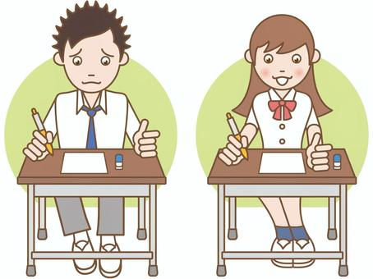

COMPETENCE BASED EDUCATION
Every learner counts
Values and competencies
GRADE 5
SCIENCE AND TECHNOLOGY
Name: ....................................................................................................................
School: ....................................................................................................................
Date: ................................................Assessment number: ...............................
INSTRUCTIONS FOR THIS EXAMINATION TIME: 1 Hour 30 Minutes
Before the Examination Begins:
- Do not open this question paper until you are told to do so.
- Ensure that you have the correct question paper for the subject and level you are registered for.
- Write your Name, school, date and assessment Number clearly in the spaces provided on the answer sheet and the question paper (if applicable).
- Listen carefully to any instructions given by the invigilator.
- Ask the invigilator if you have any questions about the instructions or the question paper before you begin.
During the Examination:
- Read each question carefully before attempting to answer it. Understand what is being asked.
- Answer all questions unless instructed otherwise.
- For multiple-choice questions:
  - Choose the one correct answer from the options provided.
  - Indicate your choice clearly on the answer sheet by shading the letter corresponding to the correct answer.
  - If you make a mistake, erase your previous answer completely before marking a new one.
  - Do not make any stray marks on the answer sheet.
- For questions requiring written answers (if applicable in other formats):
  - Write your answers clearly and concisely in the spaces provided.
  - Ensure your handwriting is legible.
  - Show your working where necessary, as marks may be awarded for correct steps.
  - Use a blue or black pen for writing your answers. Do not use pencil unless specifically instructed.
- Manage your time effectively. Allocate your time according to the number of questions and the marks allocated to each question.
- If you are unsure of an answer, move on to the next question and come back to it later if you have time.
- Do not spend too much time on any one question.
- Do not talk to or communicate with other candidates during the examination. Any form of cheating or collusion will result in disqualification.
- Keep your eyes on your own work.
- Raise your hand if you need assistance from the invigilator.
Important Reminders:
  - Be honest and do your own work.
  - Follow all instructions given by the invigilator.
  - Attempt all questions to the best of your ability.
Answer all questions

- Sarah observed different plants in her compound. She saw a maize plant which has flowers and a fern plant which does not. Into which two main groups can plants be classified based on whether they produce flowers or not? A. Edible and non-edible plants B. Tall and short plants C. Flowering and non-flowering plants D. Water and land plants
- Mwangi found a mushroom growing in a damp area. His teacher told him that mushrooms belong to a group of living things that are not plants or animals. What is this group called? A. Algae B. Fungi C. Bacteria D. Microbes
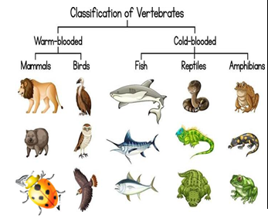
- During a video lesson, Omar saw the following animals. Which of these animals is wrongly classified?

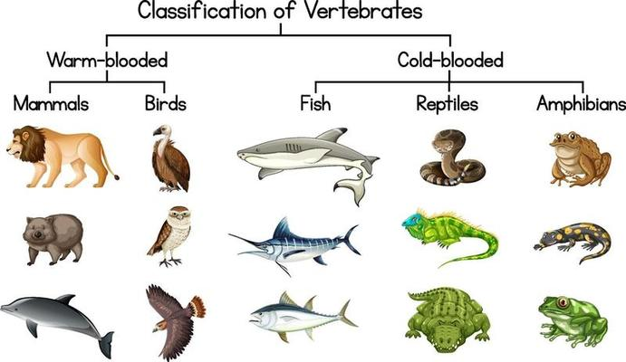
A

B
C
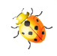
D
- Lisa was learning about the human body. She learned about the system responsible for breaking down food so the body can use it. What is this system called? A. Breathing system B. Digestive system C. Circulatory system D. Skeletal system
- James felt pain in his tooth after eating too many sweets. Which part of the digestive system is mainly used for grinding food into smaller pieces? A. Tongue B. Teeth C. Stomach D. Oesophagus

- A group of learners were discussing the importance of different parts of the human body. Which sense organ is used to detect light and enable us to see? A. Ear B. Nose C. Tongue D. Eye
- During a physical education lesson, Tom was running and jumping. Which system in his body helps him to move? A. Breathing system B. Digestive system C. Muscular-skeletal system D. Nervous system
- A glass of water was left on the table. After some time, the water level went down slightly. This is because some water turned into a gas. What state of matter is the water in the glass? A. Solid B. Liquid C. Gas D. Plasma
- Sarah put a stone and a feather in a basin of water. The stone sank, but the feather floated. What property of matter explains why some objects sink and others float? A. Mass B. Volume C. Density D. Shape
- Mwangi added lemon juice to a cup of tea and noticed the taste changed. Lemon juice is an example of a substance that tastes sour. What category of substances does it belong to? A. Bases B. Acids C. Salts D. Water
- Omar used a spoon to stir hot porridge. He noticed that the handle of the metallic spoon became hot. What property of the spoon material allows heat to easily pass through it? A. It is an insulator B. It is a conductor C. It is transparent D. It is magnetic
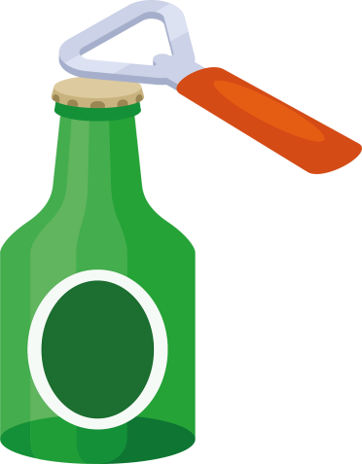
- Lisa was trying to open a tight lid on a jar. Her mother showed her how to use a bottle opener, which made it easier.

A bottle opener is an example of a simple machine. Which type of simple machine is it? A. Inclined plane B. Pulley C. Lever D. Wheel and axle
- James kicked a football across the field. What is the force that causes the ball to eventually slow down and stop rolling? A. Gravity B. Push C. Friction D. Magnetism
- Amina was playing with a torch in a dark room. She shone the torch on the wall and saw a bright spot. What form of energy allows us to see? A. Heat energy B. Sound energy C. Light energy D. Electrical energy
- The teacher showed the class a piece of clear glass, a piece of frosted glass, and a piece of wood. Which of these materials is translucent? A. Clear glass B. Frosted glass C. Wood D. All of them
- During a music lesson, the learners played different instruments. Which property of sound tells us how high or low a sound is? A. Volume B. Pitch C. Echo D. Noise
- David shouted in a large, empty hall and heard his voice repeated shortly after. What is this reflected sound called? A. Noise B. Volume C. Echo D. Pitch
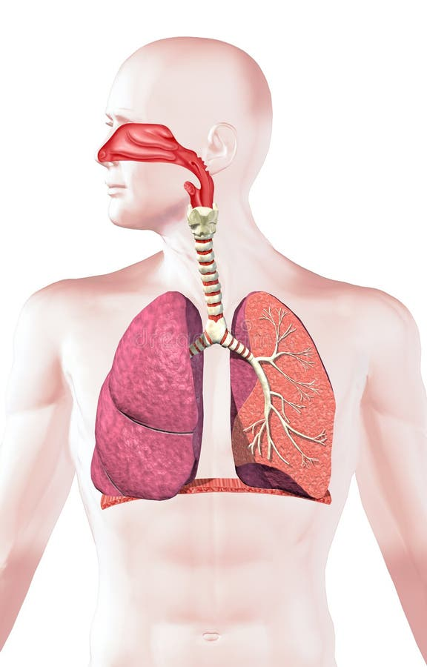
- Dominic was asked to name the part marksed P. What is likely to be the right answer?

P

A. diaphragm B. trachea C. lungs D. nose
- Mary observed the moon in the sky over several nights. She noticed that the shape of the moon seemed to change. What are the different shapes of the moon that we see called? A. Eclipses B. Orbits C. Phases D. Tides
- Tom used a device to search for information on the internet for his homework. This device has a screen and can connect to the internet. What type of digital device did he most likely use? A. Radio B. Television C. Computer D. Printer

- Sarah was typing a document on a computer. Which part of the computer uses keys to input text and commands?

A. Monitor B. Mouse C. Keyboard D. CPU
- Mwangi's teacher showed him how to use a program on the computer to draw pictures. What do we call the programs that run on a computer? A. Hardware B. Data C. Files D. Software

- Omar is learning to follow instructions to build a simple robot using a computer program.
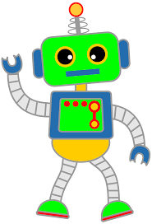
This process of writing instructions for a computer is called: A. Typing B. Drawing C. Coding D. Searching
- Lisa's teacher showed her different icons on a tablet.

These small pictures represent applications or functions. Icons are an example of: A. Digital devices B. Coded patterns C. Hardware D. Data
- Which of the following is a non-flowering plant? A. Rose B. Mango tree C. Moss D. Sunflower
- Animals that have their body covered with scales are mainly: A. Birds B. Mammals C. Fish and Reptiles D. Amphibians
- Which of the following is a symptom of an unhealthy digestive system? A. Clear vision B. Easy breathing C. Stomach ache D. Strong muscles
- What happens to a solid when it is heated to its melting point? A. It becomes a gas B. It becomes a liquid C. It evaporates D. It freezes
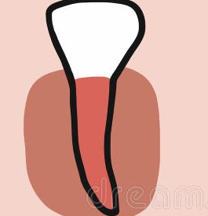
- This type of tooth is called? A. molar B. Canine C. incisor D. premolar
- The force that pulls objects towards the centre of the Earth is called: A. Friction B. Magnetism C. Gravity D. Effort

Answer Key:
- C
- B
- D
- B
- B
- D
- C
- B
- C
- B
- B
- C
- C
- C
- B
- B
- C
- C
- C
- C
- C
- D
- C
- B
- C
- C
- C
- B
- C
- C

