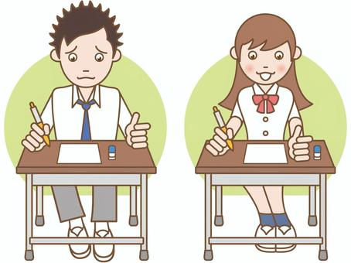

COMPETENCE BASED EDUCATION
Every learner counts
Values and competencies
GRADE 5
ENGLISH
Name: ....................................................................................................................
School: ....................................................................................................................
Date: ................................................Assessment number: ...............................
INSTRUCTIONS FOR THIS EXAMINATION TIME: 1 Hour 30 Minutes
Before the Examination Begins:
- Do not open this question paper until you are told to do so.
- Ensure that you have the correct question paper for the subject and level you are registered for.
- Write your Name, school, date and assessment Number clearly in the spaces provided on the answer sheet and the question paper (if applicable).
- Listen carefully to any instructions given by the invigilator.
- Ask the invigilator if you have any questions about the instructions or the question paper before you begin.
During the Examination:
- Read each question carefully before attempting to answer it. Understand what is being asked.
- Answer all questions unless instructed otherwise.
- For multiple-choice questions:
  - Choose the one correct answer from the options provided.
  - Indicate your choice clearly on the answer sheet by shading the letter corresponding to the correct answer.
  - If you make a mistake, erase your previous answer completely before marking a new one.
  - Do not make any stray marks on the answer sheet.
- For questions requiring written answers (if applicable in other formats):
  - Write your answers clearly and concisely in the spaces provided.
  - Ensure your handwriting is legible.
  - Show your working where necessary, as marks may be awarded for correct steps.
  - Use a blue or black pen for writing your answers. Do not use pencil unless specifically instructed.
- Manage your time effectively. Allocate your time according to the number of questions and the marks allocated to each question.
- If you are unsure of an answer, move on to the next question and come back to it later if you have time.
- Do not spend too much time on any one question.
- Do not talk to or communicate with other candidates during the examination. Any form of cheating or collusion will result in disqualification.
- Keep your eyes on your own work.
- Raise your hand if you need assistance from the invigilator.
Important Reminders:
  - Be honest and do your own work.
  - Follow all instructions given by the invigilator.
  - Attempt all questions to the best of your ability.
Answer all questions
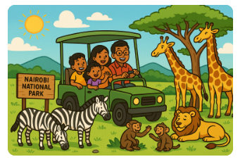
Read the passage below and answer questions 1 to 5.

Last Saturday, my family visited the Nairobi National Park. It was a sunny day. We saw many wild animals. First, we saw a herd of zebras grazing near the entrance. Then, as we drove further, we spotted a lion sleeping under a tree. We also saw giraffes eating leaves from the tall acacia trees. My younger sister was most excited to see the baboons playing near the road. We took many pictures to remember our exciting trip.

- When did the family visit Nairobi National Park?
A. Last Sunday B. Last Saturday
C. Yesterday D. Today
- What was the weather like?
A. Rainy B. Cloudy
C. Windy D. Sunny
- Which animal did they see first near the entrance?
A. Lions B. Giraffes
C. Zebras D. Baboons
- Where was the lion sleeping?
A. On the road
B. In the grass
C. Under a tree
D. Near the zebras
- Which animals did the younger sister enjoy seeing the most?
A. Lions
B. Giraffes
C. Zebras
D. Baboons

Read the passage below and answer questions 6 to 10.
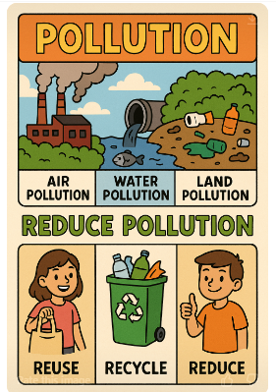
Pollution is harmful to our environment. Air pollution makes the air dirty to breathe. Water pollution makes water unsafe to drink or for animals to live in. Land pollution happens when we throw rubbish everywhere, making the soil dirty. We can reduce pollution by reusing things, recycling materials like plastic and paper, and reducing the amount of waste we create. Keeping our surroundings clean is everyone's responsibility.

- What is harmful to our environment?
A. Clean air B. Planting trees
C. Pollution D. Recycling
- What does air pollution make dirty?
A. Water B. Soil
C. Air D. Food
- When does land pollution happen?
A. When it rains
B. When we plant trees
C. When we throw rubbish everywhere
D. When we clean up
- Which of these is a way to reduce pollution?
A. Throwing more rubbish
B. Recycling materials
C. Burning plastic
D. Wasting water
- Who is responsible for keeping our surroundings clean?
A. Only children
B. Only adults
C. Only the government
D. Everyone

Read the passage below and answer questions 11 to 15.
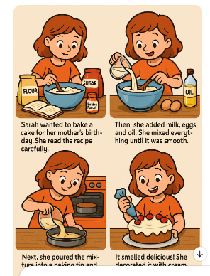

Sarah wanted to bake a cake for her mother's birthday. She read the recipe carefully. First, she mixed flour, sugar, and baking powder in a bowl. Then, she added milk, eggs, and oil. She mixed everything until it was smooth. Next, she poured the mixture into a baking tin and put it in the oven. After about thirty minutes, the cake was ready. It smelled delicious! She decorated it with cream and cherries. Her mother was very happy.

- What did Sarah want to bake?
A. Bread B. Biscuits
C. Cake D. Cookies
- Whose birthday was it?
A. Sarah's B. Her father's
C. Her mother's D. Her friend's
- Which ingredient was NOT mentioned in the mixture?
A. Flour
B. Salt
C. Sugar
D. Eggs
- What did Sarah do after mixing the ingredients?
A. Ate the mixture
B. Poured it into a baking tin
C. Decorated the cake
D. Gave it to her mother
- How long did the cake take to bake according to the passage?
A. Ten minutes
B. Twenty minutes
C. Thirty minutes
D. One hour

Read the passage below and choose the correct word from the options to fill in the blanks 16 to 20.
Our school library is a wonderful ____(16). It has many interesting _____(17). We can read stories about animals, history, and science. We must be _____(18) in the library so that we do not disturb others. We can ______(19) books to read at home. We must take good ______(20) of the books and return them on time.
A. shop B. park C. place D. field
A. toys B. books C. games D. food
A. noisy B. quiet C. angry D. sad
A. borrow B. sell C. buy D. keep
A. pictures B. care C. notice D. fun
Choose the correct word or phrase to complete each sentence.

- My sister ______ drawing a picture now.
A. am B. is C. are D. were
- Choose the correct plural for 'child':
A. childs B. childrens
C. childes D. children
- The mouse ran ______ the hole.
A. on B. in
C. into D. at
- Yesterday, we ______ to the museum.
A. go B. goes
C. going D. went
- He is ______ than his brother, but his sister is the ______.
A. tall, tallest
B. taller, tall
C. taller, tallest
D. tallest, taller
- Choose the correct adjective: The ______ sun shone brightly.
A. happy
B. lazy
C. hot
D. cold

27. ______ is your teacher? (Asking for a person)
A. What
B. Where
C. Who
D. When

28. Choose the correct sentence:
A. Birds fly in the sky.
B. Birds flys in the sky.
C. Birds flying in the sky.
D. Birds flied in the sky.

29. The opposite of 'full' is:
A. big
B. empty
C. small
D. heavy
30. Choose the word that means almost the same as 'quick':
A. slow
B. fast
C. small
D. large

COMPOSITION WRITING
You have been given 40 minutes to write an interesting composition.
Look at the following photograph and write a story about it
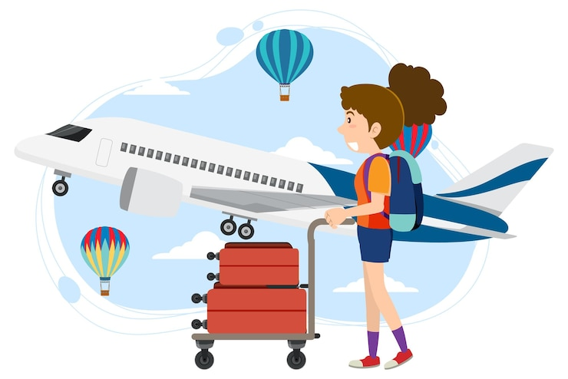
________________________________________________________________________________________________________________________________________________________________________________________________________________________________________________________________________________________________________________________________________________________
________________________________________________________________________________________________________________________________________________________________________________________________________________________________________________________________________________________________________________________________________________________
________________________________________________________________________________________________________________________________________________________________________________________________________________________________________________________________________________________________________________________________________________________
________________________________________________________________________________________________________________________________________________________________________________________________________________________________________________________________________________________________________________________________________________________
________________________________________________________________________________________________________________________________________________________________________________________________________________________________________________________________________________________________________________________________________________________
________________________________________________________________________________________________________________________________________________________________________________________________________________________________________________________________________________________________________________________________________________________
________________________________________________________________________________________________________________________________________________________________________________________________________________________________________________________________________________________________________________________________________________________
________________________________________________________________________________________________________________________________________________________________________________________________________________________________________________________________________________________________________________________________________________________
________________________________________________________________________________________________________________________________________________________________________________________________________________________________________________________________________________________________________________________________________________________
________________________________________________________________________________________________________________________________________________________________________________________________________________________________________________________________________________________________________________________________________________________
________________________________________________________________________________________________________________________________________________________________________________________________________________________________________________________________________________________________________________________________________________________
________________________________________________________________________________________________________________________________________________________________________________________________________________________________________________________________________________________________________________________________________________________
________________________________________________________________________________________________________________________________________________________________________________________________________________________________________________________________________________________________________________________________________________________
________________________________________________________________________________________________________________________________________________________________________________________________________________________________________________________________________________________________________________________________________________________
________________________________________________________________________________________________________________________________________________________________________________________________________________________________________________________________________________________________________________________________________________________
________________________________________________________________________________________________________________________________________________________________________________________________________________________________________________________________________________________________________________________________________________________
________________________________________________________________________________________________________________________________________________________________________________________________________________________________________________________________________________________________________________________________________________________
________________________________________________________________________________________________________________________________________________________________________________________________________________________________________________________________________________________________________________________________________________________
________________________________________________________________________________________________________________________________________________________________________________________________________________________________________________________________________________________________________________________________________________________
________________________________________________________________________________________________________________________________________________________________________________________________________________________________________________________________________________________________________________________________________________________
________________________________________________________________________________________________________________________________________________________________________________________________________________________________________________________________________________________________________________________________________________________
________________________________________________________________________________________________________________________________________________________________________________________________________________________________________________________________________________________________________________________________________________________
________________________________________________________________________________________________________________________________________________________________________________________________________________________________________________________________________________________________________________________________________________________
________________________________________________________________________________________________________________________________________________________________________________________________________________________________________________________________________________________________________________________________________________________
________________________________________________________________________________________________________________________________________________________________________________________________________________________________________________________________________________________________________________________________________________________
Answers
- B
- D
- C
- C
- D
- C
- C
- C
- B
- D
- C
- C
- B
- B
- C
- C
- B
- B
- A
- B
- B
- D
- C
- D
- C
- C
- C
- A
- B
- B

