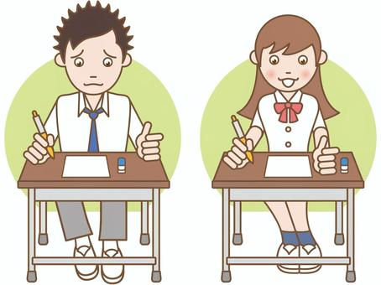

COMPETENCE BASED EDUCATION
Every learner counts
Values and competencies
GRADE 5
CREATIVE ARTS
Name: ....................................................................................................................
School: ....................................................................................................................
Date: ................................................Assessment number: ...............................
INSTRUCTIONS FOR THIS EXAMINATION TIME: 1 Hour 30 Minutes
Before the Examination Begins:
- Do not open this question paper until you are told to do so.
- Ensure that you have the correct question paper for the subject and level you are registered for.
- Write your Name, school, date and assessment Number clearly in the spaces provided on the answer sheet and the question paper (if applicable).
- Listen carefully to any instructions given by the invigilator.
- Ask the invigilator if you have any questions about the instructions or the question paper before you begin.
During the Examination:
- Read each question carefully before attempting to answer it. Understand what is being asked.
- Answer all questions unless instructed otherwise.
- For multiple-choice questions:
  - Choose the one correct answer from the options provided.
  - Indicate your choice clearly on the answer sheet by shading the letter corresponding to the correct answer.
  - If you make a mistake, erase your previous answer completely before marking a new one.
  - Do not make any stray marks on the answer sheet.
- For questions requiring written answers (if applicable in other formats):
  - Write your answers clearly and concisely in the spaces provided.
  - Ensure your handwriting is legible.
  - Show your working where necessary, as marks may be awarded for correct steps.
  - Use a blue or black pen for writing your answers. Do not use pencil unless specifically instructed.
- Manage your time effectively. Allocate your time according to the number of questions and the marks allocated to each question.
- If you are unsure of an answer, move on to the next question and come back to it later if you have time.
- Do not spend too much time on any one question.
- Do not talk to or communicate with other candidates during the examination. Any form of cheating or collusion will result in disqualification.
- Keep your eyes on your own work.
- Raise your hand if you need assistance from the invigilator.
Important Reminders:
  - Be honest and do your own work.
  - Follow all instructions given by the invigilator.
  - Attempt all questions to the best of your ability.
ANSWER ALL QUESTIONS

- Your teacher gives you a piece of paper and asks you to draw a picture showing how far away some trees are and how close others are. What element of art are you focusing on to show distance? A. Colour B. Texture C. Space D. Line
- You are using paint to create a picture. You mix red and blue paint together. What new colour will you most likely get?

A. Green B. Orange C. Purple D. Brown
- Your class is making simple prints using cut-out shapes from potatoes dipped in paint. What type of printmaking are you doing?
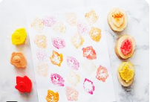
A. Screen printing B. Stamping C. Stencil printing D. Intaglio printing
- You are decorating a piece of fabric by applying melted wax in a design and then dyeing the fabric. The wax resists the dye, creating a pattern. What textile decoration technique are you using? A. Tie and dye B. Embroidery C. Batik D. Fabric painting
- You are making a small animal figure using clay. You roll the clay into long ropes and join them together to build the shape. What pottery method are you using? A. Pinch method B. Slab method C. Coil method D. Wheel throwing
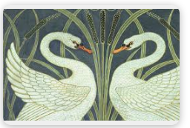
- Your teacher shows you how to arrange different shapes and colours on a page so that the artwork looks balanced and pleasing to the eye. What principle of design are you learning about?

A. Contrast B. Rhythm C. Balance D. Movement
- You are observing a sculpture made from recycled materials like plastic bottles and metal cans. What type of art form involves creating three-dimensional objects? A. Painting B. Drawing C. Sculpture D. Collage
- Your music teacher plays a piece of music and asks you to identify if it is being played loudly or softly. What musical concept are you focusing on? A. Tempo B. Pitch C. Dynamics D. Rhythm
- You are learning a song where you sing the main tune, and some classmates sing a different, lower tune that fits well with yours. What are your classmates singing? A. Melody B. Rhythm C. Harmony D. Unison
- Your teacher shows you symbols on a musical staff that represent how long you should hold a note. What musical element is this related to? A. Pitch B. Tempo C. Duration D. Dynamics
- You are using a drum made from a plastic container and some animal hide to create sounds by hitting it. What type of musical instrument are you playing? A. String instrument B. Wind instrument C. Percussion instrument D. Keyboard instrument
- Your class is composing a simple song about animals. What is the main tune of the song called? A. Rhythm B. Melody C. Harmony D. Beat
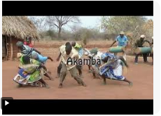
- Your teacher plays a recording of traditional music from a community in Kenya. What type of music are you listening to?

A. Topical song B. sacred song C. Folk song D. patriotic song
- You are learning to sing a song together with your classmates, all singing the same notes at the same time. What is this called? A. Solo singing B. Singing in parts C. Unison singing D. Round singing
- Your teacher shows you a picture of a musical instrument that you play by blowing air through it and pressing keys or covering holes. What category of instrument is this?
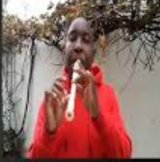
A. String instrument B. Wind instrument C. Percussion instrument D. Keyboard instrument
- Your teacher asks you to work in a group to create a short play about the importance of sharing. You will act out different characters and their interactions. What performing art form are you engaging in? A. Music B. Dance C. Drama D. Visual Arts
- You are creating a dance that tells the story of a plant growing from a seed to a tall tree, using your body movements to show the different stages. What kind of dance are you creating? A. Traditional dance B. Abstract dance C. Narrative dance D. Social dance
- Your teacher asks you to pretend you are pulling a heavy rope, showing the effort and strain through your body and face, without speaking. What performing art technique are you using? A. Singing B. Miming C. Narrating D. Dancing
- Your group is preparing a short drama for the class. You are practicing speaking your lines clearly and with feeling. What is important for actors when speaking on stage? A. Speaking very fast B. Speaking softly C. Using clear voice and expression D. Whispering
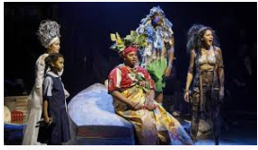
- You are watching a performance and notice the clothes the actors are wearing to represent their characters. What are these clothes called?

A. Props B. Scenery C. Costumes D. Makeup
- Your teacher shows you a video of people performing a dance with specific steps and movements that have been passed down through generations in a community. What type of dance is this? A. Creative movement B. Modern dance C. Folk dance D. Ballet
- Your group is creating a short performance. The written words that the actors will speak are called the: A. Song B. Script C. Story D. Narration
- Your class is practicing running over a short distance as fast as possible. What type of race is this? A. Long-distance race B. Marathon C. Sprint race D. Relay race
- You are learning to jump over a rope that is being swung around. What PE activity are you doing? A. Running B. Skipping C. Throwing D. Catching
- Your teacher shows you how to throw a small ball to a teammate by swinging your arm underhand. What type of throw is this? A. Overhead throw B. Chest pass C. Underarm throw D. Bounce pass
- You are practicing moving around while controlling a ball with your feet, commonly used in games like football. What is this skill called? A. Passing B. Shooting C. Dribbling D. Heading
- Before starting a game, your teacher leads you through exercises to get your body ready and warm. What is the purpose of warming up? A. To make you tired quickly. B. To prepare your muscles and prevent injuries. C. To make you sweat. D. To cool down the body.
- You are learning to balance on one foot for a few seconds. What gymnastics skill are you practicing?
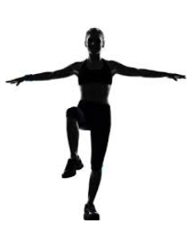
A. Rolling B. Jumping C. Balancing D. Stretching
- Your class is playing a game that involves throwing a disc to each other. What is this game called? A. Football B. Basketball C. Frisbee D. Netball
- After running, your teacher tells you to walk slowly and do some gentle stretches. What is the purpose of cooling down after exercise? A. To make your muscles sore. B. To help your body recover and relax. C. To make you run faster next time. D. To make you thirsty.

THIS IS THE LAST PRINTED PAGE
Answers
  - C
  - C
  - B
  - C
  - C
  - C
  - B
  - C
  - C
  - C
  - C
  - B
  - C
  - C
  - B
  - C
  - C
  - B
  - C
  - B
  - D
  - C
  - C
  - B
  - C
  - C
  - B
  - C
  - C
  - B

