

COMPETENCE BASED EDUCATION
Every learner counts
Values and competencies
GRADE 5
AGRICULTURE AND NUTRITION
Name: .....................................................................................................................
School: ................ ..................................................... .............................................
Date: ................................................Assessment number: ...............................
INSTRUCTIONS FOR THIS EXAMINATION
Before the Examination Begins:
- Do not open this question paper until you are told to do so.
- Ensure that you have the correct question paper for the subject and level you are registered for.
- Write your Name, school, date and assessment Number clearly in the spaces provided on the answer sheet and the question paper (if applicable).
- Listen carefully to any instructions given by the invigilator.
- Ask the invigilator if you have any questions about the instructions or the question paper before you begin.
During the Examination:
- Read each question carefully before attempting to answer it. Understand what is being asked.
- Answer all questions unless instructed otherwise.
- For multiple-choice questions:
  - Choose the one correct answer from the options provided.
  - Indicate your choice clearly on the answer sheet by shading the letter corresponding to the correct answer.
  - If you make a mistake, erase your previous answer completely before marking a new one.
  - Do not make any stray marks on the answer sheet.
- For questions requiring written answers (if applicable in other formats):
  - Write your answers clearly and concisely in the spaces provided.
  - Ensure your handwriting is legible.
  - Show your working where necessary, as marks may be awarded for correct steps.
  - Use a blue or black pen for writing your answers. Do not use pencil unless specifically instructed.
- Manage your time effectively. Allocate your time according to the number of questions and the marks allocated to each question.
- If you are unsure of an answer, move on to the next question and come back to it later if you have time.
- Do not spend too much time on any one question.
- Do not talk to or communicate with other candidates during the examination. Any form of cheating or collusion will result in disqualification.
- Keep your eyes on your own work.
- Raise your hand if you need assistance from the invigilator.
Important Reminders:
- Be honest and do your own work.
- Follow all instructions given by the invigilator.
- Attempt all questions to the best of your ability.
Answer all questions provided in this paper

- Your school garden has different types of crops planted. You see maize, beans, sukumawiki and potatoes. Which of these is classified as a tuber crop?
A. Maize B. Beans
C. Potatoes D. sukumawiki
- You observe some insects feeding on the leaves of the cabbage plants in your garden, causing damage. What are these harmful organisms that attack crops called?
A. Beneficial insects B. Pollinators
C. Crop pests D. Decomposers
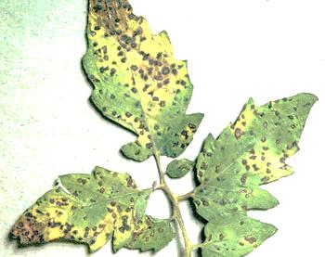
- The tomato plants in your garden have developed spots on their leaves and stems, making them look unhealthy. This is likely caused by a crop disease. What is one common way to control crop diseases?

A. Watering the plants more.
B. Applying appropriate pesticides or fungicides.
C. Adding more manure.
D. Weeding around the plants.
- The maize in your shamba is ready for harvesting. What happens during the harvesting stage of a crop?
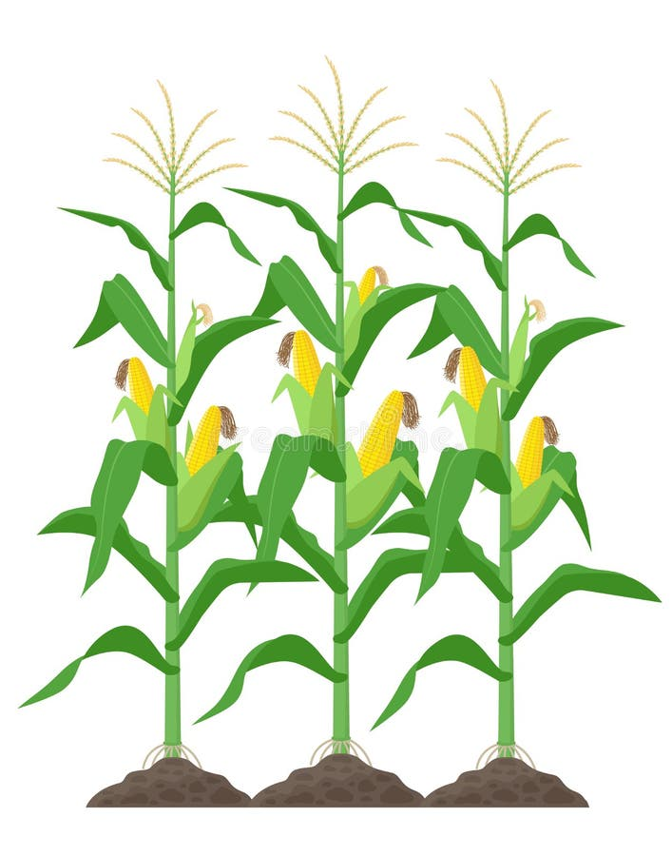

A. Planting seeds.
B. Removing weeds.
C. Gathering the mature crop from the field.
D. Watering the plants.

- Your family has harvested a lot of maize, and you need to store it for later use. What is one important reason for storing harvested crops properly?
A. To make them rot faster.
B. To protect them from pests and spoilage.
C. To make them look smaller.
D. To attract more insects.
- Before your mother cooks the maize she harvested, she removes the grains from the cobs and cleans them. What is this process of preparing harvested crops for consumption or storage called?
A. Planting
B. Harvesting
C. Processing
D. Weeding
- Your neighbour keeps chickens, goats, and a cow. Which of these animals is a type of poultry?
A. Goat B. Cow
C. Chicken D. All of them

- You visit a farm and see different breeds of cattle. Some are kept for milk and others for meat. What do we call animals that are kept by humans for various purposes like milk, meat, eggs, or work?
A. Wild animals
B. Domestic animals (Livestock)
C. Pests
D. Birds
- The farmer is building a structure to keep the chickens safe and comfortable at night. What is this structure where livestock are kept called?

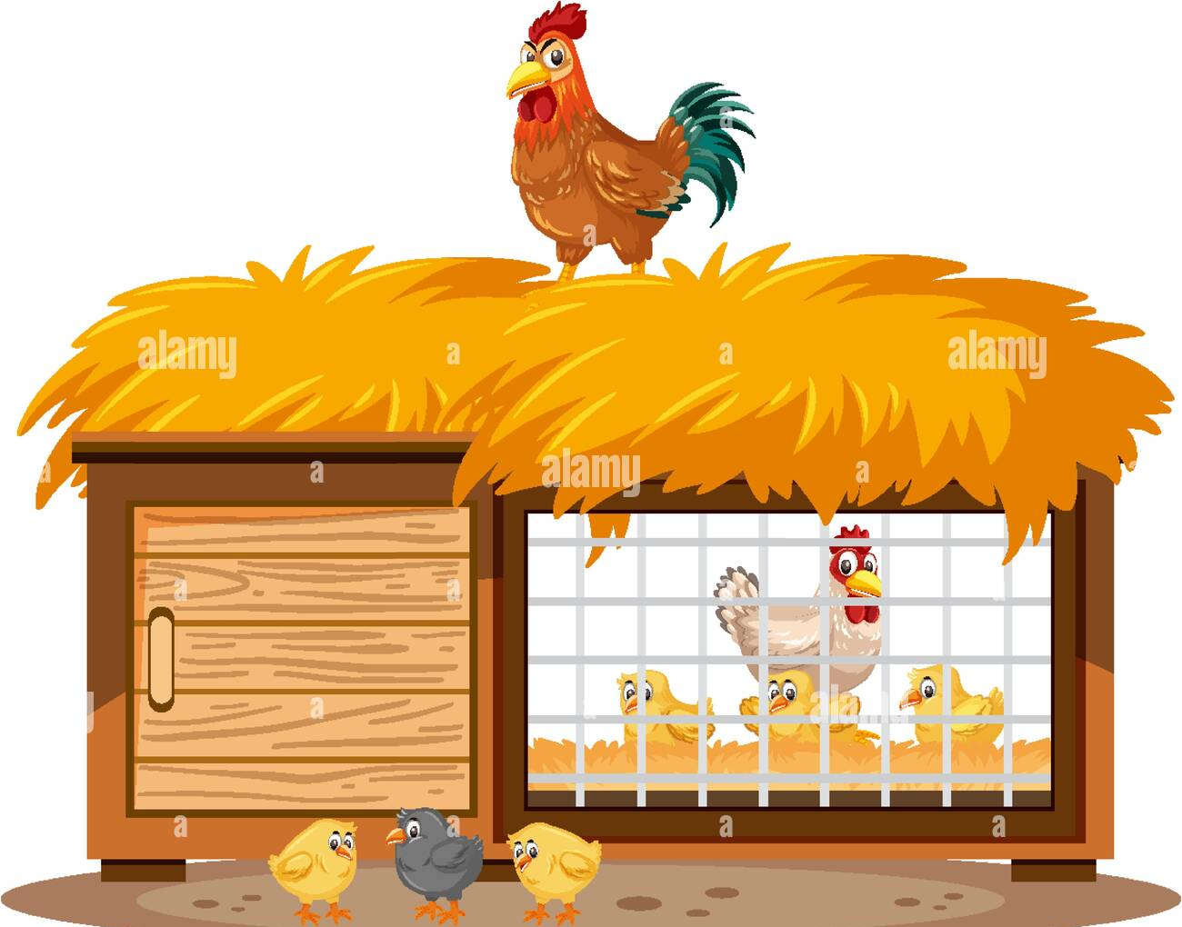

A. House B. Kennel C. Stable D. coop
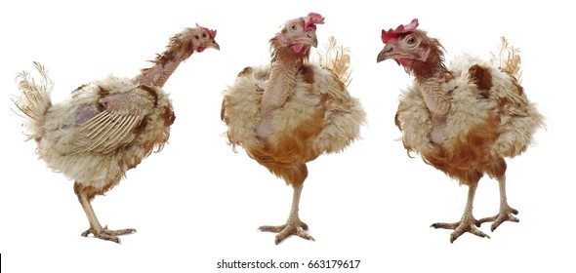
- You notice that some of the chickens on the farm are looking unwell, scratching frequently, and have dull feathers. They might have parasites. What is one way to protect livestock from external parasites like ticks and mites?

A. Giving them more food.
B. Providing clean water.
C. Dipping or spraying them with appropriate chemicals.
D. Singing to them.
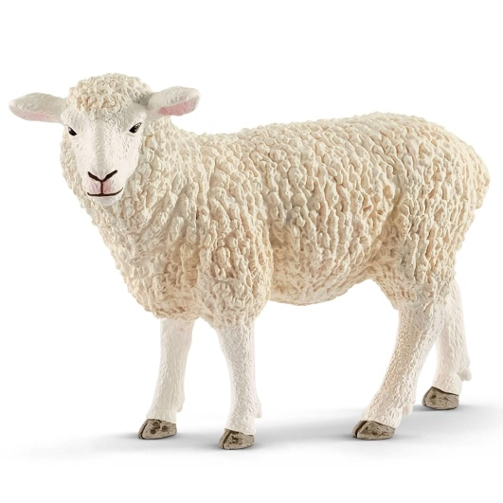
- Your teacher explains that livestock provide us with many useful products. Which of the following products do we get from sheep?

A. Milk and eggs B. Meat and wool
C. Eggs and meat D. Milk and wool
- A veterinarian visits the farm to check on the health of the animals. What does a veterinarian do?
A. Grows crops.
B. Treats sick animals.
C. Builds fences.
D. Harvests crops.
- Your class is learning about preventing soil erosion on slopy land. Which method involves digging steps or flat areas on a slope to reduce the speed of running water?

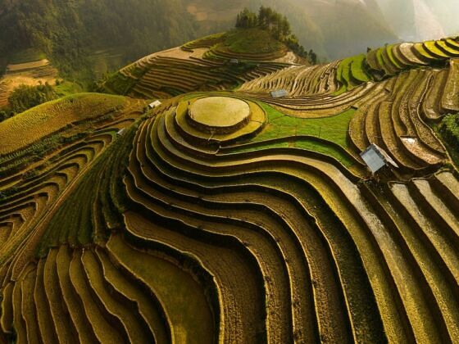

A. Mulching B. Terracing
C. Drip irrigation D. Weeding

- The farmer is ploughing his field along the curves of the land, rather than straight up and down the slope. What soil conservation method is the farmer using?
A. Strip cropping B. Contour ploughing
C. Crop rotation D. Fencing
- During the dry season, Dorothy was advised to cover the soil around the plants with dry grass. What is this practice called, and how does it help conserve water?
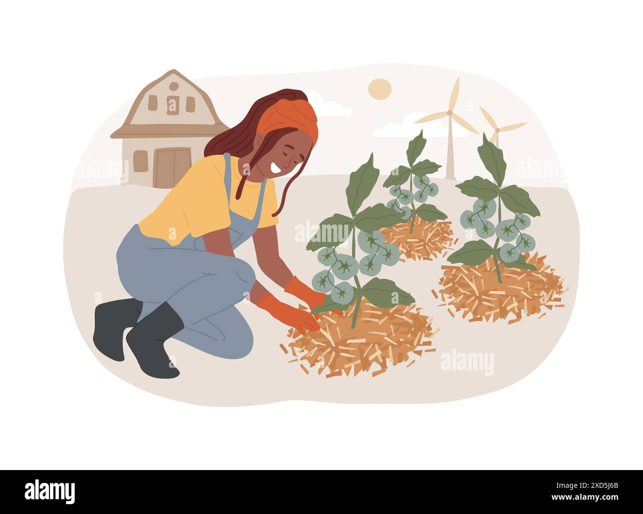

A. Weeding; removes competition for water.
B. Mulching; reduces evaporation of water from the soil.
C. Shading; protects plants from the sun.
D. Fencing; prevents animals from stepping on the soil.
- Your community is encouraged to collect rainwater from the roofs of their houses in tanks. What is this practice of collecting and storing rainwater called?
A. Irrigation
B. Water treatment
C. Water harvesting
D. Drainage
- You need to dig a hole in the ground for planting a tree seedling. Which farm tool is best suited for this task?
A. Rake B. Panga
C. Jembe D. Wheelbarrow

- After digging, you need to chop some small branches and clear the area. Which tool with a heavy blade attached to a handle is used for cutting bushes and branches?
A. Spade B. Fork jembe
C. Panga D. Trowel

- You have harvested some vegetables and need to transport them from the garden to the storage shed. Which equipment with a single wheel and handles is used for carrying loads on a farm?
A. Plough B. Harrow
C. Wheelbarrow D. Sprayer
- To protect your hands when working in the garden, you should wear gloves. What is one important reason for taking care of farm tools and equipment?


A. To make them look old.
B. To prevent accidents and make them last longer.
C. To make them heavier.
D. To make them rust.

- Your teacher is explaining the different food groups. Which food group is mainly responsible for providing your body with energy?
A. Body-building foods (e.g., meat, beans)
B. Protective foods (e.g., fruits, vegetables)
C. Energy-giving foods (e.g., ugali, rice, bread)
D. All food groups equally
- You eat a meal of fish, rice, and spinach. Which part of this meal is a good source of body-building nutrients?

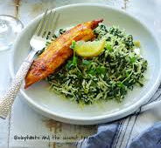

A. Rice B. Spinach
C. Fish D. onions

- To prevent food from spoiling, your mother dries some of the harvested maize under the sun. What is this process of removing water from food to preserve it called?
A. Boiling B. Frying
C. Drying D. Freezing
- You are helping to prepare a meal in the kitchen. Why is it important to wash your hands thoroughly with soap and clean water before handling food?
A. To make your hands smell nice.
B. To remove dirt and germs that can make you sick.
C. To make your hands wet.
D. To practice a habit.
- You find some food that has a bad smell and has changed colour. What should you do with this food?
A. Eat it quickly.
B. Cook it for a long time.
C. Throw it away because it might be spoiled and unsafe to eat.
D. Give it to an animal.

- Your school garden has produced a surplus of sukuma wiki, and your teacher suggests selling the extra harvest to the local community. What is the process of selling farm produce called?
A. Farming B. Harvesting
C. Marketing D. Storage
- To attract buyers for the sukuma wiki, your class bundles it neatly and displays it nicely at the school gate. What is this presentation of produce to potential buyers part of?

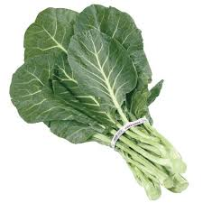

A. Planting
B. Packaging and display
C. Eating
D. Weeding
- A customer comes to buy sukuma wiki and asks for the price per bundle. What is important to agree on before the customer buys the produce?
A. The colour of the sukuma wiki.
B. The price of the sukuma wiki.
C. The time of day.
D. The weather.
- You receive money from the customer for the sukuma wiki they bought. What is the money received from selling farm produce called?
A. Expenses B. Profit
C. Income D. Capital
- Why is it important for farmers to market their agricultural products?
A. To keep the produce for themselves.
B. To earn money from their harvest.
C. To let the produce rot.
D. To feed the pests.

THIS IS THE LAST PRINTED PAGE
ANSWERS
  - C
  - C
  - B
  - C
  - B
  - C
  - C
  - B
  - D
  - C
  - B
  - B
  - B
  - B
  - B
  - C
  - C
  - C
  - C
  - B
  - C
  - C
  - C
  - B
  - C
  - C
  - B
  - B
  - C
  - B

