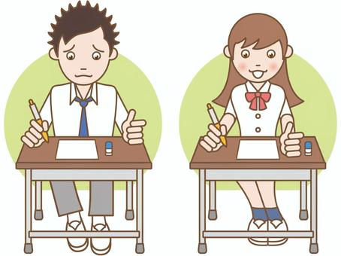

COMPETENCE BASED EDUCATION
Every learner counts
Values and competencies
GRADE 4
SOCIAL STUDIES
Name: .....................................................................................................................
School: ................ ..................................................... .............................................
Date: ................................................Assessment number: ...............................
INSTRUCTIONS FOR THIS EXAMINATION
Before the Examination Begins:
- Do not open this question paper until you are told to do so.
- Ensure that you have the correct question paper for the subject and level you are registered for.
- Write your Name, school, date and assessment Number clearly in the spaces provided on the answer sheet and the question paper (if applicable).
- Listen carefully to any instructions given by the invigilator.
- Ask the invigilator if you have any questions about the instructions or the question paper before you begin.
During the Examination:
- Read each question carefully before attempting to answer it. Understand what is being asked.
- Answer all questions unless instructed otherwise.
- For multiple-choice questions:
  - Choose the one correct answer from the options provided.
  - Indicate your choice clearly on the answer sheet by shading the letter corresponding to the correct answer.
  - If you make a mistake, erase your previous answer completely before marking a new one.
  - Do not make any stray marks on the answer sheet.
- For questions requiring written answers (if applicable in other formats):
  - Write your answers clearly and concisely in the spaces provided.
  - Ensure your handwriting is legible.
  - Show your working where necessary, as marks may be awarded for correct steps.
  - Use a blue or black pen for writing your answers. Do not use pencil unless specifically instructed.
- Manage your time effectively. Allocate your time according to the number of questions and the marks allocated to each question.
- If you are unsure of an answer, move on to the next question and come back to it later if you have time.
- Do not spend too much time on any one question.
- Do not talk to or communicate with other candidates during the examination. Any form of cheating or collusion will result in disqualification.
- Keep your eyes on your own work.
- Raise your hand if you need assistance from the invigilator.
Important Reminders:
- Be honest and do your own work.
- Follow all instructions given by the invigilator.
- Attempt all questions to the best of your ability.

Answer all questions
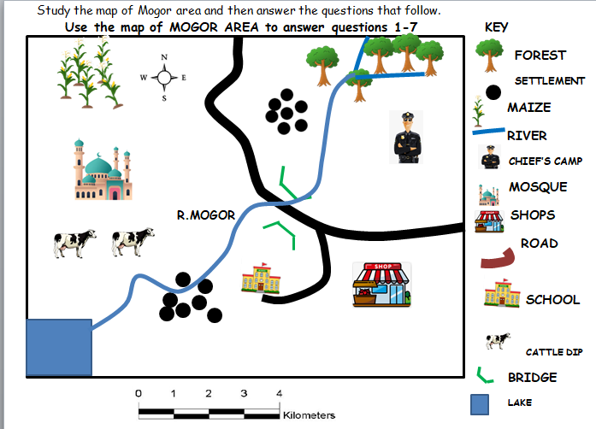

Questions
- River Mogor flows from?

- North west to south east
- South west to north east
- North east to south west
- East to west

- The people of Mogor area are?

- Pagans.
- Christians.
- Muslims.
- Hindus.

- The main crop grown in Mogor area is?

- Coffee.
- Banana.
- Maize.
- Sugarcane.

- The type of settlement found in Mogor area is?

- Clustered.
- Linear.
- Scattered.
- Densely
- Which type of domestic animal is reared in Mogor area?

- Sheep.
- Cattle.
- Goat.
- Camel.

- The main type of transport in Mogor area is?

- Road.
- Air.
- Railway.
- Water.

- Which economic activity IS NOT practiced in Mogor area?

- Fishing
- Trading
- Farming
- Mining

- How many Counties are there in Kenya?

- 4
- 7
- 47
- 74

- Which one of the following IS NOT a built environment?

- Forest
- Monument
- Museum
- Historical sites

- ________________ Is the peoples way of life

- Population
- Culture
- Trade
- tradition

- Which one of the following IS NOT a basic need?

- Food.
- Cloth
- Shelter
- Car

- Who among the following IS NOT a leader in our community?

- Teacher
- Governor
- Pastor
- Thief

- The following are factors that promote peace in school, EXCEPT?

- Teamwork
- Honesty
- Absenteeism
- Understanding each other.

- What is the main work of the police in our County?

- Arresting people
- Maintaining law and order
- Killing thieves
- Fighting on the streets.

- Which means of transport is common in out County?

- Air transport
- Road transport
- Water transport
- Railway transport

- The population of a place can be increased by?

- Diseases
- Famine
- War
- food

- The following members make up a county assembly, EXCEPT?

- County assembly committees
- MPs
- Speaker
- MCAs

- A place where raw materials are changed into finished products is called?

- Industry
- Market
- Shop
- School

- Many sub counties make a?

- Ward
- County
- Sub county
- Location

- A person who belongs to a particular country is called a?

- Thief
- Police
- teacher
- Citizen

  - Sarah's family lives in a small village. Many other families also live in the same area and share resources like water and land. What do we call a group of families living together in a specific area? A. County B. Community C. Country D. Continent
  - Mwangi's class counted the number of people living in different houses in their village. They found that some houses had many people while others had few. What does the number of people living in a particular area refer to? A. Culture B. Population C. Economy D. Government
  - Omar visited a busy town. He noticed there were many people living and working closely together compared to his village. What type of population distribution is likely found in a busy town? A. Sparse population B. Dense population C. Linear population D. Scattered population
  - Lisa's family is discussing their history. They learned that they are all related through their great-grandparents and share a common name and traditions. What do you call a group of families who are related and share a common ancestor? A. Nation B. Clan C. Age set D. Community
  - James's class learned about different economic activities. His neighbour grows maize and beans to sell at the market. What economic activity is the neighbour involved in? A. Trading B. Fishing C. Farming D. Mining
  - Amani helped his mother take their cow to the dipping spray to prevent ticks. Keeping animals like cows, goats, and chickens is a common economic activity in many parts of Kenya. What is this activity called? A. Crop farming B. Livestock keeping C. Fishing D. Manufacturing
  - David bought a loaf of bread from the local shop using money. What type of trade involves the exchange of goods and services for money? A. Barter trade B. Currency trade C. Traditional trade D. Local trade
  - Mary's grandmother told her stories about how people in the past exchanged goods like maize for beans without using money. What was this system of trade called? A. Modern trade B. Currency trade C. Barter trade D. Wholesale trade
  - Tom's community has a leader who helps solve small disagreements between people and reports to the chief. What is the title of this leader at the lowest level of local administration in a village? A. Chief B. County Commissioner C. Village Elder D. Governor
  - Sarah's school participated in a national event where they sang the national anthem and hoisted the Kenyan flag. What do we call symbols like the national anthem and the flag that represent a country's identity? A. Community symbols B. Local symbols C. National symbols D. Cultural symbols
  - Mwangi learned that children have rights, such as the right to education and healthcare. What do we call the entitlements and freedoms that every person should have? A. Responsibilities B. Duties C. Rules D. Rights
  - Omar's teacher explained that citizens have duties to perform, such as respecting the law and keeping the environment clean. What are the tasks or actions that citizens are expected to do for the benefit of their community and country called? A. Rights B. Freedoms C. Responsibilities D. Privileges
  - Lisa observed the sky and saw dark clouds gathering. She knew it was going to rain. What do we call the day-to-day condition of the atmosphere in a place? A. Climate B. Season C. Weather D. Temperature
  - James lives in a part of Kenya that receives heavy rainfall for several months of the year, followed by a dry period. What do we call the general weather pattern of a place over a long period? A. Weather B. Season C. Temperature D. Climate
  - Amina went for a walk and saw a large natural elevation of land with steep sides, much taller than a hill. What is this physical feature called? A. Valley B. Plain C. Mountain D. River
  - David lives near a large natural body of water surrounded by land. What is this physical feature? A. River B. Ocean C. Lake D. Swamp
  - Mary's class learned about features made by people. Which of the following is an example of a built environment? A. Forest B. River C. School building D. Mountain
  - Tom's school organized a tree-planting activity in the compound. Planting trees helps in the protection and wise use of resources like soil and water. What is this practice called? A. Development B. Pollution C. Conservation D. Destruction
  - Sarah visited a place where old items from the past, like traditional tools and clothes, are kept and displayed for people to learn about history. What is this place called? A. Library B. Museum C. Gallery D. Archives
  - Mwangi's teacher showed the class a simple drawing of their school compound from above, showing the location of different buildings and the playground. What is this simple drawing that represents an area called? A. Photograph B. Diagram C. Sketch map D. Globe
  - Omar's class was using a map of their county. They saw a symbol representing a hospital. What part of the map explains the meaning of the symbols used? A. Title B. Scale C. Compass direction D. Key
  - Lisa used a compass to find her direction. The compass has main points like North, South, East, and West. What are these main directions called? A. Intermediate points B. Cardinal points C. Ordinal points D. Directional points
  - James learned about traditional ceremonies in his community, like those for naming children or celebrating harvests. These ceremonies are part of the community's: A. Economy B. Government C. Culture D. Geography
  - Amina's mother wears traditional clothes during cultural festivals. Clothing styles are an aspect of a community's: A. Environment B. Technology C. Culture D. Politics
  - David noticed that during the dry season, the grass in the fields turns brown. What aspect of the environment changes with the seasons? A. Population B. Weather C. Government D. Economic activities
  - Mary lives near a river and sees people washing clothes and cars in it. This can harm the water and the living things in it. What is the harmful change to the environment caused by human activities called? A. Conservation B. Development C. Pollution D. Preservation
  - Tom learned that respecting elders is an important value in his community. Values are the beliefs about what is right and wrong that guide people's behaviour. What is another example of a positive community value? A. Laziness B. Dishonesty C. Cooperation D. Selfishness
  - Sarah's teacher explained that the national government is headed by the President, and the county government is headed by the Governor. At the village level, who is the administrative head? A. Member of Parliament (MP) B. Chief C. Senator D. Ward Administrator
  - Mwangi saw a sign along the road showing where a historical monument is located. Protecting such places is important for preserving our: A. Natural resources B. Wildlife C. Heritage D. Weather patterns
  - Omar's community relies on farming as their main source of income. This is an example of using which type of resource? A. Human resource B. Capital resource C. Natural resource D. Financial resource

Answer Key:
  - C
  - C
  - C
  - C
  - B
  - A
  - A
  - C
  - A
  - B
  - D
  - D
  - C
  - B
  - B
  - D
  - B
  - A
  - B
  - D
  - B
  - B
  - B
  - B
  - C
  - B
  - B
  - C
  - C
  - C
  - D
  - C
  - C
  - D
  - C
  - C
  - C
  - C
  - B
  - C
  - D
  - B
  - C
  - C
  - B
  - C
  - C
  - B
  - C
  - C

