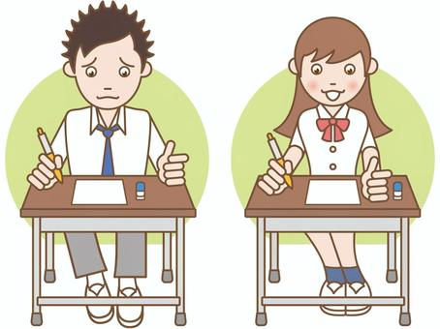

COMPETENCE BASED EDUCATION
Every learner counts
Values and competencies
GRADE 4
SCIENCE AND TECHNOLOGY
Name: ....................................................................................................................
School: ....................................................................................................................
Date: ................................................Assessment number: ...............................
INSTRUCTIONS FOR THIS EXAMINATION TIME: 1 Hour 30 Minutes
Before the Examination Begins:
- Do not open this question paper until you are told to do so.
- Ensure that you have the correct question paper for the subject and level you are registered for.
- Write your Name, school, date and assessment Number clearly in the spaces provided on the answer sheet and the question paper (if applicable).
- Listen carefully to any instructions given by the invigilator.
- Ask the invigilator if you have any questions about the instructions or the question paper before you begin.
During the Examination:
- Read each question carefully before attempting to answer it. Understand what is being asked.
- Answer all questions unless instructed otherwise.
- For multiple-choice questions:
  - Choose the one correct answer from the options provided.
  - Indicate your choice clearly on the answer sheet by shading the letter corresponding to the correct answer.
  - If you make a mistake, erase your previous answer completely before marking a new one.
  - Do not make any stray marks on the answer sheet.
- For questions requiring written answers (if applicable in other formats):
  - Write your answers clearly and concisely in the spaces provided.
  - Ensure your handwriting is legible.
  - Show your working where necessary, as marks may be awarded for correct steps.
  - Use a blue or black pen for writing your answers. Do not use pencil unless specifically instructed.
- Manage your time effectively. Allocate your time according to the number of questions and the marks allocated to each question.
- If you are unsure of an answer, move on to the next question and come back to it later if you have time.
- Do not spend too much time on any one question.
- Do not talk to or communicate with other candidates during the examination. Any form of cheating or collusion will result in disqualification.
- Keep your eyes on your own work.
- Raise your hand if you need assistance from the invigilator.
Important Reminders:
  - Be honest and do your own work.
  - Follow all instructions given by the invigilator.
  - Attempt all questions to the best of your ability.
Answer all questions

- Sarah observed a plant in her school garden. She noticed it had roots holding it firmly in the soil, a stem supporting the leaves, and green leaves. Which part of the plant helps it to make its own food? A. Roots B. Stem C. Leaves D. Flowers
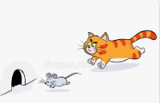
- Omar saw a cat chasing a mouse.

He noticed:-
- The cat has fur,
- Gives birth to live young, and
- Feeds its babies milk.
What group of animals does the cat belong to? A. Birds B. Fish C. Mammals D. Reptiles
- During a science lesson, the teacher showed the learners different types of teeth. Which type of tooth is best suited for tearing meat? A. Incisors B. Canines C. Premolars D. Molars
- A group of learners visited a local farm. They observed animals that have a backbone. Which of the following animals is a vertebrate? A. Snail B. Worm C. Chicken D. Spider
- Mwangi was helping his mother in the kitchen. He saw water boiling in a pot and noticed steam rising. What state of matter is the steam? A. Solid B. Liquid C. Gas D. Plasma
- Amani poured sand from a bucket into a smaller can. He noticed that the sand took the shape of the can but its volume remained the same. What state of matter is sand? A. Solid B. Liquid C. Gas D. Matter
- During a rainy day, the school compound was wet. After some time, the sun came out, and the water on the ground disappeared. What process caused the water to disappear into the air? A. Melting B. Freezing C. Evaporation D. Condensation
- Tom was playing with a toy car. He pushed it, and it moved across the floor. What is the push or pull that makes an object move, stop, or change direction called? A. Energy B. Work C. Force D. Motion
- Lisa observed different sources of energy in her home. Which of the following is a source of light energy? A. A stone B. A table C. A lit bulb D. A book
- During a thunder storm, Fatuma heard a loud sound after seeing the lightning. What form of energy travels in waves and can be heard by our ears? A. Light energy B. Heat energy C. Sound energy D. Electrical energy
- David felt warmth from the sun on his skin while playing outside. What form of energy is transferred from hotter objects to colder objects? A. Light energy B. Sound energy C. Heat energy D. Potential energy
- The teacher demonstrated how a magnet attracts certain materials. Which of the following materials is attracted by a magnet? A. Plastic ruler B. Wooden stick C. Iron nail D. Glass marble
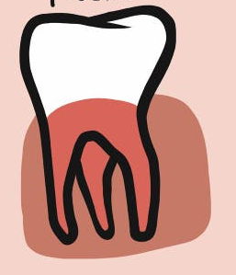
- Amina looked at a picture of a tooth as shown below.

What is the name of the tooth? A. premolar B. incisor C. molar D. Canine
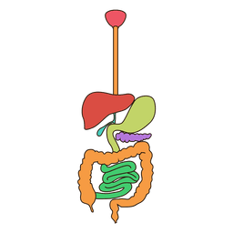
- James observed the model parts of a body.

M

What is the name of the paert labelled M? A. mouth B. Pancreas C. oesophagus D. colon
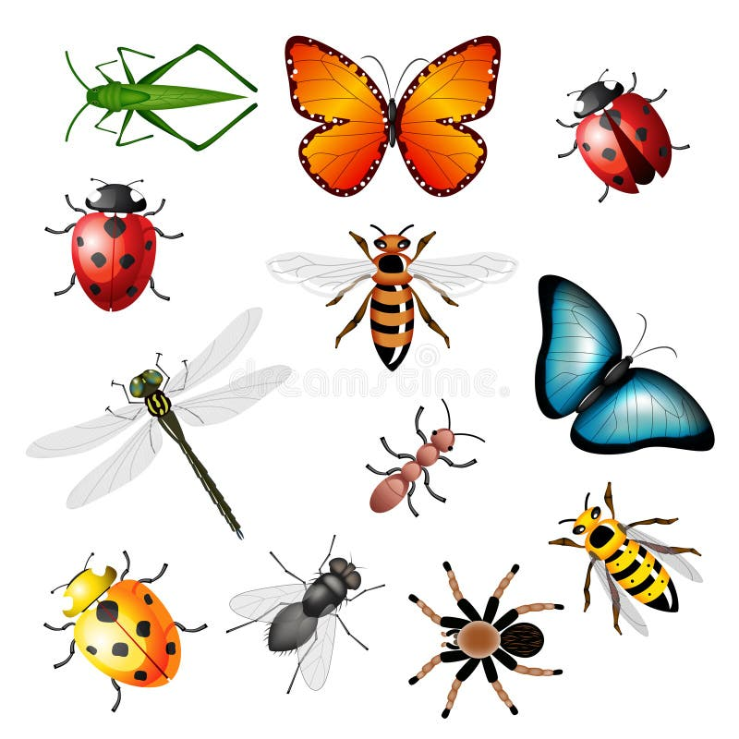
- Which one of the following animals has a backbone?


A B C D
- Mary used a device to type a story for her homework. This device has a screen and keys for typing.

What type of digital device did she use? A. Mobile phone B. Television C. Computer D. Radio
- Tom used a digital device to take pictures during a school trip.
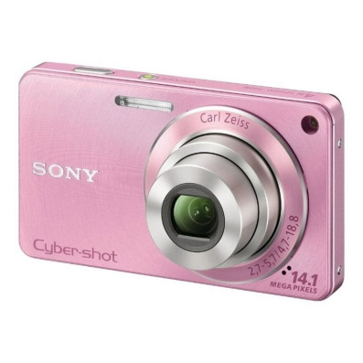
Which digital device is primarily used for capturing photographs? A. Printer B. Scanner C. Camera D. Keyboard
- The teacher explained that some parts of a computer are physical and you can touch them. What are these physical parts of a computer called?

A. Software B. Data C. Hardware D. Programs
- Sarah was learning about coding. Her teacher explained that coding is like giving instructions to a computer. What do we call the set of instructions that tell a computer what to do? A. Data B. Hardware C. Programs D. Files
- John wants to send a written message to his friend using a mobile phone. What application can he use? A. Camera B. Calculator C. Messaging app D. Clock
- Animals that feed only on plants are called: A. Carnivores B. Herbivores C. Omnivores D. Vertebrates
- Which of the following is a liquid? A. Stone B. Milk C. Air D. Ice
- What happens to water when it is heated to its boiling point? A. It freezes B. It melts C. It evaporates D. It condenses
- A simple tool that helps us to lift heavy objects using a bar that pivots on a support is called a: A. Pulley B. Lever C. Wheelbarrow D. Screw
- Which of the following is a renewable source of energy? A. Coal B. Oil C. Sunlight D. Natural gas
- The feeling of hotness or coldness is a measure of: A. Light B. Sound C. Temperature D. Force
- The solid state of water is called: A. Rain B. Ice C. Vapor D. Cloud
- Which part of the human digestive system absorbs digested food into the bloodstream? A. Stomach B. Large intestine C. Small intestine D. Oesophagus
- A coded pattern like traffic lights helps us to know when to stop or go. What does the red light in a traffic light usually indicate?

A. Go B. Slow down C. Stop D. Prepare to go
- Which of the following digital devices is commonly used for making calls and sending messages? A. Television B. Radio C. Mobile phone D. Projector

THIS IS THE LAST PRINTED PAGE
Answer Key:
- C
- C
- B
- C
- C
- A
- C
- C
- C
- C
- C
- C
- C
- B
- D
- C
- C
- C
- C
- C
- B
- B
- C
- B
- C
- C
- B
- C
- C
- C

