

COMPETENCE BASED EDUCATION
Every learner counts
Values and competencies
GRADE 4
MATHEMATICS
Name: ....................................................................................................................
School: ....................................................................................................................
Date: ................................................Assessment number: ...............................
INSTRUCTIONS FOR THIS EXAMINATION TIME: 1 Hour 30 Minutes
Before the Examination Begins:
- Do not open this question paper until you are told to do so.
- Ensure that you have the correct question paper for the subject and level you are registered for.
- Write your Name, school, date and assessment Number clearly in the spaces provided on the answer sheet and the question paper (if applicable).
- Listen carefully to any instructions given by the invigilator.
- Ask the invigilator if you have any questions about the instructions or the question paper before you begin.
During the Examination:
- Read each question carefully before attempting to answer it. Understand what is being asked.
- Answer all questions unless instructed otherwise.
- For multiple-choice questions:
  - Choose the one correct answer from the options provided.
  - Indicate your choice clearly on the answer sheet by shading the letter corresponding to the correct answer.
  - If you make a mistake, erase your previous answer completely before marking a new one.
  - Do not make any stray marks on the answer sheet.
- For questions requiring written answers (if applicable in other formats):
  - Write your answers clearly and concisely in the spaces provided.
  - Ensure your handwriting is legible.
  - Show your working where necessary, as marks may be awarded for correct steps.
  - Use a blue or black pen for writing your answers. Do not use pencil unless specifically instructed.
- Manage your time effectively. Allocate your time according to the number of questions and the marks allocated to each question.
- If you are unsure of an answer, move on to the next question and come back to it later if you have time.
- Do not spend too much time on any one question.
- Do not talk to or communicate with other candidates during the examination. Any form of cheating or collusion will result in disqualification.
- Keep your eyes on your own work.
- Raise your hand if you need assistance from the invigilator.
Important Reminders:
  - Be honest and do your own work.
  - Follow all instructions given by the invigilator.
  - Attempt all questions to the best of your ability.
Answer all questions provided in this paper

- Mwangi's father harvested 7589 ears of maize from his small farm.
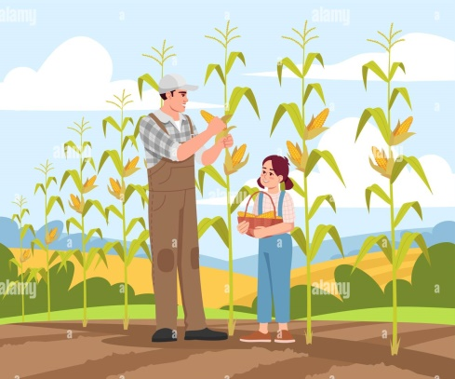
What is the number of bags harvested written in words? A. seven thousand five hundred and eighty nine B. seven hundred and eigty nine thousand C. seven five eight nine D. seventy five eighty nine
- A school requires 5,328 exercise books for the learners.

What is the place value of digit 5? A. thousands B. ones C. tens D. hundreds
- In a village, there are 12 families. Each family has 6 chickens. How many chickens are there in total in the village? A. 18 B. 62 C. 72 D. 78
- Mercy had 48 sweets. She wanted to share them equally among her 8 friends. How many sweets did each friend receive? A. 5 B. 6 C. 7 D. 8
- A tailor used 2.5 metres of fabric to make one dress. If she makes 10 such dresses, how much fabric will she use in total? A. 2.5 metres B. 12.5 metres C. 25 metres D. 250 metres
- Kamau had a string that was 3 metres long. He cut off 1 metre and 20 centimetres to tie a parcel. How much string was left? A. 1 metre 80 centimetres B. 2 metres 20 centimetres C. 2 metres 80 centimetres D. 4 metres 20 centimetres
- A square garden has a side length of 7 metres. What is the perimeter of the garden? A. 14 metres B. 28 metres C. 35 metres D. 49 metres
- Sarah drew a rectangle on her notebook. She counted the squares inside and found there were 24 squares, each measuring 1 cm by 1 cm. What is the area of the rectangle? A. 12 sq cm B. 24 sq cm C. 28 sq cm D. 48 sq cm
- A bag of sugar has a mass of 2 kilograms. How many 500-gram packets of sugar can be filled from this bag? A. 2 B. 4 C. 10 D. 20
- A water tank has a capacity of 50 litres. If there are already 15 litres of water in the tank, how many more litres are needed to fill it completely? A. 30 litres B. 35 litres C. 40 litres D. 65 litres
- The time now is a quarter past 10 in the morning. How will you write this time in figures? A. 10:00 B. 10:15 C. 10:30 D. 10:45

- A bus left the stage at 8:00 AM and arrived at its destination at 10:30 AM.

How long did the journey take? A. 1 hour 30 minutes B. 2 hours C. 2 hours 30 minutes D. 3 hours
- John saved 5 twenty-shilling coins. How much money did he save in total? A. Ksh 25 B. Ksh 50 C. Ksh 100 D. Ksh 120
- Mary bought a loaf of bread for Ksh 60 and a packet of milk for Ksh 50. How much did she spend in total? A. Ksh 10 B. Ksh 110 C. Ksh 120 D. Ksh 130
- What is the next number in the pattern: 5, 10, 15, 20, ______? A. 21 B. 25 C. 30 D. 35

- A class recorded the number of sunny days in a week using tally marks. If they recorded |||| ||, how many sunny days were there? A. 5 B. 6 C. 7 D. 8
- A teacher asked learners to draw shapes. Which of the following shapes has four equal sides and four right angles? A. Triangle B. Circle C. Square D. Rectangle
- Look at the corner of your classroom door. What type of angle is formed at the corner? A. Acute angle B. Obtuse angle C. Right angle D. Straight angle
- Estimate the number of steps it takes to walk from your classroom door to the school gate. Which of the following is a reasonable estimate? A. 10 steps B. 50 steps C. 500 steps D. 5 steps
- What is the place value of the digit 7 in the number 6,723? A. Ones B. Tens C. Hundreds D. Thousands
- Round off the number 46 to the nearest ten. A. 40 B. 45 C. 50 D. 56
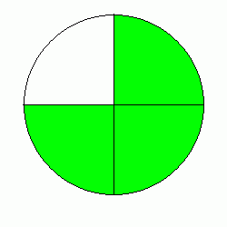
- Write the fraction representing the shaded part of a circle divided into 4 equal parts with 3 parts shaded.

A. ¼ B. $\frac{2​}{4}$ C. ¾ D. $\frac{4}{4}​$
- Convert the fraction ½ into a decimal. A. 0.1 B. 0.2 C. 0.5 D. 1.2
- Peter's height is 1 metre and 35 centimetres. How many centimetres tall is Peter? A. 13.5 cm B. 100 cm C. 135 cm D. 1035 cm
- A farmer planted 3 rows of cabbage with 15 cabbage plants in each row. How many cabbage plants did he plant in total? A. 18 B. 35 C. 45 D. 48
- What is the value of 8 multiplied by 9? A. 17 B. 72 C. 81 D. 98
- Divide 56 by 7. A. 6 B. 7 C. 8 D. 9
- How many days are there in the month of April? A. 28 B. 29 C. 30 D. 31
- A shopkeeper had Ksh 500. He bought goods worth Ksh 380. How much money was he left with? A. Ksh 120 B. Ksh 220 C. Ksh 880 D. Ksh 180
- Which of the following is a multiple of 5? A. 12 B. 17 C. 23 D. 30

Answer Key:
- A
- A
- C
- B
- C
- A
- B
- B
- B
- B
- B
- C
- C
- B
- B
- C
- C
- C
- B (Accept a reasonable estimate around this range depending on the actual school layout, but 50 is a common and reasonable estimate for a short walk)
- C
- C
- C
- C
- C
- C
- B
- C
- C
- A
- D

