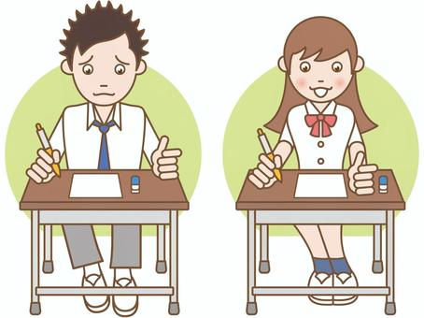

COMPETENCE BASED EDUCATION
Every learner counts
Values and competencies
GRADE 4
ENGLISH
Name: ....................................................................................................................
School: ....................................................................................................................
Date: ................................................Assessment number: ...............................
INSTRUCTIONS FOR THIS EXAMINATION TIME: 1 Hour 30 Minutes
Before the Examination Begins:
- Do not open this question paper until you are told to do so.
- Ensure that you have the correct question paper for the subject and level you are registered for.
- Write your Name, school, date and assessment Number clearly in the spaces provided on the answer sheet and the question paper (if applicable).
- Listen carefully to any instructions given by the invigilator.
- Ask the invigilator if you have any questions about the instructions or the question paper before you begin.
During the Examination:
- Read each question carefully before attempting to answer it. Understand what is being asked.
- Answer all questions unless instructed otherwise.
- For multiple-choice questions:
  - Choose the one correct answer from the options provided.
  - Indicate your choice clearly on the answer sheet by shading the letter corresponding to the correct answer.
  - If you make a mistake, erase your previous answer completely before marking a new one.
  - Do not make any stray marks on the answer sheet.
- For questions requiring written answers (if applicable in other formats):
  - Write your answers clearly and concisely in the spaces provided.
  - Ensure your handwriting is legible.
  - Show your working where necessary, as marks may be awarded for correct steps.
  - Use a blue or black pen for writing your answers. Do not use pencil unless specifically instructed.
- Manage your time effectively. Allocate your time according to the number of questions and the marks allocated to each question.
- If you are unsure of an answer, move on to the next question and come back to it later if you have time.
- Do not spend too much time on any one question.
- Do not talk to or communicate with other candidates during the examination. Any form of cheating or collusion will result in disqualification.
- Keep your eyes on your own work.
- Raise your hand if you need assistance from the invigilator.
Important Reminders:
  - Be honest and do your own work.
  - Follow all instructions given by the invigilator.
  - Attempt all questions to the best of your ability.
Answer all questions in the sections provided
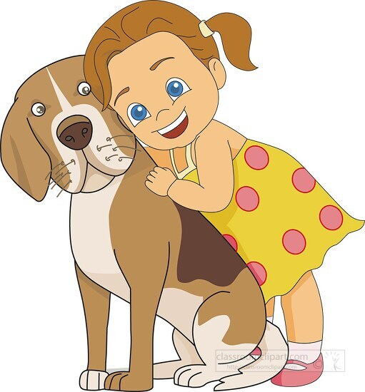
Read the passage below and answer questions 1 to 5.
My name is Akinyi. I love animals. I have a pet dog named Spot. Spot is brown and white. He loves to play fetch with me in the park. We also go for walks in the evening. Spot is a very friendly dog. He wags his tail when he sees me. He is my best friend.

- What is the girl's name?
A. Spot B. Akinyi
C. Park D. Friend
- What is the name of Akinyi's pet?
A. Cat B. Rabbit
C. Dog D. Bird
- What colour is Spot?
A. Black and white B. Brown and black
C. Brown and white D. White and grey
- What game does Spot love to play with Akinyi?
A. Hide and seek B. Tag
C. Fetch D. Running
- How does Spot show he is happy to see Akinyi?
A. He barks loudly. B. He jumps high.
C. He runs away. D. He wags his tail.

Read the passage below and answer questions 6 to 10.
Our school has a small garden. Grade 4 learners help to take care of it. We planted different vegetables like spinach, cabbage, and tomatoes. Every morning, before classes start, we water the plants. We also remove weeds so that the vegetables can grow well. Soon, we will harvest the vegetables and share them with our families. Growing vegetables is fun!

- What does the school have?
A. A swimming pool B. A garden
C. A library D. A playground
- Which learners help in the garden?
A. Grade 1 B. Grade 4
C. Grade 8 D. All learners
- Which of these vegetables was NOT mentioned in the passage?
A. Spinach B. Carrots
C. Cabbage D. Tomatoes

- What do the learners do every morning before classes?
A. Play games B. Water the plants
C. Read books D. Eat breakfast

- Why do the learners remove weeds from the garden?
A. To play with them
B. To make the garden look untidy
C. So that the vegetables can grow well
D. To plant more weeds

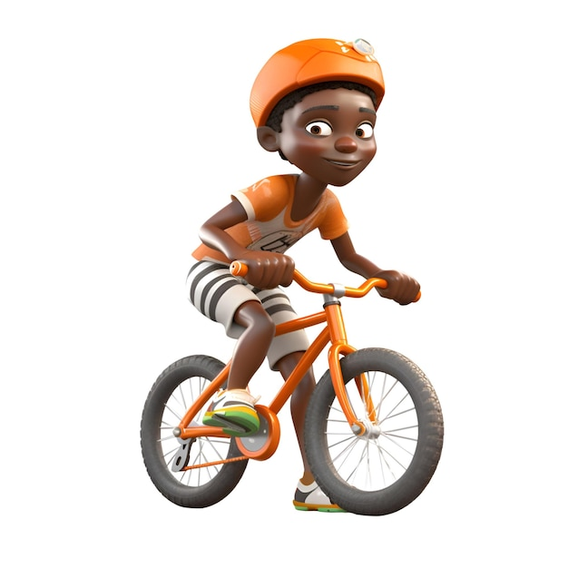
Read the passage below and answer questions 11 to 15.

Mwangi received a bicycle for his birthday. He was very happy. The bicycle was orange and shiny. Mwangi loves riding his bicycle to the nearby shopping centre. He always wears a helmet to protect his head. He also checks the brakes before he rides. Riding a bicycle is a good way to exercise and have fun. Mwangi is careful and follows the traffic rules.

- What did Mwangi receive for his birthday?
A. A ball B. A book
C. A bicycle D. A toy car
- What colour was the bicycle?
A. Blue and shiny B. Yellow and shiny
C. Green and shiny D. Orange and shiny
- Where does Mwangi love riding his bicycle?
A. To the park
B. To the school
C. To the nearby shopping centre
D. To his friend's house
- What does Mwangi always wear to protect his head?
A. A cap B. A helmet
C. A hat D. Glasses
- Why is riding a bicycle considered a good activity?
A. It is dangerous.
B. It helps you sleep.
C. It is a good way to exercise and have fun.
D. It makes you tired.

Read the passage below and choose the correct word from the options to fill in the blanks 16 to 20.
Every morning, I wake _________ (16) early. I wash my __________ (17) and brush my teeth. Then, I wear my school ___________ (18). My mother prepares ___________ (19) for me. I eat quickly and ______________ (20) goodbye to my parents before going to school.
A. down B. off C. up D. away
A. feet B. hands C. face D. hair
A. clothes B. uniform C. shoes D. bag
A. dinner B. lunch C. supper D. breakfast
A. say B. tell C. ask D. wave

Choose the correct word or phrase to complete each sentence.

- The cat is sleeping ______ the chair.
A. in B. on C. under D. at
- She is a very ______ girl. She always helps others.
A. lazy B. kind C. sad D. angry
- Choose the correct plural for 'book':
A. books B. books C. booking D. booky
- We ______ playing football in the field yesterday.
A. is B. am C. are D. were
- He ______ to school every day.
A. go B. going C. goes D. went
- Choose the correct question word: ______ is your name?
A. Where B. When C. What D. How
- As heavy as an____?
A. ant B. elephant C. eagle D. egg

- Choose the correct sentence:
A. The boy is run fast.
B. The boy running fast.
C. The boy runs fast.
D. The boy run fast.

- My brother is ______ than me.
A. tall
B. taller
C. tallest
D. more tall

- The opposite of 'happy' is:
A. good
B. sad
C. big
D. fast

COMPOSITION WRITING
You have been given 40 minutes to write an interesting composition.
Look at the following photograph and write a story about it


























