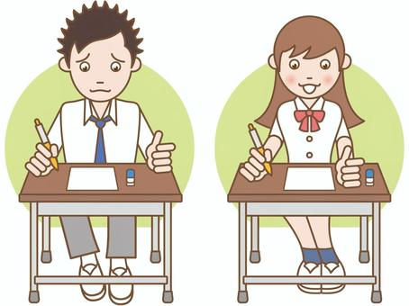

COMPETENCE BASED EDUCATION
Every learner counts
Values and competencies
GRADE 4
CREATIVE ARTS
Name: ....................................................................................................................
School: ....................................................................................................................
Date: ................................................Assessment number: ...............................
INSTRUCTIONS FOR THIS EXAMINATION TIME: 1 Hour 30 Minutes
Before the Examination Begins:
- Do not open this question paper until you are told to do so.
- Ensure that you have the correct question paper for the subject and level you are registered for.
- Write your Name, school, date and assessment Number clearly in the spaces provided on the answer sheet and the question paper (if applicable).
- Listen carefully to any instructions given by the invigilator.
- Ask the invigilator if you have any questions about the instructions or the question paper before you begin.
During the Examination:
- Read each question carefully before attempting to answer it. Understand what is being asked.
- Answer all questions unless instructed otherwise.
- For multiple-choice questions:
  - Choose the one correct answer from the options provided.
  - Indicate your choice clearly on the answer sheet by shading the letter corresponding to the correct answer.
  - If you make a mistake, erase your previous answer completely before marking a new one.
  - Do not make any stray marks on the answer sheet.
- For questions requiring written answers (if applicable in other formats):
  - Write your answers clearly and concisely in the spaces provided.
  - Ensure your handwriting is legible.
  - Show your working where necessary, as marks may be awarded for correct steps.
  - Use a blue or black pen for writing your answers. Do not use pencil unless specifically instructed.
- Manage your time effectively. Allocate your time according to the number of questions and the marks allocated to each question.
- If you are unsure of an answer, move on to the next question and come back to it later if you have time.
- Do not spend too much time on any one question.
- Do not talk to or communicate with other candidates during the examination. Any form of cheating or collusion will result in disqualification.
- Keep your eyes on your own work.
- Raise your hand if you need assistance from the invigilator.
Important Reminders:
  - Be honest and do your own work.
  - Follow all instructions given by the invigilator.
  - Attempt all questions to the best of your ability.
Answer all questions

- Your teacher gives you a piece of charcoal and tells you to rub it on your drawing and spread it with your finger to create shades. What drawing technique are you using?
A. Etching B. Smudging
C. Stippling D. Hatching
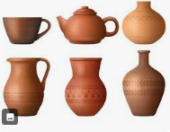
- You want to make a clay pot in your Art class. Which type of soil is best for modeling and pottery because it is sticky when wet and holds its shape?

A. Sandy soil B. Loam soil
C. Clay soil D. Silt soil
- You have drawn a picture and now you want to add colour using crayons. To create a crayon etching, you colour a surface heavily with crayons and then scratch a design on top. What tool would you use to scratch the design?
A. A paint brush
B. A blunt pencil
C. A sharp object like a toothpick or nail
D. A piece of cloth
- Your teacher shows you how to mix glue with water and use it to stick different pieces of paper and fabric onto a surface to create a picture. What visual art technique are you learning?
A. Painting B. Weaving
C. Collage D. Modelling
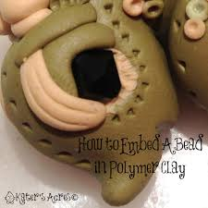
- You are decorating a pot you made from clay. You press small stones or beads into the surface of the wet clay to create a pattern. What decoration technique are you using?

A. Scratching B. Painting
C. Embedding D. Pinching
- You are asked to show how light and dark areas appear on a round object in your drawing. What element of art are you focusing on?
A. Line B. Shape
C. Colour D. Tone
- Your class is making simple woven mats using strips of paper. What is the process of interlacing materials like paper or threads to create a fabric or design called?
A. Knitting B. Sculpting
C. Weaving D. Drawing
- You want to create a simple graphic design for a school poster using freehand lettering. What does freehand lettering involve?
A. Using a ruler to draw letters.
B. Printing letters from a computer.
C. Drawing letters by hand without guides.
D. Tracing letters from a book.
- You visit an art exhibition and see many beautiful paintings and sculptures. What is the activity of looking at and appreciating works of art called?
A. Creating art B. Critiquing art
C. Performing art D. Art appreciation
- You are making a drawing of fruits arranged in a bowl. What type of drawing composition are you creating?
A. Landscape B. Portrait
C. Still life D. Abstract
- Your music teacher teaches you a song about keeping your environment clean. What type of song is this that teaches a lesson or gives information?
A. Lullaby B. Patriotic song
C. Topical song D. Action song
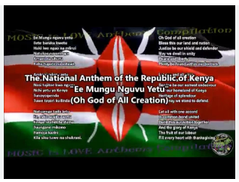
- Your class is learning to sing the National Anthem. What type of song is the National Anthem?

A. Folk song B. Patriotic song
C. Action song D. Lullaby
- You are given two sticks and asked to tap them together to the beat of a song. What type of musical instrument are you using?
A. String instrument
B. Wind instrument
C. Keyboard instrument
D. Percussion instrument
- Your teacher sings a line of a song, and then you sing it back exactly the same way. What musical activity are you doing?
A. Composing
B. Listening
C. Responding
D. Playing an instrument
- You and your classmates are creating a simple rhythm by clapping your hands in a pattern. What musical element are you focusing on?
A. Melody B. Pitch
C. Rhythm D. Harmony
- Your teacher introduces you to a small wind instrument with holes that you blow into to make sounds. What is this instrument likely to be?
A. A trumpet B. A drum
C. A descant recorder D. A guitar
- You listen to a piece of music and then explain how it makes you feel (happy, sad, excited). What musical skill are you practicing?
A. Performing
B. Composing
C. Listening and responding
D. Playing
- Which of the following is a performing art?
A) Drawing a picture
B) Singing a song
C) Weaving a mat
D) Modelling with clay
- Which part of the body do you primarily use to produce sound when singing?
A) Hands B) Legs
C) Voice D) Ears

- A fast or slow speed in music or dance is called the:
A) Melody B) Rhythm
C) Tempo D) Pitch
- Which of these is an example of a non-melodic percussion instrument you might make in Creative Arts?
A) A recorder
B) A drum made from a tin can
C) A guitar
D) A piano
- When different sounds are combined nicely in music, it is called a:
A) Noise B) Melody
C) Shout D) Beat
- Which of these is a type of dance you might learn in Creative Arts?
A) Swimming B) Skipping
C) Traditional dance D) Painting

- What should you do before starting any physical activity to prepare your body?
A) Sit down and rest
B) Eat a heavy meal
C) Warm-up exercises
D) Drink cold water
- Which of these is a basic movement skill used in many sports?
A) Reading B) Running
C) Drawing D) Sleeping
- In the game of Netball, what is the main way to move the ball from one player to another?
A) Kicking
B) Throwing
C) Heading
D) Dribbling with your feet
- Which of the following is an example of a gymnastic activity?
A) Playing football
B) Doing a forward roll
C) Running a race
D) Swimming in a pool
- What is the main goal of playing team games like Netball or Football?
A) To play by yourself
B) To compete against your own teammates
C) To work together to achieve a common goal
D) To watch other people play
- Which of these is important for staying safe during physical activities?
A) Wearing appropriate clothing and shoes
B) Playing in a dangerous area
C) Not following the rules
D) Ignoring your teacher's instructions
- When participating in athletics, what is the activity where you run a short distance as fast as possible?
A) Long jump B) Marathon
C) Sprinting D) Javelin throw
- Which of these materials can be used to create a collage in Creative Arts?
A) Water and sand
B) Pieces of paper, fabric, or pictures
C) Clay and water
D) Musical instruments
- What is the art of creating images using pencils, crayons, or charcoal called?
A) Painting B) Sculpting
C) Drawing D) Weaving

THIS IS THE LAST PRINTED PAGE
Answers
    - B
    - C
    - C
    - C
    - C
    - D
    - C
    - C
    - D
    - C
    - C
    - B
    - D
    - C
    - C
    - C
    - C
    - B
    - C
    - C
    - B
    - D
    - C
    - C
    - B
    - B
    - B
    - C
    - A
    - C
    - B
    - C

