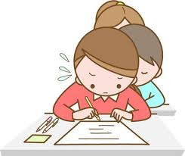

Every learner counts
Values and competencies
COMPETENCE BASED EDUCATION
GRADE 3
ENVIRONMENTAL ASSESSMENT
NAME: _________ ___________________________________________________________
DATE: ____________________________________________________________________
SCHOOL: ________________________________________________________________
ASSESSMENT NUMER: UPI NUMBER: ___________________________________
TOTAL MARKS: 40
DURATION: 2 Hours 10 minutes
Instructions to the learner:
- Read the instructions carefully.
- Attempt all questions in all sections.
- Show your working in this paper.
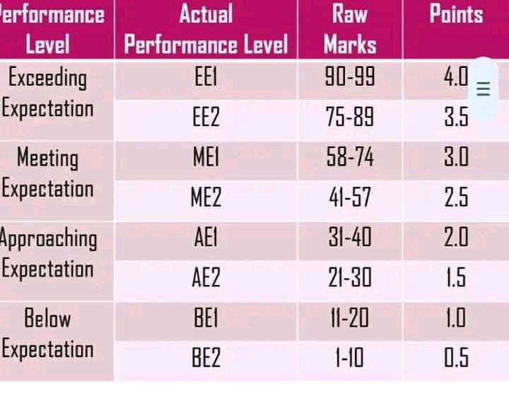
SCORING GUIDE

SECTION A:
- Name four things you can see in the natural environment.
a) ..............................................
b) ..............................................
c) ..............................................
d) ..............................................
- Draw the following cloths we wear during different weather.
Raincoat | Gumboots | Vest

- Draw one sign of a windy day.

- Name three types of soil you have learned about.
a) ..............................................
b) ..............................................
c) ..............................................
- Name three sources of water found in your local environment.
a) ..............................................
b) ..............................................
c) ..............................................
- Name two plants that are useful to people and how they are useful.
i) Plant: .......................... Use: .......................................................................
ii) Plant: .......................... Use: ......................................................................
- Name two animals that are found in your local environment.
i) ..............................................
ii) ..............................................
- Suggest three ways we can take care of our school environment.
a) ..........................................................................................
b) ..........................................................................................
c) ..........................................................................................
SECTION B:
- Why is it important to brush your teeth every day?
.........................................................................................................................................................................................................................................................
- Name three other personal hygiene practices you do daily.
i) ..............................................
ii) ..............................................
iii) ..............................................

- Name the three main food groups and give one example for each.
a) Group: .......................... Example: ..........................................................
b) Group: .......................... Example: ...........................................................
c) Group: .......................... Example: ...........................................................
- Why is eating a balanced diet important for your health?
............................................................................................................................................................................................................................................
- Why should we wash fruits and vegetables before eating them?
............................................................................................................................................................................................................................................

- Name two ways to store food safely at home.
i) ...................................................................................................................
ii) ..................................................................................................................
- Name two common illnesses that can be prevented by keeping clean.
a) ..............................................
b) ..............................................

SECTION C: PRACTICAL / APPLICATION (Teacher assessed)
- Go outside with your teacher to a designated area in the school compound. Observe the area carefully.
a) Describe the type of soil you see.
b) Identify and name two different types of plants in that area.
c) Identify and name one animal or insect you see.
d) Suggest one way that area can be made cleaner or better.
(Teacher to observe learner's participation, observation skills, and responses).
- Demonstrate how to properly wash a fruit or vegetable. (Teacher to observe the steps taken).

THIS IS THE LAST PRINTED PAGE.

