
MARANDA HIGH SCHOOL
Kenya Certificate of Secondary Education
MOCK EXAMINATIONS 2025

312/2 Geography Paper 2
May/June, 2025 Time: 2¾ Hours

Name: ………………………………………….…….…… Adm No: ………………
Class: ………………Candidate’s Signature: ………..…….. Date: 4th June, 2025.
Time: 10.45am-1.15 pm Instructions to candidates
- Write your name, admission number and class in the spaces provided above.
- This paper has two sections A and B
- Answer all the questions in SECTION A.
- Answer question 6 and any other two questions from SECTION B.
- All answers must be written in English.
- This paper consists of 15 printed pages.
- Candidates should check the question paper to ascertain that all the pages are printed as indicated and that no questions are missing.

For Examiner’s Use Only

Questions | Candidate’s  Score | Maximum  Score
1 -5 |  | 25
6 |  | 25
 |  | 25
 |  | 25
Total Score |  | 100

- (a) What is economic geography? (2 marks)
(b) State three benefits learners get by studying economic geography. (3 marks)
- (a) Differentiate between land reclamation and land rehabilitation. (2 marks)
(b) State three measures the government of Kenya has employed to control tsetse flies in Lambwe valley
(3 marks)
- The diagram below shows a fishing method. Study it and use it to answer question 3(a) and (b).
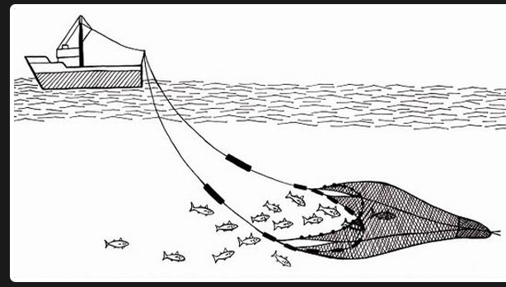
(a) Identify the fishing method represented by the diagram above. (1 mark)
(b) Describe how it is used to catch fish. (4 marks)
- (a) Distinguish between a forest and forestry. (2 marks)
(b) Identify three activities that can be undertaken by students in school to conserve trees. (3 marks)

5. Use the map of Kenya below to answer question 5 (a) and (b)
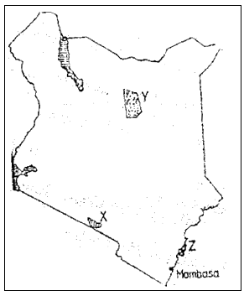

- (i) Name the national park marked X (1 mark)
- The marine reserve marked Z (1 mark)
- Apart from establishing national parks and game reserves, state three other ways through which the government of Kenya conserves wildlife. (3 marks)

SECTION B
Answer question 6 and any other two questions from this section.
- The table below shows the quantity of minerals produced in Kenya in tonnes between the years 2017 and 2020. Study it and use it to answer question 6(a).
 | Quantity of minerals
Mineral/Year | 2017 | 2018 | 2019 | 2020
Soda Ash | 397,780 | 404,110 | 462,560 | 453835
Flourspar | 61,664 | 95,015 | 70,201 | 137,986
Salt | 25,664 | 38,848 | 41,199 | 51,139
Others | 16,093 | 17,616 | 14,971 | 16,315

- Using a scale of 1 cm to represent 75,000 tonnes, draw a divided bar graph to represent the data.
(8 marks)
- Explain three ways in which well-developed transport system promotes mining in Kenya. (6 marks)
- (i) Describe the process of extraction of gold in South Africa. (4 marks)
(ii) State three problems arising from deepening of gold mines in South Africa. (3 marks)
- State four ways in which mining leads to improved living standards (4 marks)
- (a) (i) Name three counties in the western Kenya sugar belt where sugarcane is grown in large scale.
(3 marks)
(ii) Describe the cultivation of sugarcane up to harvesting. (5 marks)
- Explain three government policies that influence sugarcane growing in the western Kenya sugar belt. (6 marks)
- State three effects of pests and diseases on sugarcane production in Kenya. (3 marks)
- Explain four ways in which sugarcane contributes to industrial development in Kenya . (8 marks)

- (a) (i) Define trade (2 marks)
(ii) Name two major imports from European Union to Kenya. (2 marks)
- Explain three ways in which tariffs influence regional trade. (6 marks)
- (i) Apart from Kenya, name two other Eastern Africa countries that are part of the Common Market for Eastern and Southern Africa (COMESA). (2 marks)
(ii) State three roles of COMESA. (3 marks)
- State four problems facing small scale traders in Kenyan towns. (4 marks)
- Explain three measures the government of Kenya is taking to increase her exports. (6 marks)

- (a) (i) Differentiate between primary and secondary industries. (2marks)
- Give two types of heavy industries in Kenya. (2 marks)
- Explain three ways in which population have influenced development of agro based industries in Kenya. . (6 marks)
- Explain three measures the government has taken to revive struggling industries in Kenya.
(6 marks)
- (i) Name two major car manufacturing zones in Japan. (2 marks)
(ii) State three significance of the car and electronics industries to the economy of Japan. (3 marks)
- Maranda High School students carried out a field study on non-agricultural industries in Kisumu County.
(i) Give two reasons why they must have carried out a pre-visit. (2 marks)
(ii) Name two non-agricultural industries they may have visited. (2 marks)

- a) Define the term population density. (2 marks)
- Explain how the following factors have influenced population distribution in central parts of Kenya.
- Government policies (4 marks)
- Climate (2 marks)
- Give three factors that influence population growth in Kenya. (3 marks)
- Study the population pyramid below and use it to answer question d(i) and (ii)
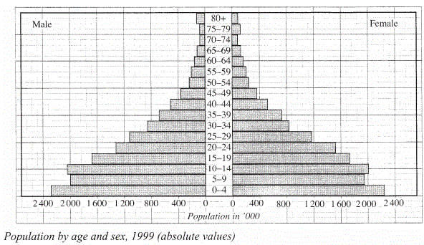
- What type of population is represented by the pyramid? (1 mark)
- State three characteristics of the population represented by the pyramid. (3 marks)
- Explain three positive effects of rapid population growth on the economy of Kenya. (6 marks)
(e) Explain differences between the population of Kenya and that of Sweden under the following:
      - Population structure (2 marks)
      - Population growth rate (2 marks)

………………………………………………………………………………………………………………………………………………………………………………………………………………………………………………………………………………………………………………………………………………………………………………………………………………………………………………………………………………………………………………………………………………………………………………………………………………………………………………………………………………………………………………………………………………………………………………………………………………………………………………………………………………………………………………………………………………………………………………………………………………………………………………………………………………………………………………………………………………………………………………………………………………………………………………………………………………………………………………………………………………………………………………………………………………………………………………………………………………………………………………………………………………………………………………………………………………………………………………………………………………………………………………………………………………………………………………………………………………………………………………………………………………………………………………………………………………………………………………………………………………………………………………………………………………………………………………………………………………………………………………………………………………………………………………………………………………………………………………………………………………………………………………………………………………………………………………………………………………………………………………………………………………………………………………………………………………………………………………………………………………………………………………………………………………………………………………………………………………………………………………………………………………………………………………………………………………………………………………………………………………………………………………………………………………………………………………………………………………………………………………………………………………………………………………………………………………………………………………………………………………………………………………………………………………………………………………………………………………………………………………………………………………………………………………………………………………………………………………………………………………………………………………………………………………………………………………………………………………………………………………………………………………………………………………………………………………………………………………………………………………………………………………………………………………………………………………………………………………………………………………………………………………………………………………………………………………………………………………………………………………………………………………………………………………………………………………………………………………………………………………………………………………………………………………………………………………………………………………………………………………………………………………………………………………………………………………………………………………………………………………………………………………………………………………………………………………………………………………………………………………………………………………………………………………………………………………………………………………………………………………………………………………………………………………………………………………………………………………………………………………………………………………………………………………………………………………………………………………………………………………………………………………………………………………………………………………………………………………………………………………………………………………………………………………………………………………………………………………………………………………………………………………………………………………………………………………………………………………………………………………………………………………………………………………………………………………………………………………………………………………………………………………………………………………………………………………………………………………………………………………………………………………………………………………………………………………………………………………………………………………………………………………………………………………………………………………………………………………………………………………………………………………………………………………………………………………………………………………………………………………………………………………………………………………………………………………………………………………………………………………………………………………………………………………………………………………………………………………………………………………………………………………………………………………………………………………………………………………………………………………………………………………………………………………………………………………………………………………………………………………………………………………………………………………………………………………………………………………………………………………………………………………………………………………………………………………………………………………………………………………………………………………………………………………………………………………………………………………………………………………………………………………………………………………………………………………………………………………………………………………………………………………………………………………………………………………………………………………………………………………………………………………………………………………………………………………………………………………………………………………………………………………………………………………………………………………………………………………………………………………………………………………………………………………………………………………………………………………………………………………………………………………………………………………………………………………………………………………………………………………………………………………………………………………………………………………………………………………………………………………………………………………………………………………………………………………………………………………………………………………………………………………………………………………………………………………………………………………………………………………………………………………………………………………………………………………………………………………………………………………………………………………………………………………………………………………………………………………………………………………………………………………………………………………………………………………………………………………………………………………………………………………………………………………………………………………………………………………………………………………………………………………………………………………………………………………………………………………………………………………………………………………………………………………………………………………………………………………………………………………………………………………………………………………………………………………………………………………………………………………………………………………………………………………………………………………………………………………………………………………………………………………………………………………………………………………………………………………………………………………………………………………………………………………………………………………………………………………………………………………………………………………………………………………………………………………………………………………………………………………………………………………………………………………………………………………………………………………………………………………………………………………………………………………………………………………………………………………………………………………………………………………………………………………………………………………………………………………………………………………………………………………………………………………………………………………………………………………………………………………………………………………………………………………………………………………………………………………………………………………………………………………………………………………………………………………………………………………………………………………………………………………………………………………………………………………………………………………………………………………………………………………………………………………………………………………………………………………………………………………………………………………………………………………………………………………………………………………………………………………………………………………………………………………………………………………………………………………………………………………………………………………………………………………………………………………………………………………………………………………………………………………………………………………………………………………………………………………………………………………………………………………………………………………………………………………………………………………………………………………………………………………………………………………………………………………………………………………………………………………………………………………………………………………………………………………………………………………………………………………………………………………………………………………………………………………………………………………………………………………………………………………………………………………………………………………………………………………………………………………………………………………………………………………………………………………………………………………………………………………………………………………………………………………………………………………………………………………………………………………………………………………………………………………………………………………………………………………………………………………………………………………………………………………………………………………………………………………………………………………………………………………………………………………………………………………………………………………………………………………………………………………………………………………………………………………………………………………………………………………………………………………………………………………………………………………………………………………………………………………………………………………………………………………………………………………………………………………………………………………………………………………………………………………………………………………………………………………………………………………………………………………………………………………………………………………………………………………………………………………………………………………………………………………………………………………………………………………………………………………………………………………………………………………………………………………………………………………………………………………………………………………………………………………………………………………………………………………………………………………………………………………………………………………………………………………………………………………………………………………………………………………………………………………………………………………………………………………………………………………………………………………………………………………………………………………………………………………………………………………………………………………………………………………………………………………………………………………………………………………………………………………………………………………………………………………………………………………………………………………………………………………………………………………………………………………………………………………………………………………………………………………………………………………………………………………………………………………………………………………………………………………………………………………………………………………………………………………………………………………………………………………………………………………………………………………………………………………………………………………………………………………………………………………………………………………………………………………………………………………………………………………………………………………………………………………………………………………………………………………………………………………………………………………………………………………………………………………………………………………………………………………………………………………………………………………………………………………………………………………………………………………………………………………………………………………………………………………………………………………………………………………………………………………………………………………………………………………………………………………………………………………………………………………………………………………………………………………………………………………………………………………………………………………………………………………………………………………………………………………………………………………………………………………………………………………………………………………………………………………………………………………………………………………………………………………………………………………………………………………………………………………………………………………………………………………………………………………………………………………………………………………………………………………………………………………………………………………………………………………………………………………………………………………………………………………………………………………………………………………………………………………………………………………………………………………………………………………………………………………………………………………………………………………………………………………………………………………………………………………………………………………………………………………………………………………………………………………………………………………………………………………………………………………………………………………………………………………………………………………………………………………………………………………………………………………………………………………………………………………………………………………………………………………………………………………………………………………………………………………………………………………………………………………………………………………………………………………………………………………………………………………………………………………………………………………………………………………………………………………………………………………………………………………………………………………………………………………………………………………………………………………………………………………………………………………………………………………………………………………………………………………………………………………………………………………………………………………………………………………………………………………………………………………………………………………………………………………………………………………………………………………………………………………………………………………………………………………………………………………………………………………………………………………………………………………………………………………………………………………………………………………………………………………………………………………………………………………………………………………………………………………………………………………………………………………………………………………………………………………………………………………………………………………………………………………………………………………………………………………………………………………………………………………………………………………………………………………………………………………………………………………………………………………………………………………………………………………………………………………………………………………………………………………………………………………………………………………………………………………………………………………………………………………………………………………………………………………………………………………………………………………………………………………………………………………………………………………………………………………………………………………………………………………………………………………………………………………………………………………………………………………………………………………………………………………………………………………………………………………………………………………………………………………………………………………………………………………………………………………………………………………………………………………………………………………………………………………………………………………………………………………………………………………………………………………………………………………………………………………………………………………………………………………………………………………………………………………………………………………………………………………………………………………………………………………………………………………………………………………………………………………………………………………………………………………………………………………………………………………………………………………………………………………………………………………………………………………………………………………………………………………………………………………………………………………………………………………………………………………………………………………………………………………………………………………………………………………………………………………………………………………………………………………………………………………………………………………………………………………………………………………………………………………………………………………………………………………………………………………………………………………………………………………………………………………………………………………………………………………………………………………………………………………………………………………………………………………………………………………………………………………………………………………………………………………………………………………………………………………………………………………………………………………………………………………………………………………………………………………………………………………………………………………………………………………………………………………………………………………………………………………………………………………………………………………………………………………………………………………………………………………………………………………………………………………………………………………………………………………………………………………………………………………………………………………………………………………………………………………………………………………………………………………………………………………………………………………………………………………………………………………………………………………………………………………………………………………………………………………………………………………………………………………………………………………………………………………………………………………………………………………………………………………………………………………………………………………………………………………………………………………………………………………………………………………

THIS IS THE LAST PRINTED PAGE

