
` MARANDA HIGH SCHOOL
Kenya Certificate of Secondary Education
MOCK EXAMINATIONS 2025

312/2 Geography Paper 2
MAY/JUNE Time: 2¾ Hours

Name: ………………………………………….…….…… Adm No: ………………
Class: ………………Candidate’s Signature: ………..…….. Date: 4th June, 2025
Time: 10.45 AM-1.15 PM Instructions to candidates
- Write your name, admission number and class in the spaces provided above.
- This paper has two sections A and B
- Answer all the questions in SECTION A.
- Answer question 6 and any other two questions from SECTION B.
- All answers must be written in English.
- This paper consists of 15 printed pages.
- Candidates should check the question paper to ascertain that all the pages are printed as indicated and that no questions are missing.

For Examiner’s Use Only

Questions | Candidate’s  Score | Maximum  Score
1 -5 |  | 25
6 |  | 25
 |  | 25
 |  | 25
Total Score |  | 100

- (a) What is economic geography? (2 marks)
- A branch of geography that studies distribution of human activities and natural resources on the earth surface
(b) State three benefits learners get by studying economic geography (3 marks)
- Helps learners understand where natural resources are found and how they are used
- Promotes environmental awareness
- Learners appreciate and understand regional differences/promotes national unity
- Encourages international understanding
- (a) Differentiate between land reclamation and land rehabilitation. (2 marks)
- Land reclamation: - is the process by which wasteland/less useful land is converted into farm a more useful land while Land rehabilitation is the process of restoring/recovering land that has been misused and destroyed through human activities to its former productive state
(b) State three measures the government of Kenya has employed to control tsetse flies in lambwe valley
(3 marks)
- Exposing male flies to gamma rays which make them sterile
- Low aircrafts are used to spray with insecticides the areas inhabited by the tsetse flies
- Clearing of tsetse fly habitats
- Creation of buffer zones
- Killing of the hosts

- The diagram below fishing method.
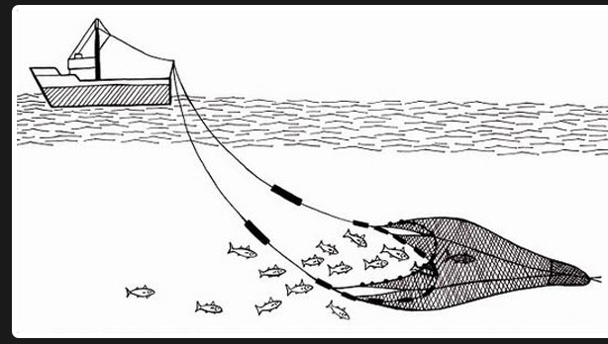
(a) Identify the method shown. (1 mark)
- Trawling
(b) Describe how it is used to catch fish. (4 marks)
- A bag shaped net cast into water by the trawler.
- The net’s mouth is kept open by otter boards/ head beams/Weights and floats position the net vertically in water.
- Trawler drags the net along the water as fish is swept into the wide opening and trapped in the cod end
- After sufficient fish has been caught, the net is hauled into the trawler to empty the fish.
- (a) Distinguish between a forest and forestry. (2 marks)
- A forest is a continuous growth of trees and undergrowth covering a large tract of land while forestry is the science of developing and managing forests including cultivating them
(b) Identify three activities that maybe undertaken by students in school to conserve trees.
(3 marks)
- Organize Tree planting day in school/community
- Adopt/care/mulch for trees
- Creating awareness/making posters
- Recycling waste papers
- Join wildlife/conservation clubs
- Organize nature walks to promote tree care/pass legislation
- Write petitions/letters to local leaders about need to conserve trees
- Petition school administration to use clean energy
- Participate in national Afforestation/reafforestation programs

5. Use the map of Kenya below to answer question 5 (a) and (b)
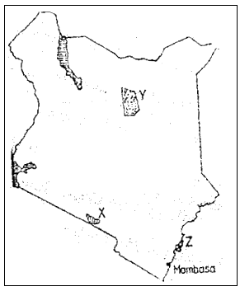

- (i) Name the national park marked X
- Amboseli National park
- The marine reserve marked Z
- Malindi/ Watamu marine park
- Apart from establishing national parks and game reserves, state three other ways through which the government of Kenya conserves wildlife.
- Enacting laws/regulations to curb poaching
- Encouraging individuals to set up game ranches for controlled hunting
- Provision of vetenary services through wildlife agencies
- Promotion of ecotourism to reduce tourism related environmental damage
- Educating the general public on the need to conserve wildlife
- Constructing electric fence in some parks to minimize human wildlife conflict
- Establishing the ministry of wildlife to oversee conservation practices
SECTION B
Answer question 6 and any other two questions from this section.
- The table below shows the value of intra-COMESA total exports in selected countries in million dollars from 2016 to 2019. Study it and use it to answer question 6(a).
 |  |  |  |  | Quantity of minerals
Mineral/Year | 2017 | CT | 2018 | CT |  | 2019 | CT | 2020 | CT
Soda Ash | 397,780 | 397,780 | 404,110 | 404,110 |  | 462,560 | 462,560 | 453835 | 453,835
Flourspar | 61,664 | 459,444 | 95,015 | 499,125 |  | 70,201 | 532,761 | 137,986 | 591,821
Salt | 25,664 | 485,108 | 38,848 | 537,973 |  | 41,199 | 573,960 | 51,139 | 642,960
Others | 16,093 | 501,201 | 17,616 | 555,589 |  | 14,971 | 588,931 | 16,315 | 659,275
- Using a scale of 1 cm to represent 75,000 tonnes, draw a divided bar graph to represent the data. (8 marks)
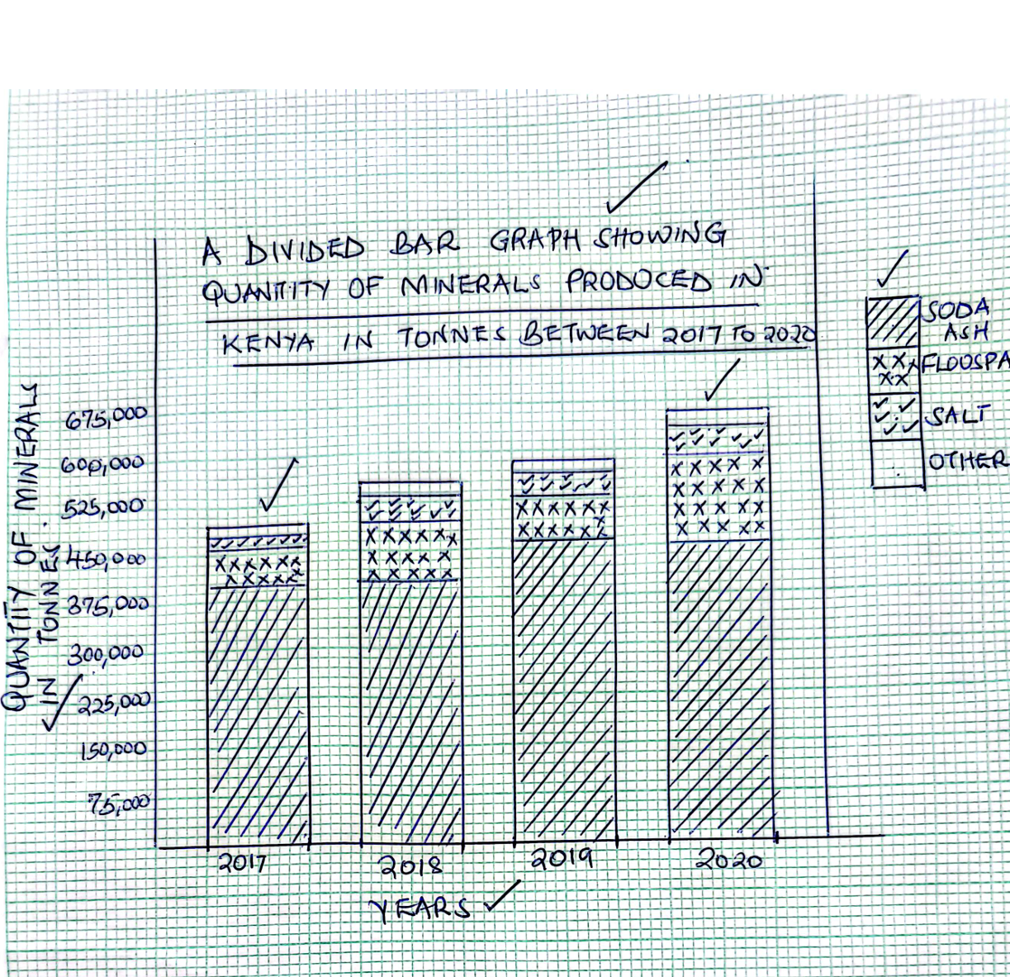
- Title ---- 1 Mark
- Cumulative Totals - 1 Mark
- X-Axis - 1 Mark
- Y-Axia – 1 Mark
- Bars 2 Marks
- Key 1 Mark
- TOTAL = 8 MARKS
- Explain three ways in which well-developed transport system promotes mining in Kenya.
(6 marks)
- Efficient roads/railways/ports make it easy/cheaper/faster movement of mineralsfrom the mining sites to the processing factories/ ports/market without delay and with ease
- New roads to remote areas leads to expansion of mining activities creating employment that leads to improved living standards
- Tarmacking of roads reduces operational costs for mining companies making operations cost effective and more profitable
- It expands the country’s mining potential/attracts foreign investments increasing mineral production/exports
- Modern railway line/SGR Supports exports of minerals improving country’s trade
- Encourage/attracts skilled labour as workers can travel to and from mining sites with ease inceasing mining
- (i) Describe the process of extraction of gold in South Africa. (4 marks)
- This is done by deep shaft mining method
- The gold bearing rock is reached by sinking vertical shafts; from these horizontal tunnels/galleries at different levels are run to access the gold bearing reef
- The gold reef is then drilled /blasted using explosives underground
- The ore is then hauled to the surface for transportation for processing
(ii) State three problems arising from deepening of gold mines in South Africa. (3 marks)
- May lead to environmental degradation/sinking
- May lead to loss of life to miners in case of collapse/high risks/poor working conditions
- It increases the cost of mining/cost of energy/insurance
- It lowers the quality of ore
- May cause ground instability/subsidence
- State four ways in which mining leads to improved living standards (4 marks)
- Creation of employment workers earn income improving their standards
- Development of roads/infrastructure
- Earning of foreign exchange used in developing other sectors
- Growth of towns that offer social services to people improving quality of life
- Mining companies provide clean water/healthcare to people who live nearby
- (a) (i) Name three counties in the western Kenya sugar belt where sugarcane is grown in large scale. (3 marks)
- Bungoma
- Busia
- kakamega
(ii) Describe the cultivation of sugarcane up to harvesting. (5 marks)
- The land is first cleared,
- The land is ploughed and/ then re- ploughed
- Furrows are made and cane cuttings are laid in them and covered with soil
- Fertilizers are applied at the early stages to enhance growth
- Regular Weeding is carried out/application of herbicides
- Spraying/t pests and diseases control are done at regular intervals till the crop attains maturity
- Harvesting is done after about 18 months by cutting manually using sharp pangas or machetes
- The cut/harvested cane is loaded onto trucks/tractors and quickly transported to the factory (to preserve sugar quality)
- Explain three government policies that influence sugarcane growing in the western Kenya sugar belt. (6 marks)
- Provision of extension services through Kenya sugar research foundation to train farmers on best practices
- Construction/mantainance of feeder roads to allow for faster delivery of cane to factories
- Provision of subsided farm inputs/fertilizers to support struggling farmers
- Protecting sugarcane farmers by banning sugar imports so as to protect their local market
- Licensing private millers to ensure farmers get competitive returns on their cane
- Extending credit/financial support to ailing sugar factories to make them remain operational

- State three effects of pests and diseases on sugarcane production in Kenya. (3 marks)
- Pests like sugarcane borers reduce yields
- Diseases like smut reduce quality of cane
- Farmers spend more on pesticides reducing their profit margins/incresase cost of production
- Reduced supply of cane to factories may disrupt industrial operations/lowers production
- Some pests/diseases may lead to crop failure discouraging farmes who may abandon sugarcane farming

- Explain four ways in which sugarcane contributes to industrial development in Kenya
(8 marks)
- Creation of employment opportunities in sugar estates and factories earns income for workers giving them purchasing power wide market for other industrial goods
- Saving foreign exchange that would have been used to import sugar by producing sugar for domestic consumption improving balance of payments/ used to develop other sectors
- Sugarcane is a source of raw materials to sugar related industries promoting industrial development
- Development of roads for easy movement of goods/rawmaterials to other industries
- Urbanization/growth of towns e.g. Mumias, Awendo and Muhoroni. These are provided with basic social amenities improved living standards
- (a) (i) Define trade (2 marks)
- Buying and selling of goods and services
(ii) Name two major imports from European Union to Kenya. (2 marks)
- Machinery
- Pharmaceuticals
- Vehicles/spareparts
- Iron and steel
- Electronics/telecommunication
- Food/Wines ans spirits
- Agrochemical/fertilizers
- Medical equipments
- Explain three ways tariffs influence regional trade. (6 marks)
- Low tarrifs may increase volume of exports increasing trade
- High tarrifs increase prices of imported goods creating trade imbalances
- High tarrifs lead to unequal trade in regional markets as countries /reduces competition
- High Tarrifs promote smuggling and illegal trade across boaders leading to loss of revenue
- Tarrifs when paid generate government revenue that can be used in developing other sectors/may reduce trade deficits/trade imbalances
- Very high tarrifs discourage/hinder exports/imports/regional trade
- Very High tarrifs may leads to protection/growth of local industries
- (i) Apart from Kenya name two other eastern African countries that are part of COMESA (2 marks)
- Ethiopia
- Burundi
- Uganda
- Sudan
- South sudan
- Erithrea
- Djibouti
- Rwanda
- State three roles of COMESA (3 marks)
- Promotion of trade among member states/removal of trade barriers
- Promotion of industrial growth among member states
- Promotion of investment among member states
- Financial assistance to member countries
- Enhancement of revenue collection
- To create regional specialization of commodities by member states
- To create political cooperation and unity
- State four problems facing small scale traders in Kenyan towns. (4 marks)
- Inadequate capital which hinders expansion
- High taxes/levis reduce profit margins
- Low purchasing power by consumers
- Inadequate structures for running businesses
- Underdeveloped transport network causing delays
- Insecurityleading to losss of wares
- Explain three measures the government of kenya is taking to increase her exports. (6 marks)
- Kenya exploring new markets in the Far East countries to avoid over reliance on the European market/ increase the quantity of Kenya’s exports.)
- Kenya has signed new trade agreements / joining more trading block with various countries in Africa, America and Far East which will help widening its market
- Some Kenya entrepreneurs are setting up branches of their industries in the neighboring countries in order to expand trading activities.
- Kenya is undertaking partial processing/promoting export of high value agricultural productst in order to fetch higher value to increase earnings.
- Implementation of vision 2030 will lead to increased production hence increased trade.
- Kenya is diversifying export products through the export processing zone to attract a wider market for her goods.
- Kenya should be aggressively advertising her products to attract more buyers.
- Kenya has improved international transport / communication links for efficient movement to neighbouring countries.
- The government has made efforts to reduce the cost of production of Kenyan goods so as they compete favorably in the regional market.

- (a) (i) Differentiate between primary and secondary industries. (2marks)
- Primary industries involve extraction of raw materials while secondary industries are involved in processing of raw materials into finished products
- Give two types of heavy industries in Kenya. (2 marks)
- Ship building/boat making
- Car assembly/motor vehicle assembly
- Steel rolling
- Cement manufacturing
- Oil refineries (edible oils)
- Glass making
- Explain three ways in which population have influenced development of agro based industries in Kenya. . (6 marks)
- High population in Kenyan highland provides cheap/abundant labour in tea/sugarcane/coffee processing industries
- High population provides /increased demand for goods/wide market encouraging expansion of industries/ expansion of industries
- High population is a source of innovators that leads quality products/efficiency/high output
- High population leads to urbanization that expands housing/roads/communication leading to expansion of related industries
- Explain three measures the government has taken to revive struggling industries in Kenya.
(6 marks)
- Privatization of state owned industries to attract new investors
- Establishment of industrial parks and special economic zones SEZe/EPZs to reduce costs/create conducive environment for industrial growth
- Credit financing through Kenya industrial estates(KIE/Industrial Development Bank) to keep them afloat/for expansion
- Buy Kenya build Kenya initiative to help in marketing of locally manufactured goods to boost their demand
- Intensifying development/mantainance of roads/communication network to easen movements of raw materials/finished products
- Training of citizens in industrial management
- (i) Name two major car manufacturing zones in Japan. (2 marks)
- Tokyo-yokohama industrial zone
- Osaka kobe industrial zone
- Nagoya industrial zone
- State three significance of the car and electronics industries to the economy of Japan. (3 marks)
- Export of cars and electronics earns japan a lot of foreign exchange
- Car manufacturing has led to growth of towns like yokohama/Osaka/Kyoto/Akashi
- It has led to creation of employment to many Japanese citizens improving their living standards
- The industries have led to development of many port eg. Port of Tokyo/kobe/nagoyas/roads and railways for easy movement

- Maranda High School students carried out a field study on non-agricultural industries in Kisumu City.
(i) Give two reasons why the must have carried out a pre-visit. (2 marks)
- To acquaint themselves to the area’s authorities and respondent/familiarize
- It assists the researchers to familiarize the with the study area to help in saving time/preventing accidents during the study.
- It assists the researchers to determine how suitable the study area is i.e. does the study area have adequate and sufficient data.
- It assists in budgeting for the study i.e. estimating cost of the study.
- It helps the researcher in identifying problems that are likely to be experienced during the field study and suggest their possible solutions.
- It helps the researchers in developing a working schedule.
(ii) Name two nonagricultural industries they may have visited. (2 marks)
- Cement manufacturing at koru
- Boat making/shipbuilding at Kisumu boat
- Textile industry at kicomi
- Concrete products limited
- a) Define the term population density. (2 marks)
- refers to the number of persons/people per unit area of land
- Explain how the following factors have influenced population distribution in central parts of Kenya.
- Government policies (4 marks)
- Establishment of mwea irrigation scheme led to dense population in mwea town as it source of rice/foodcrops/employment
- gazettement of abadares forest reserve has led to sparce/no population in the forest as it will be against the law
- construction of modern roads/thika superhighway/maumau roads led to dense population in thika towns/nyeri as it has easened movement
- resettlement of landless in schemes like lari in kiambu led the dense population in these areas
- climate (2 marks)
- high rainfall/ well distributed throughout the year received in parts of central encourage dense populations e.g in kiambu/kirinyaga as it supports agriculture
- high rainfall supports many rivers which provide water for domestic use supporting dense population
- Give three factors that influence population growth in Kenya. (3 marks)
- Fertility
- Mortality
- Migration
- Study the population pyramid below and use it to answer question d(i) and (ii)
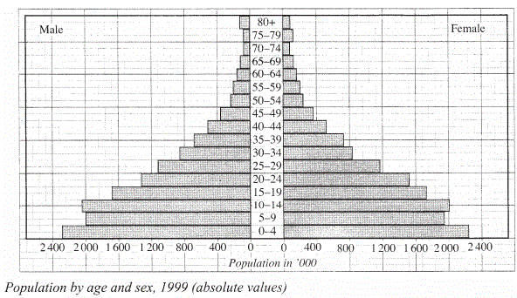
- What type of population is represented by the pyramid? (1 mark)
- Young population
- State three characteristics of the population represented by the pyramid. (3 marks)
- High birth rates shown by long bars at the base
- High death rate shown by rapidly shortening of bars
- Low life expectancy shown by very thin bars at the top of the pyramid

- Explain three positive effects of rapid population growth on the economy of Kenya. (6 marks)
- Increased market will lead to industrial growth
- Large pool of labour lead to economic growth
- Increased innovation and creativity lead to new discoveries
- Increased tax base increased revenue to fund government projects
(e) Explain differences between the population of Kenya and that of Sweden under the following:
      - Population structure (2 marks)
- Kenya population is young beacause of high birth rates/improved medical care/low life expectancy while swedens population is aged beacause of low birth rates/high life expectancy
      - Population growth rate (2 marks)
- Kenyas growth rate is high because of cultural belies/sexpreferences/early marriages while swedens growth rate is very low because of high life expectancy/late marriages/high adoption of family planning

