Name: _____________________________________________ Adm No: ____________Class: _____
Candidate’s Signature: ________________________ Date: __________________________

GEOGRAPHY
FORM TWO
END TERM 2 EXAMINATION
JULY/AUGUST 2025
TIME: 2 HOURS

INSTRUCTIONS: ANSWER ALL QUESTIONS
SECTION A
- a) Define the term environment (2 mks)

b) Name two branches of Geography (2 mks)

- a) study the diagram below and answer the questions that follow.
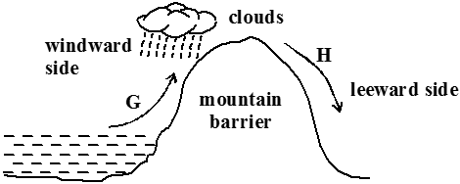

- Identify the type of rainfall shown in the diagram above (1 mk)

- State the difference in characteristics of the winds marked G and H
(2 mks)

b) State three factors that determine the amount of solar radiation reaching the earth’s surface. (3 mks)

- a) Differentiate between weather and climate (2 mks)

b) Explain how the following factors influence climate
i) Distance from the sea (3 mks)

ii) Altitude (3 mks)

- a) Differentiate between epicenter and seismic focus (2 mks)

b) State any two major earthquake seismic zones of the world (2 mks)

- Give two ways in which minerals occur (2 mks)

SECTION B (Answer all the questions in this section)
- The table below shows the area under different species of trees in forest cover in Kenya. Study the table and answer the questions that follow.

 | In ‘000 hectares
Tree Year  cover | 2013 | 2014 | 2015 | 2016
Mahogany | 100 | 85 | 60 | 40
Pine | 120 | 100 | 120 | 140
Meru oak | 140 | 120 | 100 | 80
Camphor | 80 | 60 | 40 | 20
Total | 420 | 365 | 320 | 280
- i) Using a scale of 1 cm to represent 20,000 hectares, draw a comparative line graph to represent the data shown (7 mks)

ii) Explain the difference between forestry in Kenya and Canada on
i) Transporting of logs (2 mks)

ii) Distribution of softwood forests (2 mks)

iii) Harvesting (2 mks)

7. a) Name two types of faults (2 mks)

- i) With the aid of well labeled diagrams, describe how rift valley is formed by tensional forces (6 mks)

ii) Explain three ways in which faulting may influence drainage system (6 mks)

- Explain three ways in which faulting is of significance to human activities (6 mks)

8.a) What is a natural vegetation (2 mks)

b) Describe any three characteristics of equatorial vegetation (3 mks)

c) Draw a diagram to show the vegetation zones on a mountain in Africa (4 mks)

d) Student from a local secondary school carried out a field study on vegetation around
their school.
- State two follow-up activities after the field study (2 mks)

- a) State two methods of representing relief on Topographical maps (2 mks)

b) Convert the following scales into statement scale
i) 1:50,000 (1 mk)

ii) 1:250,000 (1 mk)

c) Study the map of Naivasha below and answer the questions that follow.

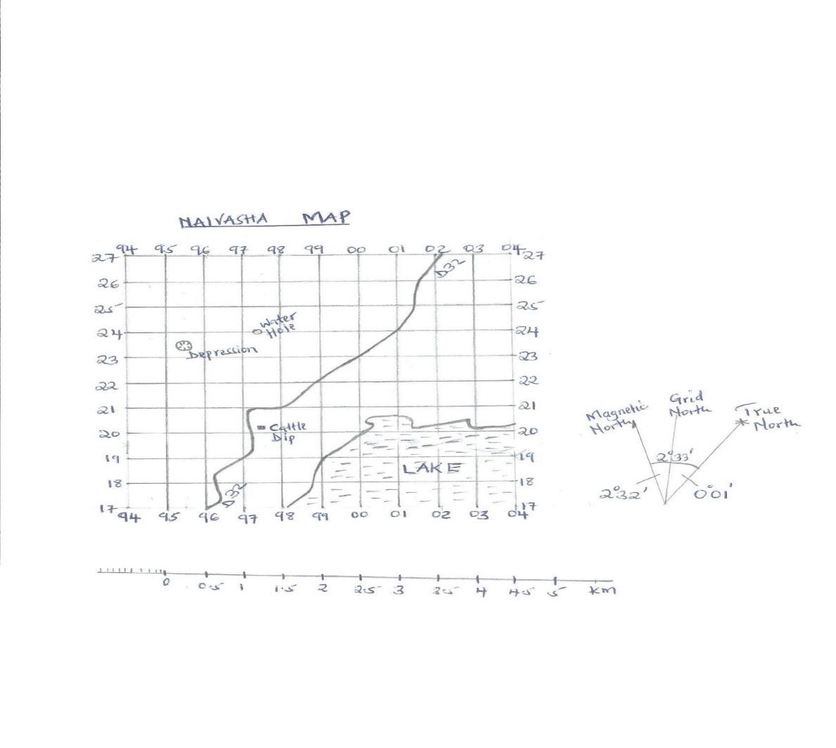
- Measure the distance of the road D32 and give your answer in kilometres (2 mks)

- Give the six figure grid reference of the cattle dip (1 mk)

- Calculate the area of the lake using the Grid Square method (2 mks)

- Give any two uses of maps (2mks)

- Give the magnetic variation/declination of Naivasha map (1 mk)

