MARKING SCHEME
GEOGRAPHY
FORM TWO
END TERM 2 EXAMINATION
JULY/AUGUST 2025
TIME: 2 HOURS

SECTION A
- a) Define the term environment (2 mks)
- Is the external conditions surrounding an organism/plants/animals
b) Name two branches of Geography (2 mks)

- Human
- Practical geography
- Physical geography

- a)
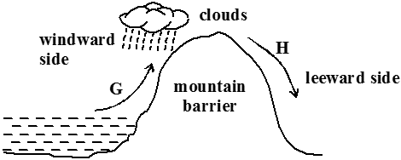

- Identify the type of rainfall shown in the diagram above (1 mk)
- Relief rainfall
- State the difference in characteristics of the winds marked G and H
(2 mks)
- G is warm and moist while H is cold and dry

b) State three factors that determine the amount of solar radiation reaching the earth’s
surface (3 mks)

- The transparency of the atmosphere
- The earth’s average distance from the sun
- The position of the earth on its orbit
- The inclination/angle of the surface on which the sun’s rays fall

- a) Differentiate between weather and climate (2 mks)

- Weather is the daily atmospheric conditions of a place over a short period of time
while climate is the average weather conditions of a place over a long period of time.
b) Explain how the following factors influence climate
i) Distance from the sea (3 mks)

- Areas closer to the sea are wetter than those for the sea due to maritime influence
- During summer land surfaces are warmer than sea surfaces so that inland areas are warmer than those nearer to the sea in winter land are warmer
- Winds blowing over the sea pick moisture which later fall as rainfall in the coastal areas. They blow as dry winds further inland causing aridity
ii) Altitude (3 mks)

- Temperature decreases with increasing to height hence high-altitude areas have lower temperatures than low altitude areas which are warmer
- High altitude areas have a low atmospheric pressure than low altitude areas which have higher atmospheric pressure
- A rise in altitude causes a fall in temperature and a cooling effect which causes
- Condensation and rainfall on the windward side
- Altitude causes Anabatic and Katabatic winds/temperature inversion in mountainous areas

- a) Differentiate between epicenter and seismic focus (2 mks)

Epicenter | Seismic focus
Is a point on the earth’s surface vertically above the seismic focus | Is the point where the seismic waves originate

b) State any two major earthquake seismic zones of the world (2 mks)
- Mid-ocean ridges
- Ocean deeps and volcanic islands
- Regions of crustal compressions
- Within the Rift Valleys
- In areas of volcanic activities

c) Give two ways in which minerals occur (2 mks)
- Beds and seams
- Lodes and veins
- Alluvial deposits
- Weathering products

- SECTION B (Answer all the questions in this section)
The table below shows the area under different species of trees in forest cover in Kenya. Study the table and answer the questions that follow.

 | In ‘000 hectares
Tree Year  cover | 2013 | 2014 | 2015 | 2016
Mahogany | 100 | 85 | 60 | 40
Pine | 120 | 100 | 120 | 140
Meru oak | 140 | 120 | 100 | 80
Camphor | 80 | 60 | 40 | 20
Total | 420 | 365 | 320 | 280
- i) Using a scale of 1 cm to represent 20,000 hectares, draw a comparative line graph to represent the data shown (7 mks)

A COMPARATIVE LINE GRAPH SHOWING FOREST COVERAGE IN “000 HACTARES BETWEEN 2013 AND 2016
Vertical scale 1 cm rep 20,000 ha
Horizontal scale 2 cm 2 1 year

ii) Explain the difference between forestry in Kenya and Canada on
i) Transporting of logs (2 mks)

- Kenya transport logs through tracks and lorries/road while Canada transport logs through melt ice/rivers

ii) Distribution of softwood forests (2 mks)

- In Kenya softwood forests occupy the highland regions while in Canada softwood
- Forests occupy both lowland and highland regions

iii) Harvesting (2 mks)
- In Kenya only mature trees are harvested while in Canada clear cutting is done

- a) Name two types of faults (2 mks)

- Reverse
- Tear/shear/slip/strike
- Thrust fault
- Anticlinal

- i) With the aid of a well labeled diagram, describe how rift valley is formed by tensional forces (6 mks)
) Layers are subjected to tensional forces
- Two normal faults develop parallel to each other
- The middle block subsides/sinks/downloads
- The sunken middle part forms a depression called Rift Valley

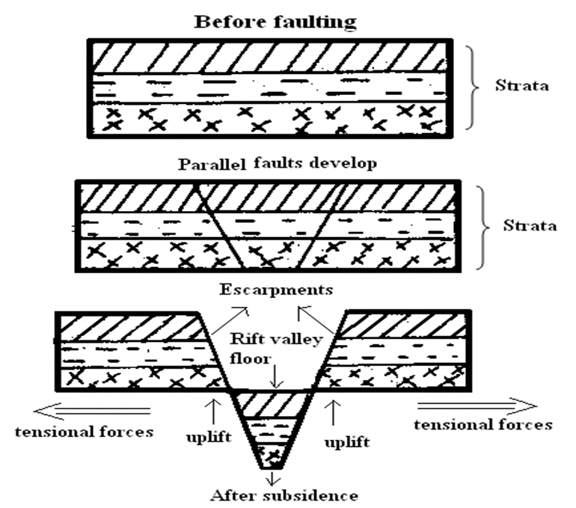

ii) Explain three ways in which faulting may influence drainage system (6 mks)
- Uplifting of land which follows faulting may block a river. This may cause it to reverse/change its direction of flow
- When faulting occurs across a river valley, it may cause the river to disappear into the ground through a fault line
- Faulting may lead to the formation of escarpments with springs forming at the forming at the base due to exposure of the water table
- When faulting occurs across a river valley, vertical displacement of land may occur. The river forms a waterfall where it descends the newly formed escarp
- If rift valley occurs in an enclosed area, a basin may be formed when rivers flow into the basin a lake may be formed. This basin may become an area of inland drainage

- Explain three ways in which faulting is of significance to human activities (6 mks)

- Faulting leads to formation of lakes that are important fishing grounds/tourist sites/provide water for irrigation/ for domestic use
- Faulting causes displacement of rocks which exposes minerals that are mined
- Faulting may lead to the formation of mountains/horst which experiences rainfall on the windward side that give rise to rivers which provide water for industrial/domestic/agricultural use

- a) What is a natural vegetation (2 mks)
- a) Is a type of plant life that develops naturally and is the most suited to that particular environment.
- b) Describe any three characteristics of equatorial vegetation (3 mks)

- Trees are tall
- Trees have straight and smooth trunks
- Trees have formed canopies
- Vegetation has little or no undergrowth
- The trees are mainly hardwood
- Trees have buttressed roots for support
c) Draw a diagram to show the vegetation zones on a mountain in Africa (4 mks)

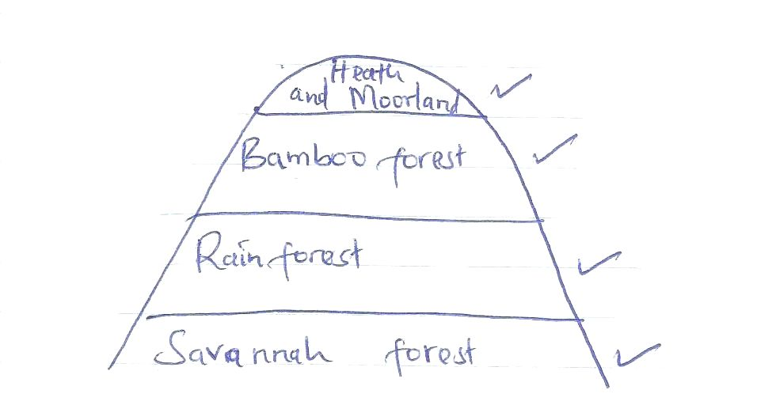

d) Student from a local secondary school carried out a field study on vegetation around
their school.
- State two follow-up activities after the field study (2 mks)
- To identify the type of vegetation around
- To investigate factors favoring the growth of vegetation
- a) State two methods of representing relief on Topographical maps (2 mks)
- Spot heights
- Trigonometrical points
- Contours
- Form lines
- Pictorials
- Hachures

b) Convert the following scales into statement scale
i) 1:50,000 (2 mk)
- 1cm rep 0.5cm

ii) 1:250,000 (2 mk)
- 1cm rep 2.5cm

c) Study the map of Naivasha below and answer the questions that follow.

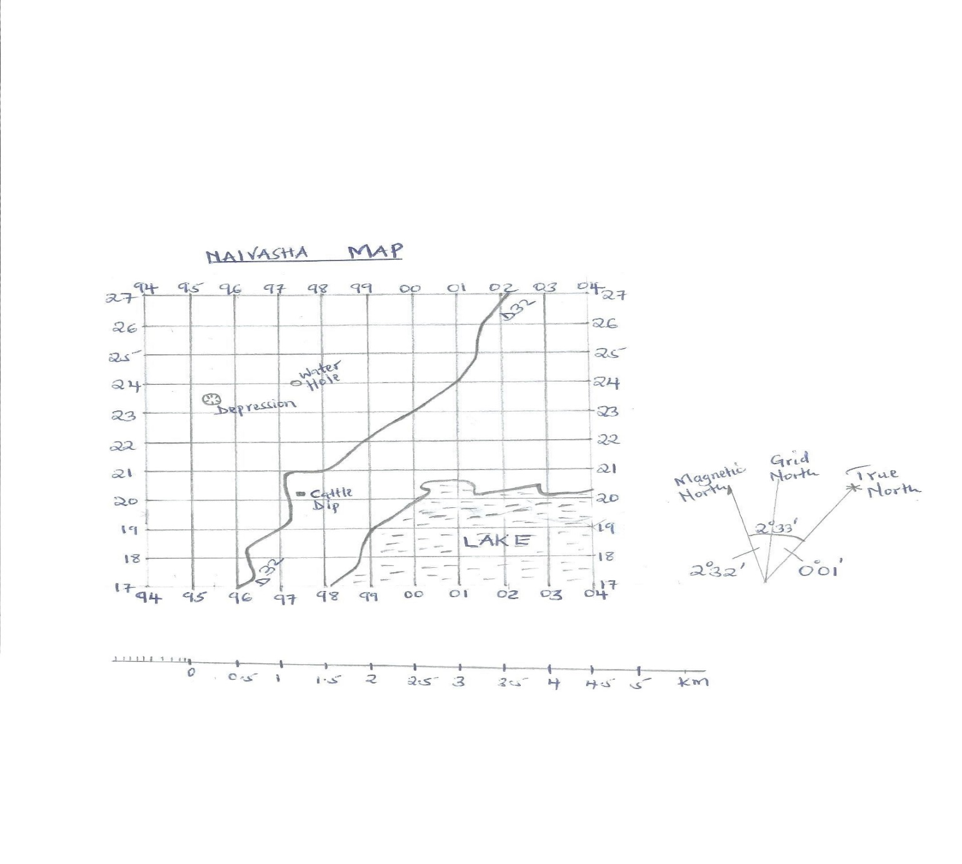
- Measure the distance of the road D32 and give your answer in kilometres (2 mks)
7.0

- Give the six figure grid reference of the cattle dip (1 mk)

977202

- Calculate the area of the lake using the Grid Square method (2 mks)
) Full squares 13+8
2
13+4
17 km²
iv) Give the magnetic variation/declination of Naivasha map (1 mk)
- 2°33`

