END TERM 2 2025
JULY 2025
312/2
GEOGRAPHY PAPER 2
MARKING SCHEME

SECTION A:

1. a) State two ways in which minerals occur (2 marks)
(i) Minerals may occur in beds and seams
(ii) Minerals may occur as weathered products
(iii) Minerals may occur in alluvial or placer deposits
(iv) Minerals may occur in veins and lodes
(v) Minerals may occur as evaporates

b) Describe panning as a method of mining (3 marks)
The method involves digging out the sand/gravel which contains mineral particles and mixed with water from the river in a shallow pan. The mixture is then whirled such that the lighter particles of sand/gravel are pushed on the sides of the pass white the heavier mineral particles are at the bottom of the pan which are easily removal by hand as the waited mineral.

2. a) Differentiate between a forest and forestry (2 marks)
- A forest is a continuous growth of trees and undergrowth covering a large tract of land.
- While forestry is a science of developing and managing forests including cultivating them/its science of planting, caring and using trees
The two MUST be well defined to score.

b) Give three characteristics of tropical hard-wood forest (3 marks)
- Some trees are evergreen, shedding a few of their leaves at a time, but never remaining bare.
- Some trees are deciduous especially those in the Monsoon forests.
- Some trees are tall – grow beyond fourty six metres/some have straight trunks.
- Most of the trees have large trunks with buttress roots. This make exploitation difficult.
- Tropical hard-wood forest have trees that are very heavy, some would not float in water.
- Trees take a very long time to mature – some take 65 and 100 years.
(Any 3) (3 marks)

3. a) Name two main rivers which supply water to Mwea Tebere irrigation scheme.
(2 marks)
- R. Thiba
- R. Nyamindi

b) State three environmental problems faced by farmers in Mwea-Tebere irrigation scheme. (3 marks)
- Incidences of water borne diseases e.g. bilharzias/Malaria.
- Pest infestation which lowers production e.g. Quelea birds.
- Water weeds which compete with rice for nutrients e.g. Rhizome weeds
- Silting in the canals reduces the amount of water
- Low water table in the rivers during the dry season.

4. a) Give two methods used to rehabilitate land in Kenya (2 marks)
- Afforestation and Re-afforestation
- Bush fallowing
- Planting cover crops
- Mulching
- Manuring
- Construction of glabious
- Drainage trenches on floaded areas.

b) State three benefits of Perkera Irrigation Scheme (3 marks)
- Made use of unproductive semi-arid land into productive land.
- Supplied agricultural produce to the local market
- Created employment opportunities for local population
- Raised the standards of living of many farmers.

5. a) What is a game sanctuary (2 marks)
- Its an area that has been set aside for protection of birds or other kind of animals or plants which are endangered/threatened with extinctive.

b) State three reasons for encouraging domestic tourism in Kenya (3 marks)
- To make Kenyans appreciate the countries national heritage/artefacts/culture/wildlife.
- To ensure that Kenyans become familiar with different parts of the country
- To make use of tourist facilities during the low tourist season.
- To expose Kenyans to the wide variety of recreational facilities
- To enable people from different communities to interact/to enhance national unity.
- To promote domestic trade by allowing circulation of money within the country. (Trade in handcrafts which are souvenirs)
- To create employment in tourists attraction sites
Any 3 (3 marks)

SECTION B
Answer question 6 and any other TWO questions from this section.

6. Study the photograph below and use it to answer question (a)
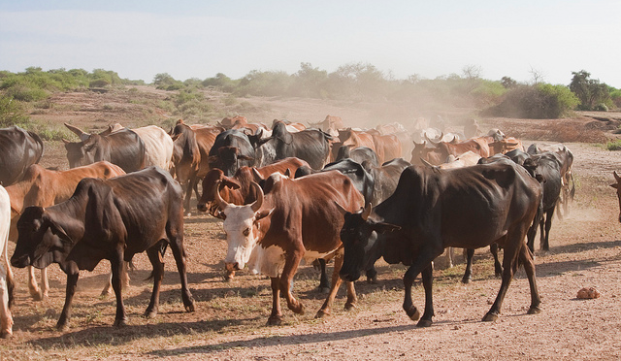

- (i) Name the type of photograph shown above (1 mark)
- Ground general view

(ii) What time of the day was the photograph taken if the camera was held facing south?
(1 mark)
- Evening
(iii) Draw a rectangle measuring 16cm by 9cm to represent the area of the photograph. On it sketch and label the main features shown on the photograph (5 marks)

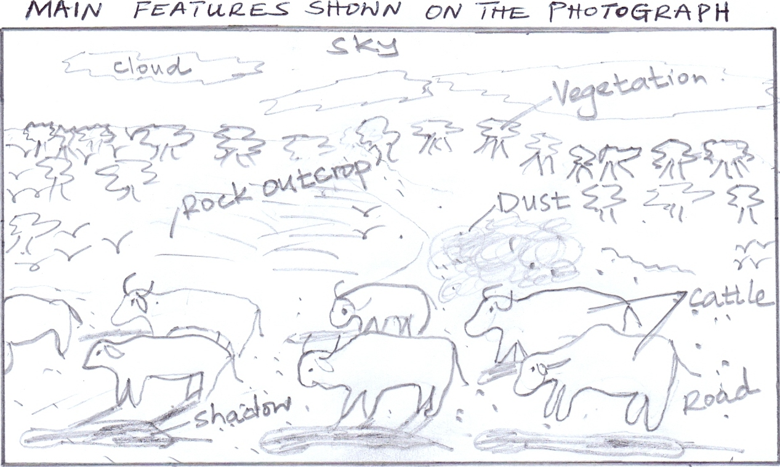

(iv) Describe the landscape of the area represented by the photograph. (3 marks)
- The land rises from the foreground towards the background
- The area covered with vegetation is slightly raised.
- The area in the background has bare rock surfaces/rock outcrops.
- The area in the foreground is gently sloping.

b)i) Identify two counties in the Rift Valley where ranching is practiced. (2 marks)
- Kajiado
- Laikipia
- Nakuru

ii) Name one exotic breed of beef cattle reared in Kenya (1 mark)
- Aberdeen Angus
- Hereford
- Galloway
- Charoleus
- Shorthorn
- Sahiwal

- State four physical factors which favour beef farming in Argentina. (4 marks)
- Availability of water for cattle supplied using wind pumps
- Warm and wet climate/maritime climate makes it possible for grazing throughout the year.
- Gently sloping landscape for easy movement of animals
- Moderate temperatures /10 - 24°C/ cool winters and warm summers ensures continuous growth of pasture.
- Fertile loose soils support growth of pasture.
- Explain four benefits of beef farming to the economy of Argentina. (8 marks)
- Beef is exported to earn foreign exchange which is used to develop other sectors of the economy.
- Beef farming has led to growth of towns e.g Buenos Aires leading to urbanization in the country.
- Beef farming has resulted in development of roads/railway lines thus increase accessibility.
- Beef farming is a source of income to farmers which has improved their living standards.
- Beef farming provides raw materials used in industries thus promoting industrialization.
- Beef farming increases employment opportunities hence improve the living standards of citizens.

7. a) Define agro-forestry (2 marks)
- The land use system which enables the portion production of trees, crops and livestock on a given unit of land for maximum production and land sustainability.

b) State three benefits of agro-forestry (3 marks)
- To maintain soil fertility
- For supply of wood and wood products
- Some trees are used for animal fodder
- Some trees are planted to provide fruits for human and animal consumption
- Trees grown act as wind breakers at the edge of farm plots or between rows of crops.

c)i) Explain how the following factors have influenced distribution of natural forests in
Kenya.
- Aspect: The windward slopes of mountains receives high rainfall hence wet therefore have dense forests.
- The south facing slopes in the northern hemisphere are warmer and wet therefore having dense/luxuriant forests. (2 marks)
- Soils: Deep, well-drained and fertile soils supports plant life hence having variety or dense forest cover. (2 marks)

ii) Explain four ways of managing forests in Kenya (8 marks)
- Research carried out on soil requirements for different tree species enabling the foresters to plant trees in suitable areas.
- Carrying out public campaigns on the value of forests through the mass media by the government and non-governmental organizations.
- Establishment of training and research institutions dealing with forestry for trained and qualified personnel to manage forests.
- Enacting of laws and regulations which are meant to effectively manage forests by the government to allow maximum participation of local people.
- Creation of forest reserves so as to protect mainly indigenous forest trees form extinction.

d) Compare softwood forestry in Kenya and Canada under the following sub-headings
- Transportation: Transportation of logs in Kenya is done using tractors, lorries,
trucks and trains while in Canada, it is done using mobile cable steel bars, skiing on ice-covered ground and also floating down rivers.
- Harvesting: In Canada, cheap harvesting is done through clear cutting while
in Kenya it is done through selective logging.
In Canada logging is done during winter and early summer while
in Kenya, it takes place throughout the year.
In both commercial logging is mechanised
- Distribution: In Kenya, softwood forests are found mainly in the highlands
while in Canada they are found both in highland and lowland
areas.
In Kenya softwood forests cover a small percentage of the total
land area while in Canada they cover large tracts of land.
- Climate: In Canada, due to low temperatures, softwood tree species take
many years to mature while in Kenya, moderate to high
temperature encourages faster growth and maturity to take
short time/few years.

8. a) What is mixed farming? (2 marks)
- The type of agriculture involving the growing of crops and rearing of livestock on the same piece of land/farm on rotational basis.

b) State three economic factors influencing agriculture (3 marks)
- Operational costs of growing crops and rearing animals
- Marketing expenditure of the products to the market
- Prize actualizations of agricultural commodities
- Government policies through subsidies and guaranteed prizes to the farmers.

c)i) Give four physical factors influencing coffee growing in Kenya (4 marks)
- Temperature between 14°C - 26°C/High up to 30°C.
- Rainfall high rainfall well distributed annually/1000-2050mm
- Altitude ranges 910-2100 above sea level/high.
- Red volcanic soil/medium loam soils/deep, well drained soils.
- Undulating landscape/gentle slopes

ii) Describe coffee production in Kenya from harvesting to marketing (8 marks)
- Harvesting of coffee involves manually picking the red ripe berries which are ripe then transported to the collecting centres where they are weighed and sorted to remove bad ones.
- They are then transported to the processing factory where they are put in large tanks having water to remove the outer covering pup exposing two white beans which are then washed and sun-dried. The beans are sorted according to size and quality then roasted at temperature about 100°C then grounded into powder and packaged ready for marketing by the Coffee Board of Kenya.

iii) Give three differences between Coffee Farming in Kenya and Brazil (6 marks)
- In Kenya, coffee farming facing climatic problem of heavy rainfall and prolonged drought while in Brazil farmers faces the problems of frost.
- In Kenya, land ownership is individual while in Brazil there is more extensive land called Fazendas suitable for coffee growing.
- In Kenya, the transportation of coffee berries from the farms to factories is mainly by road which are inadequate while in Brazil transport of coffee is by well-developed and adequate road and railway network from the farms to the factories.

- You intend to carry out a field study on coffee growing in a farm near your school compound. State two advantages of using secondary data during data collection.
(2 marks)
- Easy to obtain data which has been analysed
- It is cheaper/less expensive
- Saves time.

9. Use the map of North America below to answer questions (a) and (b)

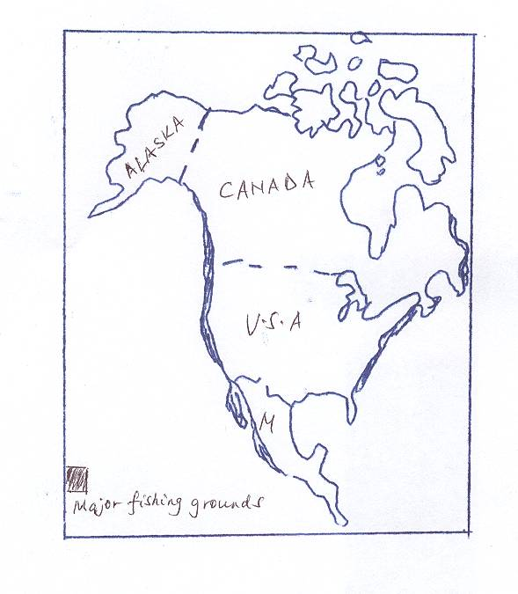
- Name; (i) The fishing ground shaded
- N.E. Pacific fishing ground (1 mark)
(ii) The ocean current marked (b)
- Warm North Pacific current (1 mark)

- Explain four physical conditions necessary for fishing in the fishing ground shaded
(8 marks)
- The availability of cool climatic condition of about 20°C favours the variety of fish species favours which is fish food.
- The warm North Pacific current that washes the coastline raises the low temperatures resulting in waters that are ideal for the health growth of plankton and ice free allowing fishing to be carried out throughout the year.
- The indented-coastline with several fords and river estuaries as well as sheltered inlets forms good sites for fish ports and fish breeding respectively.
- The presence of several rivers and lakes that form suitable fishing grounds for species such as salmon.
- The rugged mountainous landscape, dense forest cover in British Columbia and rocky surfaces discourage agricultural activities. This has forced many people to take up fishing as a source of food.
- The presence of excellent fishing ports, such as Prince Rupert, West Port makes it easier to access foreign markets.
(Any 4 well explained 4 x 2 = 8 marks)
- Describe trawling method of fishing (6 marks)
- A bag shaped net is attached to a trawler/ship
- The nets mouth is kept open by other boards
- The upper part of mouth of net has floats and weights at the bottom; to keep part of the net at the sea bed.
- Each end of the net is attached to a boat
- The net is cast to the waters, and the trawler drags the net along the sea bed
- After sufficient fish has been caught the net is hauled to the trawler to empty the fish.
NOTE: steps to follow to score.

d)i) Explain three ways in which overfishing can be controlled in Lake Naivasha (6 marks)
- Restrictions enforced on the type and size of nets that should be used to avoid indiscriminate fishing.
- By restocking, releasing fingeshings to increase generation of fish.
- A selected number of fishermen can be licensed to carry out fishing to allow breeding and maturity of fish.
- Establishing fish farms with popular species of fish such as tilapia to ease pressure on fishing in the lake.
(Any 3 well explained 3 x 2 = 6 marks)

ii) State three significance of fish farming (3 marks)
- Fish farms provide fish for both subsistence and commercial use.
- Fish from fish farms is used to restock overfished grounds
- Establishing and fishing in fish farms provide employment opportunities
- The development of fish farms complements the fish being caught from natural waters
(Any 3 well stated 3 marks)

10. a)i) Apart from coal, name three other non-renewable sources of energy. (3 marks)
- Oil/petroleum
- Uranium
- Natural gas

ii) State four reasons why there has been a decline in the use of coal as a source of energy.
(4 marks)
- Coal has a low calorific value
- Coal is dirty to use
- Exhaustion of coal
- Discovery of oil and other alternative efficient forms of energy
- Coal is bulky and thus costly to transport.
- It is expensive to mine coal found deep underground.

iii) Give three advantages of using wind energy (3 marks)
- It is a cheap source of energy
- It is an inexhaustible source of energy/renewable
- It is a clean/environmentally friendly form of energy
- It is free
- It is safe to use
- It can be found everywhere
- Land between the windmills can be put into other uses.

- Name two examples of agricultural non-food processing industries in Kenya (2 marks)
- Tobacco processing
- Footwear making
- Leather tanning
- Beeswax processing
- Sisal processing
- Pyrethrum processing

- Below is a sketch map of the Ruhr Industrial Region. Use it to answer question (i)

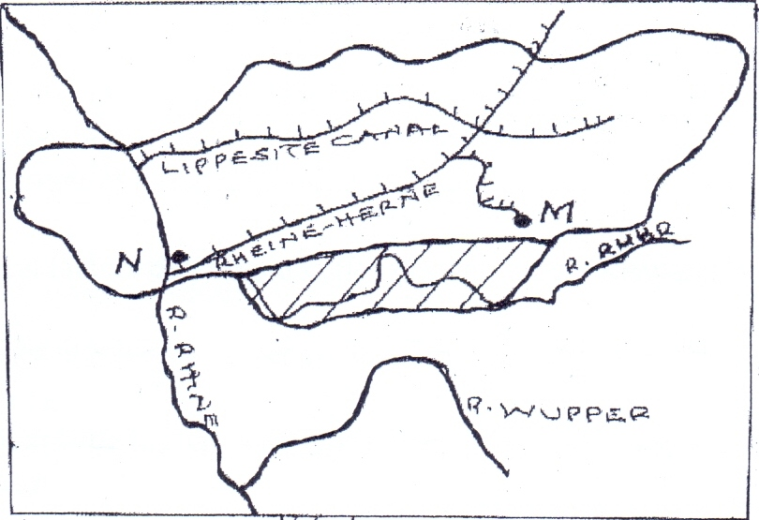

- Name;
The canal marked U (1 mark)
- Lippesite canal

The river marked V (1 mark)
- River Ruhr

The town marked W (1 mark)
- Dortmund

ii) Explain three factors which led to the growth of iron and steel industry in the Ruhr region of Germany. (6 marks)
- Availability of coal/iron ore/limestone from the Rhine Valley that provided raw materials needed in the industry.
- River Rhine/Ruhr/Lippe/Encher/Wupper provided water required for cooling machines in the industry/for industrial use.
- The region is served by navigable rivers e.g. R. Rhine and canals e.g. Lippesite which provided cheap transport for bulky raw materials and finished products.
- Coal from the Ruhr Region and imported petroleum provided power required in the industry
- The local population had acquired skills on iron working/availability of local skilled labour and this formed the foundation of iron and steel industry.
- The presence of rich companies/krupp families which provided capital for the development of the industry.
- The dense/affluent population in Europe (Central and Western)/Germany provided ready market for iron and steel.

- Explain two environmental problems which have resulted from the development of car manufacturing industry in Japan. (4 marks)
- It has led to air, noise and water pollution which is dangerous to human health and wildlife/visibility.
- Dumping of industrial waste leads to environmental degradation/water or soil pollution.
- Increased production of cars and the high local purchasing power has led to traffic congestion in the cities.
- High demand for limited raw materials like coal has resulted to over exploitation.
- Emergence of many factories has attracted large manpower which has resulted in housing problems/inadequate housing.

